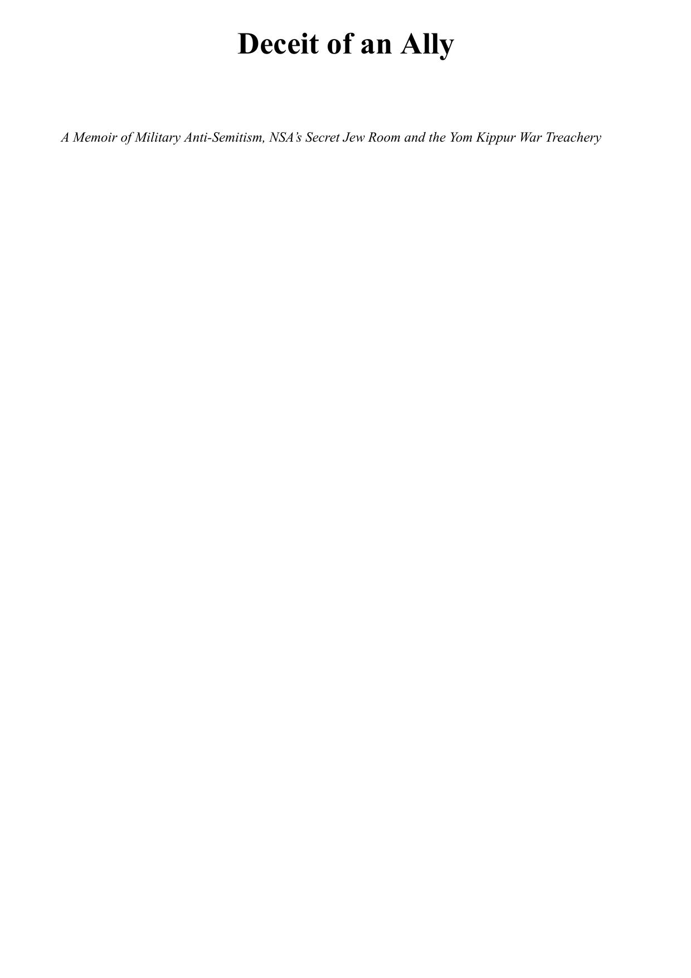

Table of Contents
PREFACE
INTRODUCTION
UNCLE SAM WANTS YOU
Draft Dodger Rag - Phil Ochs
BASIC
DILLYWICK
JEWS EAT GENTILE BLOOD
SECURITY CLEARANCE DENIED
GOODFELLOW AFB
ALL HELL BREAKS LOOSE:
YOUR YOUNG ASS
THE FISHING TRIP
MY PENPAL, MOSHE DAYAN
WAKE-UP CALL:
J’ACCUSE
THE BOTTLENECK
PSYCHOLOGICAL PERFECT STORM
PORTENTS APLENTY
PARANOIA
AMERICA’S FRIENDSHIP TOWARD ISRAEL
AMERICA VERSUS ISRAEL
NO SUCH MAN EVER EXISTED
MONITORING
CORROBORATION
FACEBOOK TEXT CHATS WITH DAVID G., KAREEM, AND DAOUD
THOUGHTS AND AFTERTHOUGHTS
BARKING UP THE WRONG TREES
EPILOGUE:
APPENDICES
APPENDIX 1:
EXCHANGES WITH CONGRESSMAN LA MALFA’S ASSISTANT, DAVID MORGAN
UNITED STATES PENTAGON APPROVALS FOR PUBLICATION OF THIS BOOK
FIGURES LIST
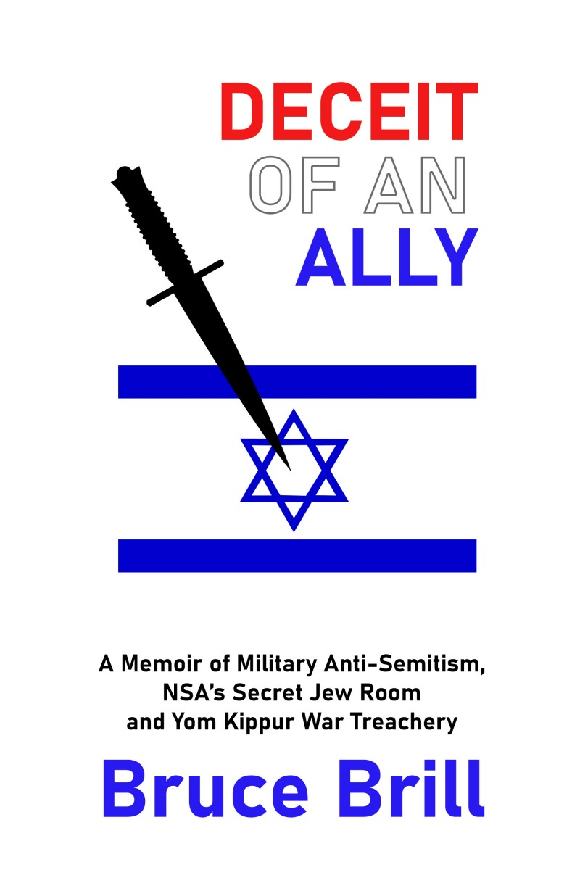

“A captivating manuscript. Not only a fascinating autobiography and sensational glimpse into the concealed darker side of the NSA, it captures the author’s discovery of his own calling to his life’s mission. Rabbi Moshe Averick, of blessed memory, taught that each individual is put on this earth for a unique purpose, that only he or she is qualified --and indeed obligated—to fulfill. Mr. Brill presents the truth of anti-Semitism that lurks in the highest places, a specific truth that only he could reveal through his extraordinary experiences. Historical, and timely.”
Sara Stenge
Indeed, important and valuable imformation which I am sure will be widely and eagerly discussed once published. ... [Brill's] findings ... will be very valuable for understanding US Israel relations.
Dr. Einat Wilf, Former Minister of Knesset
The 1973 Arab-Israeli War marks one of the most disturbing chapters in Jewish history. Bruce Brill lived through this as an analyst in Washington and later spent decades researching key questions. His answers are illuminating and his questions are vital.
Steve Rodan, award-winning journalist and Co-author of
In Jewish Blood: the Zionist Alliance with Germany, 1933-1963
These disclosures shed a new light on the issue.
Dr. Beni Michaelson, Past Director, Israeli Defense Force Archives
Bruce Brill, a serious investigator.
Aviram Barkai, Author of
For Heaven's Sake: Squadron 201 and the Yom Kippur War
I read [this]manuscript very carefully, and with especial interest ... It revealed unique, and certainly unfamiliar angles of events that underlie the failure of the Yom Kippur War. It also has first-hand evidence -- unique and important -- of the way the American intelligence community treated Israel.
Professor Eyal Zisser, Deputy Director, Tel Aviv University.
[Bruce Brill has] the talent to engage the reader to want to read more.
Rabbi Michael Schudrich, Chief Rabbi of Poland
Definitely intriguing and illuminates an important point on the question of the surprise and responsibility of [the Israeli Intelligence Directorate].
Yaron Zilberman, Director, Valley of Tears, television series.
Deceit of an Ally
A Memoir of Military Anti-Semitism, NSA’s Secret Jew Room and the Yom Kippur War Treachery


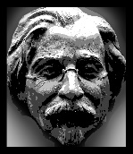
Aleichem Publishers
Grass Valley, California

Published 2022 by Aleichem Books,
101 West McNight Way, PBM 181, Grass Valley CA 95949 USA
Deceit of an Ally
A Memoir of Military Anti-Semitism, NSA’s Secret Jew Room and the Yom Kippur War Treachery
By BRUCE BRILL
Copyright © 2022 Bruce BrillAll Rights Reserved
THIS BOOK OR ANY PART OF IT MAY NOT BE COPIED, STORED , TRANSFERRED OR TRANSLATED EXCEPT WITH PERMISSION OF THE AUTHOR.
Ebook Edition ISBN: 978-108-82123-3-2
This book has been cleared for publication by the US Department of Defense pursuant to the letter enclosed as Appendix 5 in this book.
Editor: Jefferson Gaskin.
Layout Abigail Abramovich
THE PHOTOGRAPH, “THE U.S. INTELLIGENCE BOARD OF 1973,” FIGURE 50 BELONGS TO THE U.S. CENTRAL INTELLIGENCE AGENCY WHICH HAS AUTHORIZED ITS USE IN THIS MANUSCRIPT ON CONDITION THAT ITS OWNERSHIP BY THE C.I.A. IS ACKNOWLEDGED AT THE BEGINNING OF THE BOOK AND THAT THEIR AUTHORIZATION OF ITS USE DOES NOT INDICATE ENDORSEMENT OF THE BOOK’S CONTENTS.
Various periodical articles are used either by permission or under the Fair Use doctrine.
All Internet references are from 2019 and 2020
Cover flag image by Clker-Free-Vector_images from Pixabay

Table of Contents
PREFACE
INTRODUCTION
UNCLE SAM WANTS YOU
LEAD-UP TO ENLISTMENT
BASIC
DILLYWICK
JEWS EAT GENTILE BLOOD
SECURITY CLEARANCE DENIED
GOODFELLOW AFB
ALL HELL BREAKS LOOSE:
THE S**T HITS THE FAN
YOUR YOUNG ASS
THE FISHING TRIP
MY PENPAL, MOSHE DAYAN
THE MESSIAH's BLESSING
THE EVIL EVAL

I BECOME A HEEB

THE CONVERSION PROCESS

WAKE-UP CALL: US CONSULATE
J’ACCUSE
HE HAD TO LIE
THE BOTTLENECK
PSYCHOLOGICAL PERFECT STORM
PORTENTS APLENTY
PLENTIFUL PORTENTS VS. THE CONCEPT

PARANOIA
AMERICA’S FRIENDSHIP TOWARD ISRAEL
AMERICA VERSUS ISRAEL
NO SUCH MAN EVER EXISTED
MONITORING
CORROBORATION
FACEBOOK TEXT CHATS WITH DAVID G., KAREEM, AND DAOUD
YITZ's CORROBORATION
THOUGHTS AND AFTERTHOUGHTS - UNANSWERED QUESTIONS
BARKING UP THE WRONG TREES
EPILOGUE:
APPENDICES
APPENDIX 1: BARKAI INTERVIEWS WITH DMI ZEIRA RE: BRUCE BRILL
APPENDIX 2: EXCHANGES WITH CONGRESSMAN LA MALFA’S ASSISTANT, DAVID MORGAN
APPENDIX 3: THE TRUTH BEHIND THE YOM KIPPUR SURPRISE
APPENDIX 4: DANNY BEN-YAAKOV
APPENDIX 5: UNITED STATES PENTAGON APPROVALS FOR PUBLICATION OF THIS BOOK
FIGURES LIST
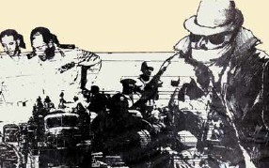
Figure 1 Assaf Berg Sketch
Former National Security Agency (NSA) Mideast analyst Bruce Brill knew days in advance that Syria and Egypt planned to invade Israel on Yom Kippur in 1973. Yet General Eli Zeira, Israel’s director of military intelligence, confided in Brill that Zeira’s American intel partners had assured him the Arabs would NOT attack Israel. From the moment Brill heard this disturbing revelation, he began a mission to unravel the deception that resulted in the unnecessary deaths of over 2,600 Israelis. The vital intelligence Brill discovered was purposely corrupted in secret NSA chambers called the Jew Room.
PREFACE
In 1991, Israeli Parliamentarian and Government Minister General Rehavam Ze’evi warned me that publicizing my disclosures about NSA’s treachery toward Israel would put my life in jeopardy. Although I took his warning seriously, I felt the best way to stay alive would be to publish my revelations. Once published, the threat of publication is no longer a factor. Furthermore, eliminating me would support my claims for those doubting them. (General Ze’evi was assassinated October 17, 2001, in Jerusalem.)
On October 6, 1973, Egypt and Syria launched a surprise attack against Israel. While it came as a total shock to Israel, we at NSA’s Middle East Section knew days in advance of Arab intentions. This surprise cost the lives of over 2,600 Israelis.
Only after the attack had begun did I learn that we hadn’t informed the Israelis. After decades of research, I came to understand that NSA not only suppressed this vital intelligence but passed the Israelis a false intelligence assessment. How, where, why, and by whom was this done?
This book will expose the hidden pieces of a puzzle that will finally explain what has until now been impossible to understand: how Israel fell prey to the disastrous October 1973 deception. “The Jew Room,” a secret-within-the-agency cabal that worked against Israel, is a major piece of the puzzle.
Most observers have blamed the failure on Israel’s then-director of military intelligence (DMI), Maj. Gen. Eli Zeira. He prevented any effective and timely action by convincing Israel’s leaders that the probability of an Arab surprise attack was “very low.” This book will show that affixing total culpability to DMI Zeira needs to be reexamined.
Sources within NSA today report the Jew Room no longer exists. Can we trust this claim?
INTRODUCTION
The interrogator said, “You’re having a problem with that one.”
I was.
I don’t know what exactly the needles on the lie detector told the interrogator, but the machine had clearly caught me in a lie.
I was an American soldier working as a Middle East intelligence analyst at the National Security Agency (NSA) at Fort Meade, Maryland, and was being interrogated by an NSA security officer.
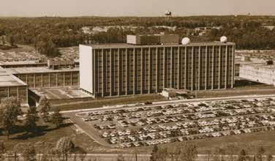
Figure 2: NSA Complex, Fort Meade as it looked in the early ’70s.
The interrogation was part of being accepted --reaccepted -- into NSA as a civilian employee. The question I was asked was, “Can you foresee any circumstance in which you would pass classified information to a foreign national?”
I answered,“No.”
I did not say this because I consciously intended to pass classified information to a foreign national and was lying -- definitely not.
But here I was, caught in a lie! Was I lying to myself?
I had always been a loyal, patriotic, and trustworthy American soldier. When I enlisted, I took an oath to honor and defend the United States Constitution. When I joined NSA, I took another oath - a secrecy oath. I would never consciously violate it. When I swore, “so help me God,” in my secrecy oath, I meant it. I engraved the oath, which I had sworn in the name of God, on my heart, and I would, of course, be very careful to never, under any circumstances, violate it. I would have been insane to answer, “Yes, under certain circumstances, I would pass classified intelligence to a foreign national.” To answer the interrogator’s question in the affirmative never occurred to me.
But the lie detector said I would - under certain circumstances - pass classified intelligence to a foreign national. It was telling the truth. Despite my negative answer, I would pass classified information to a foreign national. It correctly predicted my likely future behavior.
Lie detector tests are very sensitive and usually very reliable. They are 96-98% reliable.1 They can catch you in a lie, yes, but they don’t have the sophistication to distinguish between interrogational subtleties. This was the problem here. The question asked of me was a general one. Had it been more specific, such as “Would you ever pass classified intelligence to an enemy of the United States?” and I answered, “No,” the machine would not have caught me in a lie: because I never would! If the question were “Would you ever pass classified intelligence that was being suppressed by sinister departments within the Agency to an American ally where, if you didn’t, this ally would suffer serious injury?” and I answered, “No,” I would be lying, and the machine would no doubt catch me in the lie.

Clearly, I had heard the second question.
1 Ozeri, Beni (7 April 2021) Beni Ozeri Polygraph Institute, Binei Brak, Israel, personal communication.
This was less than a year after the Yom Kippur War had broken out on October 6, 1973.
• Less than a year since I had monitored real-time battlefield communications by Israeli and Arab forces at the beginning of the Arab surprise attack on the first day of that war.
• Less than a year since I had realized the Israelis on the front line had been totally surprised.
• Less than a year after I had realized NSA’s intelligence had somehow been kept from the Israelis - a matter of life and death they needed to know.
• Less than a year since I had asked myself, “My God, how could this be?”
• Less than a year since I had learned Israel had lost over 2,600 soldiers and realized this loss was unnecessary.
• Less than a year since a sudden passion for Israel had taken possession of me and I had become a Zionist.
Could I have prevented the loss of those 2,600 lives? That possibility was why I had been caught “lying” to the lie detector.
The following story is both a personal memoir and a historical analysis. It explains why I was in that interrogation room. It relates how the truth behind the lie defined my life, its trials and trails. It penetrates the intricate web of intrigue that made Israel fall prey to a deception that cost the lives of 2,600 soldiers in October 1973 and examines the ramifications for today.
UNCLE SAM WANTS YOU

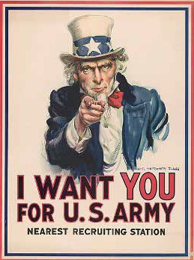
Figure 3: “Uncle Sam” Wants You!*
*​James M. Flagg created his Uncle Sam Poster in 1917 to promote the American war effort. It has since become an iconic symbol used also in WWII and beyond

LEAD-UP TO ENLISTMENT

Draft Dodger Rag - Phil Ochs
Oh, I’m just a typical American boy
From a typical American town.
I believe in God and Senator Dodd
And a-keepin’ old Castro down.
And when it came my time to serve,
I knew “better dead than red.”
But when I got to my old draft board, buddy,
This is what I said:
[Chorus] Sarge, I’m only eighteen.
I got a ruptured spleen,
And I always carry a purse.
I got eyes like a bat,
And my feet are flat,
And my asthma’s getting worse.
Yes, think of my career, my sweetheart dear,
And my poor old invalid aunt.
Besides, I ain’t no fool,
I’m a-goin’ to school,
And I’m working in a defense plant.
I’ve got a dislocated disc and a
wracked-up back.
I’m allergic to flowers and bugs.
When the bombshell hits,
I get epileptic fits,
And I’m addicted to a thousand drugs.
I got the weakness woes,
I can’t touch my toes.
I can hardly reach my knees.
And if the enemy came close to me,
I’d probably start to sneeze.
Oh, I hate Chou En Lai, and I hope he dies,
But there’s one thing you gotta see.
Someone’s gotta go over there,
And that someone isn’t me.
So I wish you well, Sarge, give ’em hell!
Kill me a thousand or so.
And when you get a war without
blood and gore, well I'll be the first to go.
In the late 1960s, America was becoming seriously bogged down in the Vietnam War. Although America’s policy of containment seemed logical to those of us with conservative political leanings, it was not so compelling as to warrant enlisting in the Army to put your life on the line. Because Vietnam was not a popular war, most young men considered trying one of the various tactics or excuses to avoid service in Vietnam. The popular anti-war song Draft Dodger Rag, shown above, gives a list of almost every possible method of avoiding the draft in the US Army with the likelihood of heading to the jungles of Vietnam. Many young men contemplated how they would avoid service.
American men tried to avoid the draft. The “Draft Dodger Rag” by Phil Ochs typified the attitude of most draft-age American men. Even military enlisted men, which I would soon be, appreciated the song. I believe one of the reasons it was universally appreciated was that it was one of the rare lighthearted things that came out of the Vietnam War. As the war dragged on into the 1970s, there was almost nothing lighthearted to enjoy.
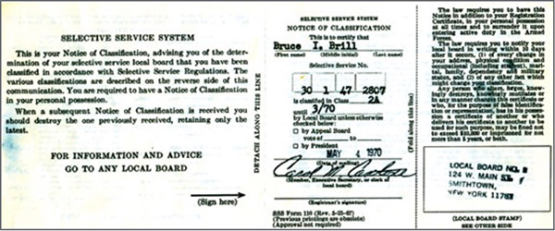
Figure 4: "2A" Occupational Deferment
When I was in college, from 1965 to 1969, I had a “2S” student deferment (“I ain’t no fool; I’m goin’ to school”) and right after college, I had a teaching deferment, “2A” (working in a defense [education] plant). It was a strong deferment since I was teaching in a “low socio-economic area.”
I had begun my second year teaching math in a junior high school on Long Island when the Selective Service decided to institute a draft lottery. It was the only lottery I ever “won,” quotes intended. My birthday, November 7, drew lottery number 51. I would be called up, no doubt. My new status was now “1A.”
Drawing #51 guaranteed a change in my status from teacher to something else. What that “something else” would be exactly, there was no way of knowing. Were I the Rambo type, I would probably not have waited for the Selective Service to tap me on the shoulder. Still, I decided I’d try to make the best of being in the armed services. After all, did I have a choice?
Yes, I did. Plenty of my contemporaries avoided the Army by leaving the country, and I could have, too, but I couldn’t go through with it. Though the border was just half a day’s train ride away, my conscience wouldn’t allow it.
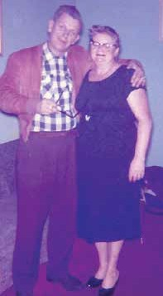
Figure 5: Robert Johnson and Mom.
The dictates of my conscience had been molded by my environment: teachers, friends, friends’ parents, and my own parents. I also benefitted from the influence of one additional person. For lack of a better word, I’ll call him a mentor. From the age of about 12, I had spent most Saturdays at Mr. Johnson’s home. The day would begin with a violin lesson, and then we would play chamber music. Later in the day, we would step into the world of the cowboy, for “Highpockets Bob,” as he had been known on the range, had been a cowboy in Montana and Wyoming in his younger days. We also explored history, philosophy, politics, and current events.
Of course, we spoke about the efficacy of the Vietnam War and the question of dodging the draft. Bob Johnson, although liberal in the most important issues, was conservative in the extreme when it came to engaging the commies. He gave no leeway to anti-war activists and had compelling arguments for why we should be confronting the communists.
No, they weren’t as compelling as the arguments for America fighting the Axis in WWII. When it came to fighting the krauts, Mr. Johnson had enlisted in the US Army “to see what these supposed supermen are made of.” As a Lutheran of Swedish extraction, if he had fallen into German hands, he would not have been a candidate for extermination.
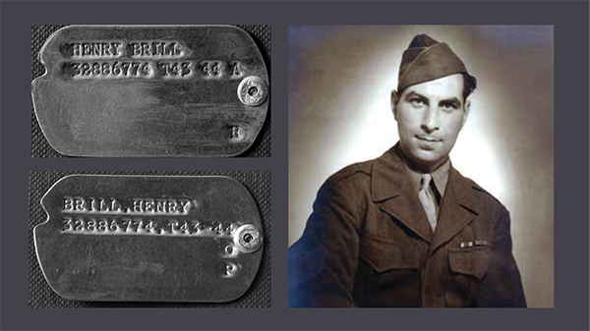
Figure 6: Pvt Henry Brill, “Protestant.”
In contrast, it was feared that my Jewish dad, who also served in the US Army in Europe during WWII, would have been, so when he was about to land in Normandy, he was given a second set of dog tags that designated his religion as “P,” for Protestant (instead of his original dog tags, “H,” Hebrew for Jewish), in case he fell into German hands.
So, no, there was no room to entertain the idea of running away. My conscience wouldn’t allow it; my dad had served, and so would I.

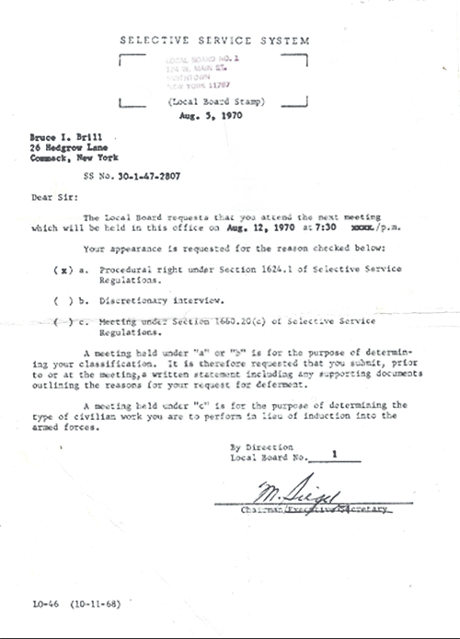
Figure 7: Selective Service notice to appear.
There was one option before talking to a recruitment officer: to appeal. The draft board offered advice to those wishing to do so.
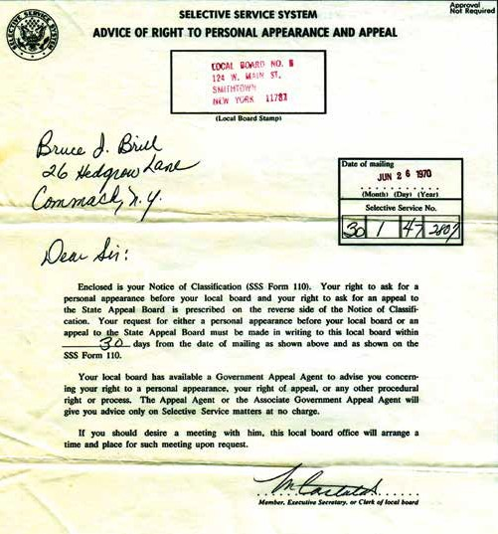
Figure 8: Selective Service appeal notice.
Since I was teaching in “a ghetto school,” my principal hoped an appeal would fall on receptive ears.
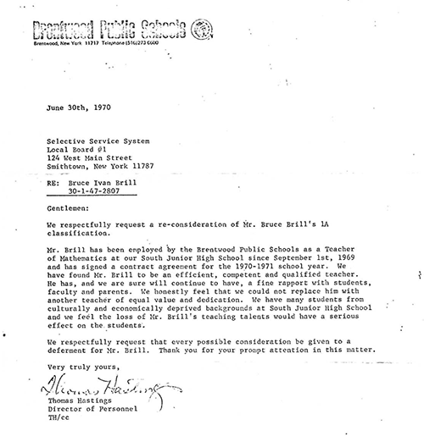
Figure 9: Board of Education deferment request.
It didn’t.
So, what was I to do at this point? I could either wait to appear before the draft board and be placed wherever Uncle Sam wanted to send me, or I could voluntarily enlist and maybe have some control over my fate. I decided to check out my options if I voluntarily enlisted.
At the recruiting office, I saw one option that seemed superbly sensible: take a battery of aptitude tests to see what I was good at and try to get placed in a particular job (a job far from the jungles of Vietnam).
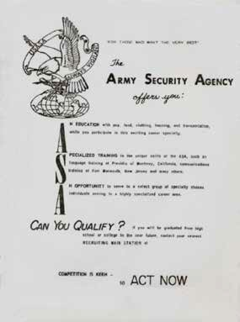
USASA:
U.S. Army Security Agency recruitment flyer.

I aced the ALAT, the Army Language Aptitude Test, scoring a 62 out of 62. As a result, I was offered the language of my choice and an assignment with USASA, the United States Army Security Agency.
Composed primarily of soldiers with the very highest scores on army intelligence tests, the ASA was tasked with monitoring and interpreting military communications of the Soviet Union, the People’s Republic of China, and their allies and client states around the world. The ASA was directly subordinate to NSA, and all field stations had NSA tech reps on site.
All information gathered had time-sensitive value depending on its importance and classification. Information was passed through intelligence channels - within hours of intercept for the lowest-priority items but in as little as ten minutes for highly critical information.
ASA personnel were stationed at locations around the globe, wherever the US had a military presence - publicly acknowledged or otherwise.
I thought, “Hey, Hebrew would be a good idea.” I had begun learning the language for my bar mitzvah, and I had also started a master’s degree in linguistics. The faculty advisors insisted that, in addition to English, a student should learn two additional languages, each from a different language family. At the time, I was learning Spanish, and I had some high school German, so a Semitic language would foot the bill just fine.
Unfortunately, the Army didn’t offer Hebrew at the time of my enlistment. They did, however, offer Arabic… so I said to myself, “Why not? Not only is it in the Semitic family group, but I don’t believe there’s much need for Arabic linguists in the jungles of Southeast Asia.”
Being drafted meant two years of service wherever Uncle Sam needed you. There was no guarantee that the “wherever” would not be the jungles of Nam. To get training in a language that pretty much guaranteed steering clear of Vietnam would require a four- year enlistment. The choice was two years with a good chance of becoming a war statistic versus four years and benefitting from language training. I didn’t hesitate to choose the latter.
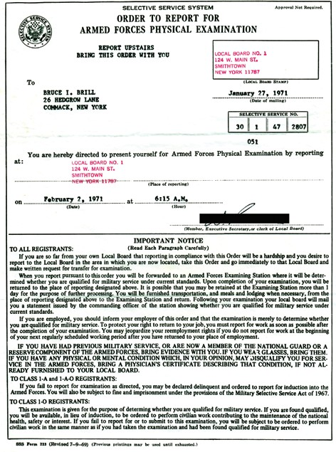
Figure 11: Induction notice.
Enrolling in Arabic language training seemed a good way to steer clear of Vietnam. This attempt was admittedly feeble; but, apparently, it worked.
Enrolling in Arabic language training seemed a good way to steer clear of Vietnam. This attempt was admittedly feeble; but, apparently, it worked.
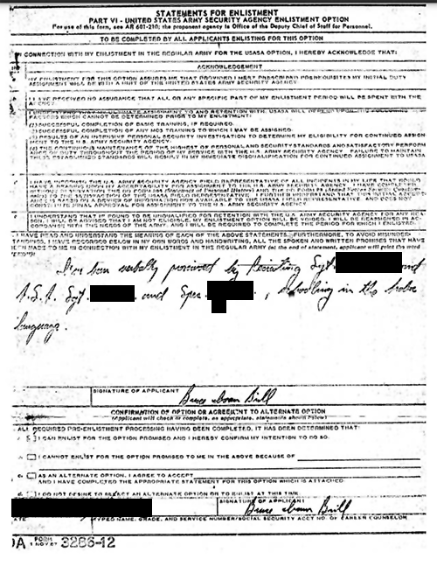
Figure 12: My attempt to guarantee assignment to ASA for the Arabic language and orders to Fort Dix.
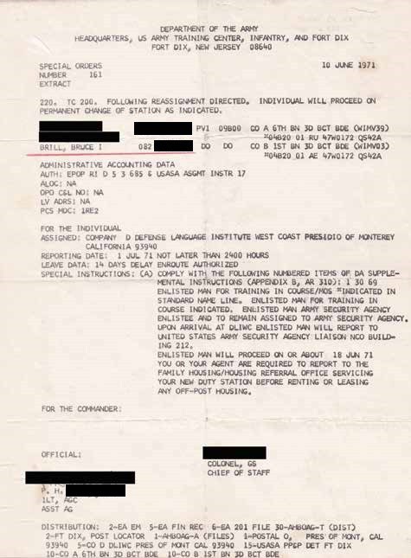
Figure 13: It worked! My assignment to USASA
BASIC

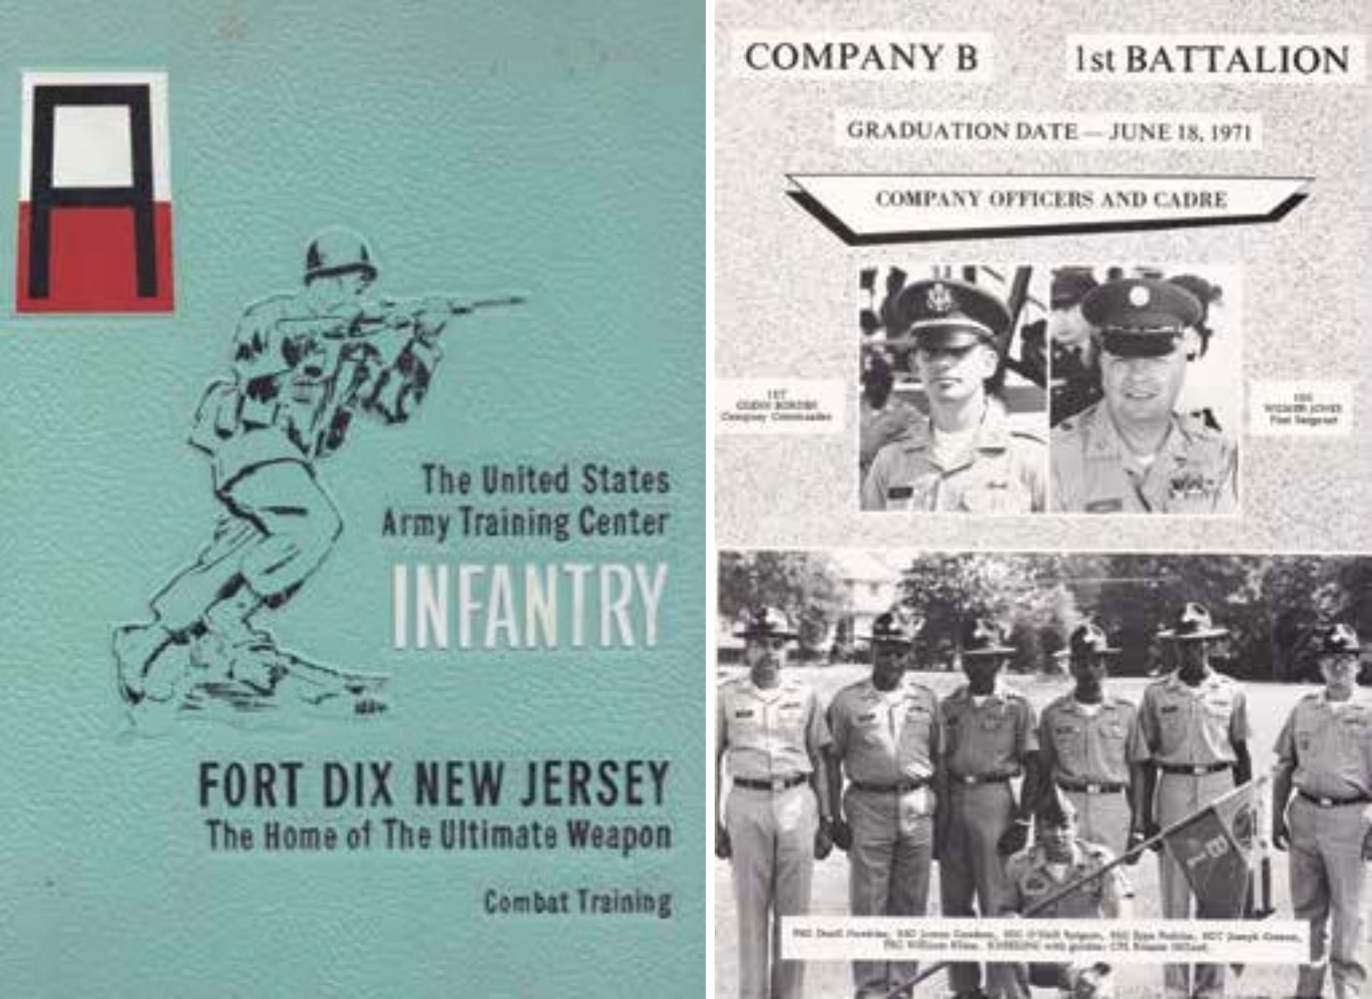
Figure 14: Basic Training.“Eight more weeks of cleaning brass, then Fort Dix can kiss my…”
This story begins at Fort Dix, where I did my basic training (“Basic”). For those eight weeks, I suspended my self-imposed dietary restriction to keep kosher (in large measure refraining from eating pig products or mixing meat with dairy). I didn’t wish to “make an issue” of the issue. In fact, typical army mess was loaded with pig-profuse fare, from vegetables cooked with lard to breakfast meat in cream on bread, otherwise known as SOS, “s**t on a shingle.”
I actually enjoyed Basic. Or, to be more honest, I enjoy the memories of Basic more than the agony of Basic:
• Sleeping in a room with dozens of other guys, some of whom were bound to be snorers.
• Agonizing “PT,” physical training, where, to add insult to injury, we would be required to shout in unison, “More PT, Drill Sergeant!” upon his cue, “What do you want?” To his other cue, “Whaddya love?” we would answer, “We love PT, Drill Sergeant!”
• The impossibility of staying awake through the most boring classroom training sessions.
• Having to stand during such sessions if you dared to close your eyes.
• Being forced to inhale tear gas as part of chemical warfare exposure.
• Suffering blisters on your feet from forced marches and blisters on your hands from the horizontal ladder.
• Being psychologically abused and denigrated, even being given a demeaning nickname.
Although my nickname was “Ugly Man,” I enjoyed playing along with the game. Whenever I heard a drill sergeant shout, “Ugly Man!” I would immediately jump up and answer with a hidden smile (one dare not smile obviously or even give a subtle smirk), “Yes, Drill Sergeant!”
Memorable moments filled those eight weeks. I especially enjoyed the cadences. To me, they were a prime example of a musical folk tradition. The chants had evolved from when my dad had served during World War II. He, too, had done Basic here, but then it had been known as Camp Dix. During my time, we never sang “The coffee in the Army, they say it’s mighty fine…” cadence. Our cadences were full of the F-word, except, of course, when we’d march through a public area where there might be a woman present, in which case there would be an instantly clean version of the same cadence.
I loved these cadences so much that I decided to record them. I purchased a recording machine at the PX. Each morning, I would place it under my shirt, route the microphone wire through my right sleeve, and hold the mic in my right hand. The machine had the option of activating the recording by a switch on the mic. By today’s standards, the machine was not terribly portable. It was about two, maybe two and a half inches thick, eight or nine inches wide, and a bit over a foot in length. Forced marches were hard enough, and the extra weight and clumsiness of the recorder bouncing under my shirt didn’t make it easier. But it was worth it.

I succeeded in getting just about all the cadences we sang. Our platoon drill sergeant created one especially brilliant cadence while leading the other platoon in our company. He got all the trainees out of step and then sang, “We’re out of step,” which they had to repeat. It was one of the more hilarious moments of Basic.
Another must-keep instance was when we had a stupid training session to teach us “how to walk.” Yes! To teach us how to walk! “When you put your left foot forward, you put your right arm forward. When you put your right foot forward, you put your left hand forward.”
Then they would single-file us past the cadre’s watchful eyes to make sure we “got it.” Try walking while throwing the same hand forward as your leg! It’s not easy! Of course, I went off to the side and practiced this, and when it was my turn to walk through, I threw my left arm forward when I placed my left leg forward, and ditto for the right arm and leg. “GET YOUR HEAD OUT OF YOUR ASS, UGLY MAN! Drop down and gimme 20!”
There were other equally “memorable” moments in Basic, but it all eventually ended… as all good things must. “One more week of cleaning brass, and then Fort Dix can kiss my ass.” We’d been singing that one since the verse was “Eight more weeks…” But it did end.
After Basic, it was off to DLIWC (pronounced “dilly wick”), the Defense Language Institute, West Coast, in Monterey, California, for the 47-week Arabic language course.
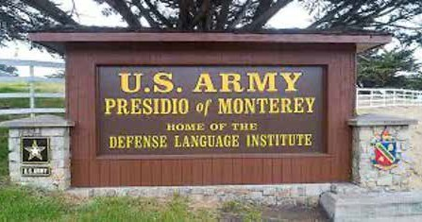
Figure 15: Presidio of Monterey.
DILLYWICK


The Defense Language Institute, West Coast (DLIWC), or “Dillywick,” only existed under that name for about a decade, from 1963-74, but it had predecessors from which it evolved.
DLI’s predecessors date back to the 1930s when the American embassy in Tokyo formalized Japanese language training for staff. By the end of the decade, when the likelihood of war between the US and Japan was becoming more apparent, the US Navy began Japanese language training, and the US Army soon followed suit. By the time America entered the war in December 1941, the Army had already begun a program called the Fourth Army Intelligence School, which was filled predominantly with Americans of Japanese descent, both as teachers and students. As the war progressed and suspicion of these Asian Americans increased, Americans with no Japanese background were trained in the language, and the name of the program was changed to the Military Intelligence Service Language School (MISLS).
After the war, the program relocated to the Presidio of Monterey, California, and was renamed the Army Language School (ALS). Although still focusing mostly on Japanese during the US occupation of Japan, it expanded the number of languages taught to cope with the requirements of the Cold War with the Soviets.

In 1963, the Defense Department consolidated language training under the Defense Language Institute. All military branches were trained either at the Presidio of Monterey (DLIWC) or at an East Coast campus in Washington (DLIEC).4
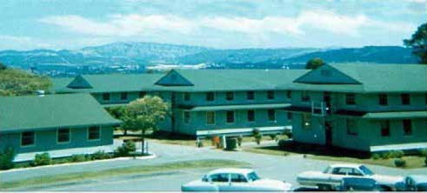
Figure 16: “Temporary” WWII wooden barracks at the Presidio of Monterey.
The wooden army barracks in the photo above were built to serve as “temporary housing” back during WWII; they were the same ones in which we were housed in 1971 and 1972. Although most of these structures were subsequently taken down, some were still in use in 2006 when I took my then 13-year-old son to see the Presidio of Monterey. One quick word about the amenities of those quarters: the showers, urinal (one long common trough), and toilets were open; there was no privacy. You somehow learned to live with it. It was actually possible.
In 1974, DLI became the language training center and was renamed the Defense Language Institute Foreign Language Center (DLIFLC), by which it is known today. DLI was a multi-service base where one could find members of the Navy (“squids”), Marines (“grunts”), Air Force (“zoomies”), and Army (“ground-pounders”).

4 Dr. Greg Bradsher, “The Beginnings of the United States Army’s Japanese Language Training: From the Presidio of California to Camp Savage, Minnesota 1941-1942,”
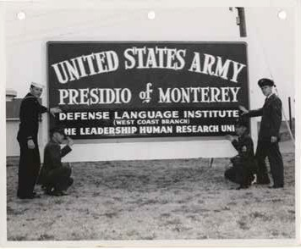
Figure 17: Presidio of Monterey: a joint services base.
The ideal number of students in a DLI language class should not exceed ten, and so it was with our class. Seven of us were fresh out of basic training: Behe, Kareem, Daoud, Hissam, Walid, Merwan, and me, Bessem (Yes, we were all given Arabic names). There was also one enlisted man, a sergeant who had “re-upped.” He had been a Persian interpreter and knew Arabic calligraphy, so he had a bit of a head start on the rest of us. There was a Navy squid, a married man, who had studied linguistics in college. And there was a lieutenant colonel.
Colonel Munro, a tank commander with experience in Vietnam, needed to learn Arabic for his forthcoming assignment in Saudi Arabia. Just as our course was beginning, he received orders to be immediately transferred to DLI East Coast. He was happy to be in Monterey and didn’t accept this sudden change of placement. But orders are orders, right?
He put his cap on his head, automatically adjusting it by inserting two fingers between the cap’s bridge and his nose. “Let’s see who has more important friends in the right places,” he murmured and then stomped out of the classroom. Inside just an hour or two, Colonel Munro returned to class with a broad smile on his face. “It looks like my orders have been rewritten again. I’m staying right here with you gentlemen.” And orders are orders.
We were in class for six hours a day and assigned an hour or two of homework each evening. The idea behind this learning regimen was that we would become conversant in the target language by the end of the course. Some may recognize this language- learning concept as the Ulpan method, which many believe was developed by the Israelis to quickly teach Hebrew to large numbers of immigrants to that country.
Wrong. The United States Army developed it during World War II. That’s right. At the outbreak of the war, after the Japanese sneak attack on Pearl Harbor, the “day that will live in infamy,” Japanese Americans were under severe suspicion. Most were rounded up and put into concentration camps. Against the European Axis, the American Army used German native speakers to spy on Germany and native-speaking Italians to spy on Italy. But the US government felt it couldn’t trust Japanese Americans to be loyal. What to do? Based on the linguistic research of a Brit named Palmer, the Army developed the language learning methods used at DLI. The Israelis subsequently adopted the system.
It’s a system that works. Well, it works most of the time. In our case, it did not work. I’ll explain why.
As a rule, DLI uses natives of the target language. For Arabic, all the teachers were native Arabs, mostly from Iraq, some Muslim and some Christian. Our first teacher, Sa’ida Q, was from Alexandria, Egypt. She was a very professional teacher and a classy lady. She gave us our Arabic names, which stuck throughout our 47 weeks…and beyond. In fact, I still use “Bessem” when I’m among my Arab friends. Had Sa’ida Q5 remained our instructor for the duration of the course, I would have been a much better student. We all would have.
As fate would have it, though, she left us after just a few weeks and was replaced by an Iraqi Chaldean Christian, Sa’id M. No one in the class liked him, partly because he couldn’t measure up to the likes of Sa’ida Q: he was a piss-poor teacher and lacked any class. Since he was Iraqi, his Egyptian Arabic was forced and phony. Of course, we students just assumed the difference of Egyptian colloquial to his native Iraqi was the same kind of difference as the slight difference between, say, British and American English. This couldn’t have been further from the truth.
We were to first learn “Modern Standard Arabic,” which is classical Arabic, universally understood by educated Arabs throughout the Arabic-speaking world. Afterward, we were to learn Egyptian colloquial. The local Arab populations do not speak “Modern Standard.” It is so vastly different from the local colloquial dialects that I would a different language. In fact, in today’s DLIFLC syllabus, “Modern Standard” is considered a language apart from Egyptian Arabic, Levantine Arabic, and Iraqi Arabic, each taught as a distinct language.
Whether our 47-week course was adequate to learn a spoken language so vastly different from English as Arabic was not a question asked in the early 1970s. I don’t know if it was even asked after the Yom Kippur War of 1973 when all the US intelligence agencies declared they could not discern Egyptian and Syrian intentions to launch a surprise attack against Israel. But it was asked after the surprise of 9/11. The 47 weeks were subsequently upped to 52 weeks. Today it has been further increased to 64 weeks,6 with not six but seven hours of classroom study per day and not two but three hours of homework each evening.
The last month or two of class was dedicated to colloquial Egyptian, but by the time we got to that, everyone in the class was suffering from language-learning burnout. Since poor teaching was allowed, we also allowed ourselves poor learning. We were never even tested on our Egyptian colloquial abilities, just the Modern Standard. No one had the desire to learn Egyptian colloquial, least of all the lieutenant colonel, who was to be stationed in Saudi Arabia, not Egypt.
Sa’id M7 preferred spending most of the day just chatting in English. It was easier for him than teaching…and easier for us than putting our mind in gear and actually learning. As soldiers, with the typical do-as-little-as-you-can-and-get-away-with-it attitude, we allowed this to happen. Even Colonel Munro, our resident disciplinarian, did not bring the teacher to task. We actually felt blessed by the situation and had no desire to have it any other way.
When our 47-week course ended in 1972, we were not by any means fluent in Arabic. The assumption was that an interpreter would learn enough of the basics to develop his proficiency through “OJT,” or on-the-job training, at his permanent duty station.
5 The Pentagon has required that all Federal employee names be redacted.
6 “Languages Offered,” DLIFLC, https://www.dliflc.edu/about/languages-at-dliflc/.
7 As required by the Pentagon Pre-Publication Office, names of Federal employees should be redacted.

JEWS EAT GENTILE BLOOD
After some time at DLIWC, I had learned that some zoomies had discovered a way to embellish their monthly paycheck by claiming they couldn’t avail themselves of mess hall chow due to “religious reasons.” If they needed to detail those religious reasons, they would simply say they had become Hindu. The Air Force admins were lenient and usually granted “separate rats,” or separate rations, meaning an addition to their monthly paycheck so they could purchase their own food.
Meanwhile, I had resumed keeping kosher (after stopping while in Basic) and was living on a hard-boiled-egg-and-salad diet due to the largely pig-based bill of fare of the Army mess hall. I inquired at my Army headquarters about the possibility that I, too, could get “separate rats.” They told me to get lost.
Colonel Munro wanted to know what had happened. He told me to submit a formal request for separate rations. I did.
The colonel was “Strack,” which, according to the Web’s Urban Dictionary, is an adjective describing an Army soldier who keeps his uniform far above required standards, has superb dignity and bearing, and is ramrod straight while still behaving with an ease born of confidence - in short, the model for all soldiers to follow. Lt. Colonel Robert Munro was super strack. Under his rigid outer appearance, he was an ethical human being with a heart. When he learned my request was denied, he instructed me to reapply and appeal, and so I did. After some time (perhaps with the colonel’s involvement and prodding), I was sent to the post chaplain. The Christian chaplain asked me why I had applied for separate rats. I told him I was a Jew and trying to keep kosher. He asked, “On what Bible verse is this based?” I was right there with the best possible answer: “Leviticus 11!” I felt proud for being so handy with chapter and verse, and I thought that I had given the most inarguable answer and my request would now be approved.
I thought too soon.
The chaplain retorted, “But it also says in the Bible” - and he quoted from the New Testament - “Jesus said, ‘It is more important what comes out of your mouth than what goes into it.’”
He denied my request.
At the first opportunity back in class, the colonel asked me how it went. I told him what had happened. He didn’t say a word. He got up from his seat and told the teacher he needed to leave the class. He fixed his cap in place with two fingers between the bridge of his nose and the cap’s visor and stomped out. You could see the anger steaming from his ears. Approximately 20 minutes later, a runner from headquarters entered the classroom and announced, “Private Brill is to report to headquarters.” When I did, I found all the paperwork approving my separate rats waiting for me.
Although Colonel Munro had a mouth that could make a sailor blush and had no patience for organized Christianity, there was a nobility about the man we all respected. I’ll share one example of his typical entertaining saltiness. One dialog we were learning dealt with morning bathroom activities. The colonel, frustrated with the lesson, said colorfully, “I’m tired of these dialogs asking how you shave your whiskers! I tell them I pound them in with a hammer and chew ’em off from the inside.”
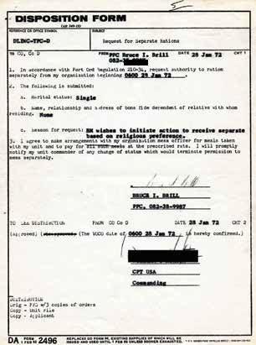
Figure 18: Separate “rats.”
By contrast, Sa’id M was a lowlife and one of the vilest anti-Semites I’d ever had the displeasure of meeting. Of course, he couldn’t be an anti-Semite since, in his words, “How can an Arab be an anti-Semite. We ourselves are Semites!” Technically, of course, he was right. To this day, I try never to call someone an “anti-Semite,” especially if they’re an Arab, preferring the crasser but more precise “Jew-hater.” Sa’id M was, more correctly, a vile Jew-hater.
Hardly a day passed that Sa’id M didn’t have something nasty to say about Jews, especially Israeli Jews. One particular incident should more than suffice to illustrate this point.
For homework, we had to translate an article from the Arabic press into English. The following day, we presented the article and our translation in class. I translated an article from a February 1972 issue of El Ahram, the semi-official newspaper of Egypt. I chose it for a couple of reasons: first, it spoke about Jews, and I was curious to see the teacher’s reaction to what was written, and second, it was short!
It read - I’m paraphrasing - “The Jews will soon be celebrating their Feast of Passover. During this feast, they take gentile blood to make their unleavened bread, which they eat during this holiday of theirs. This is the nature of our enemy. To defeat him, we must understand his vile nature.”
Sa’id M’s response was, “Is that the whole article? That’s it?!?” Initially, I thought Sa’id M was going to use the article’s brevity as an opportunity to say something critical of the resident Jew boy, but I was unpleasantly surprised. “Doesn’t it go on to say how the Egyptian Jews get the gentile blood?” Whoa! No one in the class had expected that reaction! Sa’id M could see from our expressions that he was showing a side of himself that was not acceptable to us, yet he continued. “No. Please, don’t get me wrong. I’m just curious how the Jews in Egypt get their gentile blood.” Our jaws dropped to the floor as Sa’id M explained in detail how the Jews of Iraq get their gentile blood. “You see, the Jews in Iraq use two methods.” We were awestruck but also all ears. This was going to be interesting. “One way is that they send one of their prettiest young women into the street and she lures some unwary Arab man whom she can entrap into an apartment, where he’s waylaid by Jews. The other method is to snatch Arab babies and then place them on something like a turkey cutting board, with spikes and channels to collect the blood at one drainage point.” All this detailed exposition was apparently a taste of Arab culture for our edification.
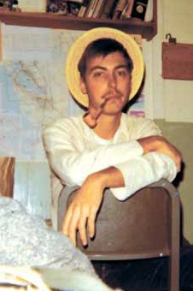
Figure 19: Merwan… ”The Goat Roper.”
My best buddy in the class was Merwan, from the mountains of rural Colorado. After this class, I discussed the incident with him. As surprised and shocked as I was with Sa’id M’s response, I was doubly surprised and shocked at Merwan’s. In his hillbilly naiveté, he said, “Look, Bruce, from what Sa’id M said, especially with all the detail, it seems obvious to me the Jews of Iraq use gentile blood for Passover.”
He wasn’t joking. He was totally serious.
He saw my shock and tried to modify what he had just said by explaining, “Y’know, we in the mountains have an expression, ‘Where’s there’s smoke, there’s fire,’ so, you see, the Jews must have used gentile blood. Maybe they don’t do it today, but they must have at one time. Otherwise, where would this idea come from?”
It made perfect sense to Merwan. I didn’t know how to answer him. At the time, I wasn’t knowledgeable about the longstanding abhorrence Jews have toward consuming blood. The prohibition against consuming blood is one of the most fundamental of the Torah’s injunctions. Under no circumstances must a Jew consume blood. Leviticus 3:17 says, “It shall be an everlasting statue throughout your generations in all your dwelling-places: all fat and all blood shall ye not eat.”
It was a lesson to me, and a hard one: the most ridiculous claims against Jews could be believed by otherwise good people, even friends. The lesson I hadn’t learned was how to combat such nonsense.
Most of us completed the course and received our diplomas.
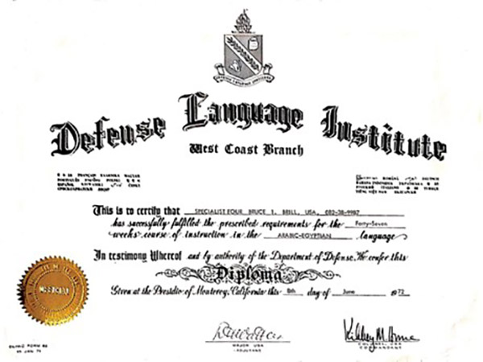
Figure 20: DLI diploma.
We received our orders for security training at Goodfellow Air Force Base, San Angelo, Texas.
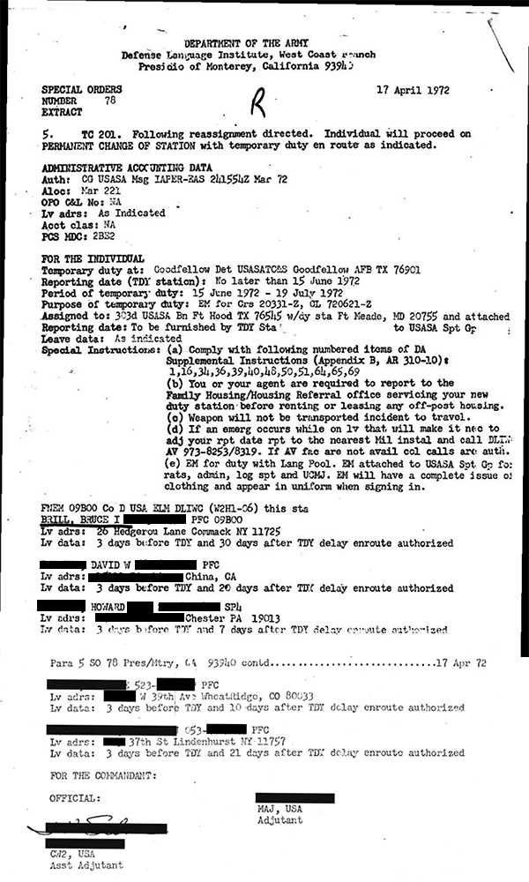
Figure 21: Orders to security training, San Angelo, TX.

SECURITY CLEARANCE DENIED

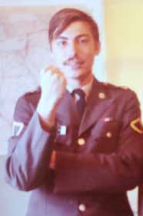
Figure 22: Merwan in uniform.
Merwan was convinced Jews used gentile blood to prepare their matzo, unleavened bread, for Passover… or at least, Iraqi Jews do this… or, at the bare minimum, Iraqi Jews had done such things in the past.
I didn’t dismiss Merwan as a friend because of this. I still liked him an awful lot. I simply put his “understanding” about Iraqi Jews and Passover and blood aside and never brought it up again.
Although I found his naiveté in this regard disturbing, I also found it intriguing, even somewhat endearing. He was open to giving the proverbial benefit of the doubt even to Sa’id M. This trait of his exemplified a certain basic goodness and wholesomeness many associate with “rural America.” We continued to pal around together.
On one occasion, a friend visited challenged tohill-climbing competition: his four-wheel-drive jeep against my 175cc on-off road bike. We set out behind the Presidio to tackle a hill. During my attempt, I badly wrenched my back. The Army clinic cared for my wrenched back and provided treatment throughout my service. One such treatment, on October 4, 1973, would be critical.
Another GI in our Arabic class, David, Daoud, was the son of a preacher and a preacher himself. I became good friends with him and his wife. I believe that for the first year we were in language school together and sat next to one another, he saw me - the Jew - as a potential target to convert to Christianity. I enjoyed getting to know him and his family and appreciated the wholesome values defining their lifestyle.
Daoud also enjoyed music and asked me to show him how to play the guitar. I’m not a guitar player, but I knew enough to show him how to back me up on old-time fiddle tunes. We had loads of fun, both of us being novices at this new art, and together we grew musically. In fact, before we left California, we had entered a couple of old-timefiddle contests. Being novices, we didn’t compete to win but for the experience and for the fun of fellowshipping, as Daoud would say, with fellow lovers of old-time music.Speaking of music and Daoud, I wrote a song about Arab-Jewish brotherhood, which I called “Daoud."

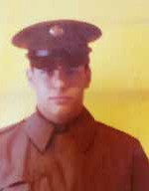
Figure 23: Kareem
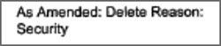
I wasn’t as close to the other students in our class. One former classmate, Kareem, has become a friend only in the last several years through our renewed acquaintance on Facebook. Kareem got his security clearance but was not assigned to NSA. Instead, he was sent to an ASA base in (because he already he already knew some Russian).
Neither Daoud nor Kareem were bad in Arabic. Still, Merwan was by far the best.
Since their inception, NSA and USASA had expanded, both in budget and personnel. By 1965, USASA boasted over 26,000 people.8 This number peaked during the height of the Vietnam War in 1969. Public dissatisfaction with that war was mounting, and US lawmakers pressed for military cutbacks. To save money, the Army offered us an early- out option. Before leaving Dillywick in the early summer of 1972, we were given a choice: instead of serving our entire four years of active-duty enlistment, we could leave after serving only three.
None of us passed up this opportunity.
Six of us ground-pounders were granted “04B2LAE,” or “Arabic Egyptian interpreter,” as our “MOS,” which, translated from Army-ese to English, means our “military occupational specialty.” Yet, when it came time for reassignment to our permanent duty station, Merwan, unlike the rest of us ground-pounders in the class, would not be assigned to NSA or any ASA base requiring a security clearance, even though he finished at the top of the class. Why wasn’t Merwan given a security clearance?
Merwan grew up in Canon City, Colorado, where his only choice of foreign language was Spanish. Merwan wished to immerse himself in a totally Spanish-speaking environment to learn the language more proficiently. Of course, Mexico was the most convenient place to find that immersion. With his limited funds, he went to Mexico, and when his money began to run out in Mexico City, he learned about a work-study program in Cuba. There the participant would work half the day on a commune and study Spanish the other half of the day. This seemed like an ideal way to learn the language, given his limited funds. He went into the Cuban embassy in Mexico City to get information on the program. According to Merwan, he walked in, took some brochures, and walked out. That was it, nothing more; he never went to Cuba for the program. Instead, he returned home.
During the standard BI (background investigation), Merwan was asked if he had ever had any contact with foreign communist officials. Of course, he hadn’t forgotten he had stopped in at the Cuban embassy in Mexico City, but he thought it would be less problematic if he didn’t mention this trivial detail.
He was wrong.
Somehow the security people responsible for his BI had learned he had visited the embassy, and they had caught him in a lie. That was enough for them to deem him untrustworthy. Had Merwan simply “fessed up,” it would have been fine. Because he didn’t level with his interviewer, he wasn’t given his security clearance. The importance of this is clear: at “the Agency,” security is very, very strict. There’s no fooling around with anything even slightly suggesting a potential security risk. The fact that such effort had been made to monitor who stepped into a communist country’s embassy in a foreign country shows how important such seemingly trivial pieces of information are to the US security agencies.9
The six of us USASA Arabic interpreters who got our security clearances were destined for our permanent duty station at cushy NSA at Fort Meade, Maryland, or some exotic ASA base overseas. But this would come only after some weeks of security training at Goodfellow Air Force Base in San Angelo, Texas.
Merwan, however, was sent to “the hole,” Fort Huachuca, Arizona. Ironically, it’s a mere 15 miles from the Mexican border. The surrounding area is so bare the GIs there joke, “It’s the only fort in America where you can be AWOL for three days and they still see you leaving.”
Fort Huachuca was established before World War I. Ironically, it was - officially, anyway
- “the home of the US Army Intelligence Center,” and it was where clearance-less Merwan ended up.

8 Department of the Army, The Secretary of the Army’s Program for Command Supervision of Readiness (Command Presentation by USASA, Sept. 2, 1965)

9 Recollection from 1972, confirmed in personal communication, February 2021.

The next stop for all of us new Arabic interpreters, except for the best of us, Merwan, was security training at Goodfellow Air Force Base.
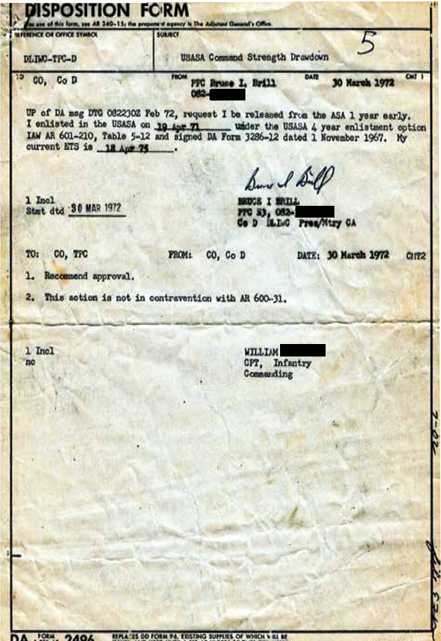
Figure 24: Early out.
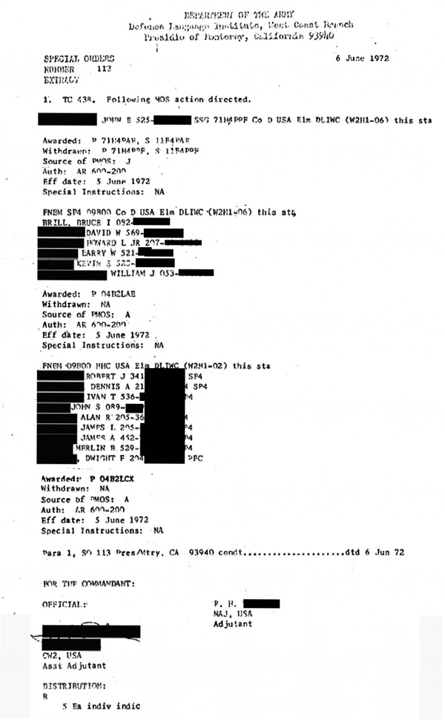
Figure 25: Arabic Egyptian “MOS.”

GOODFELLOW AFB
NO CAMERAS; NO PHOTOGRAPHING
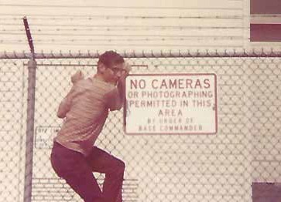
Figure 26: Goodfellow Security: No cameras! No photographing!
Obviously, I didn’t take the photo.
At the Presidio of Monterey, we were placed in those old wooden barracks built during the exigencies of World War II. On a trip with my then 13 year old son to the States in 2007, one of our stops was in Monterey. I wanted to show him the Presidio. Though it had been an open base when I was stationed there in ‘71-’72, soon after 9/11, security requirements had made the base inaccessible to the general public. Nevertheless, at certain points, one could look over the fence to see some of the “temporary” barracks were still in service in 2007!
Apart from the open latrines, I didn’t mind the old wooden barracks of lower DLIWC. Since most of the other servicemen in our particular barracks were zoomies, and since Army ranks came a bit quicker than in the Air Force, I was assigned one of the only four separate rooms. I enjoyed the privacy and quiet, and I appreciated not having to bunkin the open barracks. After almost a year with my own room, I found an off-base room in the modest home of an older woman. Actually, she was rather ancient. She had been an army nurse… in World War I!
Our studies at Goodfellow were not the most exciting. The Elint course, or Electronic Intelligence, not only bored us to tears, but it was taught in stuffy classrooms without windows - for security reasons, we were told. One time, I dozed off in class, and the instructor thought he would have some fun at my expense. He motioned to everyone in the classroom to quietly leave. Then he shut off the lights and quietly closed the door behind the last to leave. There were no windows and no light. It was blacker than night. The instructor had the class congregate just outside the classroom, where they waited for me to wake up and stumble over desks and chairs as I fumbled my way to the door. I recall that when I awoke, I had no idea where I was or what had happened. I thought, “I must have died!” When I finally stumbled to the door and opened it, that bright Texas summer sun blinded me. I was certain the deafening laughter could be heard all the way to Oklahoma.
Daoud learned about an old timer’s fiddle contest in Childress, Texas, right on the Oklahoma border. We decided we’d go. He had a car and –more importantly– permission from his wife for our weekend journey.
We drove seven hours to get to the contest, and once there, we got in line to register as participants. After reaching the registration desk, the registrar looked at us and told me, “Sorry, you can’t participate.”
What?!? “Were we supposed to pre-register?” we asked. “Nope,” he answered calmly.
“So, what’s the problem?” we demanded to know.
“This is an old timer’s fiddle contest,” he said in his thick Texas drawl. We tried to explain to the registrar that we had already participated in a couple of such contests in California. We knew what an old-time fiddle contest was, which was why we had taken this long trip to Childress. Finally, the man said, “Please, listen closely. This is an old-timers fiddle contest. You have to be at least 65 years old to participate.”
Well, never mind that at the time of this writing, I would qualify for the contest. We had invested so much time, effort, and gas to get to Childress that we decided to stay and listen to the old-timers fiddling. We had a most enjoyable weekend. The folk wisdom and tales of those Texas old-timers were something to cherish. One old-timer sitting next to me shared some Texas wit: “Texas, the only state in the union…with more cows and less milk. More windmills and less water. You can see further and see less than anywhere in the world.”
The excessive temperatures of San Angelo, exacerbated by the humidity, couldn’t diminish the pleasurable Texas experiences we had there. One of these was the mess hall. In all the Army mess halls we were familiar with, you would wait in line, and the server would slap down onto your tray whatever was being served. Period. At Goodfellow, the first time we approached the serving counter, the cook asked, “How do you want your omelets?” An omelet? How do I want it?!? I thought he was making a joke. Or perhaps we had died and gone to heaven. This couldn’t be a military mess hall! Yet it was. And we appreciated it.
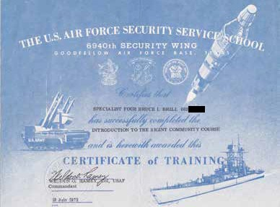
Figure 27: Security training diploma, Goodfellow Air Force Base, Texas.

FORT GEORGE G. MEADE


Figure 28: U.S. Army INSCOM.
The Nation’s Platform for Intelligence, Information, and Cyber Operations
From Fort Meade’s official website:
Welcome to Fort George G. Meade, Md., an installation dedicated to providing quality support to service members, Department of Defense civilian employees, family members, and military retirees.
Our mission: Provide required services, infrastructure, a safe and secure community, and a quality of life that supports mission readiness and the fort Meade community.
Our vision: The Nation’s Center for Intelligence, Information, and Cyber Operations.
Fort Meade is conveniently located between Washington, D.C. and Baltimore. The installation lies approximately five miles east of Interstate 95 and one-half mile east of the Baltimore-Washington Parkway, between Maryland State routes 175 and 198. Fort Meade is located near the communities of Odenton, Laurel, Colombia and Jessup. With approximately 56,000 employees, Fort Meade is Maryland’s largest employer and is the second-largest workforce of any Army installation in the US.
In addition to the many recreational activities available on Fort Meade, the region sites of Annapolis; visit the White House in Washington, D.C.; it is full of interesting places to visit. You can tour the historical sites or attend a football, basketball or baseball game with one of the many professional and college teams in the Maryland, D.C., and Northern Virginia areas10
Some of the above, including the US Army Intelligence and Security Command (INSCOM) insignia, is from after my service at Fort Meade. Upon my arrival in late summer 1972, it was possible to bunk in post barracks. The USASA Student Support Group barracks were modern but utilitarian concrete structures located within walking distance from the NSA complex.
However, I looked for an off-post option and found another single soldier seeking to share an apartment in town. “In town” usually meant Laurel, Maryland. Dirk, a tall blonde fellow of Dutch extraction, was a Mormon. We became friends, and on the occasional long-weekend visits home, I even brought him with me. He returned the favor by bringing me to Monday “family nights,” where Mormon families would get together and play wholesome family-oriented games. They were exceptionally conservative, i.e., “straight.” Each Mormon household reminded me of Father Knows Best, the TV show from the 1950s. Instead of the word “exceptionally,” I imagine most Americans would use the word “excessively.” I, however, found their conservatism nice. It was quaint, yes, but something about their sense of responsibility and decency spoke to me. I would even go with Dirk to church services on occasional Sunday mornings. I believe that Dirk, much like Daoud, saw me as a potential convert.
Our connection with Fort Meade was peripheral at best. A vast tarred parking lot separated USASA’s headquarters from the NSA complex, maybe a 20-minute walk. Once we were processed in at headquarters and given our NSA work assignments, visits to ASA’s headquarters were rare. Fort Meade activities were also infrequent. The army dental clinic, eye clinic, recreation center, and post synagogue were about the extent of it. Daoud and I appeared at the recreation center on rare occasions, performing our country/traditional music. The Post Synagogue offered regular Tuesday lunches, which I attended on an irregular basis. Aside from these few things, most of our workdays were spent inside NSA.

10 https://home.army.mil/meade/index.php

WHAT IS NSA?

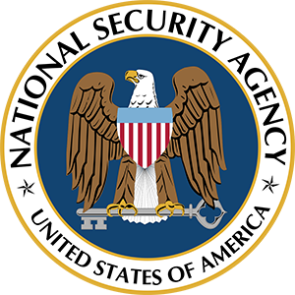
“In God we trust.
We monitor all others.”
NSA, the National Security Agency, was born on November 4, 1952. Its birth was assured to be quiet, for November 4 was also Election Day, and all eyes were focused on the presidential race between Adlai Stevenson and Dwight Eisenhower. Not only would its birth be overshadowed by Election Day, but since no public announcement was made, there was zero news coverage. Its creation wasn’t even noted in the Congressional Record. Its existence was so secret that few in the government knew of its inauguration.11
When we were assigned to NSA twenty years after its creation, it was still off most people’s radar. At about that time, Pulitzer Prize winner and former editor for the New York Times Daniel Schorr called NSA “one of the deepest secrets.” He noted in Clearing the Air, “not one American in 10,000 has even heard its name.” He wasn’t referring to the work going on within NSA, but to NSA itself,12 yet by the 1970s, the barely known NSA already far exceeded the well-known CIA in resources. In 1973, the period this book focuses on, Secretary of Defense James Schlesinger further elevated the relative strength of NSA by slashing a few thousand CIA personnel. In his 1982 bestseller, The Puzzle Palace, James Bamford wrote that NSA had “more than all of the employees of the rest of the intelligence community put together.”
11 James Bamford, The Puzzle Palace (New York: Penguin Books, 1983), 15.
12 Daniel Schorr, Clearing the Air (Boston: Houghton Mifflin, 1977), 183.
From Wikipedia:
The National Security Agency (NSA), the U.S. intelligence agency within the Department of Defense that is responsible for cryptographic and communications intelligence and security. Its headquarters are in Fort Meade, Maryland.13
The NSA grew out of the communications intelligence activities of U.S. military units during World War II. It was established in 1952 by a presidential directive from Harry S. Truman in which he specified its mission as to provide an effective, unified organization and control of the communications intelligence activities of the United States conducted against foreign governments, and to provide for integrated operational policies and procedures pertaining thereto.
The NSA was created in part out of the belief that the importance and distinct character of communications intelligence warranted an organization distinct from both the armed forces and the other intelligence agencies. While it operates within the Department of Defense, the NSA also belongs to the Intelligence Community (a coalition of 17 intelligence agencies) and as such acts under the supervision of the director of national intelligence. The director of the NSA is a military officer of flag rank (i.e., a general or an admiral) with a minimum of three stars. Not being a creation of Congress, the NSA often acts outside of congressional review; it is the most secret of all U.S. intelligence agencies.
The Agency’s mission includes the protection and formulation of codes, ciphers, and other cryptology for the U.S. military and other government agencies as well as the interception, analysis, and solution of coded transmissions by electronic or other means. The Agency conducts research into all forms of electronic transmissions. It also operates posts for the interception of signals around the world. In 1972 a joint organization, the Central Security Service (CSS), was created to coordinate the intelligence efforts of the NSA with the U.S. military. The director of the NSA also heads the CSS (under the title of Chief, CSS).
I arrived at NSA in the late summer of 1972. Earlier that year, President Nixon had quietly established the CSS, the Central Security Service, at Fort Meade, which combined the cryptologic resources of the Air Force Security Service (ASA), the USMC Cryptologic Unit, and the Naval Security Group.14 Their combined manpower totaled some 45,000 military personnel. This was added to NSA’s 50,000 civilian employees. All 95,000 were under the governance of the director of NSA.15The establishment of the CSS created a system of dual staffs at NSA, which aimed to simplify the intermixture of the four military branches and the civilian staff, thereby streamlining the confusing bureaucracy. In fact, it did the opposite. (This confusion was a personal blessing to me, as I’ll explain in The Evil Eval.)
13 https://en.wikipedia.org/wiki/National_Security_Agency.
14 Keith Clive, “NSA’s Central Security Service,” US Military Academy’s Cryptologia 2002.

15 James Bamford, The Puzzle Palace (New York: Penguin Books, 1983), 204-5.

I was among the 45,000 military personnel and was assigned to NSA’s “G-Group,” which itself boasted over 1,800 workers: 1,244 civilians and about 600 of us military. All branches of the service were represented, and we appeared for work in uniform.
My first boss, Jim McC., was a tad less than average height, with a fair complexion, reddish-brown hair, early signs of balding, a goatee, and steel-rim glasses. He was a tad paunchy, clean-cut though not crew-cut, soft-spoken, and congenial. He was central casting for a Madison Avenue businessman type. I was looking forward to working for him, for, from my first positive impressions, he seemed like a nice guy.
As luck would have it -bad luck for me in this case- Jim left for another government position somewhere outside the Agency. None of his workers knew what his new position was because we didn’t need to know. “The need to know” is a basic principle in intelligence work. If an intelligence worker does not need to know something, he or she is forbidden from obtaining, or even asking to obtain, that information. Anyway, I wasn’t interested; it wasn’t any of my business. This was my general approach for the entire time I worked at the Agency. From this point of view, I was “very well-behaved.” Throughout this exposé, pieces of information might be missing because I didn’t have the proverbial “need to know” back then.
My new boss, Mike G, was very different than Jim. Mike was a tad taller than average, big-boned, dark-haired, fleshy-lipped, and, although clean-shaven, somehow reminiscent of Popeye’s nemesis, Bluto. He became my nemesis as well, not so much because I resembled Popeye, but because I was me, a Jew.
Nothing about me could have distinguished me as a Jew (most people would not recognize “Brill” as a Jewish name), yet it was no secret that I was a Jew, something anyone who came to know me would learn by the time of the first Jewish or Christian holiday. Although I’ve never “made an issue” of being Jewish, I also have never hidden the fact.
It was not possible for me to know all the workers in my division, but in the open area (there were closed areas as well) on the floor where I worked, I might have been the only Jew.
And this singular Jew fell under the management of a man who would eventually show himself to be an anti-Semite. Before discovering I was a loathsome Jew boy, he would share with me occasional pearls of wisdom. “Wear a clip-on necktie when you go bar hopping. If you wear a regular necktie, the guy you get into a fight with can grab it and put you at a disadvantage.” He also once gave me another handy piece of advice: “The minute you come into the office, scatter some papers around on your desk so it looks like you’ve been here and hard at work. Looks is everything!”
When he realized he had a Yid under his charge, he became cool, careful, and “correct.” From that point on, his criticisms of my work habits were never constructive. No more helpful pieces of advice, like wearing clip-on ties and keeping a messy desk. In fact, he was waiting for the opportune time to spring a serious trap to screw the Jew. I, too, much like poor Popeye, came to be a victim of this NSA Bluto.
Soon after my work assignment at NSA began, I had an opportunity to begin studying Hebrew. It was considered a “collateral language” and, therefore, one which the Agency would encourage an Arabic linguist to learn. A few years before my assignment with NSA, Hebrew was, in fact, referred to as “Special Arabic.”
My work assignment took less than a half-hour to perform, and my use of the Arabic language, which I had been trained in for 47 long weeks, was minimal. This was sad from a couple of points of view: first, “if you don’t use it, you lose it,” and second, what a waste of government money to train someone and then use him for a job that could be performed by anyone after merely a day or two to learn Arabic numbers. My boring job dealt with flight coordinates, numbers, which usually took not more than a half-hour’s work. Another part of the usual routine was to keep abreast of intelligence summaries of the day which took five or ten minutes. The toughest part of my typical workday was to look busy. I devoured book after book, including historical novels like O Jerusalem, Genesis 1948, and The Source. I read nonfiction books and articles about the Israel- Arab conflict as well. The more I read, the more I began to realize that Israel wasn’t necessarily the automatic bad guy despite what we had been led to believe by our DLI Arab instructors. Israel had its side of the issues.
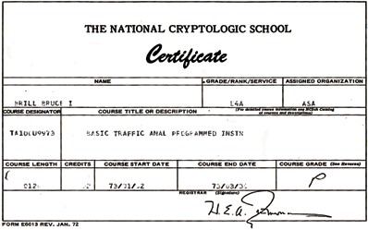
Figure 29: National Cryptologic School certificate.
Another work-related time-filler was cryptology. To my credit,
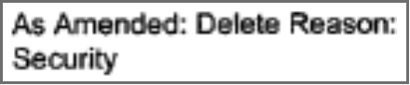
I wasn’t looking for any pat on the back, and I got zero acknowledgment for this accomplishment. In hindsight, I reckon Mike didn’t refer me for any recognition.
I wasn’t looking for any; I was happy to contribute to the intelligence-gathering effort and wasn’t seeking reward. I did look forward to our lunchtime chess matches.
Learning Special Arabic was another great time-filler.
I registered for Hebrew language study at the American University in the evenings. Eva Tsur, the instructor, was Israeli and a great teacher; she reminded me of Sa’ida Q. The textbook she used had been developed by the US Army and used at the Defense Language Institute, East Coast.
David Gallaspy, another Arabic interpreter, came to the Agency a few months after my arrival. He was also interested in learning Hebrew. Together we registered for a summer ulpan (Hebrew language learning program) at the Baltimore Hebrew College. Later I found out about an intermediate Hebrew class at the University of Maryland. This course was scheduled for the middle of the day, and NSA was very flexible in allowing me an extended lunch break so I could attend this course.
The instructor there was Professor Ivri. Ivri, in Hebrew, means “Hebrew.” How appropriate, “Professor Hebrew” teaching Hebrew. Dr. Ivri always called me “the General” because I attended class in uniform. He was a true Hebrew scholar, with a caustic manner. This was my first encounter with what many consider to be the salty Israeli national character. But like most Israelis, there was something warm and likable under his rough outer surface. Ivri was born and raised in Poland, and as a young man, he escaped the German onslaught by fleeing eastward. He spent the war in China and
- linguist that he was - seized the opportunity to learn Chinese, both language and culture. He would often spice up the tedious Hebrew grammar lessons by pointing to Chinese-Hebrew cultural and linguistic connections.
While learning Hebrew, I came to know some of NSA’s “Hebees,” as the Hebrew linguists at the Agency were known. Some were real characters. Ridgley B, the assistant head of the Hebrew department, for instance, although straight out of central casting for a stereotypical WASP, converted to Judaism. He came on board the Agency after his stint spying on Israel from the Navy’s base in Greece. This, too, is where he decided to convert, requiring his circumcision. His navy buddies, being so sensitive, caring, and thoughtful, visited him at the hospital soon after the operation to comfort and console him by bringing him reading material: Playboy magazines. All this was done in good fun. And the spirit among the Hebees was “positive energy.” I thought I’d like to be part of this good-spirited group and it would be good for my Hebrew, but such thoughts were premature. A few hours here and there of Hebrew courses, with no spoken Hebrew, couldn’t compare to the intensive 47 weeks of Dillywick Arabic. My Hebrew wasn’t yet up to snuff.
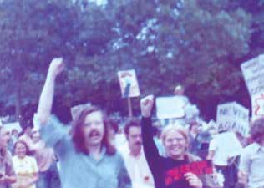
Figure 30: Peter: hippy Hebrew head
I was always intrigued by Peter S, the head of the Hebrew Department. He looked like a hippy, with long hair and a Fu Manchu mustache. His unkempt appearance was very different from the typical, clean-cut military or ex-military NSA workers, yet he, too, was ex-military. He had spent four years in the Navy as a Chinese linguist. He also knew Spanish, Greek, German, and Russian. A linguistic genius? Without a doubt! He was full of energy and always offered a wry smile and giggle for some cute comment he might have just made.
There was one other Hebee who was even stranger than Peter S This was the scholarly looking James M. He had a PhD in comparative Semitic languages and sat all day reading Hebrew and Arabic newspapers. In his spare moments, he even authored a dictionary of Hebrew and Arabic cognates. His Coke-bottle-bottom eyeglasses and slinky walk contributed to his fitting the Nazis’ negative stereotype of Jews. Although James M wasn’t Jewish, everyone at the Agency referred to him (behind his back) as “Hymie.” It wasn’t nice, I know, but there was a certain poetic justice in his being referred to in this derogatory way. He was behind the full-page ad in Life Magazine displaying a photo of a group of people smiling big, broad smiles. The caption over the photo asked in large font, “Why Are These Jews Smiling?” The answer below was, “Because they found Jesus.” But Hymie was a good chess player, and playing chess with him was a fun way to spend my lunch break.
Another member of the chess-and-sandwich group was Jim J. He was a huge Texan - maybe six foot four and weighing over three hundred pounds - and full of good spirit. His wife would pack his lunch bag with goodies he’d share with us. Texas Jim refused to ride a horse. “I’m scared of anything bigger than me.”
Mike wasn’t part of the chess-and-sandwich club. In fact, I don’t recall him ever staying around our work area at lunchtime. He had his own buddies, I presumed, with whom he preferred to pal. I didn’t know who they were or where they hung out; I did not need to know.
It wasn’t long after I began studying Hebrew and hanging out more and more with the Hebees that I learned that Peter S was looking for a roommate to share his apartment. This was an opportunity to live with the best Hebrew speaker on the block! What could be better? I moved in with him and got to know him much better. What I learned from living with him was that he was more of a character than the caricature he portrayed at work. He was not only a linguistic genius, but he was also a buff in areas of interest to me. First and foremost was music… American music… American traditional music. Peter played piano and guitar and could back me up on all the old-time fiddle tunes I was learning. His memory and attention to detail were evident from the myriad songs he could sing. And he would be true to the original recordings, with perfect nuance.
One trick I used for relieving the tediousness of my desk job was a periodic visit to the Agency’s medical clinic. That failed motorcycle hill climb back at Fort Ord had resulted in a recurring upper-back-neck problem. The relaxing treatment I received at the clinic relieved the muscle spasm. They would lay me face down on a cot and apply a cloth bag of heated salt to my neck. I remained in that position for about 20 or 30 minutes. Invariably, I would doze off during this time. This experience was so pleasurable! It was the highlight of an otherwise humdrum workday.

If I’d had my druthers, I would have enjoyed a treatment every day. Obviously, I couldn’t take advantage of this routine too often for fear that Mike G would nix it. With Mike G’s knowledge, I arranged to leave work immediately after the treatment on Thursday, October 4, 1973. If the treatment lasted its usual half-hour or so, I’d be out to my car and driving by three o’clock.
That Saturday, October 6, was Yom Kippur, and I planned to travel home to Long Island to be with my family. The beginning of the almost five-hour road trip required driving through the Baltimore Tunnel. If I could head out from Fort Meade by 3 pm, I could be at the tunnel just in time to beat the traffic jam one could expect at rush hour. Getting a head start was a smart idea…

ALL HELL BREAKS LOOSE:

WHY DIDN’T THEY KNOW?

THE S**T HITS THE FAN

Gosh, that hot salt pack on my neck. Man! It was like heaven. What could be nicer? I closed my eyes and drifted off, as I had done during this treatment several times before, thinking about the ride home to New York. I smiled to myself at the thought of beating the traffic through the Baltimore tunnel. I’d overinflated my Chevy Nova’s tires to about 35 pounds of pressure and fitted oversize wheels to the rear so I’d have what I called a “poor man’s overdrive.” I was certain I would beat my previous record of 26 miles to the gallon, especially if I beat the stop-and-go traffic through that darn tunnel.
When I got home, I’d see my sister and my folks. Gosh, I hadn’t seen them in so long. It’d be nice to be home and have a home-cooked festive meal before the Yom Kippur fast. And then there was Elyse. I’d started seeing her just before I’d left for California, so we hadn’t gotten to know one another really well. Once I was stationed at Fort Meade, I could see her whenever I could get up to New York, or she could come down to visit me in Maryland. Uncleo thought we were unsuitable for each other. “Why do they even bother?” was his take. He never said that to me, but he did tell my sister. My sister is nicknamed “Gabby” because she likes to talk, so you can guess it wasn’t long before she shared Uncleo’s take on Elyse and me.
Of course, Uncleo was right. Elyse, though, had a great sense of humor, which she must have gotten from her mother and grandmother, who would have been in the running for the Funny Woman of the Year Award had there been such a competition. In one memorable instance, I was talking to her grandmother - ”Buhbie,” as they all called her. Not being a Yiddish speaker, I called her “Bubbie,” and without missing a beat, she grabbed her breasts and said in her thick Yiddish accent, “Deez are mine bubbies. Leave mine bubbies alone!”
I must’ve dropped off into dreamland. I was awoken by the nurse, who said, “Specialist Brill! Specialist Brill! You have a phone call at the desk.”
That was unusual. I’d never gotten a phone call down at the clinic before. Who could it possibly be?
I staggered over to the desk, and through blurry, just-awoken eyes, I saw the phone the nurse was pointing out to me. I picked up the black receiver and mustered a “Hello?” It was my “charming” immediate supervisor, Mike G.
“You’re planning on leaving straight from the clinic, right?”
“Yes, Mike. I already cleared that with you.” I wondered if he was going to nab me on some infraction or other. Had I left some classified papers on my desk? Had I forgotten to lock the desk? What could I have done wrong? Because of Mike G’s ever-critical eye on me, I was always super careful.
“Listen up… Don’t even think about going home to New York this weekend. We have a war on our hands FOR REAL this time, and the s**t hits the fan on Saturday. If you go home, I’ll be calling your young ass right back down on your holiday.”
I was dubious since we had had several false alarms already this year. None had ever amounted to anything; they’d all been false alarms. Wouldn’t this alert be yet another? I asked, “You can’t be certain about it, can you?”
He answered, “This info is A-val,” and hung up. ("A-val" means unquestionable validity.)
Son of a bitch. We’d had these alerts every few weeks for the past several months. Even the serious ones in January and May hadn’t amounted to anything. He was just making it sound like “this time, it’s for real.” C’mon, I thought. He’s just trying to get a rise out of me. Or trying to screw up my weekend with my family. Didn’t I detect a certain snide giggle hiding behind his all-so-serious message? Wasn’t all this an act, a put-on, to make me miserable? The guy’s full of bulls**t. I’m going home! That was my conclusion: he’s not going to ruin MY Jewish holiday.
But wait. He said this was A-val.
At the Agency, you didn’t use the adjective “A-val” unless something was certain. Not just certain, but without-a-doubt certain. This thought kept bouncing around in my mind the whole trip up to New York. I couldn’t stop thinking about it. Well, as soon as we knew this intelligence is A-val, we’ll notify the Israelis, won’t we? What if we don’t? Ahh, the Israelis have good intelligence - celebrated world class intel. Won’t they be able to figure out Arab intentions? What do they need us for?
The thought of our not informing the Israelis was unfathomable; they were our allies. The notion of notifying them too late also did not cross my mind. In 1973, means of communication were already instantaneous. The possibility of their not knowing seemed remote. But the thought of MY informing the Israelis never occurred to me. That wasn’t my job. There were plenty of higher-ups at the Agency, and there were those among these higher-ups whose job was to communicate intelligence to foreignfriends…or to suppress such intelligence for foes. I really didn’t know how that worked; I didn’t have any need to know such things.
I tried to distance myself from thoughts of how, exactly, “the s**t would hit the fan” and what part I would be playing in the scenario about to unfold. Instead, I tried to concentrate on breaking my gas mileage record. I’d drive like there was an egg between my foot and the gas pedal. I’d also slip the car into neutral on downgrades and even turn the engine off. Slipstreaming tractor-trailers, of course, constituted illegal bumper- hugging, but it reduced wind resistance and would therefore help in the gas economy effort. But in between my driving preoccupation with downhill coasts and diesel drafting, I couldn’t keep my thoughts from returning to that fan and the s**t about to hit it.
After leaving Maryland and driving through Delaware, the road led through the sandy pine forests of Southern New Jersey, the home of Fort Dix. I thought of my eight weeks there just a year and a half before. I somehow pined for the simple hell of Basic rather than the hell about to erupt once the s**t hit the fan in the Middle East.
The pine forests ended. My recollections of Basic ended. The thought of that fan and what was about to hit it did not end.
I had driven this Laurel-to-Commack route many times, but this time, everything seemed different somehow. I sensed something historical was about to happen, and I and only a handful of others knew about the fan. But I kept hoping Mike G was just sh**ting me about the fan.
Yet he did say “A-val.”

YOUR YOUNG ASS

The four-and-a-half-hour trip from Laurel to Commack is always somewhat tedious, which makes Exit 42 on Long Island’s Northern State Parkway all the more welcome when it comes into view. The secondary road leads past Elwood on the way to Commack.
Once when Uncleo came home with me he wryly noted that the East Northport Synagogue was located in the southwest part of the township. Any other time at that synagogue I would smile when I thought of this southwest-East-Northport quip. But at synagogue that Friday evening I did not think of that quip…nor was I smiling: “the fan” instead was on my mind.
My sister sensed something was troubling me, and I told her about the fan. I whispered to her, “What if I let the rabbi in on the secret and he prophesizes the attack in his sermon? He’d be regarded as some kind of prophet.” Of course, I didn’t tell him. I related to the bombshell as classified, even though, technically, I could have disclosed it without violating my secrecy oath. This was because Mike G had revealed the news to me over that black phone.
Black phones at the Agency were insecure. They could be used to make outside calls, but conversations about Agency business were a big no-no, highly likely to be monitored and documented. Punishment - severe punishment - for the offender would be imposed, and little mercy shown. Maybe Mike G should not have shared the fan intel over that black phone?
In our family, we never called one another by our proper given names. My dad called my mother “Babe,” and she called him “Hendry.” My sister called me “Boopie,” and I called her “Gabby.” Although I was anything but a butch, my dad called me “Butch.”
On Saturday morning my Dad calls me, “Hey, Butch, ya got a phone call from da Army.” I went over to the phone hanging on the kitchen wall. It was Mike G, calling “my young ass back down to NSA,” just as he had promised.
The weekend of October 6 was a three-day weekend since Columbus Day was that Monday, October 8. I was planning on returning to Laurel Monday afternoon or evening, and it was already very early Saturday morning. It seemed like I had just gotten home, and now I had to return so soon and so suddenly. I rushed to get organized for the long ride back. One “good” thing was that I didn’t have to concern myself with breakfast or preparing food for the journey: it was, after all, Yom Kippur. This was going to be an exceptionally tough fast. But that aspect of the day paled in comparison to the more important concern: men - Jews - were engaged in a life-and-death struggle on the other side of the planet. Just as I deferred my keeping kosher to the constraints of basic training, so, too, did I submerge honoring the dire religious requirements of Yom Kippur to the US Army’s requirements. I was more American than Jewish; I was a Jewish American, emphasis on American.
I don’t recall what I was thinking on the ride back down to Fort Meade, for I was in a kind of stupor. A historical event was unfolding, and I was privy to it before it happened. It was like being in a time machine and watching what you already saw play out in front of you again.
When I reported to NSA, I was immediately given a new assignment since I was one of the few linguists who could gist both Arabic and Hebrew. I was sent to the strangest of rooms. It was off a secondary corridor and was more like a big walk-in closet than a room. Several steps up led to a platform about a yard and a half by a yard and a half, just big enough for a chair for one person. Against the wall was what looked like a huge radio receiver.
My job was to scan the various frequencies on which I might pick up some radio communication from the battlefronts in what appeared to be a full-fledged war between Israel and Syria and Egypt. I would eavesdrop for a while, gist each communication, and record any exchange that might have military content. The recordings I would make would be sorted through and sent to the appropriate department, Hebrew or Arabic, for transcription. These transcriptions would then be sent for translation. The translation would then be passed on to intelligence analysts, who would analyze them and determine what specific content needed to be noted and sent on to the higher-ups. The higher-ups would weed through this material further, condense the intelligence, and pass their concentrated summaries and assessments on to the members of the National Security Council, the Pentagon, the US Intelligence Board, and the White House.
That first day at the job was memorable.
REDACTED One particular conversation I eaves-dropped, though, was exceptional.

I had known this “surprise” was about to take place two days before. How could it be that the Israelis, who did need to know, didn’t? How could it be that we didn’t get what we knew beyond a doubt to our allies on time (or at all)? They truly needed to know! What was going on?

At that moment, something touched my heart. No, it was more like a sledgehammer striking my innermost soul. “My God,” I said to myself as I looked down in sorrow, bewilderment, and indignation. If what I understood
like…” then, I thought to myself, “I’m wearing the wrong uniform.” At that very moment, I swore to myself that I would go to Israel once I was discharged from the Army. I guess, at that moment, I had become a Zionist.
Up until then, I had assumed that we at NSA’s G6 had, of course, shared this vital intelligence of the Arabs’ October 6th invasion plan. When I learned we hadn’t notified the Israelis, my assumption, at first and for years afterward, was that the intelligence had somehow been innocently delayed due to bureaucratic ineptitude. It hadn’t crossed my mind that the critical intelligence for an ally would be purposely suppressed or manipulated to dupe our Israeli friends.
My real-time radio communications monitoring those first days of the war required me to get a higher security clearance for this special job. My regular job for over a year had been monitoring air traffic over Lebanon, Syria, Jordan, and Northern Israel. This job had required higher-than-top-secret clearances, but this new task demanded an additional clearance. I was called into the security office to sign a memorandum of understanding. This new and higher clearance included travel restrictions that applied even after your release from the military and intelligence service. These restrictions could last for 10, 15, or 20 years, depending on two things: the nature of the higher clearance being granted and the country you were interested in visiting.
Of course, communist countries or their affiliates, especially Warsaw Pact nations, were number one on the list of restricted countries. There was also a clause stating: “and areas of political and military unrest.” I found this problematic since I had just sworn an oath to myself about going to Israel when I got out of the military. Good trooper that I was, I didn’t want to violate any signed agreement, so I placed an asterisk by that phrase and wrote a footnote at the bottom of the agreement: “* not including Israel.” In a clear way, I was announcing to the security folks that I intended to travel to Israel. It was interesting to me they didn’t seem to find that problematic. Well, maybe, unlike Merwan’s not “fessing up,” they appreciated my candidness. Maybe. Or maybe there was another reason they didn’t bring attention to this asterisk.
By and by, I was given several additional higher security clearances because of the nature of my new assignments. On each memorandum of understanding, I would add the note “* not including Israel.” Some of these assignments required that I send teletype communications to our various bases around the world, .
As the war on the ground began to stabilize after a couple of weeks and air skirmishes played a more central role, I was back at my desk under Mike G. He was now exceptionally irritable for some reason. He was obsessed with his notion that a phantom Israeli force was moving up into Lebanon. He thought this force was pulling a flanking maneuver and going to attack Damascus by first coming up the Beqa Valley in Lebanon and then heading east. The theory seemed somewhat plausible but was based on faulty intelligence, premature conclusions, and Mike G’s defective imagination. He didn’t like being wrong. I had no opinion on this hypothesis and remained a casual observer.
There was so much air activity even then, several weeks into the war, I was working 16-hour days. In addition, we Arabic linguists were suddenly assigned to the 82nd Airborne Division, with tentative plans to be airdropped into Egypt. For a period, we were on “red alert.” We couldn’t even go to the bathroom without calling into headquarters and telling them we might not be able to get to the telephone for those five to ten minutes. We were also prepared - medically and administratively - for battle:

The red alert was the result of the Soviet threat to send troops into Egypt to save the Egyptians from a suspected attack on Cairo.17 The U.S. showed muscle by making our military readiness known to the Reds. Our assignment to the 82nd entailed more than just an administrative “assignment.” No, it was true readiness.18 We were called down to USASA headquarters and had our last wills and testaments drawn up. Then we went down to the medical facility to get a complete series of vaccinations for overseas service, AND I was given - just like my dad when he was sent into Normandy to fight the krauts - an alternative set of dog tags stating my religion was “Protestant.”
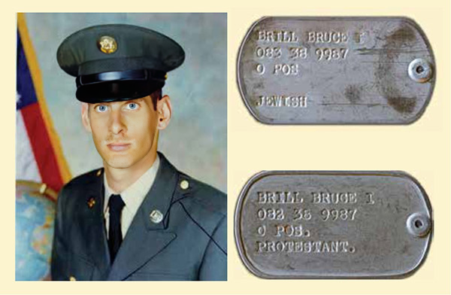
Figure 31: Specialist Bruce Brill, “Protestant.”

17 Admiral Thomas Moorer, Records of Admiral Thomas Moorer, Diary, October 1973, National Archives, RG 218.

18 James R. Chiles, James R., “Go to DEFCON 3,” Air and Space Magazine, March 2014.
This was yet another example of what could be a running theme of this book: those folks who see the evil in some others’ tendency to “screw the Jew” and act on behalf of the potential victim. In a 1790 letter to the Hebrew Congregation of Newport, Rhode Island, George Washington guaranteed that American Jews would “possess alike liberty of conscience and immunities of citizenship.” He assured the Jews of America that the new republic would give “to bigotry no sanction, to persecution no assistance.”19 However, on the less-than-national level, the level I experienced in my US Army service, I saw that Washington’s guarantee is only true when good folks step in to confront those who don’t follow his guidelines.
There are clearly good guys and clearly bad guys. There is another category, though, one perhaps larger than these first two: those who simply turn a blind eye. Brigette Gabriel, the Lebanese Christian commentator, stresses that “the peaceful majority are irrelevant.” Elie Wiesel speaks much about this third category, saying:
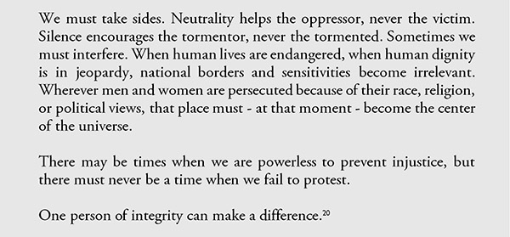
This “red alert” period was a terribly exhausting time. The usual half-hour of actual work I had gotten used to had stretched to 16 hours. The constant pressure and lack of sleep day after day had a devastating effect. Yet no one complained; everyone was ready - even eager - to help their colleagues through this hard time.
But then suddenly Mike G announced he was taking off about a week, right at the height of the pressure, for a hunting trip in Colorado. How could he, a supervisor, desert us at a critical time like this?
That seemed very peculiar to us all, and it puzzled me for years… up until I happened to read Inner Circles by General Alexander Haig some 20 years later.
19 George Washington, “From George Washington to the Hebrew congregation in Newport, Rhode Island, 18 August 1790,” Founders Online, https://founders.archives.gov/documents/Washington/05-06-02-0135
20 Elie Wiesel, The Night Trilogy: Night, Dawn, The Accident, Hill and Wang, 1 September,1987.

THE FISHING TRIP

We were at the height of the conflict and struggling with a tremendous workload. Mike’s sudden need to take a hunting trip seemed strange to us. I asked myself: it was necessary I return to work on Yom Kippur, the holiest day of the year for Jews, while it was just fine for him to take off out of the blue on some hunting expedition 2,500 miles away from NSA. This oddity cried out for explanation.
In 1992, General Alexander Haig, former chief advisor to President Nixon, published his autobiography, Inner Circles: How America Changed the World.21 In it, he describes how, in early 1973, the White House was becoming more and more preoccupied with the unfolding Watergate scandal. According to Haig, this was one of the prime reasons the Soviets encouraged their Arab client states of Syria and Egypt to launch their promised offensive. The promise of their aggression is well documented in public sources. It was becoming a kind of joke: the Arabs were good at talking military action but not taking any. Watergate distracted the White House from focusing on the international arena. This was particularly true with anything unrelated to US embroilment in Southeast Asia. The Soviets noted this lack of focus and saw in it an opportunity. They would capitalize on this American weakness to make gains wherever they could. A prime venue was the Middle East, where their clients had lost big-time in ‘67. A successful Arab military action against Israel could somehow make up for the loss, both territorially and psychologically. The aspect of saving face was a prime motivation among the Arabs.22
The Arabs certainly have no shortage of lebensraum, especially compared to postage- stamp-size Israel. But their humiliating defeat on the battlefield in 1967 - by those lowly Jews - was a hard pill for them to swallow. The Soviets not only encouraged them psychologically but were also resupplying them with serious armaments, in both quantity and quality.
21 Alexander Haig Jr., Inner Circles: How America Changed the World: A Memoir (New York: Warner Books, 1992).
22 Ibid, 400-401.
Before the outbreak of the Yom Kippur War, Egypt and Syria had an overwhelming advantage in military hardware over the Israelis. In aircraft, for instance, the Soviets supplied the Arabs with MIG-17s, -19s, and -21s in great numbers, as well as Sukhoi-7s. The Soviets supplied the MIG-23 state-of-the-art attack plane provisionally: only Soviet pilots would fly them. Yet, they were there on the Arab airfields, almost as a muffled warning to the Israelis: the Russians were prepared to intervene at any given moment.
Then there were tactical missiles of all flavors: ground-to-air, ground-to-ground, air-to- air, and air-to-ground. And the Soviets sent vast quantities of them. Of the ground-to-air SA series, there were the older SA-2s, with which the Israelis were not yet sufficiently familiar to know how to effectively dodge, and the SA-3s, or the “Goa,” which were more effective against the Israeli pilots but not as foolproof as the latest SA-6s, which the Israelis had not yet come to know well enough to develop countermeasures against. Then there were the SA-7s, the “Strela,” supplied by the Soviets in such massive quantities that almost every Arab infantry unit had them. They could be carried by hand and could down a jet fighter, but they were much more successful against helicopters, especially when deployed in four - or eight - cluster batteries mounted to half-tracks.
Finally, there were the soon-to-be-proven - devastating AT-3s, better known as the “Sagger missile.” This “the tiny one” was an improved version of its AT-2 predecessor, which was hardly used by the Arabs (although they had plenty in their arsenal) since they also had no shortage of the much more effective AT-3s. The AT-3s, guided by a thin wire, could hardly miss their target, usually the quality, American-made M-60 tanks.23
One of the main reasons the Soviets encouraged Syria and Egypt to open hostilities with Israel was to try out their latest military stock. According to Alex Springer, the renowned German journalist of the day, the Soviets were looking for a testing ground for their latest equipment, just as the Germans used the Spanish Civil War in the mid- 1930s to test Germany’s latest “battle toys” in anticipation of future use.
Similarly, the US military, always being interested in testing its latest equipment against Soviet arms, would prefer to see a level playing field rather than Israel pre-empting an Arab attack and thereby denying such an opportunity. Could it be that toward this purpose there were those in US intelligence who repressed the certain knowledge that the Arabs would attack Israel? This is a question people have asked.
Returning to Mike G’s hunting trip, what light can Alexander Haig’s Inner Circles account shed on it?
23 Dan Ofry, The Yom Kippur War (Tel Aviv: Zohar Publishers, 1974), chaps. 1-2.

The Watergate break-in was first reported in June 1972. It wasn’t until the spring of ‘73 that four of Nixon’s top aides lost their jobs in the wake of the scandal: Chief of Staff Haldeman, Chief Domestic Policy Advisor John Ehrlichman, Attorney General Richard Kleindienst, and White House lawyer John Dean. By the summer of ‘73, Watergate had become a full-blown scandal, with two official investigations constantly revealing new and damaging details. In July of that summer, White House aide Alexander Butterfield dropped the bombshell that Nixon had set up a secret recording system in the Oval Office for phone calls. By the autumn of ‘73, the Nixon White House was in turmoil and trying its best to present a face of composure. Damaging disclosures were coming daily.
On October 6, in midst of all this turmoil, the Yom Kippur War began, and Haig notified the president, who was in Biscayne, Florida, about the outbreak of hostilities at six o’clock in the morning EST. Nixon was informed on the 7th that Israel had lost a thousand men, hundreds of tanks, and dozens of planes. Nixon immediately ordered a resupply.
But the resupply didn’t happen, not the next day, the day after, or even the day after that.
Nixon’s military advisor, Alexander Haig, noticed this with frustration, but he was powerless to counter purposeful delays. In his memoir, he describes the start of a fateful moment in which Israel’s fate hung in the balance:
As soon as the scope and pattern of Israeli battle losses emerged, Nixon ordered that all destroyed equipment be made up out of US stockpiles, using the very best weapons America possessed. At the same time, he ordered a massive airlift to deliver the necessary materiel.24
24 Alexander Haig Jr., Inner Circles: How America Changed the World: A Memoir (New York: Warner Books, 1992), 411.
Nixon told Kissinger to save Israel, saying that he should do “whatever it takes.” But Kissinger didn’t.
Schlesinger, for his own reasons, also found excuses to delay the vital shipments.
The US wanted to keep the deliveries as low-key as possible so as not to anger the Arabs. One of Schlesinger’s delaying tactics was to insist that the blue Jewish Star, the logo displayed on Israel’s El Al planes, be painted over before they were loaded with any American military supplies. Another delaying tactic called for third-party contractors to carry the arms and direct flights to Israel from the United States be stopped. Kissinger blamed Schlesinger’s people for the foot-dragging, telling Haig they would “dump it in the Azores, they’ll take it to the North Pole, they’ll get it to Greenland, Antarctica - any place” but to the Israeli clients urgently in need of the materiel.
Diplomat par excellence that he was known to be, Kissinger showed signs of wearing two hats. On the one hand, he found Schlesinger’s shenanigans intolerable and called such mischief “Schlesinger’s sabotage.” On the other hand, at this critical moment for Israel, Kissinger was purported to have said he wanted Israel “to bleed.”25Recently declassified transcripts of an October 18 phone conversation between Kissinger and Nixon confirm this. Kissinger admitted to Nixon that he told Soviet Ambassador Dobrynin, “My nightmare is a victory for either side” - that is, for either Israel or the Arabs - and Dobrynin agreed with him, saying, “It is not only your nightmare.”26
While such sinister hold-ups delayed the vital resupply shipment, Israel was bleeding to death. On October 12, despite Nixon’s other distractions, what happened in the Oval Office that day was nothing if it wasn’t a “finger of God” occurrence. Haig, who was present, recalls:
That same day [October 12], Nixon called Kissinger and Schlesinger into the Oval Office, and in a rare, but to me highly gratifying, display of personal domination, banished all excuses. He asked Kissinger to itemize the arms and materiel Israel needed, and Kissinger read out the list.
“Double it,” Nixon said. “Now get the hell out of here and get the job done.”27
25 Drew Middleton,Zumwalt, in Book, Says Kissinger Sees a Lack of U.S. Stamina, New York Times, Mar. 17, 1976.
26 “Kissinger told Soviet Envoy During 1973 Arab-Israeli War: ‘My Nightmare Is a Victory for Either Side - The Soviet Agreed,” https://nsarchive.gwu.edu/briefing-book/henry-kissinger/2019-08-09/kissinger-told-soviet-envoy-during-1973-arab-israeli-war-

27 Alexander Haig Jr., Inner Circles: How America Changed the World: A Memoir (New York: Warner Books, 1992), 412.
Haig wrote: “in a rare…display of personal domination…” In light of the White House tape recording revealing Nixon’s clear dislike of Jews, I would suggest a more appropriate rendering: “in a rare display of Jew-friendliness.” In this regard, even more than in his “display of personal domination,” one can feel the “finger of God”.

The very next day, October 13, 30 C-130 transports headed for Israel. For the next week, thousands of tons of weapons and supplies arrived in Israel from the United States every day.
On October 16, General Ariel Sharon’s bold crossing of the Suez Canal began, cutting off the Egyptian Third Army. Things were getting exciting.
On the 17th, Arab foreign ministers met with Nixon in the Oval Office and demanded he pressure the Israelis for a ceasefire.
On the 18th, the Soviets intended to submit a ceasefire proposal at the United Nations. At the same time, Elliot Richardson, formerly the secretary of defense, asked for updates about the Yom Kippur War before he was appointed attorney general.
By the 19th, the situation had become critical: Brezhnev told Nixon to send Kissinger immediately since there was a likelihood things could explode between the USSR and the US. Haig and Richardson spoke, and according to Haig, Richardson asked if Israel would hold back if the Soviets threatened action. It seemed like World War Three was about to begin when American decision makers considered DEFCON3 to counter Soviet moves to intervene in the fighting
As things escalated in the Mideast, events in Washington surrounding the Watergate break-in were escalating as well. New damning disclosures continued emerging almost daily. The joke at the Agency was that Nixon was Jewish “because there was no end to the prick.” The climax seemed to come on October 20 when Elliot Richardson suddenly announced he would take a trip out west to fish steelhead trout with Caspar Weinberger, a known Jew-hater.28 Haig recalls:
I called Richardson to inform him of this [latest] development [namely Cox’s rejection of a compromise put forward by John Stennis, Democratic Senator from Mississippi, to lessen the subpoena demands of the special prosecutor to acquire all the White House recordings] and ask him to come to the White House for another meeting with the lawyers and me. … A few minutes later, Richardson and the others met again in my office.
… Richardson was clearly hoping that Cox would go voluntarily, thus relieving him of the necessity of firing him.
Richardson was relaxed enough through all this to mention that he planned to take a few days off as soon as the matter was resolved to go fishing out West for steelhead trout with Caspar Weinberger.29
28 Weinberger later became Jonathan Pollard’s prime nemesis, writing a confidential affidavit to judges in his case to sentence him most severely.
Perhaps there was a legitimate reason for these two odd and sudden trips out West to take place at the same time.30 If such a reason can be uncovered, they might seem less odd.
The original question, why Mike G took off for Colorado at that most untimely moment, I’m thinking, should be restated.
What was really going on in Colorado in late October 1973?

29 Alexander Haig Jr., Inner Circles: How America Changed the World: A Memoir (New York: Warner Books,1992), 400-401. Author’s italics and bold.
30 Whether they actually went or not.

MY PENPAL, MOSHE DAYAN

As the war progressed, the folks at NSA saw that Specialist 4th Class Brill was as efficient in Hebrew as in Arabic. Some of the good folks in mid-level administration were also aware that Specialist Brill was a Jew and that Mike G, Brill’s immediate supervisor, was a Jew-hater. The suggestion was made that I be transferred from the Arabic sector to the “Special Arabic” sector.
Even at that time, in the early 70s, using the term “Special Arabic” in place of Hebrew was a joke. But like all good jokes, it was based on an element of truth, and the truth of this joke was that, in the 60s, Hebrew WAS called “Special Arabic” at NSA.
In our time, there was a clear policy - in the spirit of the acronym NSA standing for “No Such Agency”- that an NSA linguist could tell someone on the outside he was either a specialist in his language or he worked at NSA but not both in the same breath. Similarly, just before my time at the Agency, it was NSA policy not to say or even hint publicly that we were spying on our supposed ally Israel. How? By saying that one was a “Special Arabic linguist” rather than a “Hebrew linguist.” Sounds pretty funny, doesn’t it?
I was thrilled with the idea of getting out from under the stressful eye of Mike G. Maybe Uncleo had something to do with my being transferred to work in his department. While the request for my transfer was in the works, I was still in the Arabic sector and under Mike G, and I returned to my usual boring job of mapping out plane flights over Northern Israel, Lebanon, and Syria. The only way I could demonstrate my frustration at what was going on in the air over the fields of battle and not being able to do a darn thing about it was to do something somewhat childish but also somehow satisfying. Before I would send the over-flight mappings on, I would add what looked like an over- flight but was actually Hebrew script spelling “Am Yisrael Chay,” or “The People of Israel Live.” What else could I do? Nothing. Absolutely nothing.
Nothing except dream about going to Israel once I was discharged from the Army. That is, of course, if Israel were still around.
And Israel’s demise at the end of the first week or week and a half of the war was a distinct possibility. In less than a week, they had lost over a third of their best tanks, their mainstay of ground defense. The Israeli air force, too, previously celebrated as nearly invincible, suffered severe losses, victims of the Soviet-supplied SA-6s. The Egyptians had successfully crossed to the East Bank of the Suez, and the Syrians had practically overrun the Golan. It didn’t look good for Israel. Thousands of Israel’s finest young men fell in the first week alone. They could not be replaced, but the armaments needed to be… and fast. If the Egyptians and Syrians could press their advantage to the fullest at that critical moment, Israel was in existential danger. Fortunately, a few critical things prevented this.
First, the Arabs did not have the organizational wherewithal to press their advantage. The Arabs had been notoriously bad military strategists. The door was wide open to Tel Aviv from the south and Galilee from the north. Some military analysts attribute the Arabs not capitalizing on their initial successes to precisely that: their own successes stunned their military leaders, who didn’t have clear contingency plans for the outside chance they might be successful in the first stages of the war. In other words, they stupefied themselves.
Second, as Dan Ofry, a renowned Israeli journalist who covered the war at the time, says, Israeli soldiers, both officers and enlisted men, “fought like lions.31” One critical example was the inspired maneuver of General Arik Sharon, who, against the wishes of his superior, Chaim Bar Lev, crossed to the Western Suez and surrounded the Egyptian Third Army. Of course, this was not in the dubious early stages of the war, and Arik’s chutzpah was something quite well known and somehow simply “to be expected.”
The third critical thing that happened was America’s resupply of Israel, described in the previous section, “The Fishing Trip.” This was the proverbial finger of God. Israeli losses had become clear, yet Henry Kissinger and Secretary of Defense James Schlesinger had been dragging their feet on resupplying them.
A few days after the resupply began, I had a cute idea. Some years before I had enlisted in the US Army, back during my time in college, I had become enamored with an unusual weapon: the ancient sling, the kind David had used against the giant Goliath as told in the book of Samuel. I had learned how to make these deadly weapons and built several. But more than just making them, I began playing around with them. And darn it, once you get handy with them, you can see how they can be accurate, forceful, and, yes, deadly.

31 Dan Ofry, The Yom Kippur War (Tel Aviv: Zohar Publishers, 1974).
I made a nice one and decided I would send it to Israel’s minister of defense, the legendary one-eyed general, Moshe Dayan. I wrote a letter in my fledgling Hebrew in which I told him I was an American Jewish soldier and realized Israel lost a lot of armaments in the first stages of the war and desperately needed resupply. I referenced the Bible story of David and his use of the sling against Goliath. I added that this weapon had come in handy in Israel’s military history, and I jokingly made the outlandish suggestion that although the Bible recounts that David hit Goliath in the forehead, he actually hit the giant in another place, not polite to mention in a holy book. Had there been smiley faces back in 1973, this would have been the appropriate place to insert a winking one. I wished him the same good luck against Sadat and closed.
I didn’t expect to hear any reply from Israel’s celebrated minister of defense to my spoof… but I did! He certainly noticed my Hebrew was a beginner’s and wrote me a two-sentence reply: “Thank you for your letter of 18 October 1973. I enjoyed reading the letter written in our Hebrew language.”32
32 Although Dayan’s letter to me was stamped with an official running number, the archivists at both the Israel National Archives and the IDF Archives cannot locate it or his secretary Aloni’s letter.
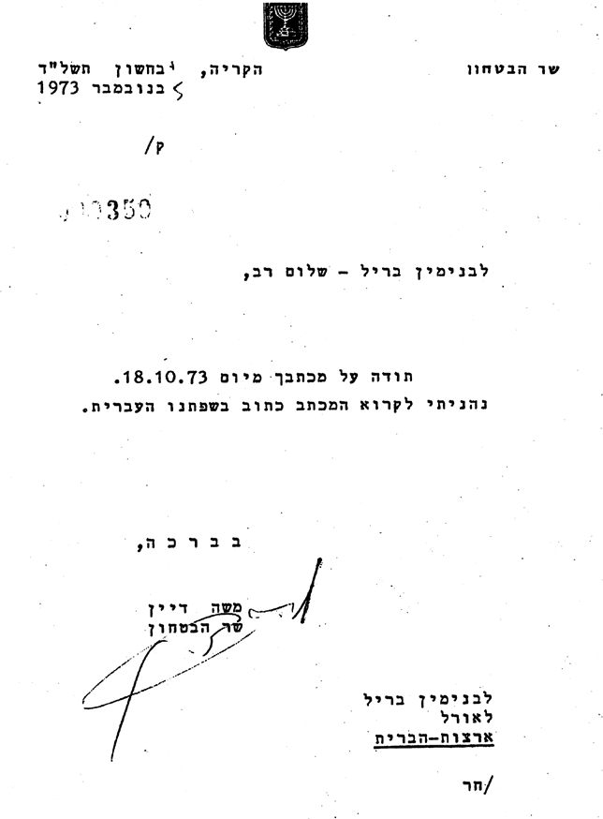
Figure 32: Israeli Defense Minister Moshe Dayan’s letter to me.
Some days later, his secretary wrote me an additional letter of thanks in English. In this letter, the secretary said the defence minister had asked her to thank me FOR THE EYE PATCH I had so kindly given him.
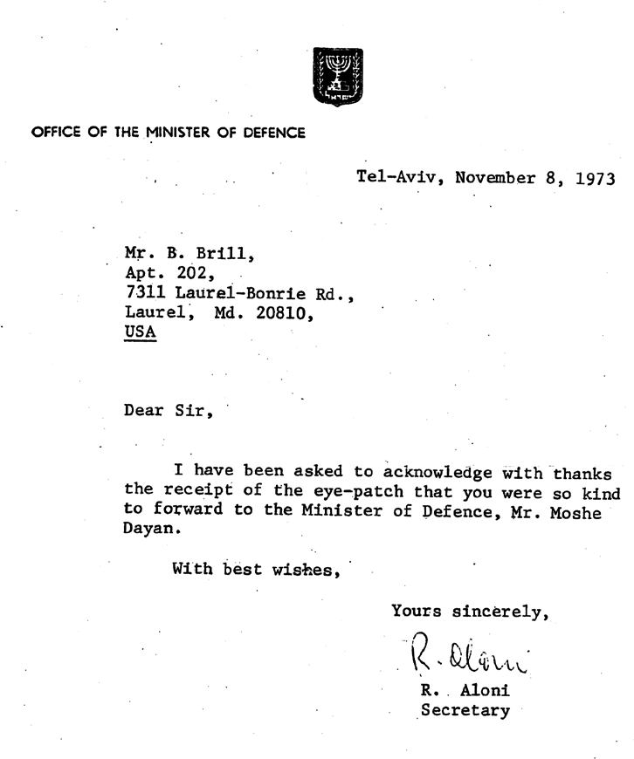
Figure 33: Moshe Dayan’s secretary’s letter thanking me for the “eye patch.”

THE MESSIAH’S BLESSING

As the war continued into its second and then third week, my 16-hour workdays were taking their toll: it would be nice to have an “R&R”. “R&R” is a military term meaning “rest and recreation,” a period to unwind from the stress of battle or - in our case - overwork. A few days’ respite to get away from military issues would be so nice and so appreciated. My problem, though, was my Jew-hating immediate supervisor, who, “in the heat of battle,” when the rest of us were working 16-hour days, decided to take off on his hunting trip to Colorado around the 18th of the month. He couldn’t approve giving me any extra time off for an R&R in his absence.
But thanks to Daoud, I learned a soldier could request an extended weekend to attend “a religious retreat.”
At one of the Tuesday luncheons I sometimes attended at the Fort Meade Post Synagogue, I asked if the chaplain there knew of any Jewish retreats, and to my pleasant surprise, he knew of one offered by Chabad, a Hassidic group based in Crown Heights, Brooklyn. I inquired and was invited to attend the retreat in early November, the weekend of the 2nd and 3rd.
While the Yom Kippur War raged and we worked 16-hour days while on red alert, it seemed very unlikely that I’d be able to get away for such a weekend seminar. Fortunately, by the 26th of October, things had stabilized in the war, so it was possible to consider going away for the weekend. It’d be like R&R, a chance to get away from the war and all the work involved in monitoring it, a “retreat” in every sense of the word.
I arrived at the Chabad “headquarters” in Crown Heights early Friday afternoon. Arriving early on Friday was one of the organizers’ stipulations; things had to be set up well before the commencement of the Sabbath at sundown. I was placed with a family, a young couple with a few small kids: a toddler and a baby. They were what’s called ba’aley teshuvah, literally “masters of the answer.” The English word “penitent” comes the closest to the meaning of the phrase. What it meant, somewhat disappointingly to me, was that they were “Nuovo Hassids”; they weren’t yet part of the established Chabad community. The official reason I was on this retreat was to attend Jewish studies. These studies included some of the traditional practices of the Chabad and how they differed from other Orthodox Jewish groups, what was “acceptable” in their eyes and what was not. A number of orientation sessions dealt with topics related to religious practice and theology.
I hoped to get away from all things military for that weekend, but they kept popping up. The men’s outfits - black pants, white shirts, black suit jackets, and wide-brimmed black hats - they called “uniforms.” They also organized the children into “Hosts of the Lord” groups. Then, too, they talked about different “units” within the “Army of HaShem (“HaShem,” literally “the Name,” their substitute for the Hebrew name of God). The other Hassidic groups each had their own distinctive “uniforms.” Some gartered their pants above the ankle. Others kept their pants tucked inside their socks. Some insisted on white socks. Some furled their hats’ wide brims upwards. Each group had a name, usually indicating its place of origin: Breslov, Munkatsh, Satmar, and Lubavitch - which was Chabad’s town of origin.
I found Shabbos (what they called “Shabbat”) pretty regimented. You weren’t allowed to do this and that. It seemed like a day of prohibited things. One of these was turning on a light…and even a bigger one was turning OFF a light. So, what does one do if you need a light in a bedroom on Friday night? Remember, this was 1973; today’s omnipresent “timers” weren’t available back then, so their ingenious workaround was to light a lamp before the onset of Shabbos and place it in the closet. When you needed light, you opened the closet door; when you didn’t want light, you closed the closet door. Simple enough!
After Shabbos ended, I was invited to attend a “Farbrengen,” where the famous Chabad rebbe, Rabbi Menachem Schneerson, was to hold a tish. The Yiddish tish, like the German Tisch, literally means “table,” but what it means in this context is that the lecturer sits behind a table and speaks to those assembled. We gathered in a huge hall teeming with Chabad “soldiers”, all in their uniform black and white. As we packed in like sardines, I tried to imagine how their esteemed rebbe was ever going to get to the tish, which was center stage. When he suddenly appeared, there was such a hush you could hear a pin drop. Amazing! Thousands of Jews packed into one big hall, and there was silence?! What a strange phenomenon. Borderline miraculous.
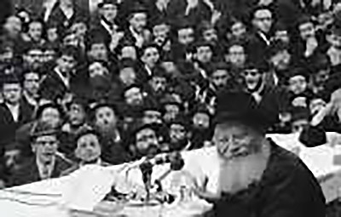

Figure 34: The rebbe.​Figure 35: The Lubavitcher rebbe at a tish.
However, for this old man to cross the room and get to the tish would require a bigger miracle. How would he negotiate that packed room? Impossible! But the moment he stepped forward, this “sea of black and white” split apart like the Red Sea parting for the ancient Israelites on their Exodus from Egypt. I was standing quite some distance from the ground floor of the auditorium in a kind of balcony. It was like watching a Cecil B. DeMille movie. The rebbe did not have to hesitate or wait for a clearing of the crowd to take place; it just happened. And he took his place behind the tish. A bottle of vodka and a shot glass stood on the table. He filled the shot glass, said a blessing, drank it down in one gulp, and began speaking.
My escort had to tell me what the rebbe was saying because he spoke only in Yiddish. At first, he commented on the weekly Torah portion and its implications for man’s behavior. This was all good; at least it had nothing to do with military issues I was happy to be away from. But around his fourth or fifth shot, he left theology aside and addressed a topic I was trying to distance myself from: the Yom Kippur War. From my escort’s translation, General Schneerson actually made a lot of sense. He didn’t speak in vague generalities; he talked specifically about the Syrian front. At that time, the Israelis were at “Kilometer 100,” a mere hundred kilometers from Cairo, with scant resistance between them and the Egyptian capital (at least, now that Sharon had conducted his breakthrough to the West Bank of the Suez and managed to cut off the Egyptian Third Army, totally neutralizing them). The Rebbe did not address the possibility and advantages of taking Cairo, but he did insist that the Israelis must take Damascus. His reasons for such a move were threefold: it was militarily possible; it would psychologically devastate the Arab world and thereby save Israel from future military problems and loss of life; and most importantly, it was deemed by God.
When he was done speaking about taking Damascus, he filled another glass with vodka and held it up in my general direction. Then he fixed his eyes on mine, singling me out from among the thousands there, gave me a blessing in Yiddish, and drank his final shot.
“What an honor! Let me shake your hand!” my escort said. “Do you realize how blessed you are?” Well, I can’t say I felt particularly blessed at that moment. However, after hearing so many people over the years refer to Schneerson as one of the greatest rabbis, with many believing he is Messiah, I guess it’s worth mentioning… and devoting a chapter to it.
The weekend provided worthwhile R&R, yet my soul was still troubled by those Israeli soldiers being surprised by an Arab attack. Why didn't they know? Why?

THE EVIL EVAL

Just as Sa’id M replaced Sa’ida Q, my original immediate supervisor at NSA was replaced by Mike G. In the case of the Arabic teachers, an angel had been replaced by ineptitude. In the case of my job at NSA, I couldn’t pass judgment on Mike G’s competency; I did not need to know if he was or was not competent or, if he were, to what degree. It wasn’t my job. What I am sure of is that he was no less the Jew-hater than Sa’id M. Mike G was more subtle about his Jew-hatred. Once he learned I was a Jew, he was careful not to use derogatory epithets for Jews, as he constantly did for other minorities, particularly those not present in our department, like calling Orientals “gooks.” I could only imagine what lovely terms he’d use for Jews when I wasn’t in earshot after he learned I was one.
How can I make such a judgment about his prejudice against Jews? Precisely because of his action to seriously screw me when the time was ripe. He never admonished me for not working hard enough. Never. Not once. The opposite was true, and one example of this was his suggestion that I spread papers around on my desk to make it appear I had a lot of work.
Sometime in late November, after Mike had returned from his so-called hunting trip in Colorado, he filed an “eval” on me. An “eval” is an enlisted man’s efficiency report. It affects when your next raise in rank will occur, and it can also affect your chances of getting hired at the Agency as a civilian after discharge from the military. In short, it’s a very important report… and it’s in your permanent record. It can make or break one’s future career.
This was Mike’s chance to seriously damage the kike. He wrote me the worst possible eval, and it became the talk of other sections beyond just Mike G’s. It raised a lot of eyebrows, and reasonable people who learned about it were aghast. But what could be done? It seemed like the answer was nothing and the Jew boy would “eat it.”
This was the most severe case of up-close Jew-hatred I had ever personally experienced. It affected my health; the tension took its toll on me physically. This tense period lasted for some weeks. I was at my wits’ end. I didn’t know what to do. I didn’t know if I had any recourse. I would just have to grin and bear it. But I was not grinning.
Fortunately, an Air Force master sergeant in some other section on the floor found out about the eval and came to my rescue. I don’t know how Sergeant Robert 33 I learned of this. since his section was not physically adjacent to ours. I can only guess it might have been ever-smiling Dusty, an African American supervisor in the section adjacent to ours, who had the discernment to know Mike G was a bigot and out to get me. It is doubtful that Dusty’s civilian position outranked Mike G’s; to help me, a supervisor who outranked Mike needed to be found. Sergeant Robert obvious to him and other fair-minded middle management people that Mike G was gunning for me for no other reason than I was a Jew. Thanks to the establishment of the CSS’s dual staffs, civilian and military, at NSA the year before, Sergeant Robert could write me an eval of his own. Since his military rank surpassed Mike’s civilian rank, his eval would supersede, revoke, and replace Mike’s .

33 "The Pentagon disallowed mention of Sergeant Robert L. ’s full name. How sad, since his rectitude and courage should be celebrated. (Perhaps if he’s still alive and happens to read this book, he could give me his permission to publish his name, please God, in a future edition.)"
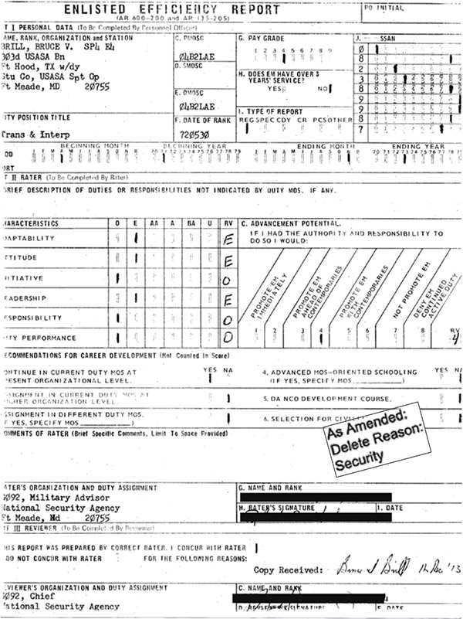
Figure 36: Evaluation report.34
I couldn’t continue working under Mike G’s command.

34 As the reader has taken note, the author, compulsive hoarder that he is, has saved all kinds of paperwork from that period. However, the Evil Eval, unfortunately, was destroyed for obvious reasons. If I knew that someday I’d be writing a book, I would certainly have saved it.

I BECOME A HEBEE

Within some weeks of the evil “Eval” and its rectification, approval came for my official transfer into the Hebrew section. Although I outdid Uncleo on the ALAT (Army Language Aptitude Test), I was nowhere near the linguistic genius he was. This new job would be ideal for improving my Hebrew language skills.
I was to transcribe and then translate audiotapes. The transcription job required learning English-letter substitutes for the Hebrew letters since we typed the transcriptions on English typewriters. Some of the letters were sensible substitutes, while a minority of them bore no resemblance to the Hebrew. With time, all these became second nature, as eight or nine hours daily on the job made for the eventual internalizing of this new mongrel alphabet. I had learned how to touch-type (in English, of course) back in high school, and I believe that even being new at the job, I put out a good amount of work, both in quantity and quality. Unlike my job under Mike, where I did little actual work, there was plenty of work, and the busy workday flew by enjoyably and quickly.
The physical setting, inside a restricted area accessible only with a door code, is nicely described by an Arabic linguist colleague, David Gallaspy, in his book Storm Over Malham Cove. This book is a fictional account of an NSA linguist, Trace, during the Yom Kippur War (David admits that he sensed something foul about the war, which drove him to write his book):
Both Sol and the girl had earphones with curly cords hanging free. In each case, one clear plastic earpiece on a cord was dangling from the clip at the lapel, the other was in an ear. A phono plug dangled a few inches below the waist, and the girl held the plug cord in her hand, twirling it in an accustomed way. They were unplugged from something - tape machines, as Trace would find out - but were ready to plug back in at a moment’s notice. The general impression was that of a doctor with a stethoscope, called away from a patient. The “patients” must be in that room, Trace thought. Glancing through the double doors as they slowly closed, he caught a glimpse of a large, brightly lit space with rows of consoles at which people were sitting, most listening intently. There was an awful lot of clicking and mechanical whirring going on.
He had led Trace into a small alcove, in which there were several of the big desks or consoles Trace had seen through the door. There were some on each wall of the alcove, with utilitarian gray but comfortable-looking rolling chairs in front of them.
Trace sat down at the second console against the wall on the right. These were substantial metal desks that had obviously been specially designed for the function of listening to tapes and typing something about them - translations, presumably. The heavy duty typewriters were mounted on shelves that could swing down and under to open up workspace. In front of Trace when he sat down was an angled panel that went up to about head height, and installed in the panel was a reel-to-reel tape recorder with a number of controls. In addition, there were various knobs, lights and meters arrayed around the tape player, and a microphone on a flexible silver stalk was mounted on the right. He had no idea what the mic might be for. As Trace pulled his chair up to the console, he stepped on something - looking down there were some foot pedals under the desktop that must serve as hands-free controls - no doubt you could play, stop, rewind or fast forward the tape with your feet. Pretty cool, Trace thought. There were a couple of file drawers and some cubbyholes in which to store things - files, personal items perhaps.35
I loved the work and my fellow workers. The big difference in the atmosphere in this new position was that I also loved my supervisor. In addition to being my roommate and a dear friend, Uncleo had now become my boss. His piquant sense of humor and good spirits made being with him a pleasure.
As the Yom Kippur War progressed, and after the cease-fires, he was sent abroad to an NSA collection station . Internet and mobile phones didn’t exist back in those days, but I needed to be in contact with him about household matters like paying the rent (the apartment we shared was in his name) and other things, like his car insurance and registration. I could be in touch with him about work-related matters
through teletype. However, the supervisors at his base in didn’t allow any personal teletype messages,
so we arranged a sneaky workaround: we piggybacked personal matters on work-related texts. I created two fictional Israelis. One would pose the question I needed answered, which would be clear, “A-val,” but the answer would be “garbled.” I would then ask Uncleo for clarification.
I teletyped to Uncleo frequently.

35 David Gallaspy, Storm over Malham Cove (2015), Kindle, location 1598.
In teletyping, one’s message was prepared in advance and typed into the teletypewriter, which produced a paper ribbon about 5/8 of an inch wide and punched with holes. This holey ribbon contained your message. You would take this ribbon to the teletype transmission machine to send it electronically to the waiting recipient.
The teletype transmission machine was in a room for which I needed an additional security clearance. I was collecting security clearances one after the next. Although I now had clearance to access the teletype transmission room, I did not have clearance for another large area through which one needed to pass to get to this teletype room.
Access to this large room was restricted, just as it was for the room where I did my Hebrew transcription and translating work. This meant the entrance was locked. One needed to know the numerical code on the door handle to unlock the door. With all my additional security clearances, why wasn’t I authorized free access to this particular large room, especially since I needed to pass right through it to get to the teletype room? This was a question I only asked myself since I had no “need to know.” But still, it seemed a bit curious. I didn’t dwell on it at the time, until…
The usual procedure for entry into a limited-access room to which you didn’t belong was to first ring the doorbell. This was like any typical doorbell in the real world. But then the real-world likeness ends, for you would need to take a step or two backward and show your face and badge clearly to the in-house monitoring camera. Since I wore my ID around my neck on a thin ribbon, it was a simple matter. I had to stand there for a time to allow whoever was viewing my ID to see it clearly and identify who I was. Then I would wait for several minutes before someone opened the door to let me in. I had no idea why this procedure was necessary; I did not need to know.
On one particular occasion, however, while I was waiting the usual several minutes after displaying my ID card to the camera, the door opened prematurely, and one of the workers - obviously not opening the door to let me in, but merely to let himself out - exited the room.
Without thinking, I proceeded through the door without waiting for the necessary process to be completed.
On all previous occasions, whenever I waited for my entry to be allowed, I never noticed anything much different there than in my limited-access Hebrew sector or, for that matter, any of the open areas within the Agency. In fact, this area resembled all the open areas rather than the other closed ones I had seen. Why, then, was this a limited-access region? On this occasion, though, as they didn’t have enough time to “prepare” for my entry, I saw what the deal was.
As I entered this seemingly mundane work area, I saw the entire back wall of the room was covered with a huge map and a ceiling-to-floor curtain was closing over it as I entered. It was like a scene from a James Bond movie. What was this all about? Why the huge map? Why the secrecy within the Agency? Why was it off limits to me, who had well above top-secret clearances? Why? I didn’t ask, because…I did not need to know. I noticed the map was of the Middle East, with Israel at the center. I recall seeing Israel’s “West Bank settlements” labeled with a number next to each. I assumed the numbers represented the Jewish populations of each town. The map didn’t cause me to bat an eye, since G6 dealt with the Middle East. What were the particulars on that map that obliged management to restrict it from my eye? I could only imagine.

THE CONVERSION PROCESS

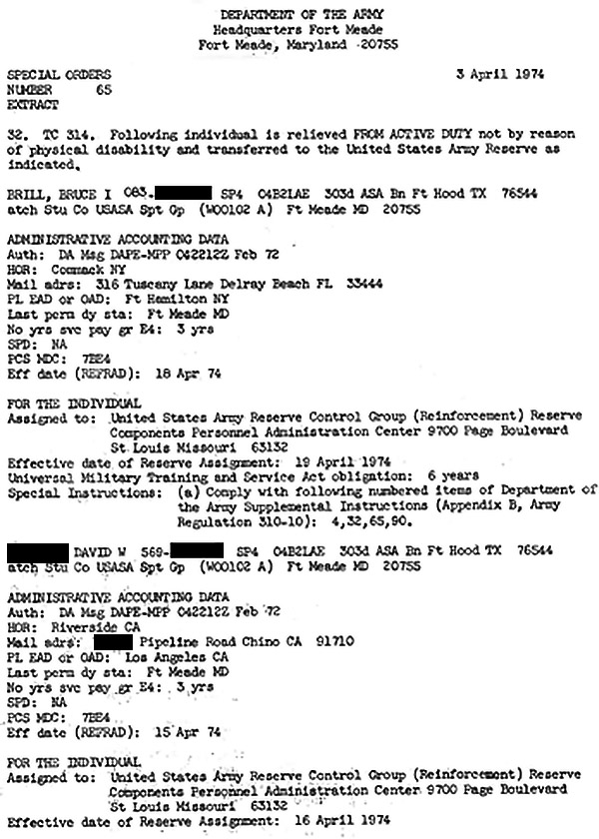
Assignment to Reserves
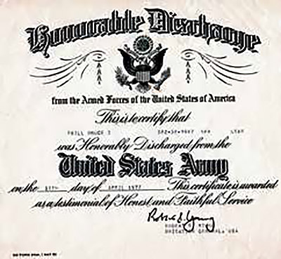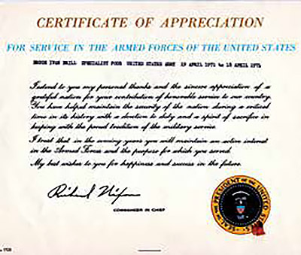
Honorable Discharge​Letter of Appreciation
Figure 37: Assignment to reserves, honorable discharge, and the president’s letter of appreciation.
Near the end of our military service, we had several options. One was to “re-up,” which meant signing up for another tour of military duty. By 1974, the wages of the professional soldier had been considerably increased since I had first joined the army in 1971. This was an inducement to military personnel to re-enlist. A second option was to say goodbye to the military and NSA. A third possibility was “to convert.”
The expression “to convert” would give conniptions to most Jewish parents (at least, it would have, back in the early 1970s), but this conversion had nothing to do with religion. It meant to convert from military to civilian and continue working the same or a similar job to the one you worked while enlisted.
Since all my colleagues in 1972 had chosen the early-out option, re-upping was not a serious consideration. Daoud was interested in returning to the pulpit, so converting might be something he would try to do to his Jewish buddy, but not something he would do to continue working at NSA. Walid and Hissam liked what they were doing at NSA and opted for conversion. Although I enjoyed working in the Hebrew section, I had made a promise to myself to go to Israel. However, until signing on the dotted line, I was not committed, and anyway, this “conversion process” sounded more interesting than the Hebrew work I had been doing. The conversion process was done during work hours, so you got out of the routine of everyday work.
The conversion process had four steps:
1. The “BI,” or “background investigation.” Why that was necessary is unclear since we were already insiders working with the most highly classified material.
2. A psychological examination. Back in those days, the intelligence community was extremely sensitive about possible homosexuals.36
3. Polygraph. Here a security officer interviewed the candidate under polygraph conditions: the lie detector test.
4. Salary negotiation.
The first three steps were all security related. I passed the first two stages with no problem and was invited to the third, the polygraph. The NSA Recruitment Office routinely put any job-seeking candidate through the polygraph interview. It was a primary tool in NSA’s selection process.37 Although there was a Pentagon regulation at the time instructing, “The polygraph shall be employed only as an aid to support other investigative techniques and be utilized generally only after the investigation by other means has been as thorough as circumstances permit,”38 it was used extensively to gather compromising information on candidates. NSA admits that over 95% of all negative findings on prospects came from the polygraph and 90% of those warranted further investigations. Typically, 30% or more were rejected in the wake of the polygraph exam.39

36 James Bamford, The Puzzle Palace (New York: Penguin Books, 1983), 113.
37 Ibid, 163-164.
38 DOD Directive 5210.48, The Conduct of Polygraph Examinations and the Selection, Training and Supervision of DOD Polygraph Examiner, Section III-A.
39 James Bamford, The Puzzle Palace <(New York: Penguin Books, 1983), 164
In my case, too, as described in the Introduction, the polygraph showed I was likely to pass classified intelligence to a foreign national. More damning was that I lied about it. Contrast this with Merwan, the top linguist in our group, who was not assigned to NSA because he had been caught in a tiny white lie.
Naturally, I expected this would be the end of my conversion process. It should have stopped it dead in its tracks. Much to my surprise, however, I was invited to the fourth step, the salary negotiation. I couldn’t believe it!
Since my use of Arabic had been minimal, and for the last half-year, I had been using Hebrew exclusively, my Arabic had to have been rustier than Walid’s and Hissam’s, who, I assumed, had been using their Arabic more than I had been using mine. Although I had been working with the Hebrew language, my official MOS remained Arabic- Egyptian. The salary negotiation official offered Walid and Hissam an attractive GS-7. Surprisingly, I also was offered a GS-7.
At that time, GS-11 was offered only to newcomers who had a PhD. I didn’t even have a master’s degree at that time. Since I had promised myself I would be going to Israel, wasn’t interested in a job with NSA, and knew they couldn’t offer me an 11, that’s precisely what I asked for. I thought this should have been the end of the salary negotiation. Again, to my surprise, they offered me a GS-9, two full grades higher than my contemporaries. Still, I held on to my demand for the impossible GS-11. They upped their offer further to GS-9, Step 3. I again held my ground. Only if they agreed to my demand for an 11 would they be calling my bluff. They went one step further, offering me a GS-9, Step 4.
I stood on principle and honored the promise I had made to myself to go to Israel. Still, it baffled me why they were so eager to entice me, a security risk, to come on board. I should have been rejected out of hand and been among the 30% of newcomercandidates rejected, or the 20% of potential converts from the military who are judged unacceptable by NSA’s Applicant Review Panel. Ninety percent of those rejected servicemen are nixed because of fallout from the polygraph examination. Why was I not among them? This question troubled me.
That is, it troubled me until I learned about and studied the Jonathan Pollard Affair. I believe some NSA bad guys were already looking for “a Jonathan Pollard” back in April 1974, a decade before they were able to find one in 1985.
Who was Jonathan Pollard… and who were these bad guys?

WAKE-UP CALL:
THINGS DON’T ADD UP
US CONSULATE
After getting discharged from active duty, I had the opportunity to catch some military hops from Andrews Air Force Base outside of Washington, DC, to the West Coast. From there, I did a bit of traveling and reconnected with Daoud in California and Merwan at his home in Colorado. Next, I hopped freight trains to Laurel, Maryland, for a few days, where I participated in the National Fiddle Contest, which was hosted on the Mall in DC by the Smithsonian Institute (I tied for first place in “Most Unique Fiddle Style”). Then it was on to Israel.
In Israel, I took a course to get certified to teach English as a second language. One of the instructors was Vivian, who caught my eye. We dated and decided to get married. However, the Israeli Rabbinic Authority would not accept that I was Jewish because my parents couldn’t find their ketubah, their Aramaic marriage certificate. After I arranged the American Bicentennial Celebration in Jerusalem on July 4, 1976, Vivian and I flew off to America, where we could get married. Uncleo came up to Brooklyn to hold one corner of our chuppah (marriage canopy).
After a honeymoon road trip out to Merwan’s in Colorado and then a visit with John M in Wyoming, we moved in with Uncleo in Maryland, not far from NSA. He had now graduated from the apartment we had shared (when I was at NSA) to a Civil-War- vintage house in the center of Laurel. We were the oddballs at Uncleo’s since his other housemates were single military guys who worked at NSA. In Uncleo’s typical charming way, he called his place “Uncleo’s Home for Unwed Fathers.”
While in Laurel, Vivian and I began working for a DOD subcontractor, Techtran, in Glen Burnie, Maryland. The work we did was confidential and secret, so we needed to get clearances. Much - most - of the translations we did were military instruction manuals for Soviet equipment the Israelis had captured from the Arabs during the Yom Kippur War. What we translated were translations of translations of translations. The originals were in Russian, and they had been translated into Arabic, then Hebrew, and finally English. If you’ve ever played the game of a sentence being passed from one person to another in a circle and then seeing how the sentence has “evolved” into something hardly resembling the original, you can imagine that some of the renderings into English were a bit peculiar.
Because of the Yom Kippur War related nature of our daily Techtran work, my thoughts of that troublesome time returned to me. It was then that I began to suffer from recurring nightmares about being back in NSA without my top-secret clearance and fearing getting caught. I have such dreams to this very day.
After spending the better part of a year at “Uncleo’s Home for Unwed Fathers,” we got an apartment not far from him, and of course, we maintained contact with him. He was practically family. We stayed in Maryland for five years and then returned to Israel at the end of 1981. “We” now included children; we were a family. We made our home in Tekoa, just outside Jerusalem.
One day in 1991, I happened upon a demonstration on behalf of Jonathan Pollard outside the American consulate in West Jerusalem. In 1985, Jonathan Pollard, an intelligence analyst for the Navy, had been caught passing classified information to Israel. He had been brought to trial and sentenced to life in prison. That was all I knew of the Pollard affair then. At the demonstration, I stood next to one of the organizers, Geula Cohen, a prominent politician. I mentioned to her that I had also worked in US intelligence. I told her my story about the Yom Kippur War. I don’t recall if I expressed my opinion about Pollard, which, at the time, was not very favorable: he had taken the same secrecy oath I had, but he had violated it and, therefore, deserved to be behind bars.
Didn’t he?

Geula asked me to take the microphone and recount my Yom Kippur War story. Although it wasn’t clear to me how my own story could assist someone who, unlike myself, was not a loyal American and had broken US law, I agreed to tell my tale.
News reporters were in the audience. One from Israel TV and another from Israel’s Hebrew daily, Yediot Aharonot, approached me afterward and asked for my contact information. A few days later, I got a phone call from the Yediot Aharonot reporter. I had a feeling from his very few cursory questions that he might be interested in interviewing me in the future. Was I ever surprised when an article appeared in that paper’s weekend edition with what looked like a full-blown face-to-face interview,40 complete with my photograph! Some days later, I received an invitation from Gil Sedan, the host of a widely viewed Israeli TV show. Then I was asked to appear on Gabi Gazit’s equivalent to America’s The Tonight Show. Apparently, my story was of interest to Israelis.

40 Nachum Barnea, Bruce Brill’s Story, Yediot Aharonot , Apr. 12, 1991.
Some activists working on behalf of Jonathan Pollard saw my story as useful in his cause and tapped me on the shoulder. Why, though, would I wish to assist an un- American violator of US law? I felt obliged to learn about his case.
One of the Pollard advocates who contacted me was his sister, Carol. She provided me with reams of documents and articles about his case. The more I read, the more I came to realize there was more to the story than met the eye…much more. In fact, the more I read, the more it seemed to me that Pollard might have been set up. One book, by Pollard’s father-in-law, Bernard Henderson, was extremely enlightening. His book convinced me Pollard had indeed been set up.41 He was someone’s lackey, but whose… and why?
Pollard’s superiors in Naval Intelligence had made a point of telling him they were deliberately withholding intelligence from the Israelis. Pollard believed this intelligence was vital to the Israelis. Much of it was about Iraq’s chemical warfare capacity and how they intended to use it on Israel’s civilian population. According to Henderson, Pollard’s superiors Jew-baited him, telling him they were suppressing this vital intelligence from the Israelis “because those Jews have a problem with gas.”
I had also begun to see another aspect to the affair. It was clear to me this unfortunate fellow had courage. Only an intelligence community insider like myself could appreciate this. At security sessions, the point was repeatedly driven home that any security infraction, whether accidental or conscious, would be discovered and the consequences would be severe, especially if the breach were intentional.
Pollard must have sat through such security sessions. He had to have known his infringement would almost certainly be discovered, and he must have been aware of the severe consequences.
That he still decided to pass classified information to a foreign national, albeit an ally, was a sign of courage… stupidity… or both.
Everything I learned about Pollard demonstrated he was anything but stupid, so to do what he did, he must have been courageous. I had to tip my hat to his nerve. Pollard wrote, “I’d rather be sitting in prison for life than be conscious-ridden for not passing the Israelis information I saw as vital.”42
I was also beginning to see yet another part of the picture that had been overlooked.

41 Bernard R. Henderson, Pollard: The Spy’s Story: An American Dreyfus Affair (Alpha Book Distributors, 1988).
42 Pollard, Jonathan, "Appeasement of Iraq Made Me a Spy" (Wall Street Journal, February 15, 1991).
After WW II ended, the Allies conducted trials for Nazi war criminals at Nuremberg. These Nuremberg Judgments said a German soldier could not be deemed innocent of committing a “crime against humanity” by claiming he was “just following orders.” What was unprecedented was that this ruling was being applied retroactively. Although the Nuremberg Judgments came about after the fact, the perpetrator was still held accountable post factum.43
I asked myself: Couldn’t withholding vital information from Israel that would result in innocent Israeli citizens being victimized be considered a crime against humanity? And couldn’t withholding this information be seen as committing such a crime as defined at Nuremberg? Shouldn’t Pollard’s supervisors, who consciously withheld vital intelligence, be answerable under the Nuremberg Judgements? Shouldn’t Pollard, therefore, be seen as a correctly behaving-even heroic-American?
If a German soldier had refused to carry out an order that, at some point in the future, was labeled a “crime against humanity,” he would be considered a hero. Wasn’t what Pollard had done the same? I became convinced this was the case.
The American Jewish community saw Pollard as an embarrassment, yet in light of Nuremberg, he should have been viewed as a hero - not a Jewish hero, not an Israeli hero, but an American hero.
Now I saw my job as convincing American Jewish leaders and organizations that this is how Pollard was to be viewed, to “make him kosher” and then win their support on his behalf.
How, though?
Before publishing my disclosures about my NSA Yom Kippur War experience, I felt I should first get clearance from the American authorities. I would try to guarantee that nothing I would disclose would violate my secrecy oath or break American law.
I wrote my disclosure, concentrating on Jonathan Pollard, for his situation was the incentive for making my disclosures. If not for his tribulations, I would not even have thought to tell my story. At the same time, it was clear that Israel’s security was a more important consideration, even if not as personal, timely, and seemingly pressing as Pollard’s.

43 Gerald Dickler, Man on Trial (Garden City, NY: Doubleday, 1962), 328-329.
I had occasion, at that critical time, to share my first draft with a celebrated writer, Joel Bainerman. Joel was a well-respected and up-and-coming investigative author. He recommended taking out references to Pollard. The informed reader, Joel contended, would draw his own inferences from the Pollard affair.
With my disclosure, now focused on the Yom Kippur War, in hand, I went to the US consulate in Jerusalem. Deputy Consul General Eugene D understood I wanted to bring it to the attention to higher-ups in the US government, and invited me to lunch at the YMCA on King David Street in Jerusalem. Although the restaurant had ample seating outside, Eugene D insisted we sit indoors. In addition, he insisted we sit at a large booth against a wall rather than a smaller table more appropriate for just the two of us in the middle of the room. Though gentlemanly in every other aspect, Eugene D entered the booth first. I mention these details because it seemed like our conversation over lunch was being recorded. Even given that, I felt Eugene was sympathetic to what I had to say. I told him about certain peculiar instances at NSA that had always baffled me, defying logic and explanation:
• My non-admittance to a certain large room I needed to pass through to get to the teletype machine.
• The Israel-related map I wasn’t supposed to see on the wall in that room.
• The statement by my Hebrew supervisor about certain rooms I was not allowed to enter “because you’re a Jew.” (see: “Because You’re a Jew” chapter herein)
• My being offered a job even though I should have been seen as an obvious security risk (I was on record saying, “Under certain circumstances, I would pass classified information to a foreign national,” during my “conversion process”).
• My being enticed to stay on by being offered a salary far above that of my peers.
The only way to make sense of all these peculiarities was to realize there was a hidden- from-all-those-but-those-who-belong entity within NSA working against Israel (and, by extension, even American Jews44) and this “entity” had been trying to create “a Jonathan Pollard” back in 1974.
I felt Eugene tried his best to convince the appropriate people in the US government that this matter needed to be investigated and dealt with. He did this through appropriate internal US government channels. When he did not get an answer through these internal diplomatic channels, he was at a loss. It seemed to him there was unwarranted uncooperativeness, maybe even a degree of nastiness, in the State Department’s bureaucracy toward anyone sympathetic to promoting Israel’s cause. So it seemed. For his effort, Eugene, who, I understand, was next in line to become the consul general in Jerusalem, was instead reassigned to Turkey.
Since the internal channel didn’t work, I took a deep breath and wrote a letter to NSA’s chief of security. This was November 1993. Since it was yet not clear to me that my disclosure did not contain any classified information, I, of course, sent it registered and requested return receipt. The registered letter “got lost” somehow. I put in a request to the Israeli Postal Service to trace the letter. After some weeks, they came back to me with a frustrating answer: they weren’t getting any response from the US Postal Service about the location of the registered letter.
In desperation, I sent a similar follow-up letter the next year by DHL secure courier service:

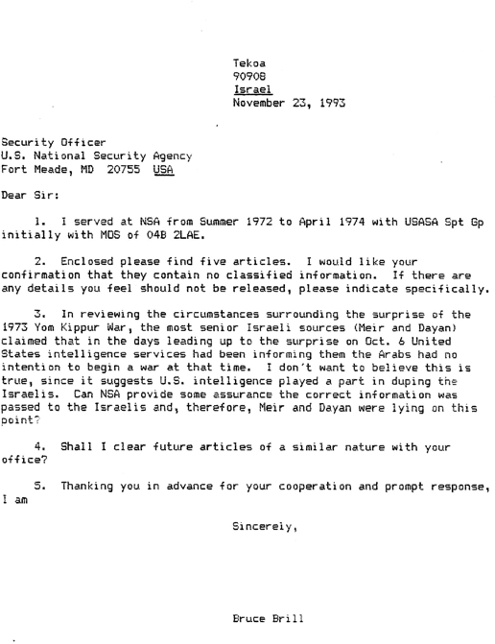
Figure 38: 1993 letter to NSA security chief.
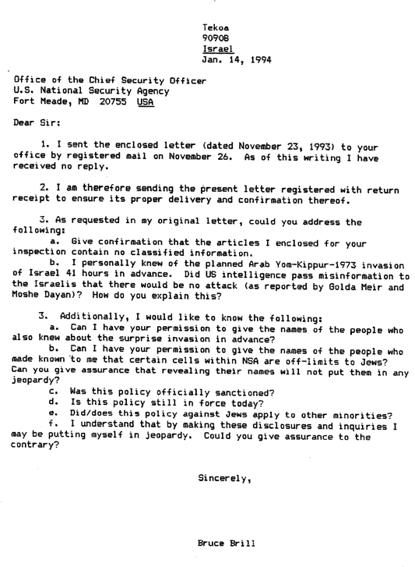
Figure 39: 1994 letters to NSA security chief.
This time, I got my return receipt so I could be certain my letter got to the chief of security, or at least arrived somewhere at NSA.
Did I get a response? Negative. The non-response is telling, for it confirms certain points raised in the letter.

44 John Loftus and Mark Aarons, The Secret War Against the Jews (New York: St. Martin’s Press, 1994), 181, 192-195, 585 (note #94).

The main point was a question: was the policy of maintaining Jew-free rooms within NSA that had been in force in 1972-74 still in force in 1994? In anticipation of a non- response, I signed off by stating that if I didn’t hear otherwise, I would assume the disclosures I was about to seek publication for did not contain any classified material unlawful to publish.
After waiting a generously long period of time, I decided to seek publication.
At about the same time, I thought it prudent to share the dubious trustworthiness of US intelligence when it came to Israel with Israelis for whom this important tidbit would be of interest. IDF General Rechavam Ze’evi, whom my wife, Vivian, and I had met when he had given a talk in Tekoa, invited us to meet him at his Knesset office.
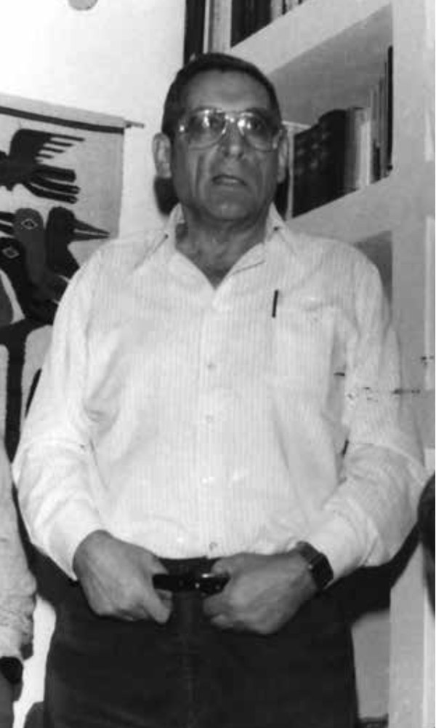
Figure 39. IDF General Rechavam Ze’evi
Ze’evi listened carefully and even shared his own pre-Yom Kippur War experience. He said that on October 5, Chief of Staff (CofS) David Elazar had given him a folder containing some hundreds of intelligence points and asked him to take it home for the weekend, peruse it, and return his opinion at the beginning of the coming week. He told us he had already skimmed over the report that very Friday morning and returned his conclusion: an attack was imminent. Elazar, however, relying on the head of IDF intelligence’s “low probability” assessment, did not accept Ze’evi’s conclusions.
Ze’evi asked me what I hoped to achieve by publishing my disclosures. I told him I believed it could help Jonathan Pollard. Ze’evi was aware of the Pollard situation and said he wasn’t certain my publishing the disclosures would help, but he was certain I’d be putting myself in jeopardy. He told me with certainty about a committee of Americans that met in Northern Virginia. They had a list of names, and when they put an “X” next to one, that person was systematically eliminated.
J’ACCUSE
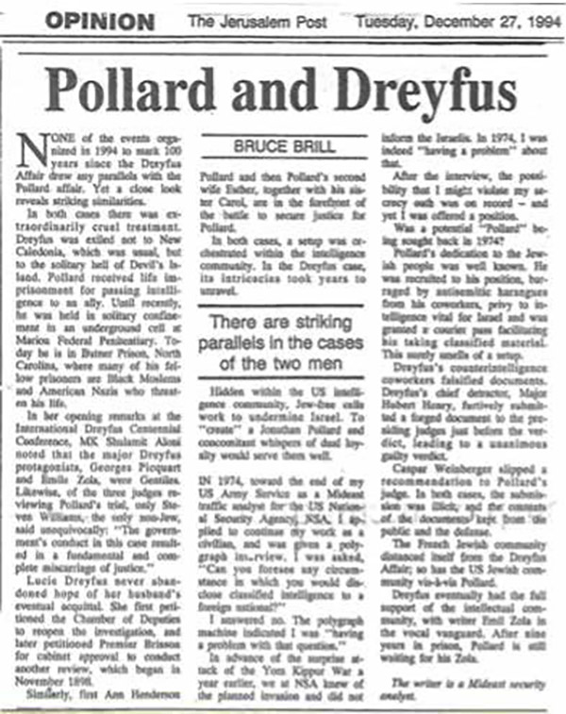
Figure 43: “Pollard and Dreyfus,” the Jerusalem Post.
In 1894, Captain Alfred Dreyfus was falsely accused, tried, and convicted of treason by a French military court. He was later -much later- exonerated, in large measure thanks to Emile Zola’s open letter, “J’Accuse” (“I Accuse”). The similarities between the Dreyfus Affair and the Pollard Affair inspired me to write “Pollard and Dreyfus.”
“I Indict,” more than any other piece I wrote, encapsulates the major points of the issue. In fact, several OPEDs were created from portions of the article. Here it is in its entirety: 45

45 Bruce Brill, “I Indict” (Midstream Magazine, May 1994).
I INDICT
by BRUCE BRILL
The responsibility for Israel’s being caught by surprise in the 1973 Yom Kippur War, its near demise, and the loss of over 3500 casualties, has been one of the most tightly guarded secrets for the past 20 years. The answer not only fingers those culpable, but has strong bearing on the nine year old [at the time of publication] Pollard Affair and -most importantly- Israel’s current security situation. The time, then, has come to make the answer public.

I was privy to the sensitive intelligence that gives the answer while I worked as a Mideast analyst at the US National Security Agency in the early 1970’s. The ongoing public debate since the Yom Kippur Surprise has centered around how much Israeli Intelligence and General Staff really knew or didn’t know, whether there was a choice to preempt and why the decision was taken to let the Arabs strike the first blow when it finally did become clear they were going to attack.
It is widely held that it was only in the morning of 6 October 1973, Saturday, Yom Kippur, that Israel’s General Staff knew for certain of the impending attack. Even at that time, however, the precise hour of the attack was believed to be several hours after it had actually begun. Although General [Arie] Brown claims that the Americans informed the Israelis of suspicious Arab movements indicating warlike intentions ten days before Yom Kippur, it is generally assumed that US Intelligence was caught totally unawares. A widely quoted secret report published in the New York Times of 12 September 1975 stated, “the United States Intelligence community acknowledged that it failed to predict the 1973 Arab-Israeli war and that several intelligence agencies even predicted that there would be no war only hours before the hostilities broke out.” General Brown maintains the Israelis had actually convinced the Americans in the interim that Arab movements were not preparations for war! And so it has always seemed perfectly acceptable that during the lead- up to the invasion, US Intelligence was reporting to the Israelis that, according to its best information, there would be no attack in the near future, certainly not on or by Yom Kippur. Moshe Dayan begins his account of the Yom Kippur Surprise in his autobiography abstrusely, “The Egyptian and Syrian attack on Yom Kippur came as a surprise, though it was not unexpected.” He continues that contingency plans for an Arab attack were based “on the assumption that there would be advance warning of more than 24 hours.” “But,” he adds, “both our own Military Intelligence and that of the United States concluded that Syria and Egypt were not about to go to war. They interpreted the heightened military activity on the Egyptian front as ‘army maneuvers’ and not preparations for an invasion. Nevertheless, we were not at ease...”
“During the night of 4 October, we received reports which strengthened the probability that Egypt and Syria were about to launch a war,” Dayan relates. Yet, he adds at the Cabinet meeting next day that “ the American evaluation was that neither Syria nor Egypt intended to launch an attack in the near future."
Dayan writes, “Thus, without our having been either complacent or blind to its possible outbreak, the Yom Kippur War broke over us on the very day we did not expect it to.” Dayan concludes that the army command and the government were, “led to the situation whereby too few Israeli forces were in position during the containment or blocking stage, and that the reinforcements which were rushed to the front arrived in small numbers with no time to make preparations for a counterattack.” Later, Dayan recaps the “mishap” by quoting copiously from the September 12, 1975 New York Times article.
Golda Meir, too, begins her autobiographical account of the Yom Kippur Surprise, with unclear innuendo: “Even as a personal story, there is still a great deal that cannot be told... [Before the outbreak of the war, Mrs. Meir recalls:] I was convinced that the army was ready for any contingency - even for full-scale war. Also, my mind was put at rest about the question of a sufficiently early warning. Then, for whatever reason, the tension relaxed.”
After receiving the ominous reports from Israel’s own intelligence services of the rushed exodus of Soviet advisors’ families on Thursday night 4 October, Mrs. Meir was convinced in her own mind that an attack was imminent:
“How could it be that I was still so terrified of war breaking out when the present chief of staff, two former chiefs of staff [Dayan and Bar Lev] and the head of intelligence were far from sure that it would? ... Not only that, but foreign [American Intelligence] services with whom we were in constant touch agreed absolutely with the assessment of our experts. So why was I still ill at ease?”

IDF Reserve General M.K. Rahavam Ze’evi recounts that Israel intelligence had 500 intelligence indicators just prior to the “surprise” that an attack was imminent. Yet, there was an element of doubt in Israel’s pre-surprise assessments. The effect of American intelligence reports passed to the Israelis was to strengthen Israeli Intelligence’s own doubts. Matti Golan The Secret Conversations of Henry Kissinger, indicates that the US influence had already pre-colored Israel’s own intelligence evaluations. At the critical cabinet meeting on Friday, 5 October the Israeli chief of intelligence “expressed his view that these were only maneuvers -and added that American intelligence shared this evaluation.”
Contrast these widely accepted accounts with a telephone call I received from my NSA supervisor about 2:45 PM, East Coast Time, Thursday afternoon, 4 October 1973: “Don’t even think about going home this weekend, ‘cause I’ll be calling your young... right back down again. We’ve got a war for real this time and... [it] hits the fan on Saturday.” The Syrians and Egyptians were going to launch a coordinated surprise invasion of Israel on Yom Kippur, 6 October. We knew of the impending coordinated attack, knew it was scheduled for Yom Kippur, and I, personally, knew of it 41 hours in advance. Higher-ups knew hours, if not days, before I did.
Besides my TV interview with host Gabi Gazit of Israel’s “Tonight Show” March 1991, the importance of this disclosure is evidenced by Israel TV news senior correspondent Gil Sadan granting me an interview on the eve of the 20th anniversary of the Yom Kippur War, and by the interview’s subsequent suppression by TV news management. The apology given was not that management doubted my testimony, but rather they doubted that of Dayan and Meir!
All Israeli personalities closest to these personalities from whom I tried to obtain confirmation held their cards very close to the vest. Even Yael Dayan shrugged off my inquiry by: “Was I [she] there?” In a registered letter of 23 November 1993 to the security officer of the US National Security Agency, I queried:
“In reviewing the circumstances surrounding the surprise of the 1973 Yom Kippur War, the most senior Israeli sources (Meir and Dayan) claimed that in the days leading up to the surprise on 6 October United States intelligence services had been informing them the Arabs had no intention to begin war at that time. I don’t want to believe this is true, since it suggests U.S. intelligence played a part in duping the Israelis. Can NSA provide some assurance the correct information was passed to the Israelis and, therefore, that Meir and Dayan were lying on this point?” NSA has not provided an answer as of this writing. If the US intelligence community passed the Israelis misinformation and put them off guard, this indicates that the certain knowledge we at NSA had of the impending invasion scheduled for Yom Kippur was falsified somewhere along the line. Regardless of where along the line of intelligence processing the intelligence was manipulated, this was duplicity of the highest order.
It doesn’t take great imagination to conclude that somehow the intelligence manipulation took place inside cells within the Agency that are off-limits to Jews, even those possessing the highest clearances, simply because they are Jews. The existence of these cells, even within the Agency, is a tightly guarded secret, known only by cell members and protected by the “Need to Know Principle.” Obviously, it was quite by accident that I, a Jew, learned of their existence. (I am not at leisure to disclose my source, an NSA higher-up, since this would compromise his/her career.) In effect, there is no reason not to assume that the likes of the secretive Skull & Bones, a respectable white-shirt-and-tie crowd that sees no evil in working toward Israel’s demise, are not untouchably imbedded in the inner workings of the US intelligence community.
The existence of such cells, kept off-limits to a particular minority (or minorities), flies in the face of the US Constitution’s Bill of Rights. That such Jew-free cells within the US intelligence community can manipulate intelligence and remain absolutely immune from monitoring, checks or counterbalances, is an outrage against American democratic principles. That they are well-funded by the US taxpayer and have no accountability to the US Congress defies public trust. That their hidden agendas do not reflect US public will violates stated American policy. That the results of their operation have put and continue to put the innocent citizens of a publicly declared friend in jeopardy should be indictable under the Judgments of Nuremberg.
Other evidence of the US intelligence community’s seeking Israel’s demise includes: 1) valuable US spy satellite information that would have been helpful to Israel was sidetracked in the early 1980’s by Caspar Weinberger; 2) information in the mid 1980’s about the mounting chemical and biological capabilities of certain Arab countries was withheld from Israel in contravention of an explicit 1983 Intelligence Exchange Agreement (forcing Jonathan to the responsibility); 3) US Intelligence has been able to spot every housing start in Judea, Samaria (the West Bank), but in 1991 somehow managed to lose a Scud-laden North Korean vessel bound for ran on the open seas; 4) real-time information about Scud launchings from Iraq during the Gulf War was not forwarded to Israel, putting Israel’s civil defense at a critical disadvantage; 5) recently US intelligence volunteered to supply Palestinians with information about new building starts in Jewish settlements in Judea, Samaria and Gaza; 6) inquiries of the National Security Agency in December 1993 suggest that the discriminatory policy of maintaining Jew-free cells is still in force today.
This Jew-free clique suppressed intelligence vital to Israel even after the signing of the 1983 Israel-US Binational Understanding, which expresses both American will and law, requiring the exchange of vital intelligence. Although US intelligence knew beforehand (and the Gulf war proved) that Israel’s citizens were the potential targets of a modern- day SCUD-delivered holocaust, these Jew-free cells in the US intelligence community made certain the information was not forwarded.
American public will toward Israel, the only democracy in the Middle East, is expressed in innumerable ways. During the Gulf War grassroots expressions of American solidarity with Israel and Israelis flowed in torrents from Columbia to Zion. This One, personal and heart-rending instance is indicative of this positive attitude. During a 1976 road trip across America, my wife and I had occasion to stop at Fenwick, West Virginia’s Chamber of Commerce. A member of the town council, there in open session, gave us some information, and asked us to sign the visitors’ book. In the residence column, we recorded, “Jerusalem, Israel.” After inspecting the visitors’ book, he turned to the others and announced, “Gentlemen of the council, our guests here are from Jerusalem, Israel.” Without the slightest hesitation, all of the council members stood up and applauded. This totally unsolicited response expressed a feeling of fellowship toward the Jewish state among Middle Americans that we encountered throughout the US.
Clearly, most Americans have a special place in their hearts for Israel. At last year’s Feast of Tabernacles celebration in Israel, some 6,500 Christian pilgrims, mostly from the US, assembled in Jerusalem to express identity with and love for the Jewish State. The traditional antagonism toward Israel of the US State Department, reflected, as we have seen, in the US intelligence community is strangely un-American.
Another un-American aspect is that this unstated anti-Israel policy within the US intelligence community is one which, besides putting a publicly declared friend in military jeopardy, has imperiled its innocent citizens. The legal responsibility for atrocities perpetrated during World War II on innocent victims was dealt with at the American-initiated Nuremberg Trials. Unique in the history of jurisprudence was the indictment of whole institutions at these trials. Gerald Dickler in Man on Trial states, “In a move as novel as it was significant, a number of key Nazi groups were named as defendants.” The judgments handed down found the Leadership Corps of the Nazi Party, the Gestapo, and the SS guilty, thus clearing the way for their members’ subsequent prosecution.
With few exceptions, the defendants at Nuremberg hid behind “the Fuehrer principle,” insisting they had no personal responsibility for their actions, and were simply abiding by German national policy. Dickler states, “In general, they tried to create the impression that they had been lowly supernumeraries in a war effort run entirely by Hitler, Goebbels, Himmler, and Bormann”, adding, “The Fuehrer principle enabled the German people to put their consciences on ice...” In fact, acting under superior orders had historically provided a formidable defense under international law. Understandably, this position was one that was sacred in all military organizations.
Dickler goes on to say that the Fuehrer principle was disallowed by the Nuremberg Trial Charter, which “recognizes that one who has committed criminal acts may not take refuge in superior orders nor in the doctrine that his crimes were acts of states ... [H]eretofore ... [t] hose in lower ranks were protected against liability by the orders of their superiors. The superiors were protected because their orders were called “acts of state.” This disallowal of the Fuehrer principle put the German citizen of the Nazi Reich in a fearful position. First he had to have the discernment to see the illicit in a superior’s orders. The necessary courage to defy it in a totalitarian state such as Nazi Germany, “swarming with political police devoted to the extirpation of faintheartedness,” was shown by few Germans. By 1942 the “thousand year Reich” showed clear signs of dissolution, and answerability for war crimes could be just around the corner. Yet, it was only a clairvoyant who could have foreseen the Nuremberg Judgments of 1946; the well-worn Fuehrer principle would serve as it always had as legal refuge.
Compare this to the situation in the United States intelligence community since the Nuremberg Trials. The Nuremberg Judgments have become part of the American, indeed, the civilized world’s conscience and consciousness; the Fuehrer principle can no longer find moral quarter. At the same time, by its inherent nature, the US intelligence community is a “totalitarian state” in that it is impervious to the monitoring of the democratic government which it purports to serve. The severe consequences of a security violation and the inevitability of getting caught are hammered home at regular intervals by “Big Brother.” And finally, there is no power on earth “just around the corner” that would redeem an American intelligence worker who felt obliged by the Nuremberg Judgments to defy his secrecy oath.
The Nuremberg Judgments represented America’s indignation at the crimes of the Holocaust. The judgments are very clear in stating the responsibility of the individual in not participating in acts of inhumanity ... even under orders. Were an individual to actively intervene on behalf of potential victims, his courage would certainly be acclaimed. In fact, one brave US intelligence analyst did just that. By forwarding intelligence, acknowledged as essential to Israel’s security, this analyst certainly acted correctly as a good American in light of the Nuremberg Judgments and the 1983 Israel-US Understanding, if not heroically.
Jonathan Pollard wrote, “I’d rather be rotting in prison than sitting shiva for the hundreds of thousands of Israelis who would have died because of my cowardice.” Ironically, his being Jewish clouds his heroic act of defying his superiors, who did not pass on vital information to Israel.

Albeit not well known, a case not dissimilar in certain critical aspects to Pollard’s is that of one Aaron Pareira, a Jewish soldier in the Union Army during the American Civil War. He was an only son, whose mother requested him at his dying father’s bedside so that he could say first kaddish. His request for furlough denied by his captain, he slipped away to be with his parents. And although he returned to his base after his absence without leave and reported directly to his captain, he was court-martialed for desertion and faced the firing squad. The courts would not grant his appeal; he was perceived by the courts and the public as a deserter. His harsh punishment would serve as an example to discourage the increasing number of Union army desertions. Only his mother’s direct petition to Abraham Lincoln himself could save her son’s life through a presidential pardon. The president granted Mrs. Pareira a hearing. Mr. Lincoln thoroughly reviewed the case. His conclusions were penetratingly perceptive and humane. First, it was clear to Lincoln that the “crime” to be with parents in their distressful hours of greatest need was not desertion deserving of the death sentence. Lincoln also discerned the heroic in Aaron Pareira’s behavior: he had risked the certainty of severe consequences to do what his conscience dictated was right. In spite of tremendous public, military, and judicial pressures, Lincoln granted Pareira this exceptional pardon. Abe Lincoln’s judgment was not faulty. Pareira served the United States with devotion, advanced to become an officer and was decorated for unusual bravery in action. His name stands in history with the other great Jewish American heroes.
Heros like Asher Levy, whose defiance of Peter Stuyvesant’s tyranny won religious liberties for Americans of all religious persuasions. David Frank, Gershon Seixas, Haym Salomon risked life, limb and fortune to support the American Revolution. Francis Salvador was known as the Jewish Paul Revere, and Benjamin Nones as the Jewish Lafayette. Judah Touro, and Uriah Levy in the War of 1812, Mordecai Noah in the campaigns against the Barbary Pirates, David de Leon and Judah Benjamin in gray and Abraham Jonas in blue during the Civil War, Adolph Marix in the Spanish American War, all won renown for their distinguished service. Almost ten thousand Jewish American officers served in World War I. Three Jewish soldiers received the Congressional Medal of Honor and 150 were given the Distinguished Service Cross, not to mention nearly three thousand who made the ultimate sacrifice.
Among the 550,000 Jewish servicemen in World War II, more than 10,000 gave their lives from over 35,000 casualties. Over 61,000 awards were given to Jewish soldiers, sailors and airmen. Also, the number of Jews in the armed services was in greater proportion than the general population. This is a legacy American Jews can be proud of.
Jonathan Pollard has been perceived by the American public as a traitorous spy. He has aroused uncomfortable whispers of dual loyalty in the ears of the American Jewish community. He has been seen by the courts as a violator of explicit espionage codes. And he has been an unfortunate embarrassment to Israel.
Pollard, caught passing classified documents to the Israelis in 1985 in his capacity as an intelligence analyst for the US Navy Department, was sentenced to life imprisonment with recommendation against early release. His appeals through the judicial system have all met with failure. His only hope for freedom today is a presidential pardon. The dissimilarities between the Pollard and Pareira cases in fact make the case even stronger for including Pollard’s name with other Jewish American heroes: in Pareira’s time the very existence of the Union was in jeopardy; today the US is the unquestioned economic and military power in the world. Disloyalty to his country was the contortion of Aaron Pareira’s commendable loyalty to his parents; Pollard’s was to his people. Pareira disobeyed specific orders; Pollard abided by the compelling letter and the even-more-compelling spirit of two US pronouncements: The 1983 Israel-US Intelligence Exchange Understanding and the Judgments of Nuremberg.
[Over] eight long years of public perception notwithstanding, if the crime of Jonathan Pollard is treason, it is not to America, but to un- American treachery. An indictment not of Pollard, but of his supervisors is in order. Likewise, in the spirit of Nuremberg, an indictment of the US National Security Agency and other US intelligence agencies is in order for allowing Jew-free cells operating toward Israel’s demise in contradistinction to stated American public will and policy.
“Mad-dog Israelis” is how Israelis were often referred to by “Heebes” (analysts working the Israel problem) at the National Security Agency in the early 1970’s. It developed in part from the Israeli attack during the Six Day War in 1967 on the US spy ship “Liberty,” in which some analysts were wounded or had friends who were killed or injured. By 1973 many of these same analysts had attained supervisory positions at the Agency.
Among the Arabic linguists there was anti-Israel prejudice brought along from the 47 intensive weeks of Arabic language training at the Defense Language Institute (DLI). All instructors at DLI were native speakers and much time was allotted to culture of the target nation. With six hours daily of in-class study, this naturally allowed the instructors ample opportunity to inundate the student with their perspectives on history, religion and politics.
One example, though exceptional in its poignancy, was just one of a continuous stream of Israel - and Jew-bashing declamations. During one session, we had translated an article from Egypt’s semiofficial daily, Al-Ahram, describing the Passover blood libel and the “nature” of the Jewish enemy. Our instructor’s reaction was most telling ... as were those of some students. The teacher volunteered, presumably for our cultural enrichment, to describe the methods Jews used in his native Iraq to obtain Gentile blood. The sincerity, authority, and detail with which the instructor told of the Jews’ blood passion had actually convinced some of my classmates that there had to be something to it. For, certainly, “where there’s smoke, there’s fire.”
This intensive antisemitic indoctrination is the kind of baggage many Arabic language graduates of DLI come on board with at the Agency. Thus, fed with the traditional anti-Israel bias of the US State Department that filters into the intelligence community, it is no wonder that the antagonism toward Israelis, and by extension toward Jews in general, simply found fertile ground in which to flourish. CBS’ Daniel Schorr (Clearing the Air, 1977) states that by 1976 this anti-Israel bias was institutionalized in the American intelligence community.
Soon many of the veteran anti-Israel Mideast US intelligence supervisors will be retiring from the Agency. Today there is a White House that can reestablish the rapprochement between Israel and the US that was lost during the Bush/Baker administration. Clearly, the long called-for democratization in the Arab world is long in coming. Israel, a proven stable democracy based on a long tradition of human rights, should be admitted into the community of trusted codemocracies which pool intelligence as a matter of course (e.g. The US, Great Britain, Canada, Australia). As the time was ripe in the wake of the attack on the American spy ship Liberty for planting seeds of hatred by the Israel demise seekers, now the time can be ripe for an about face that is more reflective of American public will.
At the same time, the culpable departments of the US intelligence community shoul dbe made legally answerable for their misdeeds of discrimination against American Jews and for working toward Israel's Demise. Clearly this should be prerequisite to Israel making any territorial (read: security) concessions to traditional enemies in exchange for US assurances. Likewise, a thorough Review of the Pollard Affair is overdue, as is his recognition as an American hero.
The writer is a former Mideast Analyst for the US National Security Agency.

JERUSALEM POST PLUS
My Yom Kippur War Surprise disclosure appeared on October 23 in the national edition of The Jerusalem Post as “One Man’s Agony after the Fact” and on October 31, 1992 in the international edition. The piece generated interest. I was asked to submit related articles to a number of American Jewish weeklies including The Jewish Press.46 On September 23rd the following year, the Washington Jewish Week published “A Spook’s Yom Kippur Shock”:
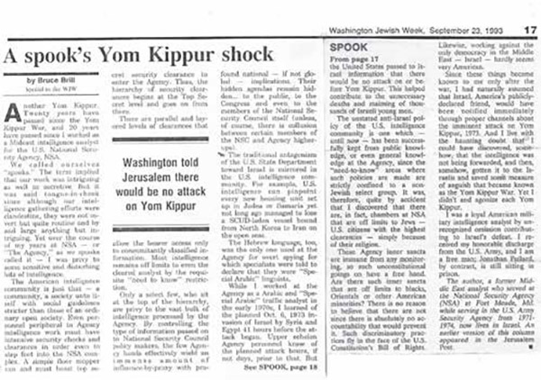
Figure 44: “A Spook’s Yom Shock” - The Washington Jewish Week
The difference between the earlier pieces and the one above is that my initial naïve, benefit-of-the-doubt assumption that US intelligence did pass the warning to the Israelis, but passed it too late, was updated with new information that the intelligence had not been forwarded.
46 Bruce Brill, “Revelations of a Former NSA Insider”, The Jewish Press, New York, December 25, 1992.
These publications began a de facto --albeit short-lived-- writing career.
Of course, my interest in discovering details about both the Pollard Affair and the Yom Kippur War Surprise was piqued. I began reading as much as I could about both. In archival material, I found an article by Nicholas M. Horrock in The New York Times from September 12, 1975, entitled “Signs of 1973 Mideast War Eluded U.S. Spy Agencies.” What?!? How could that be? It didn’t “elude” us; instead, it was the opposite. We had proof that this would happen, and we had it days in advance. Here’s what the article reported:
The New York Times, WASHINGTON Sept. 12th
The United States Intelligence Community acknowledges that it failed to predict the 1973 Arab-Israeli War and that several intelligence agencies even predicted that there would be no war only hours before the hostilities broke out according to a secret report made public today.

Press reports in the past …and the findings of an Israeli military review board had blamed Israeli intelligence services for inadequately evaluating information of the Arab build-up.
Today the House Select Committee on Intelligence made public parts of a “postmortem” prepared by the intelligence community on its handling of the Arab-Israeli conflict in October, 1973. The report disclosed that a top-level committee that met the day the Arab forces attacked Israel said, “We can find no hard evidence of a major, coordinated Egyptian-Syrian offensive across the canal and in the Golan Heights area.”
The report of the committee, which is charged with advising the National Security Council on war and critical situations, went on to note, “It is possible that the Egyptians or Syrians, particularly the latter, may have been preparing a raid or other small-scale action.” The committee met, its report said, at “0900 on 6 October, 1973,” which was a few hours before the attack.
In an intelligence summary dated the same day, but presumably prepared the night before, the Defense Intelligence Agency reported, “There are still no military or political indicators of Egyptian intentions or preparation to resume hostilities with Israel.”
A Central Intelligence Agency bulletin dated the day before the attack said of the Egyptians, “The exercise and alert activities [deletion] may be on a somewhat larger scale and more realistic than previous exercises, but they do not appear to be preparing for a military offensive against Israel.”
On the day of the attack the C.I.A. reported that another round of hostilities would almost certainly destroy President Anwar el-Sadat’s “painstaking efforts to invigorate the economy and would run counter to his current efforts to build a united Arab political front.”
The C.I.A. bulletin went on to contend that for the Syrian President, Hafetz al-Assad, “a military adventure now would be suicidal.”
The report on the intelligence assessment attributed failures to the analysis of the various agencies and not to a failure to collect intelligence.
“The information provided by those parts of the community responsible for the intelligence collection was sufficient to prompt a warning,” the report said. “Such information (derived from both human and technical sources) was not conclusive but was plentiful, ominous and often accurate.”
Maj. Gen. Howard P. Smith, an Air Force officer in charge of the Pentagon agency’s analytical section, said that three analysts had been transferred as a result of the failure.
The material from the secret report was made public after nearly two days of jousting between the Ford Administration, the intelligence community and the House committee. Part was read into the record by William Parmenter, chief of the C.I.A.’s office of current intelligence.
The report was made public in the third set of hearings conducted by the House committee in its examination of the efficiency of the intelligence community, which some estimate requires an expenditure of $6 billion a year.
The committee has sought first by letter and then by subpoena, materials given to Presidents Johnson and Nixon on four major recent crises, including the 1973 Arab-Israeli war, the 1968 Communist Tet offensive in South Vietnam, the Cyprus crises and the recent revolution in Portugal.
Representative Otis G. Pike, Democrat of Suffolk County and the committee chairman, complained today that the Administration had been unwilling or slow to respond to the committee’s requests.
The C.I.A. was prepared to make public part of the material that went to the committee today, but when Mr. Pike asked C.I.A. officials to read other portions they balked.
The committee met through the afternoon in closed session and finally voted, 6 to 3, to make public a half dozen of the intelligence evaluations noted in the postmortem. Most of the document remained secret.
Dr. Ray Cline, a former director of the State Department’s Intelligence Bureau and once a top official of C.I.A., testified before the committee today that the intelligence breakdown was in part a result of the resistance by Secretary of State Kissinger to conclusions made by the intelligence community. Moreover, Dr. Cline implied that Mr. Kissinger might not have kept the intelligence community fully informed of high-level information he might have received from the Soviet Union.
Dr. Cline, who is now with Georgetown University’s Center for Strategic and International Studies, said that the Soviet Union had been given advance warning of the war and had time to withdraw dependents of its advisers in Cairo. Under treaty clauses, he said, the Russians were obligated to consult with the United States on “threats to peace.”
“I do not know whether the Secretary of State received any tip-off from his close friend, Ambassador Dobrynin, or if he missed some informal signal of danger,” Dr. Cline said, referring to the Soviet Ambassador here, Anatoly F. Dobrynin.
Dr. Cline also said that it was difficult to get the conclusions of the intelligence community to the higher policy level. He said that his analysts at the State Department had concluded war imminent the night before the Arab attack and had wanted to give Mr. Kissinger a memorandum to that effect, but that Mr. Kissinger's aides did not want to trouble him in New York at that late hour - 8 or 9 PM. "The memorandum was sent by pouch the next morning, but hostilities has already begun," Dr. Cline said.
The State Department, in a statement issued tonight, said that if Dr. Cline had sought to reach Mr. Kissinger and failed to get through, he would have "a clear obligation" as director of the department's Intelligence Bureau to warn the director of the C.I.A., the Deputy Secretary of State or other high officials.
"There is no evidence," the spokesman said, "that Mr. Cline tried to reach any of these, any one of whom would have immediately relayed a message to the Secretary."47

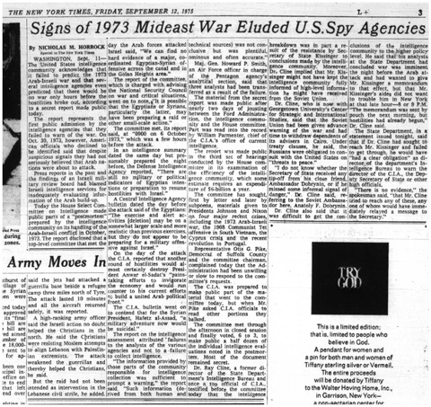
Figure 45: “Signs of 1973 Mideast War Eluded U.S. Spy Agencies”

47 Nicholas M. Horrock,“Signs of 1973 Mideast War Eluded U.S. Spy Agencies, The New York Times September 12, 1975.
This piece was an eye-opener for me. All I knew upon reading it was that it did not jibe at all with what I knew for a fact. We at NSA had definitely known, yet they told the congressional committee they had “failed to predict the 1973 Arab-Israeli War.” NSA was lying. This, in itself, was enough incentive for me to search out the truth. I felt obliged to set the record straight. At the time, I had no idea what the other agencies within the US intelligence community knew or didn’t know. According to the Pike Committee Report, they all claimed to have been taken by surprise.
This was an out-and-out lie. One sees in “I’ll Tell You Why” that the disingenuous testimony the US intelligence community gave the congressional committee was only the tip of the perfidious iceberg.
At the same time, I was asked by the Jewish Journal of South Florida to be a regular contributor to their weekly. I was also given certain deference on the opinion page of the Jerusalem Post. Between 1993 and 1998, several of my opinion pieces appeared there.
To see one’s name in print was rewarding; by contrast, the monetary reward was slim. One recalls the phrase “opinion is cheap.” The dozens of published pieces I wrote all came in the wake of my initial writing from passion about the Yom Kippur War…

THE PIKE COMMITTEE

The House Select Committee on Intelligence Report became known as the Pike Committee Report, named for the chairman of the committee, Otis G. Pike. Pike was the congressman of New York’s First Congressional District on easternmost Long Island. This district bordered my own congressional district. The name “Otis G. Pike” was more familiar to us than our own congressmen from that period. This was due to his contentious chairmanship of his namesake committee. The purpose of the Pike Committee was not to deal specifically with the US “intelligence failure” with respect to the Yom Kippur War,48 but mainly to investigate budgetary accountability of the American intelligence community49 :
• Where was the American taxpayers’ money going?
• How much money was being allotted?
• Were the taxpayers getting their money’s worth?
A similar investigative committee in the United States Senate was trying to get answers to these very questions. It was headed by Senator Frank Church. The overlap of their investigations was broad, and they shared one other important thing in common: they got no clear answers to any of their questions.
48 Gerald K. Haines, “The Pike Committee Investigations and the C.I.A,” Studies in Intelligence, Winter (1998-1999)
49 Ibid, 7-10
The two congressional committees were being stonewalled and sidestepped by every representative of the intelligence community they interviewed. The most the committees were able to glean from the scarcity of facts they were able to obtain was that NSA was the major recipient of funds. At least ten billion dollars of taxpayers’ money was allocated to intelligence, and the taxpayer was not getting much bang for their buck. Several cases showed that US intelligence failures seemed to be the rule rather than the exception:
• 1968 Tet Offensive in Vietnam
• August 1968 Warsaw Pact invasion of Czechoslovakia
• October 1973 Yom Kippur War
• April 1974 coup in Portugal
• May 1974 Indian nuclear explosion
• July 1974 coup against the Makarios government in Cyprus
Although the committee dealt with the budget most of the time,50 they also dealt with the intelligence community chiefs’ reluctance to share information with the investigators. The most common excuses the chiefs gave was that committee members lacked the proper security clearances. In-depth discussions then centered on the need for clearances beyond top secret. This led to disclosures about the immense compartmentalization within the intelligence community, especially the humongous and unwieldy NSA. American intelligence chiefs testified before Congress that none of their agencies had predicted the Arab attack on Israel on October 6, 1973.
Many concluded the Pike Committee failed because its recommendations were so limited and served to strengthen the CIA’s and the other agencies’ untouchability. To evaluate the committee’s work, one must examine it along with the other investigative bodies: the Senate investigating committee under Frank Church and the White House’s Rockefeller Commission. Both of these groups, and President Ford as well in his “reforms” of February 18, 1976, concentrated quite naturally on the same areas as the Pike Committee: increasing congressional oversight; improving the quality of intelligence, the management of intelligence agencies, and their budgets; andpreventing future abuses. To expect more, like complete abolition of covert operations or prohibiting CIA support of foreign clandestine intelligence services that torture and murder, was unrealistic.51 After all, the CIA and the other services existed to protect the government, of which the investigators were a part.
Despite all the limitations of the reform exercise, the work of the Pike Committee and the other investigative bodies is a positive chapter in American history. Who would have dreamed that two years before the inquiries, such a great volume of information on secret American intervention in foreign countries would ever be made public? Who would have dreamed the vast, illegal domestic operations of the CIA, FBI, and NSA would be revealed in such detail?52 The information that emerged could now be used to protect against abuses in the future. Details of CIA operations were omitted almost entirely, but knowledge of secret intervention had improved somewhat, thanks to the investigations.
Of equal importance was the strengthening of the best popular traditions in the United States: the freer flow of information, streamlining government bureaucracy, and exposure of government secrecy and cover-ups. Americans learned how integral corruption and hypocrisy were to the way the current system operated. Abolition of illegal covert operations, which fly in the face of the country’s expressed principles, should be a given. Should clandestine cells that work against an American ally exist within the intel community? The Pike and Church Committees fell short of asking that question.

50 Ibid.
51 Ibid, pp. 13-14.
52 Ibid.

HE HAD TO LIE

I’LL TELL YOU WHY
Dr. Ray Cline was under oath to tell the truth, so help him God, when he testified before the Pike Committee in 1975. He had been head of the Bureau of Intelligence and Research (INR) in the lead-up to the Yom Kippur War. Dr. Cline testified that US intelligence did not know about the planned Arab attack against Israel, blaming the Israelis: “Our difficulty was partly that we were brainwashed by the Israelis, who brainwashed themselves.” That US intelligence needed to rely on Israeli intelligence is absurd,53 yet the Pike Committee bought this weak and contorted explanation.
Cline’s explanation of how the US intelligence community failed to predict the Arab surprise attack against Israel is based on The Performance of the Intelligence Community Before the Arab-Israeli War of October 1973: A Preliminary Post-Mortem Report.54 This report was published by the director of Central Intelligence on December 20, 1973, after it was reviewed by the United States Intelligence Board. The report was top secret and only released to the public 35 years later in March 2008.55 Even after its declassification and release, significant sections are redacted. The revealed sections prevent the release of any means, sources, or details that might compromise American security. So why the inordinately long time before its release?
The report apparently had limited distribution even within the intelligence community. I never saw this report when I worked in G-6, the NSA section dealing with the Middle East. I never even knew such a report had been written. To my knowledge, none of my colleagues in G-6 had heard of such a report. Had such a report admitting intelligence failure unrestrictedly circulated within the Arabic Section, there would have been a hue and cry since there had been no failure. We had predicted the Arab onslaught and pinpointed the day it would happen in advance. So, for whom was this report written?
53 See: “America versus Israel” in this book, supra.

54 Director of Central Intelligence, The Performance of the Intelligence Community before the Arab- Israeli War of October 1973: A Preliminary Post-mortem Report, (December 1973), http://www/.cia.gov/readingroom/docs/DOC_0001331429.pdf.
55 Dr. William Burr, personal communication, 2020.
Brainwashing has two elements: the passive party, or the brainwashed, and the active party, the brainwasher. Cline used the term to imply the Israelis brainwashed the US intel community. What Cline failed to disclose is that US intel first brainwashed the Israelis. “The Israelis” were DMI Eli Zeira and his Research Section/Egyptian Desk Chief Yona Bandman. “US intel” were those American intelligence officers with whom Zeira and Bandman were in contact. This point is central: in a rare moment of candor (see “Moment of Truth”), Zeira told me he had been convinced by the American intelligence generals he’d been in contact with that the Arabs would not attack.56 Cline simply got the direction of the brainwashing backwards. It was Zeira who was brainwashed by his American friends. When the Americans asked Zeira what his understanding was of Arab intentions just before October 6, this was, in my opinion, to confirm his brainwashing had been successful. To repeat, Cline presented this segment of the intelligence exchange between Israel and the US thus:
56 See: “Moment of Truth”, Supra.
We were brainwashed by the Israelis [outright lie] who brainwashed themselves

A more truthful rendition would be:
We helped to brainwash the Israelis.
The “we” in that statement needs further definition. The “we” would not have been those of us in the intelligence community who knew the Arabs’ true intentions. Rather, the “we” would have referred to those in the security groups who depended on NSA assessments for their understanding:
• Henry Kissinger. On or around October 23, Kissinger gave his State Department senior staff his assessment of the situation, based on the immediate pre-war intelligence estimation: no possibility of an attack.
• Brent Scowcroft. A document from Scowcroft to Kissinger, dated October 5, 1973, stated that neither Israeli nor US intelligence recognized the imminence of war in early October 1973.
• William Quandt. In an October 6 document entitled “Arab-Israeli Tensions,” NSC staffer William Quandt “downplay[ed] the likelihood of an Arab attack on Israel.”
• Dr. Ray Cline. As noted previously, Cline observed, “Our difficulty was partly that we were brainwashed by the Israelis, who brainwashed themselves.”
The next question that should be asked is, did Cline misstate the brainwashing direction innocently or knowingly? If he had no other indications of Arab aggression, then his testimony before Congress was an innocent error. But there were several:
• We knew in G-6 at NSA. How could the head of INR not have known?
• INR analyst Roger Merrick produced a prescient report in May stating the chance of Sadat attacking Israel by autumn of that year was likely.
• The withdrawal of Soviet advisors’ families on October 4, 1973, a sure sign large-scale military action was imminent. This was known to American intelligence.
• Dr. Ray Cline was recipient number one of the CIA report Complete Deployment of Syrian Units for Assault Upon Israel, which stated clearly the CIA knew the battle plan in detail.
The next question - the big one - is why? Why falsely admit to a failure? Such an admission gives credence to your testimony. That’s a benefit, not a reason. What benefit? First, the minor bureaucratic benefit is to use the failure to petition the government for a bigger budget for increased resources.
The second reason is the point of this treatise. If certain cells within the US intelligence community intended to harm Israel by duping her into complacency by withholding vital intelligence, then this plan must be hidden by the culprits. If discovered, the perpetrators would be held accountable and prosecuted for deceiving an ally. It would be a violation of public trust. Under the Nuremberg Judgments, it could be considered a crime against humanity. But if it could be concealed by pleading ignorance, then they could get off scot-free. Now one can also see why:
• The post-mortem report was kept secret, and its distribution was restricted.
• There was a myriad of protestations of ignorance, either because those pleading had bought into the assessments of ignorance or they were in cahoots with or part of the criminal cabal.
• It took years for Dr. Burr to locate and arrange the release of Merrick’s INR report.
• The September 29, 1973 CIA report, Complete Deployment of Syrian Units for Assault upon Israel, was not shared at all with the Pike or Church Committees in 1975, hardly mentioned within the community, and not declassified for 39 years.
• The wording of the recipients’ list of the states, “TO STATE [U.S. State Department]: NO DISTRIBUTION EXCEPT TO DR. CLINE.” This restriction was to keep its distribution very narrow: to only one man, the same man who lied to Congress.
The Performance of the Intelligence Community Before the Arab-Israeli War of October 1973: A Preliminary Post-Mortem Report can be viewed at the National Security Archive website.57
It was a whitewash. It did not point accusing fingers at particular individuals or even specific departments, yet it did place general blame on the analytic sections and basically forgave the collection services of any wrongdoing. In addition, while exonerating the data collectors, the report recommended “increasing resources.”
Since the post-mortem openly admitted failure to predict the Arab aggression, it seemed legitimate. There was no reason to suspect otherwise. Why would a government bureau be self-critical otherwise? As noted above, if the truth (that U.S. intelligence knew of Arab intentions to invade) were told, the question would be asked: Why weren’t the Israelis informed? Who was responsible for withholding such vital intelligence from a friend? It was a massive and successful cover-up.
Summaries of intelligence information somehow relevant to our work at the Agency were circulated daily. Those of us who could have blown the proverbial whistle were unaware of the post-mortem report. To my knowledge, not even a summary was circulated at the Agency. Had one been, it would have raised eyebrows in G6 and been a call to action for analysts like myself who knew it was false.

57 https://nsarchive2.gwu.edu/NSAEBB/NSAEBB276/doc04.pdf.
Within the post-mortem, passing mention is made of the May 1973 INR report by Roger Merrick.58 This prescient memorandum predicted that the chances of Egypt launching hostile action against Israel by autumn were “better than even.” It was slated to be declassified in 2002 but, inexplicably, it was not. Subsequently, it (conveniently?) went missing. Only after great efforts by Dr. William Burr of the National Security Archives was a copy located, after 15 years of what Burr calls “hide and seek.” Burr finally acquired the document in 2013.
While the Merrick Report was released to the public in 2013, it existed in the State Department’s INR before the Yom Kippur War. It also existed when the post-mortem was written in December 1973 and during the Pike and Church Committee Hearings in 1975. The head of INR, Ray Cline, was privy to the document. He breathed not a word about it when he falsely testified before Congress that the Community failed to predict Arab aggression against Israel. Not a word.
Let us examine the redacted secret CIA document “Complete Deployment of Syrian Units for Assault upon Israel” from September 29, 1973 [below], declassified in 2012. The report states clearly the CIA knew the battle plan in detail, and then some. According to the report, the assault would be launched along an 80-kilometer-wide front on the Golan Heights, with the aim of occupying the Heights up to the pre-June 1967 border. The attack was not to begin until all units were in place. Three infantry divisions were already in place on September 29. As the document states, “Brigade commanders have the operations order now and are briefing battalion commanders at their headquarters in secrecy. Missiles and anti-aircraft units are deployed close to the front lines to support the attack at zero hour.”59
It is crystal clear the stationing was an attack deployment. There is no basis to claims that Syrian military positioning on the Israeli border was purely defensive.
58 William Burr (ed.), State Department Intelligence and Research Predicted 1973 Arab-Israeli War, National Security Archive, https://nsarchive2.gwu.edu/NSAEBB/NSAEBB415/.
59 CIA report “Complete Deployment of Syrian Units for Assault Upon Israel” September 29, 1973.
<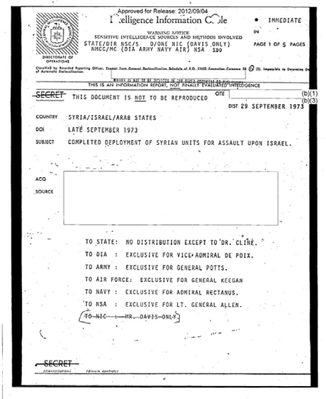
Figure 43A: CIA’s “Complete Deployment of Syrian Units for Assault upon Israel” - Page 1

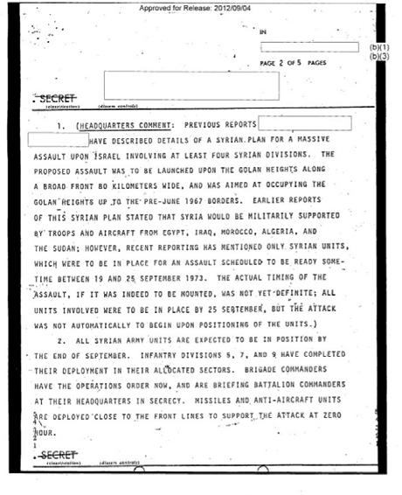
Figure 43B: CIA’s “Complete Deployment of Syrian Units for Assault upon Israel” - Page 2.

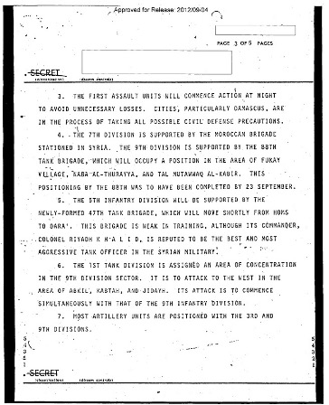
Figure 43C: CIA’s “Complete Deployment of Syrian Units for Assault upon Israel” - Page 3.

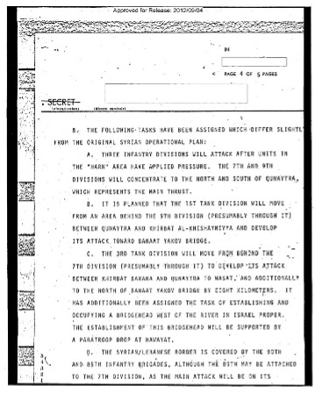
Figure 43D: CIA’s “Complete Deployment of Syrian Units for Assault upon Israel” - Page 4.

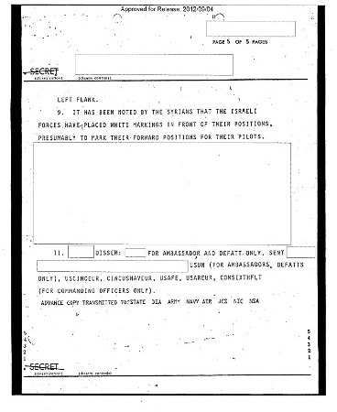
Figure 43E: CIA’s “Complete Deployment of Syrian Units for Assault upon Israel” - Page 5.
Cline lied, and we know why.
To dispel any notion that might remain that Cline was just a neutral American public servant with no desire to harm America’s ally Israel, let us end with a reference from Doron Geller’s Israeli Intelligence and the Yom Kippur War of 1973:
… the Rogers Plan … called for a freeze of Egyptian and Israeli deployments as of August 7, 1970. The Egyptians broke that part of the agreement the next day, moving their Soviet anti-aircraft batteries close to the banks of the Suez Canal. The Soviets and Egyptians gambled that Israel would not respond so soon after the cease-fire went into effect - and they were right. Israel did nothing. This would have telling effect three years later, when Egyptian anti-aircraft batteries along the Suez Canal pounded the IAF in the first days of the October 1973 War. At the time, in the summer of 1970, however, when “Israel complained to Washington that the Egyptians had breached the agreement, Ray Cline, the head of the State Department intelligence unit… told the White House that the Israeli complaint was baseless. When Israeli Ambassador Yitzhak Rabin told his military attaché, General Eli Zeira, what had happened, Zeira immediately asked Tel Aviv to send him a photographic interpreter and a set of aerial photographs showing the Egyptian deployment. These duly arrived in Washington and Zeira was summoned to the White House, where he laid out the evidence before President Nixon. Nixon, angry with Cline, then ordered the Pentagon to remove its veto on several categories of weapons the Israelis had asked for during the preceding months.

60 href="http://www.jewishvirtuallibrary.org/intelligence-during-the-six-day-war-1967" id="id-0-6086">-1967. (emphasis added by author).

MAKING SENSE FROM NONSENSE
THE BOTTLENECK
I had no idea how Israel fell prey to the surprise attack, neither at the moment the Yom Kippur War began nor half a year later, just before my honorable Army discharge. In subsequent years, I continued to agonize over the tragedy of the Yom Kippur Surprise. I was tormented by it, especially each year around Yom Kippur. I dwelt on the lead-up and the unanswered question, “How?” How did the Israelis allow themselves to fall prey to the deception? I read, learned, questioned, probed, and tried to make sense out of what seemed inexplicable
The questions I asked myself most were: What did the Israelis know? What didn’t they know? If they knew, why didn’t they act? Why didn’t they preempt the attack? Why didn’t they do something? Why did they do almost nothing? Was this a conscious decision, or were they caught by surprise?
From my live monitoring on the first day of the war, I knew they had been caught by surprise. Could I have done something to stop their being caught with their pants down? Could I have somehow prevented the full agony the Israelis suffered? This last question is the easiest to answer, and that answer is an emphatic “no.” This is not just because it wasn’t my job and doing so could have been illegal. How might I have informed the Israelis at the Israeli Embassy in Washington and been believed? “Hi. I’m Joe Blow and your country is going to be invaded in two days.” The most that could have been expected by whoever answered my telephone call might have been a polite brush-off.
“Very low probability” was the assessment that Israeli Director of Military Intelligence Eli Zeira passed on to Israel’s leaders of the likelihood of an Arab attack on or before October 6, 1973. How General Zeira came to this faulty conclusion is a major question that Israel’s Agranat Commission tried to answer. In the findings they released to the public, the answers to how and why the faulty conclusions were reached are not disclosed. Whether those parts of the report still undisclosed could answer that question is doubtful: according to Professor Yaakov Hisdai, who was an Agranat Commission investigator, the investigation did not probe American intelligence influence.61 The Israeli public has agonized over this conundrum since the time of theYom Kippur Surprise.

61 Prof. Yaakov Hisdai, Jerusalem, personal communication, 2021.
I, too, have agonized over this and tried to find the answers. Now the picture, which I will share on the pages of this book, is finally clear.
One of the keys to unlocking the mystery is that Eli Zeira was the distinguished, convincing, and highly respected bottleneck through which intelligence assessments were passed on to Israel’s leaders. Even the head of Israel’s renowned Mossad at the time, Zvi Zamir, deferred to General Zeira’s commanding presence.62
On Wednesday, three days before the outbreak of hostilities, the General Staff accepted Zeira’s assessment and stated, “It seems that the enemy is just carrying out a war of nerves, like twice before this year in January and in May.” Egypt was simply conducting “large-scale military maneuvers,” and Syria was only expressing nervousness.
Finally, one other non-prejudicial piece of intelligence could have helped the decision makers assess the worrisome situation more carefully. “Special measures” could have and should have been employed. Most researchers believe the as yet undisclosed special measures involved wire-tapping Egypt’s leaders’ phone lines. No army can be put into motion without orders from headquarters. The Egyptians were savvy enough to know wireless communication was vulnerable to Israeli intelligence interception. To maintain security, Egypt was obliged to restrict communication to landline telephones. Were the Israelis to have tapped into this medium by activating the special measures, they would have certainly discovered Egypt’s true intentions.
This, of course, was clear to Israel’s defense minister and CofS, and herein lies the rub. Zeira told them special measures had been employed and yielded no warning signs. Military experts have doubted this. Despite General Zeira’s claim that the special measures were employed, redacted sections of the Agranat Commission’s report released in May 2020 suggest that they were not activated. Perhaps it could be claimed that General Zeira did activate some special measures, but it was too little, too late. And even if there is some truth to this, why, then, did Zeira mislead the Security Cabinet into thinking the special measures were employed in full? The still-secret portions of the Agranat report might answer that question.
The Agranat Commission was appointed by the Knesset on November 21, 1973, to investigate the military’s failure in the Yom Kippur War. It was composed of a team of experts:
• President of Israel’s High Court of Appeals, Dr. Shimon Agranat, commission head.
• High Court of Appeals Justice Moshe Landau.
• State Comptroller Dr. Yitzhak Nebenzahl.
• Lt. General, Reserves, Prof. Yigael Yadin.
• IDF Ombudsman, Lt. General, Reserves, Chaim Laskov.
62 Prof. Zeev Drori, Neve Geranot, Jerusalem, personal communication, 2018.
It was to investigate two basic elements:
The information, in the days preceding the Yom Kippur War, concerning the enemy’s moves and its intentions to open war, as well as the assessments and the decisions of the duly authorized military and civilian bodies with regard to the aforementioned information;
The Israel Defense Forces’ deployment for the battle in general, its preparedness in the days preceding the Yom Kippur War and its action up to the containment of the enemy.
This commission decided:
• The opening of the war by Egypt and Syria on Yom Kippur, October 6, 1973, at approximately 14:00 hours, took the IDF by surprise. Until the early morning hours of that day, the IDF’s Supreme Command and the political leadership did not realize total war was about to commence.
• In light of his serious failure, Director of Military Intelligence Major-General Eliyahu Zeira could no longer continue to serve in his position.
PSYCHOLOGICAL PERFECT STORM
The Yom Kippur Surprise tragedy in Hebrew is HaMechdal, which can also be translated as “Negligence,” “Mishap, “Flub,” “Screw-up,” or “Intelligence Failure.” Most blame Israel getting caught with her pants down on DMI Major General Eli Zeira. In his book, Myths and Reality, he acknowledged his responsibility thusly:
The Chief of Staff must decide, and his decisions must be clear. The best aid the head of Military Intelligence can give to the CofS, as far as it is objectively possible, is to give him as clear and as sharp an assessment as possible. It is true that the clearer and sharper the assessment is, if it is mistaken, the clearer and sharper the mistake is; but this is entirely the responsibility of the head of Military Intelligence.63 [author's translation from the Hebrew]
His book is a defense of his own part in the failure.
According to Israeli military analyst Professor Uri bar Yosef, Zeira’s understanding may have been acceptable on the battlefield, where he had served up to the time he assumed the position of chief of Israeli MI in 1972. But such an understanding can be totally misguided and have dire consequences on the national level, where all possibilities must be presented, heard, and considered to reach appropriate and prudent decisions.
The previous Israeli DMI, Aharon Yariv, had a close relationship with Zvi Zamir, the head of the Mossad (Israel’s equivalent to America’s CIA). Zeira, however, had a cold and distant relationship with Zamir. Yariv had shared raw intelligence on an informal and almost daily basis with Israel’s CofS. Zeira, by contrast, maintained infrequent and formal contacts with the CofS. Zeira also snuffed out the direct contacts between his immediate underlings and the three decision makers of the Security Cabinet: the CofS, the minister of defense, and the prime minister. He acted as a filter and chose to relay to the members of the Security Cabinet his own “clear and sharp assessments.” Bar Yosef maintains that intelligence is neither totally black nor totally white but multiple shades of gray. None of these shades of gray were delivered to Israel’s decision makers by Zeira or those immediately under him. Only Zeira’s all-black or all-white assessments reached their ears. This more rigid and formal “American style,” rather than the typical Israeli practice, I believe, was due to Zeira’s multiple official military assignments in the States, his concomitant long stays in the US, and his infatuation with American Army practices.
Zeira’s sharp assessment reports became standardized in the year he was DMI. This practice was reinforced after Zeira’s spring “victory” when Israel’s leaders put the IDF on alert and mobilized the reserves in May 1973 while Zeira tried to allay their fears of an enemy attack. He proved correct in his assessment that there would be no attack. He was right, and all the others were wrong. A similar situation happened earlier that year, in January, when Zeira’s assessment was to discount any perceived threat.64
By the fall of 1973, Zeira began to see a secondary purpose to his job: to quell anxiety among the public and the decision makers.65
In October, Zeira saw Egyptian and Syrian mobilizations as a “repeat performance.” According to bar Yosef, Zeira created a situation where the responsibility of the intelligence supplier, AMAN, and the intelligence consumers, namely Israel’s Security Cabinet, was becoming clouded. Zeira created assessments that were his own understandings rather than simple summaries of the raw intelligence. His massaged assessments forced the hands of the decision makers. According to bar Yosef, Zeira went so far as to ignore and even suppress any intelligence that ran counter to his own assessments.66
In the days leading up to the Yom Kippur Surprise, there were numerous instances in which Zeira forwarded these opinions rather than raw intelligence summaries. Despite clear intelligence signals that something was afoot, he reported that it “does not mean they are really preparing for war. Egypt is merely holding large-scale military maneuvers, while, in the case of Syria, their military command is nervous. In the wake of the air battle on September 13, they may want to provoke local battles and artillery duels. There is no need to mobilize. Nothing will come of the whole thing!”
63 Eli Zeira, The Yom Kippur War: Myth verses Reality, Yediot Sefarim Press,2004.

64 Uri Bar Joseph, The Watchman Fell Asleep (Albany SUNY Press, 2005).
65 Uri Bar Joseph, The War of Yom Kippur and Its Lessons“The Interaction between Intelligence Officers and Policymakers prior to the 1973 war," (Tel Aviv: Israel Ministry of Defense, 2004), 28-36.

66 Ibid.
This is commentary, not raw intelligence. Every aspect of his assessment is opinion:

• “Does not mean.” Here he is giving his interpretation of “what it means.”
• “Merely holding… maneuvers.” He is dismissing the possibility of preparing for an attack.
• “They might want to.” He’s assuming what is in the enemy’s mind.
• “There is no need to mobilize.” Here he is making a decision, not doing his job!
• “Nothing will come of the whole thing.” Again, this is his opinion, not intelligence.
This type of assessment, namely commentary, became common practice.
PORTENTS APLENTY
Israel had plenty of intelligence suggesting an attack was not only pending, but imminent.
Lieutenant Colonel Shabtai Brill pioneered drone overflights west of the Suez Canal in 1969. Although his drone project was discontinued prior to the outbreak of the Yom Kippur War, he still reported there were clear signs of Egypt’s intention to attack days before the onslaught. Shabtai told me, “AMAN had no shortage of clear signs.”67 (Although Zeira ignored Brill’s warnings, he does credit Brill as the only intelligence officer who didn’t passively accept Zeira’s automatic dismissal of such warnings.) General Rechavam Ze’evi told me of hundreds of intelligence points that CofS Elazar had received showing that an attack was imminent.68 Historian Abraham Rabinovich lists 11 clear signs that an attack was about to happen.69
General Hofi on the Golan had reported concentrations of Syrian forces and armaments along the cease-fire line. He was told to “relax” by none other than Israel’s MI director. The Syrians had just set up some of the recently supplied SAM anti-aircraft missile batteries right next to the cease-fire line on the Golan. Network Intelligence Officer Shmulik Fefferman, who was monitoring Syrian military communications, there were clear signs the Syrians were planning an imminent attack:70
• Syrian units which had advanced to near the front line with Israel for training exercises were not withdrawn to their home base.
• Unit “47” was moved to the front.
• Anti-tank-trench bridging equipment was moved to the front line.
Israeli military high command received reports of unusual concentrations of Egyptian forces nearing the canal as early as October 1.

67 Shabtai Brill, personal communication, 2020.
68 Rechavam Ze’evi, private communication, early 1992.
69 Abraham Rabinovich, The Yom Kippur War (New York: Shocken Books, 2007), 65-83.
70 https://youtu.be/mPjucvhObog
On October 2, Captain Moti Ashkenazi in the Northern Bar Lev stronghold called Budapest to inform his headquarters that his soldiers had seen trench mortars being set up on the Egyptian side of the Suez Canal. Ashkenazi was castigated by his superiors for bothering them. The following day, Ashkenazi reported that his men had noticed Egyptians covering armaments with camouflage netting. This, too, was ignored, and he was called a nuisance. The next evening, the Israelis on the ground noticed strange goings-on: numerous Egyptian army trucks were arriving at night with their headlights turned off. Later that Thursday night, the Israelis heard the rumble of tanks approaching the canal. Finally, on Friday, Ashkenazi reported directly to a visiting superior, “For days, we have been continuously reporting to headquarters what the Egyptians are doing and that the situation looks serious. Headquarters has been ignoring our reports.” Similar warnings were reported from other positions along the Bar Lev line. All these reports were ignored.
Even armored commander General Avraham Mendler, who was outside the Israeli intelligence bubble, had been looking over staging areas along the cease-fire lines. He suspected something was afoot. Days before the outbreak of hostilities, he said that his promotion ceremony, scheduled for Sunday, October 7, might be postponed because of a suspected Egyptian attack.
One of the clearest signs of an attack was the evacuation of Soviet military advisors’ families that Thursday, October 4, from Syria and Egypt. At that point, one would think, there could have been no doubt.
Days in advance, Israelis along the canal noticed bridge-building tanks had been brought to the banks. Advanced Soviet-supplied SAM missile batteries were moved up to the Golan cease-fire lines. All this was known within AMAN, yet Eli Zeira chose to ignore these signs. Also, on October 5, General Arik Sharon concluded, “There will be war.” That same day, when General David Elazar showed General Rechavam Ze’evi hundreds of intelligence points, General Ze’evi reached a stronger conclusion: “War is imminent.”
Besides the 20-20 hindsight, a recently declassified intelligence summary shows there were already clear signs on September 30 that Egyptian forces were moving toward the Suez Canal at that time:
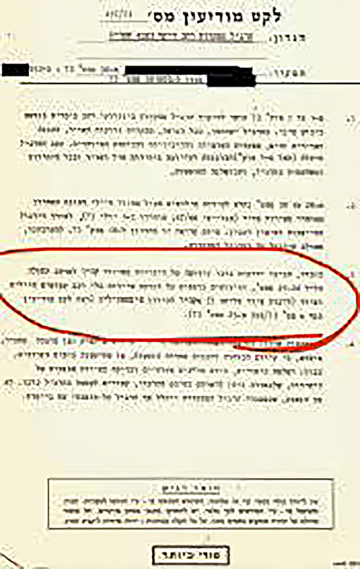
Figure 44: September 30, 1973, Israeli intelligence summary.
Translation: As will be recalled, there were reports of a division advancing from the Cairo area to the canal area on the night of September 24-25 and additional reports of convoy traffic of vehicles laden with soldiers and equipment (including bridging equipment?) from Cairo toward Ismailia (see Intelligence Summary 6 No. 256/73 from 25 Sept. 73).
Another AMAN report from October 1, 1973:
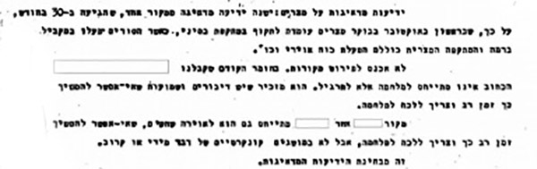
Figure 45: October 1973 AMAN report.
The report from an unnamed “good Egyptian source” speaks of worrisome intelligence received the day before that Egyptian and Syrian forces would stage an attack against Israel in the coming days. But another source in the report, expunged in the redacted document, dismissed the disquieting report of imminent attack, saying the movements were most likely military exercises.
I would not be surprised if the appraisal’s second source were Israel’s “foreign friend,” namely the United States. (Yet a third source maintains Egypt and Syria would not refrain from military action against Israel for long.)
Arie Shiloh reports in his book that the dismissive source is given precedence over the “good” Egyptian source, though it had given bad intelligence in the past. The unnamed “good” Egyptian source reported again on October 2 and 4 of preparations for an imminent attack.
A top-secret Mossad report confirms the above:
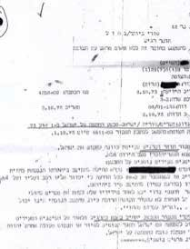
Figure 45A: October 2, 1973, top-secret Mossad report.
It states the Egyptian Army’s maneuvers would begin as a military exercise and then turn into a full-fledged attack.
Even before these recently declassified documents were made public, Yom Kippur War author Abraham Rabinowitz wrote “all the cries of alarm going up around them” were ignored by Israel’s intelligence chiefs. All the dire signs were shared with the Israeli Cabinet on Friday, October 5. They also learned of the bridge-building tanks brought to the banks of the Suez Canal. They were made aware of advanced Soviet-supplied SAM missile batteries brought forward to the Golan cease-fire lines. They learned of the evacuation of Soviet military advisors’ families that Thursday, October 4. Yet Ministers Peres, Bar-Lev, Hazani, and Hillel went home on October 5 for the holiday weekend… with AMAN’s sedative assessment that although war was possible, its probability was “very low.” Zeira was the filter and bottleneck through which AMAN’s intelligence assessments were passed to the higher-ups, particularly Dayan, Elazar, and Meir.
If ample intelligence indicated an attack was possible, why weren’t the special measures fully activated? Why was Zeira so convinced the situation was not critical at this most critical moment? Most observers mistakenly attribute Zeira’s dismissal of the plentiful disturbing signs to his marriage to “The Concept”…71

71 The Hebrew "conceptsia" is generally (mis)translated into English as “The Concept,” A more correct translation would be “mindset.” Having here given the correct meaning, we will continue, to use the conventional (mis)translation.

PLENTIFUL PORTENTS VS. THE CONCEPT
Most everyone attributes the fact that “cries of alarm” were ignored to the belief that Arabs wouldn’t dare attack Israel. This belief was held by all segments of Israeli society, including political and military leaders and most MI higher-ups. It was so universally accepted that it even had a name: “The Concept.”
Eli Zeira was not ignorant of intelligence indicators; he was ignoring them. Ignorance is usually understood to mean the lack of knowledge, but it can also mean the act or state of ignoring. “Ignoring” is the state or act of not paying attention; “ignorance” is a simple lack of knowledge. They are interrelated, as explained in Wikipedia:
Ignorance is a lack of knowledge and information. The word “ignorant” is an adjective that describes a person in the state of being unaware, and can describe individuals who deliberately ignore or disregard important information or facts, or individuals who are unaware of important information or facts…
There are reasons for ignorance. People do not experience instant gratification and therefore they do not invest time and effort in learning and developing. Eradicating ignorance completely from an individual’s life is an impossible task but reducing the gap can truly benefit the individual in the long run.
Also, making the decision to remain ignorant by committing to an ideology despite scientific, extensive, reliable proof is a dangerous mindset that can inhibit an individual from discovering the truth.
Ignorance can stifle learning, especially if the ignorant person believes they are not ignorant. A person who falsely believes they are knowledgeable, does not try to clarify their beliefs but rather relies on the ignorant position. Many may also reject valid but contrary information, neither realizing its importance nor understanding it.72

72 https://en.wikipedia.org/wiki/Ignorance.
Israel’s military intelligence chose to ignore all the worrisome signs. None of AMAN’s and Israel’s political and military elites believed the Arabs would dare attack Israel.
Former Knesset Member Dr. Einat Wilf wrote:
My perspective is that Sadat himself could have called Golda to tell her he is going to war and it would not have made a difference. The war was so devastating that many people look at history with that knowledge, rather than with the perspective of those living at that time.
After 1967 Israel’s assessment of Arab armies was one of open disdain. The view was that even if there would be war, it would be a walk in park for Israel - so even once there were greater indications of imminent war, there was a sense that Israel has a wide room to maneuver, including responding to American pressure not to take the kind of pre-emptive steps taken in 1967.73
Professor Yosef ben Ari goes into a deep sociological and psychological analysis of how the entire Israeli public succeeded in hoodwinking itself. He analyzes eight elements of Israeli society, including social, academic, intellectual, political, military, and intelligence. All these segments fed on one another until they managed to dupe themselves. This supposition, that the Arabs wouldn’t dare attack Israel, Professor ben Ari points out, came to be known as the Concept.
Paper after paper has been written on the Concept. This is where general interest has been focused. But is this the reason Eli Zeira stood fast in his “very low” estimation in the face of overwhelming evidence something was afoot?
73 Personal email communication, 2019.
DEATH OF THE CONCEPT

The idea that the Arabs would not dare attack Israel, the Concept, had held sway in the half-dozen years leading up to September 25, 1973, a week and a half before that fateful day, October 6. The Concept was the assessment of AMAN, not the infamous MOSSAD. It was AMAN’s responsibility to formulate what was called the "national intelligence estimate." This assessment was used both for the IDF General Staff and Israel’s Cabinet.
The Concept was based on the theory that the Arabs, realizing they had no chance against the image of invincibility Israel had created in the 1967 Six-Day War, wouldn’t dare launch an attack against Israel at that time. In 1967, Israel beat three bordering Arab nations: Jordan, Syria, and Egypt. At that time, Israel did not have the advantage of strategic depth that they had in 1973. Another tactical reason for AMAN’s “low probability” assessment of Arabs initiating hostilities against Israel was that the Soviets hadn’t delivered Scud missiles, which the Israelis believed Sadat saw as a prerequisite to launch a war against Israel.
Add to this the fact that AMAN’s head, Zeira, had stood his ground of “low probability” when there was a military build-up in the spring that scared most of the country’s military experts, including Israel’s CofS David Elazar. And Zeira was proven right. Now, in October of 1973, it seemed like a repeat performance of May’s false alarm. In fact, when Professor Ze’ev Drori asked Zvi Zamir, Mossad’s head, why he didn’t “turn over the table”74 at the critical Security Cabinet meeting on Friday, October 5, Zamir admitted he was - very regretfully - not only intimidated by Zeira’s power of persuasion and commanding presence, but that Ziera had been proven right in January and again in May of 1973. Zeira’s self-assuredness was reflected in his saying the probability of the Arabs attacking was not just “low” but “very low.”
To determine whether the cause of the failure was either the Concept or the soothing intelligence Zeira was getting from his foreign friends, one further event should be considered. On September 25 King Hussein had met Golda and warned her Sadat was NOT waiting for the Soviet delivery of the long-awaited Scuds as a prerequisite to launch an attack. He was planning to open full-scale hostilities. Hussein's visit was a sure and potent antidote against conceptitis the haughty belief the Arabs would not wage war.
74 An Israeli expression meaning “to make a scene.”
After Hussein’s visit, Golda Meir and Eli Zeira now knew the Concept was dead and were cured of conceptitis. The others might still have been suffering from it, which would certainly explain their acceptance of Zeira’s low-probability assessment.
Of course, there was a certain amount of inertia at play: since the Concept had been in force for the past half-dozen years, it had a life of its own despite the fact that Hussein’s warning signaled its death knell. But Israel’s military leaders, whose purpose was to guarantee the lives and well-being of Israel’s citizenry, should have been focusing on worst-case scenarios and taking all the clear and present warnings of danger seriously. These leaders include the head of AMAN, but more than merely being “included,” AMAN’s head should have been taking these warnings more seriously than anyone else. It was his responsibility, more than any single individual, to not take such warnings lightly, yet he dismissed them with certitude. From where did this certitude come?
As Zero Hour approached, it became clearer and clearer an attack was soon to come. Yet at the critical Cabinet meeting in the early afternoon of October 6, Zeira continued chanting his “very low probability” song until suddenly, at two o’clock in the afternoon, the musical accompaniment of air raid sirens sounded throughout the country.
What, then, besides the Concept, was responsible for AMAN’s - read: “Zeira’s” - delusion? If Zeira’s certainty was based on something besides the long-held Concept, it obviously had to be those foreign friends. Only one person could confirm that: General Eli Zeira.

ZEIRA’S MISTAKES

General Eli Zeira doesn’t often speak in public. In one exceptional instance, though, he appeared in a Tel Aviv University’s Institute for National Security Studies Webcast on October 20, 2013. The event was entitled “40 Years since the Yom Kippur War.”
The usually taciturn officer spoke at great length about his mistakes in the lead-up to the Yom Kippur War Surprise. He began by categorically listing them:
• Deputy CofS Chaim Guri was not invited to attend Zeira’s initial briefings when he first assumed command of AMAN, Israel’s military intelligence, and toured the Bar Lev Line (the string of fortifications along the Suez Canal).
• He admitted that neither he nor the other Israeli military leaders knew “the soul of the Egyptian people,” that they were “not Bedouin sitting in the sand in the desert,” but people whose pride was hurt by being defeated in 1967 by a mere two-and-a-half million Jews who had somehow survived their planned annihilation in the Holocaust a generation before. The famous photos of Israelis bathing their feet in the Egyptian waters of the Suez that appeared on the covers of Life Magazine and other journals throughout the world added insult to injury. Neither he nor any Israelis discerned the depth of shame in the Egyptian soul, made manifest by Sadat saying while dressed in military attire, “We have removed the five-hundred-year shame of the Six- Day War defeat.”
• Neither he -- nor any of Israel’s military leaders -- said or thought “if not.” What Zeira meant is that the Concept was so much a part of Israeli consciousness that no one considered the possibility the Arabs would dare attack. And so, no contingency plans were in place “if not.”
• He didn’t insist on adopting Arik Sharon’s mobile defense of the Bar Lev Line. Zeira went on to expound on the military need for “maneuvering space.” This concept is learned in military schools, and Zeira was lecturing as if before a class of cadets. He included discussions about such maneuvering space in the Six-Day War and compared this to the lack of adequate maneuvering space along the Suez Canal before the outbreak of hostilities in ’73. He spoke about Moshe Dayan saying Israel should have “gone for the Nile,” which he learned from Uri Ne’eman, head of the Mossad at the time. Zeira admitted that he didn’t understand exactly what Dayan had meant by such a declaration but that Dado (General David Elazar, Israel’s CofS in October ’73) explained it would have “given me the opportunity to screw them so badly that there won’t be another war for ten years,” and Galili added something “very interesting”…and the DMI explained how this frightened Golda (Golda Meir, then PM) and all this was being shared “in mixed company,” or “strangers,” namely with Zeira himself. Zeira’s “ale-house talk” went on and on…
• Zeira then gave “full marks to the Egyptian deception operation.” He described in detail the military staging that occurred several times earlier in 1973 that could have evolved into an attack but didn’t.
• He touched briefly on “Special Sources” traffic that subsequently “went down.” He explained, “Dubi operated Special Sources, which operated at 1:15 hours after midnight Thursday until 11:00 Friday morning. Then he, Dubi, shut down the Special Sources operation.”
This is when people in the audience showed signs of impatience and began interrupting him with pointed questions about issues he was skirting. The main issue was that he wasn’t being honest about activating Special Sources. It was clear from segments of the Agranat Commission of Inquiry Report that Zeira had not activated them. Zeira’s explanation seemed to those who were well read on the inquiry commission’s conclusion that Zeira was fabricating a cover-your-ass story that didn’t jibe with the commission’s findings.
I maintain that the question of the Special Sources’ activation is an unintentional smokescreen clouding the underlying question: why didn’t Zeira believe an Arab attack was imminent when there were indications aplenty that there likely would be (as explained in the chapter “Portents Aplenty”)? No one broached that question.
One could see clearly the frustration of people in the audience who were there to get answers. Instead of giving clarification on unanswered questions, Zeira was gingerly sidestepping them. The most basic and critical question was why was Zeira so convinced that the probability of an Arab assault before October 6, 1973, was “very low”? The audience felt like they were being hoodwinked. The whole talk was noise camouflaging this critical question, and Zeira was circumventing it either because he didn’t wish to address it or simply didn’t know. I granted the general the benefit of the doubt and assumed he simply didn’t know.
But that was in 2013. On July 4, 2017, however, he did know the answer because I told him.
On that day, I met with the authoritative yet reclusive General Zeira, “the Bottleneck,” at his home in Tsahala, North Tel Aviv.

MOMENT OF TRUTH

DMI Eli Zeira is perceived both by historians and rank-and-file Israelis as the man most responsible for the Yom Kippur ’73 surprise and the resulting anguish. Over the years, he referred to “foreign friends” who assured him the Arabs would not attack Israel on or before October 6, 1973. Anyone seeking the truth behind Israel’s falling prey to the costly deception would certainly wish to know who those foreign friends were. At the same time, any knowledgeable and discerning investigator would assume the friends were the Americans.
Few confronted him to demand who these foreign friends were, even at Tel Aviv University’s Institute for National Security Studies Webcast on October 20, 2013. Part of the reason no one nailed him on this point was that he, being the top security man in the country, routinely kept his cards close to his vest. Intelligence professionals are not blabbermouths; it’s a basic and assumed prerequisite for the job. Another reason is the answer is obvious. There is little doubt the unspecified foreign friend was America. Who else would be even a distant choice?
This assumption was mine as well. I wondered what Israel’s director of military intelligence would say. Wouldn’t it be nice to hear confirmation from his own mouth?
At the same time, wouldn’t it be interesting to shake the general up, to tell him we at NSA’s ground floor (actually the sixth floor) knew very well that Egypt and Syria were about to attack, knew it days in advance, and knew it was scheduled to happen on Yom Kippur, Saturday, October 6?
Yet I was afraid to contact him, not just because of the import of the question - and its answer - but also because of his well-known commanding personality. Anyone to whom Israel’s CofS, minister of defense, prime minister, and head of Mossad would defer would have to be the kind of personality who could chew people up and spit them out…or so I was led to believe.
This tough image of Zeira is corroborated by Shmulik Fefferman, who worked under Zeira at the time as a Syrian Arabic monitor in 1973. Captain Fefferman said Zeira wasn’t just tough, but “he was very tough.”75
75 Shmuel Fefferman, Personal communication 2021.
This imposing image of General Zeira was reinforced by a man who worked under Zeira in 1973. Shabtai Brill had contacted me in the early 1980s. He noted we shared the same last name. He was an IDF intelligence officer who pioneered drone over- flights of the West Bank of the Suez Canal in the late 1960s. Did he know General Eli Zeira? Indeed! Shabtai also mentioned Zeira was intimidating. At the same time, Shabtai had been mentioned by Zeira as one of the only officers under him who had been trying to alert him of the Egyptians’ imminent belligerent intentions.
From Shabtai, I understood these clear warning signs were also in the hands of Israeli military intelligence. They were even known elsewhere in the Israeli military, as I learned from General Rechavam Ze’evi and an officer named Danny Ben-Yaakov (see: “No Such Man Ever Existed,” supra). Even higher-ups in the Israeli political echelon, like PM Golda Meir, were aware of the worrisome warnings.
For years, I had been curious why Zeira was so convinced the Arabs were not going to attack when there were so many signs an attack was imminent. In 2017, my curiosity overcame my apprehension. Also, my fear overcame my fear. How can fear overcome fear? I realized that Zeira, almost 90 years of age, was no youngster. If I was to have a chat with him, I’d better not put it off. I was afraid that any day, I might be one day too late.
After much hesitation, I called General Zeira, the one living soul who knew the answer to the question that had troubled me for 44 years: why was he convinced the Syrians and Egyptians would not launch an attack against Israel in early October 1973. Was it in some measure because of assurances he had gotten from those “foreign friends”? And were those friends the Americans?
He was pleasant and courteous on the phone. We arranged a meeting at his home on July 4, a memorable and easily remembered date for an American.
The expectation to meet with man was overwhelming. The night of July 3, my mind raced. What would it be like? How should I behave? What questions should I ask? What should I share with him? What shouldn’t I share with him?
Out of a degree of embarrassment, I parked my Tin Lizzie some distance from the entrance to his house in Tsahala, an upscale Tel Aviv suburb. He invited me into his home and ushered me past a prominent statue in the middle of the foyer, something one would never see in a traditional religious Jewish home. We sat at his kitchen table. Over a cup of tea, which he prepared, he listened to my story. I thought the two of us could make sense of how a lowly specialist 4th class knew of the Arab surprise in advance while Israel’s DMI did not. I sensed it was uncomfortable for him to sit across from a low-ranking American enlisted man who had known vital intelligence that he, Israel’s DMI, had not, yet I felt I needed to share this truth and ask him how that could be? I believed I knew the answer to that question. Wouldn’t he also wish to know? Additionally, I hoped to glean his answer to the question: who was the foreign friend whose calming assessment was that the Arabs were not going to war? Was that foreign friend US intelligence? How much trust did he put in that assessment?
At one point, the general drew a sketch of certain bodies in US intelligence and pointed to a box indicating the US Intelligence Board, on which sat American generals with whom he had been in contact. When I asked him, “Are these the ‘foreign friends’ who shared with you intel assessments that the Arabs were not going to attack?”
He did not answer in Hebrew, nor did he answer in English. Instead, he answered in a language more potent, commanding, convincing, expressive, illuminating, and revealing than any possible combination of words in Hebrew, English, or any other spoken language. He kept his mouth shut tight. He closed his eyes. He nodded his head slowly, deliberately. The poignant agony on his face when he confided he had received (read: accepted, adopted, and embraced) the American assessment was grievously apparent. His afflicted, closed-eye nod bespoke a man in pensive, painful remorse. If he hadn’t been a soldier, I believe he would have cried.
Before his appointment as director of Israel military intelligence, Zeira had worked in the Pentagon for two and a half years as a “lobbyist.” It is clear from his autobiography that he had a sincere liking and respect for Americans, particularly American officers. His love affair with America and Americans, or at the very least, his connection and familiarity with Americans, had a long history. In the late 1950s, he was sent to Fort Leavenworth in Kansas for an army command course. In January 1970, he was appointed IDF attaché for Canada and the US, stationed in Washington, DC, and received the rank of general.
One could assume a discerning Eli Zeira could have sensed if these US generals with whom he was in contact in October 1973 were Jew-haters. I questioningly suggested to the general that his American colleagues purposely duped him. Zeira retorted resolutely that these US generals were “trustworthy friends of Israel.” His reliance on such a credible human resource was apparently why he was so hard-headed in dismissing his own IDF intelligence. To have mistakenly placed his trust in this seemingly reliable personal resource, understandably, must have been devastating in the extreme, especially when the cost was thousands of lives of his underlings and comrades-in-arms, whose security was his responsibility.
Zeira’s revelation could have been closed-mouthed because he feared I was recording him. This was suggested to me by an intelligence-savvy investigative reporter from Ha'Aretz newspaper. Zeira, he suggested, “did not wish to be on record pointing an incriminating finger at his American counterparts, and he assumed you were recording him.”
I sensed Zeira was a man troubled by his feelings of responsibility - guilt, if you will. He was guilty of ignoring clear signs of imminent danger due to something other than “the Concept,” since it had been given the death knell by King Hussein’s visit on September 25. The other something was what Zeira felt so strongly about; it superseded the strength of the moribund “Concept.” The reason for this is clear: this other factor was not merely a factor, a concept, “the Concept,” but people, real-life human beings. In fact, they were more than “just” people; they were men he respected and who shared a similar profession and similar stature. They were “fellow travelers,” and they were people he had come to know personally while in Washington, whom he had maintained contact with and heeded. They had sat on the prestigious US Intelligence Board.
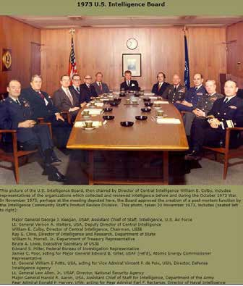
Figure 46: The U.S. Intelligence Board of 1973. (Permission given to use the photo from the CIA)
Now came the big conundrum: how was it we in the Arabic Section knew definitively about the attack, but misinformation was passed to an ally? Maybe General Zeira and I could put our heads together to find the answer.
Zeira and I discussed how my colleagues and I had known when the Arabs would attack yet his American intel friends had not. He had no explanation. I then told him about cells within NSA that were clandestinely working against Israel. I suggested this Israel-hating group had corrupted the intelligence before it got to his friends, the American generals, on the Intel Board.
Understandably, Zeira was skeptical. A nobody had come in off the street and told him what seemed to be a conspiratorial cock-and-bull story. To give credence to my incredible revelation, I mentioned John Loftus’ and Mark Aarons’s The Secret War against the Jews. I was surprised he had not heard of it. I told him the authors mentioned clandestine cells within NSA and called them the Jew Room. I told him I could bring the book with me if we met again. He invited me to come back, and we set the meeting for the following week, July 12.
Our July 4th meeting had been pleasant. The almost 90 year old general was not all as scary as I was led to believe. Our July 12 meeting was even more pleasant. I had brought a record I had made in the late ’70’s. I was - pleasantly - surprised when I asked Zeira if he had a patiphone, a record player, that he answered, “Of course.” We descended to a room where we played my EP, and he seemed happy I shared the music with him. I gave him the record. His obvious fondness for music and Hebrew song was a springboard to chat about things not related to the Yom Kippur War.
I was more composed on this second visit and left him copies of pertinent documents. He was interested in The Secret War against the Jews, and he wanted to check out the book’s contention that chambers exist within NSA that are working against Israel’s interests. Zeira told me if anybody could confirm whether this or any other disclosure made by Aarons and Loftus were true, it would be him. I assumed / hoped from that statement that I would have continued contact with him.
I was mistaken.
Within the first year of our July 2017 meetings, I called him several times, but he did not answer. Then I wrote him several letters. He responded to none of them. I wondered if my letters were intercepted before they could be delivered. Upon communicating with Israeli author Aviram Barkai, who has almost exclusive access to Zeira, I learned the general had received my letters. Apparently, he chose not to respond.
I had written to him about other things besides the difficult-to-deal-with topic of the Yom Kippur Surprise. None of the other “unrelated” things I wrote about induced him to respond. Not even my concluding remarks: it was an honor for me to have visited with him, and I was hopeful of continued contact.
My purpose in maintaining contact was twofold. First, I wanted to enlist his help in “setting the record straight.” I felt it was important to finally get the word out about the heretofore hidden truth behind the Yom Kippur Surprise. Who could do this better than Israel’s DMI? Second, I wanted to help the disrespected general clear his besmirched name.
My third letter to him:

Dear General Zeira,
April 8, 2018
As I’m sure you understood from my two visits to you at your home on July 4th and July 12th last year, the story of how you were innocently duped into believing that the intention of Syria and Egypt to attack Israel on Oct 6, 1973 was “low probability.”
I’m writing you in English because writing this letter is hard enough for me emotionally, that I trust your English is more than adequate to understand every word and the intention behind each printed word. And I, likewise, understand to a certain degree, that you, probably much more than I, suffer emotional pain from the subject. Yet, I feel I must share with you my continued thoughts.
I say CONTINUED thoughts, because I did write you two letters to your home address, which were not answered. I wonder to myself if your not answering indicates 1. You never got my letters; 2. You received them but chose not to answer. If the latter, then you chose not to answer either because of rudeness, or, as I said just before, the subject is unpleasant and you’d rather not deal with it and the best way is to simply ignore it -and me. In my two meetings with you, sir, I was absolutely impressed that you are anything but rude. I’m assuming that you did receive my letters (a big assumption, given my paranoia about “the bad guys” and their means) and that, since you’re not rude, that you are a sensitive man and hoping that Bruce Brill and his claim that there are, and were, “bad guys” at NSA (The “Jew Room” crowd) who work/worked against Israel and arranged for misinformation about clear Arab intentions to attack Israel on Oct. 6th to be passed to that group of American generals with whom you were in constant touch, would simply disappear.
I left Israel for a trip to Poland shortly after I tried to make my disclosures subsequent to my visit with you public (and only very partially succeeded). I thought that I’d be a candidate to be knocked off, and joke how “disappointed” I was that I was not killed. The serious point here: I haven’t {yet) “disappeared,” and you’re stuck with me.
Stuck with me, and my claim that there is/was indeed this Jew Room crowd embedded within NSA.
When I mentioned to you that the existence of The Jew Room was mentioned in John Loftus’ book (The Secret War Against the Jews, you said that you would acquire it and check out their (and, by extension, my) claim that the Jew Room exists/existed. Did you? Also subsequent to our meeting, I made contact with three of my fellow Arabic linguists who worked in US Intelligence at the time. They, each one of them, more than confirmed what I told you ... that each one not only knew in advance, and knew for a certainty, BUT KNEW DAYS BEFORE I DID. I was then in contact with John Loftus. He asked me to ask you (again), if you would be willing to go public along with me (and perhaps my three fellow Arabic linguists), and that he, Loftus, could arrange an interview on “60 Minutes,” with whose staff he has direct contact. The 60 Minutes staff would like to arrange an interview with you for September telecast.
Now I’m going to say something that won’t be pleasant for you to read, but is the truth.
After I made my disclosure public, however limitedly, I had the opportunity to see Michael Oren, the former Israeli Ambassador to the US, and asked him if he would get a copy of my disclosure to David Friedman, the present US Ambassador to Israel. In our discussion he said that he didn’t know how you could live with yourself with the death of 2600 Israeli men on your conscience. I’m sure you’re not totally out of touch with most Israelis’ perception of you being responsible for Israel being caught unawares and the resultant -mostly unnecessary- death of those 2600 souls. It saddens me that you, and you alone, are perceived as guilty for this disaster, not just in the eye of an isolated well-read Israeli, but by the Israeli public at large.
As I suggested to you at your home months ago, by your “making a noise” exposing The Jew Room, you would be doing the following: you would be redeeming (at least partially) your besmirched name in the public eye and in the historical record; and you would be giving assistance to The President of the United States in his effort to deal with the anti-Israel “Deep State” embedded in the US Intelligence Community.
You know about my paranoia about keeping our communication low profile. I don’t know exactly how to proceed; If to once again mail you letters through the Post Office, or to get it to you through people who might see you.
If you choose to proceed, perhaps you should have a not-close friend call me and tell me, “Green Light” and I’ll tell John Loftus to arrange the 60 Minutes interview (or you could call him yourself. His number in the States is: ).
Israelis maintain that 45 years ago you, more than anyone else, were responsible for “The Slip-Up.” Sure, you can justify your actions then, but the public perceives that you are to blame. Now you have the chance to have the world understand that the entire blame is not wholly Eli Zeira’s. I’ve been trying; but I’m “just a little guy.” You’re the general.
And it’s your call.
Very Sincerely,
Bruce Brill
Recall the Bottleneck: Israel’s Security Cabinet’s contact with AMAN was through DMI Major General Eli Zeira. The very occasional exception would have been his second-in-command, Brigadier General Arye Shalev, or the head of the Egyptian Desk of the Research Section, Lt. Colonel Yona Bandman. Each was basically Zeira’s rubber stamp. It was generally only Zeira who sat with and reported to the Command Staff and the Security Cabinet. Zeira was pretty much the sole conduit through whom intelligence synopses reached Israel’s top decision makers.
Zeira continued to insist war was not an Arab option, despite:
• The myriad clear intelligence indications of war preparations throughout September that Israeli intelligence possessed.
• The independent warnings delivered by Mossad agents in Egypt.
• King Hussein’s September 25 warnings of Arab war preparations, signaling the Concept’s death knell.
What kept Zeira entrenched in this opinion of war’s “very low probability”? Could it be those “foreign friends” he mentioned in all his interviews and writings?
Those foreign friends had to have had such tremendous intelligence-gathering capacity for Israel’s DMI to pooh-pooh his own intelligence services’ warnings. This was certainly the case when one compared America’s capabilities to those of tiny Israel’s. As good as Israel’s are purported to be, America’s capabilities are an order of magnitude greater. Had Zeira dismissed his own IDF intelligence assessments in favor of America’s, he would have been standing on very firm ground.
Yet Zeira is reluctant to publically declare his American counterparts gave him assurances the Arabs would not attack. When I recounted he confided this in me at that moment of truth over his kitchen table, people find it hard to believe. “Did you record him?” “Did you have a second witness hear (“see” in this particular case) him declare it?” Only in June 2021 almost a half century later has the IDF Archives declassified a critical document76 from October 7, 1973 giving credence to what Zeira furtively confided in me. In this protocol, Israel’s legendary Moshe Dayan, Israel’s then minister of defense, admits he received reliable intelligence assessments just 12 hours prior to the Arab attack commencing that “according to the American assessment, the Arabs are not going to attack” … precisely what Zeira confided in me.
76 June 6, 2021 declassified Dayan protocol from 7 October 1973.

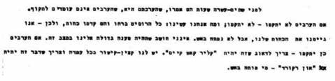
Figure 51: Moshe Dayan Protocol: October 7, 1973
Translation: 12 hours before, they [the Americans] said that their assessment is that the Arabs are not going to attack. If the Arabs don’t attack, they don’t attack. What did we do? All the Russians exited and they advanced forces. And, so, we enlisted (readied) our forces, but would not open fire. I don’t think there should be large (severe) recriminations toward us in such a situation. And if the Arabs would attack, we must assure that this will be a “clear cut case.” We have a communications officer at each station. We must assure that whoever opened fire [first] be “on record.”
Eli Zeira was not to be faulted for dismissing his own people’s warnings of an imminent attack. He, more than his underlings in AMAN, was aware of how much more reliable America’s intelligence capabilities were than Israel’s (see "America versus Israel"). One cannot fault Zeira on this point: he couldn’t have been more correct.
However, just as he was AMAN’s bottleneck to getting assessments to Israel’s higher-up decision makers, so, too, did a bottleneck exist in getting intelligence assessments to the higher-ups in the American military.
I maintain the bottleneck between the raw intelligence NSA’s G6 had and the American higher-ups (e.g., the US Intelligence Board), whom Zeira relied on, was NSA’s Jew Room.
Sure, in January and May of 1973 Zeira could rely on the Concept to discount Arab aggression. But now, after September 25, 1973, his reliance had to be on the assurances of his Israel-loving American counterparts. Everything else pointed to an imminent Arab attack. Eli Zeira relied on the Americans’ word, not the Concept, to stand firm in his assessment that the probability of an Arab attack was “very low.”
It could be nothing else.

AN ANGEL FROM HEAVEN

In my meetings with Zeira, I saw how troubled he was about relying on his American general friends’ assurances that Arab military maneuvers were merely exercises and not staging for an invasion. I wrote him later that month.
Every Saturday, the Jewish Sabbath, I -“religiously,” you might say- read what’s called the Weekly Torah Portion, that 1/52nd portion of the Pentateuch that traditional Jews read in synagogue. On the portion that fell in the middle of July, Pinchas, there appeared what I call a “Godincidence.” Godincidences are coincidences too coincidental to be merely coincidental. In Numbers, chapter 5, verse 11, the name “Pinchas” (פנחס) appears, but it is strangely written with a yud (פינחס) and - even more strangely - the yud is in a very unusually tiny font. The great German Jewish biblical commentator, Rabbi Samson Raphael Hirsch, goes into a detailed grammatical explanation for all this, saying:
1. The reason for this strange fontal rendition of the name Pinchas is to indicate this biblical personality displayed an “energetic stepping forward” to confront evil. Pinchas’s selfless and courageous act was not merely his “stepping forward” to confront that evil, but “the result of his deep inner feeling which made a betrayal of God’s affairs felt as treachery against one’s own self.” This is precisely what I was suggesting to Zeira in my letter: he should “step forward” and expose the evil that resulted in over 2,600 Israeli Jews dying unnecessarily.
2. That tiny yud has a name in Hebrew… and this is the truly “Godincidental” part of this anecdote: that tiny yud is called “Zeira” (זעירא)!
I spoke in my letter to him about other things besides the difficult-to-deal-with topic of the Yom Kippur Surprise, such as the record I gave him. Neither that nor the other “unrelated” things I wrote about induced him to respond, not even my concluding remarks that my visit with him was most pleasurable and an honor for me, and I was hopeful of continued contact.
In 2018, Yom Kippur fell on September 18. This holy day always ignites in me recollections of that troubling Yom Kippur in 1973. It inspired me to write an op-ed about the Yom Kippur Surprise in light of what I had learned from my visits with General Zeira. I wrote him and included the op-ed draft and asked if he would check the content and give me his comments and blessing. I then sought publication. It was published at the time of the Gregorian anniversary of the Yom Kippur War, October 6, in The Times of Israel.
I wrote General Zeira a third letter within the first year of our July 2017 meetings. He replied to none of my letters. Author Aviram Barkai, who has almost exclusive access to Zeira, informed me the general did, in fact, receive my letters.77 Apparently, he chose not to respond.
77 Personal communication with Aviram Barkai
On July 4, 2019, I thought it would be an appropriate time to contact the general by phone, as it was a kind of “anniversary” of our first meeting. I called both his mobile and his home landline, but my calls were not answered. I believe that he consciously chose not to answer them. I find this strange, especially in light of my last letter, in which I suggested to the general that he do an interview with the US TV magazine 60 Minutes, with the idea of pointing the finger of warranted culpability where it belongs: at NSA’s Jew Room. This would not only “set the record straight” by exposing those truly culpable, but at the same time, it would serve to exculpate Zeira and, even if partially, clear the old man’s tarnished name. Why on earth wouldn’t he jump at such an opportunity? Had he answered the phone, I would have made the case that this unknown Jewish American GI appearing out of nowhere should be seen by Zeira as an angel from heaven.
A stellar argument but irrelevant if there was no chance to speak with the man.
Reverend David Matthews reviewed one of my book manuscript’s very first drafts in the fall of 2019. He was curious how John Loftus’s offer to arrange the 60 Minutes interview with General Zeira was progressing. After hearing from me that Zeira did not even take up the offer, Pastor David said with surprise, “Doesn’t he realize that you’re an angel sent from heaven to redeem his tarnished name?”
Apparently not. Pastor David recommended contacting the general’s children to have them help him realize that removing the stain from his name would also remove it from theirs. While pursuing this route, I discovered that Zeira has three daughters and no sons, so the relevance is slim. Additionally, Aviram Barkai told me Zeira can’t be reached through his daughters; he does not discuss the Yom Kippur War intelligence mishap with them at all.
So, if I were to make what should be an obvious case, I would need to do it by myself and not via Zeira’s offspring. If Zeira wouldn’t answer my phone calls, I’d once again put pen to paper and stamp to envelope. Aviram also volunteered to email my petition to the man.

22 אוקטובר 2020
לאלוף זעירא, שלום רב,
למדתי מאבירם ברקאי שאתה כן קבלת את שלושה המכתבים הקודמים ששלחתי
אליך. אז> למה אני כותב מכתב רביעי למי שלא ענה לשלושה מכתבים שכבר כתבתי?
>.1 הבנתי מאבירם שאני לא סיפקתי לך מסמכים שמאשרים מי אני וששרתתי בחיל המודיעין של ארה"ב בתחילת שנות ה.70- אז, רצ"ב מסמכים על הרקע שלי (הפקודות הרשמיות) יחד עם תוצאות פוליגרף ומאמרים שנכתבו עליי
>ושכתבתי אני.
>.2 אני דואג להחזיר את השם הטוב שלך. כי אין עוד יהודי שגילה את "החדר
>היהודי" בתוך הסוכנות לביטחון הלאומי )NSA( של ארה"ב שפעל נגד ישראל. שם עיוותו את ההערכה הנכונה שהייתה בידינו במחלקת המזרח התיכון, שידענו
>בוודאות וימים מראש שמצריים וסוריה יתקפו ב6- לאוקטובר.
>לא מבינים שפעלת אתה נכון (אולי כולל אתה) שסמכת על ההערכה האמריקאית שנשלחה אליך מהגנרלים האמריקאים. לא מבינים (שוב, אולי כולל אתה) בכמה האמצעים המודיעיניים האמריקאים היו גדולים מאלה של ישראל בתחילת שנות
>ה.70- לא פי2- ולא פי,3- לא פי4- או ...5 או אפילו פי,10- אלא פי!50-
>לכן פעלת נכון לסמוך על ההערכה של ארה"ב.
>.3 אם אתה זוכר כשישבתי מולך בשולחן המטבח שלך שאלתי אותך איך אתה מסביר שברוס ברי"ל (הדרגה שלי הייתה Class 4th Specialist שהיא בעצם נמוכה מ"סמל)" ידע בוודאות יומיים וחצי לפני פרוץ המלחמה שמצריים וסוריה
>יתקפו ב6- לאוקטובר והאלוף זעירא, ראש אמ"ן, לא ידע. לא הייתה לך תשובה. אבל ניסיתי להסביר לך שהתשובה נמצאת בחדר היהודי שעיוות את המידע הנכון (שאנחנו במחלקת המזרח התיכון ידענו) והעביר הערכה מוטעת הלאה
>לגנרלים שהיית בקשר איתם.
>כל זה ברור לי. מה שלא ברור לי בכלל, למה אתה, בן אדם חכם, לא עולה על ההזדמנות להחזיר את שם הטוב שלך. כל ישראלי רציני איתם אני משתף את
>הגילויים שלי שואלים אותי את אותה השאלה: למה אתה לא קופץ על ההזדמנות?
>אני כתבתי ספר על כל הענין. אני אשמח לשלוח לך טיוטה מאחר והנושא נוגע לסוגיה
>הנ"ל >(עדיף כמובן דרך אימייל.)
>בברכה, ברוס ברי"ל
Translation:
To General Zeira, Greetings,
October 22, 2020
I learned from Aviram Barkai that you did receive the three previous letters I sent you. So why am I writing a fourth letter to someone who has not answered three letters I have already written?
1. I understood from Aviram that I did not provide you with documents confirming who I was and that I served in U.S. Intelligence in the early 1970s. So, I am attaching documents about my background (official orders), along with polygraph results, articles written about me, and ones I wrote.
2. I am concerned about redeeming your good name, for there is no other Jew besides me who discovered the “Jew Room” within the
U.S. National Security Agency (NSA), which acted against Israel. There the correct assessment we had in the Middle East Section, that we knew days in advance that Egypt and Syria would attack on October 6, was corrupted.
People (perhaps including you) do not understand that you acted correctly in relying on the American assessment you received from the American generals. People do not understand (again, maybe including you) how much American intelligence resources were greater than those of Israel in the early 1970s. Not double, and not triple, not four or five times…or even 10 times, but 50 times!
Therefore, you acted correctly in trusting the assessment of the United States.
If you remember when I sat with you at your kitchen table, I asked you how you would explain that Bruce Brill (my rank was Specialist 4th Class, which is actually lower than “sergeant”) knew for sure two and a half days before the outbreak of war that Egypt and Syria would attack on October 6th, whereas General Zeira, the head of AMAN, did not know. You had no answer. But I tried to explain to you that the answer lies in the Jew Room, which distorted the correct information (which we in the Middle East Section knew) and passed on a misassessment to the generals you were in contact with.
All this is clear to me. What is not clear to me at all is why you, a wise person, do not take the opportunity to redeem your good name. Every serious Israeli with whom I share my revelations asks me the same question: Why do you not jump at the opportunity?
I wrote a book on this, I would be happy to send you a draft since the subject concerns the above issue (better, of course, via email).

Regards,
Bruce Brill
I never received a reply. Admitting what he confided to me would serve him well for his own exculpation. Why wouldn’t Zeira wish to go public with this information? Author Aviram Barkai suggested to me it’s because it would be perceived somehow as being unfaithful to Israeli MI. I guess one could say, “To Zeira’s credit.” Barkai also told me that Zeira, in his 90s, is set in his ways and not to hold my breath. Some people are their own worst enemies.
Pastor David Matthews wrote me: “We will be praying that he reconsiders. Thank you, my friend, for all you do. May Abba make your path straight and the obstacles few.”
Whether Zeira likes it or not and whether he is concerned with redeeming his own name, I will.

“I HAVE MY REASONS…”
Author Aviram Barkai has written several books on the Yom Kippur War. He also has the singular distinction of having access to the reclusive Eli Zeira. After learning of my meetings with Zeira, he invited me to meet with him early in 2018 (I understood he was gathering material for a forthcoming book on the Yom Kippur War). Before our meeting, he asked Zeira about my visit and chat with the general (See Appendix 1).
Barkai asked Zeira:
According to one Bruce Brill, you told him that despite clear signs your intelligence department had [of Arab intentions to launch an imminent invasion], you were completely convinced that the Arabs had no intention of attacking because of assurances of “anonymous friends.” American generals?
Zeira replied:
Someone came to talk to me. I received him out of courtesy. He said, “I was at NSA.” He did not present me any certificates. I did not investigate him. He may have been. He may not have been. I don’t kick him out. Then he told me they did not treat him well or the Jews and they made the “Jew Room” there where anti-Israeli and anti-Jewish activities took place. And he also said it was there they did all kinds of manipulations against Israel. And so they did not pass on to Israel the material the Arab Section knew about. I don’t know if that is correct or incorrect. That’s what he said. I listened.”
Barkai asked Zeira about my mentioning “anonymous friends.” This was unfortunate wording because I never said “anonymous friends.” I said “foreign friends” because this term was what he, Moshe Dayan, and Golda Meir mentioned in their autobiographies (Barkai’s faulty wording allowed Zeira to evade the question without lying). The “foreign friends” are never explicitly specified. Who else could they be other than the Americans? Zeira confirmed this to me during my visit with him. Yet Barkai pressed Zeira on whether those same parties convinced him that the Arabs had no intention of attacking:
You insist you did not tell him, “Listen my friend, now it makes sense to me why I did not know the truth: because … you were there and knew they were going to war. I was told by anonymous friends in the US that the Arabs have no intention to attack and therefore I didn’t know what you knew.” Did you tell him that or did you not tell him such a thing?
Zeira dismissed this categorically:
Nonsense. It never happened. A guy comes and tells me stories. I make him a cup of tea. I tell him, “I don’t know what you’re talking about” He’s gone. End of story.
DMI Zeira here demonstrates the salty personality for which he is known. His “It never happened” is a strange comment since -apart from what he confided to me- it is amply documented that he was quite certain the Arabs were not going to attack, right up to the H-Hour moment when the air raid sirens began to sound. The question of why he was so convinced the Arabs were not going to attack is the central one. In that brief moment of unaffected candidness with me, he admitted it was those American generals, those trustworthy, Israel-loving American generals, whose assurances he embraced over the plethora of contrary indications from Israel’s own intelligence services.
That exchange sounds like it’s from a spy thriller screenplay. Zeira displayed a similar tone on a separate occasion. When speaking about “Bruce Brill’s document,” he told Barkai that “the Americans are strong” and “they have a long memory.”

Eli Zeira - August 25, 2019
Barkai: What was the weight of American Intelligence services in assessing pre-Yom Kippur intelligence situation?
Zeira: I don’t want to answer. Let’s move on. Next question.
Barkai: You’re in a bad mood? ...
Zeira: No. I have my reasons.
Barkai: Were you in regular contact with U.S. General Alexander Haig and/or Brent Scowcroft?
Zeira: I had no contact with them. Neither of them. No contact.
Barkai: On Saturday morning, October 6, a document leaves Prime Minister Golda Meir’s office describing the meeting with U.S. Ambassador Kenneth Keating, according to which Keating told Golda the Americans have already been asked about the situation, and are aware of the preparedness in Egypt, and believe the Egyptian intent is only defensive.
Who asked the Americans what they thought of the situation?
Zeira: Certainly not me.
Barkai: Doesn’t part of AMAN’s permanent headquarters’ protocol state when there are unclear things that provoke troubling questions, to turn to Americans to understand what’s going on?
Zeira: Could be. But the DMI does not do that. Someone maybe in the Research [Section]. But I do not remember if they passed me something.
“I don’t want to answer. Let’s move on. Next question.”
Here, DMI Zeira is obviously extremely uncomfortable with Barkai’s question. Barkai wants to know about Israeli MI’s (read: DMI Zeira’s) reliance on American assessments. Why won’t DMI Zeira answer that simple, straightforward question? Zeira’s sidestepping, “I have my reasons,” says a lot. The non-answer indicates:
• Weight was indeed given to American assessments.
• He is uncomfortable detailing what those assessments were.
• The weight given to them is embarrassing to disclose.
One sees, first, that American assessments were received; second, the assessments were incorrect; and third, more weight was given to the calming American assessments than Israel’s own worrisome assessments. The details of precisely how those American assessments were delivered to the Israelis are not specified. One would assume that after Zeira’s two and a half years working in the Pentagon, he was personally in contact with those Americans. But even if he weren’t, some Zeira underling was. Yona Bandman, head of the Egyptian Desk in the Research Section, would likely be suspect number two. Zeira’s receiving American intelligence assessments directly or indirectly is unimportant. That he received them and relied on them is important. This was a grievous mistake. No wonder Zeira doesn’t wish to answer Barkai’s question.
The wording of Barkai’s next question is unfortunate. From the day hostilities began on October 6, 1973, to this very day, conspiracy theories galore have tried to explain Israel’s intelligence failure just before the Yom Kippur War. Some attribute the failure to individuals who conspired to orchestrate the deception. In addition to Arabs, the suspects include Americans, first and foremost Henry Kissinger. Other prime candidates include Alexander Haig and Brent Scowcroft. This is why Barkai asked Zeira if he was in contact with these two specific individuals.
It is unfortunate that Barkai asked such a specific question. Zeira did not tell me which specific American or Americans he was in contact with, just that they were members of the US Intelligence Board. Neither Haig nor Scowcroft had sat on that board. On the other hand, I doubt if Barkai would have gotten a different answer had he worded the question more generally. Zeira’s closing words in the interview were: “I do not remember if they passed me something.” It would have been very interesting to watch the needles on the polygraph machine had the DMI been hooked up to one when he gave that answer.

PARANOIA
There is no shortage of “fraudulent suicides” or “strange deaths,” with dozens, if not hundreds publicized, in the last few decades. Some analysts pooh-pooh the notion that these are the result of conspiracies, yet the fact so many of the victims are whistleblowers or people associated with political personalities does give pause to any critical thinker.
Admiral Michael Boorda shot himself in the chest (some reports say twice, with two different guns) in May of 1996. Navy Secretary John Dalton reported that he saw Boorda just before the “suicide”:
I had a meeting [just prior] with Admiral Boorda …he was in great spirits. We had an excellent meeting with him, the commandant of the Marine Corps and senior Navy and Marine Corps staff, and he was in excellent spirits.
Take Ron Brown, a former DNC chairman, who, with 39 other passengers, died when their plane crashed just before he could make a plea bargain with prosecutors. This was on April 3, 1996, one day before his personal lawyer was murdered in a drive-by shooting. The air traffic controller in charge during the crash committed suicide just a few days later (did I forget to put quotes around “committed suicide”?).

Another is the shooting death of 27 year old Seth Rich, who was shot in the back in July 2017 in a so-called attempted robbery where the shooter forgot to take Mr. Rich’s phone… and wallet.
Never mind the most well-known cases of people who were prepared to testify against political personalities but then committed suicide by shooting themselves in the back of the head. A 1997 “gunshot suicide” study documents 138 such suicides (Karger and Brinkmann, 1997), five of whom shot themselves twice. One victim was shot four times (Introna and Smialik, 1989).
In August 2019, we saw the death of Jeffrey Epstein. People have begun to use “suicide” as a passive verb: “He got suicided.” Writing in The Nation, Elie Mystal stated, “It was utterly plausible that something fishy happened surrounding the death of Jeffrey Epstein.” Wikipedia notes that “the events surrounding his death have been subject to doubt and speculation.” New York’s mayor claimed, “I’m not a conspiracy theorist, but something’s way too convenient here.” Investigator Bob Fitrakis, who predicted Epstein’s being “killed in prison,” doubts his death was suicide. Spencer Kurin, a lawyer for Epstein’s victims, said, “there was a high probability that he would be murdered in prison,” and, “Powerful people wanted Epstein killed.”
Joel Bainerman was an author and investigative reporter. His book Crimes of a President spoke of the little-known criminal activities of George Bush Sr. Inside the Covert Operations of the CIA & Israel’s Mossad dealt with the inner workings and dirty deeds of the CIA and Mossad.
Joel partnered with another investigative reporter, Barry Chamish. They worked together on a regular bulletin, “Inside Israel,” where their probing into dirty deeds of powerful personalities was their bread and butter. Joel claimed there was a secret conspiracy between certain key figures in the Israeli political scene and the Vatican to assist the Catholic Church in taking control of Jerusalem, or at least to prevent Israeli control of Jerusalem and its establishment as the capital of Israel.
Barry would enhance the intrigue of his reports by claiming he was targeted for elimination, especially after uncovering damning pieces of evidence promoting his claim that Shimon Peres was behind Yitzhak Rabin’s assassination. He was published in some major periodicals, including The Atlantic, National Review, and Newsday. His books, Traitors and Carpetbaggers in the Promised Land, The Final Days of Israel, Israel Betrayed, and Who Murdered Yitzhak Rabin? are all about conspiracies. I had to smile when I saw a list of “the shortest books ever written,” circulating about the turn of the century on the internet, included “Conspiracy Theories I’ve Rejected by Barry Chamish.”
Both these exposers of intriguing morsels met early demises. After Joel gave a talk, a woman reportedly put a scarf around his neck as a gift. Unknown to him, the scarf was radioactive, and he died at the age of 57 on June 4, 2014, of causes connected to radiation poisoning. Barry survived several alleged attempts on his life and died mysteriously at age 64.
I knew them both personally.
Such suspicious incidents are nothing new. On March 28, 1949, United States Secretary of Defense James Forrestal, who was deeply involved with the ASA’s highly secretive (and illegal) Shamrock operation, suddenly resigned. Within a week, he was admitted to Bethesda Naval Hospital with a severe case of acute paranoia. He believed he was being targeted. The experts treating him declared he was suffering from “involutional melancholia psychosis.” On May 22, he left off writing in the middle of a sentence - in fact, in the middle of a word - to throw himself out a 16th-story window to his death. Was Forrestal “suicided”?
Another terribly unfortunate loss was General Rechavam Ze’evi, who had warned me that a committee of Americans met in Northern Virginia and decided whose name on a list would have an “X” placed next to it. General Ze’evi warned me back in the ’90s that making my disclosures public might result in my being “X-ed.” He was assassinated, X-ed out, on October 17, 2001, less than a decade after he warned me of the danger of being X-ed out.
His warning wasn’t without basis. Back in NSA’s infancy at the outset of the 1960s, when NSA workers Bernon F. Mitchell and William H. Martin (who, coincidentally, lived on Eighth Street in Laurel, where my wife and I also lived) defected to the USSR, President Harry S. Truman said, “They ought to be shot.” Martin became paranoid and changed his name to hide his identity.
Elliot Goldenberg, an investigative journalist I connected with in 1994, is the author of two books dealing with the intelligence community, with a focus on Pollard. He, too, suspected he was wiretapped by NSA because of some of the controversial characters he had come into contact with: “I waited for that polite but threatening warning from my friends in the CIA (such as do I like being tossed head first out of a moving helicopter) that I fortunately never received.”
Yes, I also became paranoid.
Besides the physical elimination of a person who might be perceived as being a threat to the intelligence community (whistleblower, spy, traitor, investigator), there are other means of dealing with such enemies, perceived or real. In the case of Otis Pike, who chaired the House select committee investigating the US intelligence community, his career was threatened with elimination:
“Pike will pay for this, you wait and see... We will destroy him for this.” Strong words, quoted on the floor of the US House of Representatives by Congressman Otis Pike himself. He was quoting from an alleged threat made by Mitchell Rogovin, the CIA’s Special counsel for legal affairs, to Searle Field, staff director of the House Select Committee on Intelligence headed by Pike. According to Pike, the CIA’s Counsel went on: “I’m serious. There will be political retaliation. Any political ambitions in New York that Pike had are through. We will destroy him for this.” Pike’s revelation of the threats, which were immediately denied by the CIA’s Counsel, came on March 9, 1976, a month after his committee for investigating the CIA had submitted its recommendations and gone out of existence. Even if the threats were never made, or if they were, in fact, expressed in a milder, more suggestive fashion, they were consistent with the controversy within the committee and its stormy relations with the executive branch that had prevailed from the time the committee was established thirteen months earlier. In his denunciation of the threats, Pike was reacting to a series of events that culminated only days earlier when New York’s weekly Village Voice, in special supplements on February 16 and 23, 1976, published most of the secret report based on the work of Pike’s investigating committee. Publication of the report, highlights of which had already leaked into the press from January 20 onwards, provoked an emotional and angry outburst from Secretary of State Henry Kissinger who was criticized severely in the report for his “passion for secrecy” and for making false statements to the Congress. At a news conference Kissinger denounced the committee’s “totally irresponsible behavior...the misuse of highly classified information in a tendentious and misleading manner [that] must do damage to the foreign policy of the United States...the use of classified information in a manner that is so distorted that the total impact is to produce a malicious new version of McCarthyism.78
In addition,
On June 5, 1975 the New York Times dropped a bombshell by revealing that two years earlier Congressman Nedzi, the Chairman of the House Armed Services Intelligence Subcommittee, had been briefed by the new CIA Director, William Colby, on the results of a recent CIA “in-house” investigation of assassinations, illegal operations, and other abuses. Nedzi had taken no action and had not even informed the other members of his committee (one wonders why). Several members of the Select Committee demanded Nedzi’s resignation.79
78 (Congressional Record, March 9, 1976) Intelligence, Crises and Security: Prospects and Retrospects Len Scott, R. Gerald Hughes, Routledge, 13 September 2013.
79 (The New York Times, June 5, 1975) Ibid.
My paranoia is understandable. Taking imagined possible dangers with a grain of salt helps to preserve one’s sanity by not being overly obsessed or acutely paranoid. Other issues might keep me from sleeping, but paranoia over being X-ed has never been one of them. Although “paranoia” can technically be a psychological malady, a mental illness, it is more commonly used to simply mean suspiciousness. Certainly, I am using the casual meaning of the word with regard to myself.
However, I do take certain precautions. In Israel, I almost always have my .357 Magnum strapped to my hip. “Better safe than sorry” and “be prepared” are good maxims to live by. Nor am I a Rambo; I shun violence. I would say I carry this cannon because I appreciate Murphy’s law: when I have protection, nothing threatening is liable to happen. As a fiddler, my philosophy of life is, “more violins, less violence.”
My explicit postscript to a 2019 letter I sent to NSA’s security chief also demonstrates my security concerns:
P.S. *Neither [the 1993 nor the 1994 letter] was answered. I am assuming that your office’s non-response indicates that:

• There was no classified material in the documents that I sent for your inspection.

• I can release the names of other 1973 NSA analysts who also were privy to the intelligence.

• Neither they nor I will be put in physical or legal jeopardy.

• I can release the name of the NSA supervisor who disclosed to me that there are rooms within The Agency that are off-limits to Jews.

• He will not be put in physical or legal jeopardy.

In July of 2017, General Eli Zeira confided to me that the “foreign friends” who assured him the Arabs weren’t going to attack on or before October 6, 1973, were American generals. Since he assured me those generals were trustworthy friends of Israel, I concluded it was NSA’s Jew Room crowd who manipulated the intelligence before it ever reached these Israel-loving generals, thereby duping them. After publishing this conclusion, I feared being without my gun and traveling to a foreign country. I feared that my subsequent trip to Poland would be suicidal.
My degree of suspicion was alleviated by the presence of a pleasant distraction: a Polish lady who arranged lodging for me at her mother’s apartment in Warsaw and accompanied me to Poznan for my research (Poznan Matzevas Redemption Project) there. She even arranged lodging in Czerniejewo in Poznan’s outskirts at her relatives’ vintage 18th-century palace. The five-star-plus accommodations and being with an attractive lady made me jokingly remark, “My fears of being murdered came true; I must be in heaven!”
Back in Israel, I wrote a third letter to General Zeira. When I had met the general, I had confided to him that since, as a routine practice, NSA monitors any former analyst who lives abroad. I was suspicious of NSA’s monitoring my communications and movements. I was well aware of what “we,” meaning NSA, were capable of doing in the early ’70’s.
The mind boggles at NSA’s potential today. I always keep this in mind.
The general knew of my paranoia. In my letter to him (April 8, 2018), I again mentioned it:
Dear General Zeira,
… I’m assuming that you did receive my letters (a big assumption given my paranoia about “the bad guys” and their means)…that you are… hoping that Bruce Brill and his claim that there are, and were, “bad guys” at NSA (The “Jew Room” crowd) who work/worked against Israel… would simply disappear.

I left Israel for a trip to Poland shortly after I tried to make my disclosures subsequent to my visit with you public…. I thought that I’d be a candidate to be knocked off and joke how “disappointed” I was that I was not killed.
Yet the fact remains: 2,600 Israeli men were killed… unnecessarily. How could that “little detail” not be important?

THE LITTLE DETAIL
Michael Oren was Israel’s ambassador to the United States. He is also a historian. Like most Israelis, he puts the lion’s share of the blame for these losses squarely on Eli Zeira’s shoulders. He told me he can’t imagine how Eli Zeira can live with himself with 2,600 dead Israelis on his conscience.
Is 2,600 lives a fair assessment?
The exact “official” number of fatal Israeli casualties in the Yom Kippur War is 2656, according to Professor Zeev Drori, a recognized expert of Israeli military history. In private communication with me, he agrees with my assessment.
The only way to reach an understanding about the deadly cost to Israel when she was caught off guard would be to compare it to a similar circumstance in which she was not caught off guard. Of course, the 1967 Six-Day War is such a case.
In the Six-Day War, Israeli fatalities against Syria and Egypt were 115 and 275, respectively. Subtracting the total, 390, from 2656, the difference is 2266. That’s pure, simple arithmetic.
To these calculations, one would have to add other factors. On the one hand, in 1973, the Syrians and Egyptians had sophisticated anti-aircraft SA-6 batteries that might prevent a 1967-like Israeli pre-emptive strike, which knocked out the Syrian and Egyptian air forces before the land battles even began. On the other hand, Israeli air force countermeasures could have dealt with this factor to some degree. Military experts could debate the degree of these factors.
However, it is plain to see other factors working in favor of the idea that an even lesser body count in ’73 than in ’67 would be applicable. One is that in ‘67, there was zero absorptive territory; Israel’s enemies were right on her doorstep. By contrast, in ‘73, there were the Golan Heights and the entire Sinai Desert, giving Israel breathing space from which to withdraw without the Israeli heartland being put in jeopardy.
In 1973, Israel was fighting two adversaries, while in 1967, she was up against three. Against this third adversary, Jordan, Israel suffered her severest losses, 550 dead, more than the combined losses on the other two fronts. This meant Israeli troops in greater numbers could have confronted the Syrians and Egyptians in 1973, thereby taking less risky options than with fewer troops.

Another element in this comparative study is the number of Israeli soldiers wounded: in 1967, 3,500; in 1973, 9,000. Some of the wounded subsequently died of their wounds. In fact, most casual assessments of the fatal Israeli losses in the Yom Kippur War put the number at 2,700, with some simply rounding off and others factoring in these sorrowful subsequent “changes of status.” A sad fact is that many of the wounded would have preferred to have been counted among the fatal casualties.
A final element in comparing the two wars is the number captured. In 1967, on all three fronts, 15 Israeli soldiers were captured. In 1973, a whopping 293 Israelis fell into enemy hands. There is no way of objectively measuring the importance of this. The psychological impact and the deleterious effect on Israeli morale were immeasurable but real.
What with three, instead of two, adjacent adversarial countries, and with the enemy forces right on her doorstep, there should have been far greater losses in 1967 than in 1973. It also means Michael Oren’s quoting 2,600 unnecessarily lost souls in the Yom Kippur War is anything but exaggerated.

THE HORROR OF THE LITTLE DETAIL
In the late ’60s, America was focused on the Vietnam War. My peers and I, being of draft age, were acutely aware of the draft and our deferments. Only a tiny minority would have enlisted in the military. My best friend, Ricky Quinn, was just such an exception, joining the Marines. Ricky was sent off to Nam and -among other things- was an enemy body counter. Body-count statistics were a moribund way “success” was measured in the Vietnam War.
There were American losses, too, and these were reported daily on the nightly news. All told, in that war, there were 58,220 American combat fatalities. Subsequently, even some decades after the war, there were additional war-related casualties, including Ricky, who passed away in the late ’80s at the age of 42 from Agent Orange-related medical complications.
The Vietnam War is the standard by which other near-contemporary wars are often measured. All war is horrible. How does the horror of the Vietnam War compare to the horror of the Yom Kippur War?
“They fought like lions” is a phrase often attributed to the Israeli soldiers who fought off the invading Syrians and Egyptians in the Yom Kippur War. Sure, Israeli fighters in all of Israel’s previous and subsequent wars also fought bravely and with distinction. But the Yom Kippur War was unique in that it was an existential war, and the field fervor and losses reflect this.
At first glance, when comparing the number of fatalities, it seems the Israeli losses pale in comparison to America’s, which were over 20 times greater. However, to understand the full impact, one must look at these raw figures from two different perspectives. The first is the percentage of loss in comparison to the total population of each country. In the American case, the 58,220 was 0.03% of the US population of some 216 million at that time, whereas the Israeli losses were 0.09% of their Jewish population of 2.8 million in 1973, or three times greater than the relative American Vietnam War losses. In real terms, there is hardly an Israeli family that didn’t have a family member or friend who was a fatal casualty in the Yom Kippur War.
A second measure of misery is the number of fatalities per day. This figure is truly traumatic. Take, for example, the World Trade Center attack on 9/11. If these 3,000 deaths had been spread over months or years rather than all in one day, the impact would not have been so great. Likewise, the rate of death in the Yom Kippur War, 137 per day on average (2,600 deaths over 19 days), is a whole order of magnitude larger than the Vietnam War’s, namely 8.2 per day over the 19-plus-year-long war (58,220 deaths over 7,115 days). Even considering the most catastrophic year of the Vietnam War, 1968, in which the American fatalities were 16,899, the average daily loss was 46.3 (16,899 deaths over 365 days). The daily Israeli losses during the Yom Kippur War were still two and a half times this most horrific year of the Vietnam War.
It’s not pleasant to engage in such moribund statistics. The bottom line, though, is the Yom Kippur War was truly traumatic to Israel. In the words of Rabbi Berel Wein, “It [The Yom Kippur War] was the darkest time since the Holocaust for the Jewish people.”
I repeat, there was hardly an Israeli family in Israel in 1973 that didn’t have a friend or family member who was lost or maimed. This was not true in America during the Vietnam War. This is not to pooh-pooh American suffering and losses at that time, but simply to show the tremendous trauma Israel suffered in the Yom Kippur War and its aftermath.
As horrific, catastrophic, and traumatic as these losses were, the bigger catastrophe, the larger trauma, and the most egregious aspect would be if these losses were unnecessary… and they were. They were totally unnecessary, and that’s the point. Dr. Itzhak Brook, in his book In the Sands of Sinai, wrote:
This war posed the most serious threat to the existence of Israel in modern history and shattered conventional wisdom about the country’s strengths and lack of vulnerability throughout the psyche of Israeli society. It came as a surprise to everyone involved and the army’s lack of preparation and consequent delay in calling up the military reservists inflicted a heavy toll on the entire population. 80
80 Dr. Itzhak Brook, In the Sands of Sinai, 2011
A friend who took part in that war tells me:
I will never forget the terrible outcry that arose from the temporary military cemetery set up in the northern Negev during the war. It was the first time the families of the martyrs met with the coffins of their loved ones. It was a superhuman cry that sounded like a mass pogrom. Hundreds of mothers shouted at the same time and asked why it happened and how it could have happened.81
81 Shlomo Arad, Personal Communication, Jerusalem 2021
The anguish is felt even today in Israel. A tearjerker, if there ever was one, The Children of the Winter of ’73, is a monologue of the children born after the war to their parents who lived through that terrible time. They challenge their parents not to forget their promise to bring the dove and olive branch of peace. The song expresses the grief experienced after the war, a sorrow that still continues.
No song is sung by the thousands of children unborn in the winter of ’73 because their fathers fell in the fall of ’73. At any gathering of Israelis about the same ages as my own children, I can’t help but think there are a couple of Israelis who should be among them but aren’t because their father was killed in the Yom Kippur War. This is an example of unnoticed agonies.

“BECAUSE YOU’RE A JEW”

Eli Zeira confided to me that his US intel partners, his Israel-loving and trustworthy partners, had told him the Arabs would not attack on or before October 6. Yet, days in advance, we in my section at NSA had definitely known there would be an attack and when it would commence. In trying to resolve this paradox, I suggested to Eli the only plausible explanation: the correct intelligence had been corrupted en route to Eli’s trustworthy, Israel-loving American intel friends.
By whom?
In the Arabic Section at NSA, where I worked, I don’t recall the workers ever getting together socially after hours. However, among us Hebees, there was a spirit of camaraderie. This good spirit was in no small measure due to Uncleo. As in other NSA work areas, there were both military and civilian personnel; In most, Jews were underrepresented even with respect to their tiny percentage of the general American population. During WWII, by contrast, Jews served in the military in a much greater percentage than the general population. Now, however, in the 1960s and early 1970s, Jews were adept at avoiding the military. This, coupled with the fact that most civilians working at NSA came aboard through their military service, Jews at the Agency were sparse. This was even true among the Hebees. Besides the assistant supervisor and me, there was just one other transcriber-translator who was Jewish: Rona, a single Orthodox Jewish girl from Baltimore. She was very correct and unassuming. Her Hebrew language skills were good, and I felt comfortable asking her questions regarding Hebrew if Uncleo or Ridge, the assistant supervisor, weren’t available.
There was another civilian woman among the Hebees, but unlike Rona, she was very unJewish, both culturally and in appearance. Kathy had a Scandinavian last name and was of Scandinavian descent. She happily announced her engagement to a Chinese American and we helped the couple celebrate one evening after work with a little reception at a bar-restaurant. It was one of those occasional opportunities for us Hebees to get together socially outside of work. It was also an opportunity for Uncleo to practice his Chinese, one of the dozen or so languages he had mastered.
Uncleo liked alcohol and would always have the fridge at home stocked with beer so he could unwind from work with a cold one… or two… or more. The “more” was testified to by his developing a beer belly. At Kathy’s party, he went at some beverage a bit more alcoholic than his usual suds. As he imbibed, you could see he was losing control. A mutual friend of ours, who had known Uncleo for many years, warned me, “Uncleo’s a mean drunk. Keep your distance when he hits the bottle.”
I’d never really seen this side of Uncleo. While on vacation in Nags Head, NC, he had gotten stewed at a restaurant. In that area, liquor could not be sold in restaurants. However, a patron could bring his own liquor by “brown-bagging.” So, there was Uncleo with his brown bag in hand, or more accurately, there was a brown bag with Uncleo in hand. Boy, did he ever get soused!
At the time, he had learned an old-time song called “I Love a Piano.” Uncleo, as tight as I’d ever seen him, was sprawled out on the front lawn of this North Carolina eating establishment, lovingly clutching his brown-bagged bottle, singing “I Love My Bottle,” a parody he was making up spontaneously in his stupor. It was hilarious. As far as I could tell, there wasn’t an ounce of meanness in the man, just his usual funny self, only magnified.
At Kathy’s party, Uncleo was taking on this latest jag. Some of the Heebees were doing the unheard of outside the Agency: talking shop. Talking shop outside “the shop” is a no-no, yet that’s where the conversation was going, and Uncleo, usually very, very careful about security in and-especially-outside the office, was in no position to monitor and screen what was being said. In fact, he wasn’t even monitoring himself. When the conversation turned to “certain rooms” in the Agency, he turned to me and violently thrust his finger into my chest and said, “And YOU can’t enter because you’re a Jew.”
I always attributed this to two things. First, to paraphrase the words of Solomon the Wise, “As the liquor goes in, the truth comes out.” Second, Uncleo’s conscience was bothered about the existence of such Jew-free rooms… and what might be going on inside.
I had hints apart from my being poked by a soused supervisor: perhaps that room through which I had to pass to access the teletype machine was part of this Jew-forbidden area?

THE JEW ROOM

I did not connect my being poked by a soused supervisor, telling me about secretive Jew-free rooms at NSA, with the possibility of that large, limited-access room through which I had to walk to get to the teletype was exactly one of those rooms. In retrospect, the curtain that closed over that huge map to prevent me from seeing Israel at the center, suggests it might very well have been part of the Jew-free complex.
Recall the pained moment of truth when Israel’s director of military intelligence confided in me that he received clear and calming assessments from his American friends that the Arabs were not going to attack. He relied - correctly - on these assessments over the myriad intelligence indicators in AMAN’s hands. His strong, dominant, charismatic, glowing and ever so persuasive personality82 took precedence (over all the worrisome signs Israel had) to convince Israel’s leaders that the Arabs would not be attacking.
But wait…. How could these trustworthy friends of Israel pass him false assessments? Let’s see how that could happen…
There is a network within the American intelligence community through which raw intelligence is processed, assessed, filtered, summarized, and passed on to the higher- ups. We peons of U.S. intelligence knew of Arab plans to attack Israel long before the attack was executed (see “Corroboration”), yet the US Army generals with whom Israel’s head of military intelligence was in contact did not know. In fact, those trustworthy friends of Israel’s, passed on to Zeira intelligence assessments saying the Arabs were not going to attack. This is fact. The reason for this, I believe, is that inner circles within US intelligence were working against Israel. Eli Zeira was the bottleneck through which all Israeli military intelligence assessments had to pass to reach Israel’s decision makers. Likewise, this Jew-free inner circle was in a bottleneck position and could massage and corrupt the raw intelligence we at the bottom were providing to the higher-ups. That is the only explanation for how we peons knew but these particular higher-ups didn’t.83
82 https://youtu.be/AjKcv5N9hpM at minute 11:40.
83 Or some, not all, did not know, or some pretended not to know.
Clearly, this is the only reasonable explanation: Israel became a victim of these secretive cells within NSA, compartments that worked against Israel and were known to insiders as “the Jew Room.”

I would like to emphasize that the Jew Room crowd was not typical of NSA. Most all of the folks I came to know working at NSA were good people, salt of the earth, patriotic Americans. The Jew Room cells were clandestine and beyond monitoring. It was there the dirty deeds were done. This, the cancer within the NSA body, is what my account addresses. My hope is my exposing it will serve as the prerequisite biopsy for its removal. If the cancer has already gone into remission, my hope is that my exposé will help guarantee it will never return.
An additional word must be added here: Eli Zeira must be a very troubled individual. If he’s not, he should be. His conscience has to be troubling him terribly. I don’t envy him. He must look at his face in the mirror every morning and wonder how he will face the 2,600 men who died because of his arrogant, know-it-all attitude. He speaks out of two sides of his mouth to feebly try to look less culpable. Here is yet another example: he told me he was in close touch with American generals who were sharing US intel assessments with him yet, when questioned by author Barkai, he said perhaps others in the Research Department of Israeli MI were in touch with American generals. One could fault my non-mother tongue Hebrew for perhaps misunderstanding what I claim he told me. But he wasn’t speaking Hebrew at that moment.
The easiest way for the old man to deal with my suggestion that he had been duped or, at the very least, had been given a false assessment, was for him to assume I was not telling him the truth, that I was - as he told Barkai - “telling him stories.” Of course, I sensed that even during my visit with him. Corroboration would be essential to my story, whether to convince old man Zeira or the reader of this book.
In the early 1990s, my wife, our children, and I were living in “a West Bank settlement.” Each new family moving into our village would raise the number of members, carrying my recollections back to that map on that clandestine room’s wall at NSA. In retrospect, that number next to each Jewish community was likely the population of the village.
In my 1993 and 1994 letters to NSA’s security chief, I asked if maintaining Jew-free rooms was still NSA policy. At the time, I didn’t know these areas were known as “the Jew Room,” which I learned in 1996 from John Loftus, author of The Secret War Against the Jews.84 I did not receive a response to either of my letters (sent by registered and secure courier mail). I consider the non-response as an affirmative answer.
All this can be viewed as a historical footnote. Clearly, what with the unnecessary deaths of thousands of Israelis, it’s an important footnote, but a footnote nonetheless… that is, unless this Jew Room exists still today. How can we know if it does or doesn’t? Is it possible that within a US government institution, there could be departments so insulated from the outside as to be able to have their secretive existence maintained without any outside monitoring? And by “outside,” I’m not necessarily talking about outside of the intelligence community. I’m speaking about even within NSA. Is it possible? How could it be?
In the early 1960s, a centralized administrative office, the National Reconnaissance Office, or NRO, was created by the Air Force in conjunction with the CIA to run the US satellite spy program. This body was so clandestine that even its name was secret. In fact, much like NSA itself in the Agency’s early days, its very existence was denied by US officialdom. Just substitute “Jew Room” for “NRO,” and you can see how the Jew Room could exist within the US intelligence community and remain unmonitorable. Working in coordination with the NRO is an affiliate branch, “Special Projects.” This office, much like the NRO - and the Jew Room? - is so insulated, even within the community, that it was not even listed in the Air Force Pentagon telephone directory or the United States Government Manual, where government offices are routinely entered.85
The US military loves acronyms. Somewhat reminiscent of “Dillywick” is an NSA office known as “Defsmack,” the Defense Special Missile and Astronautics Center, DEFSMAC. It is so secret that it has never been officially acknowledged, even within the US intelligence community, and has been surrounded by intrigue from its inception in the late 1960s.86
84 John Loftus and Mark Aarons, The Secret War Against the Jews (New York: St. Martin’s Press, 1994), 193.

85 James Bamford, The Puzzle Palace (New York: Penguin Books, 1983), 249.

86 Ibid 246, 247.

I was “a little guy” during the period of the Yom Kippur War and wasn’t privy to juicy “inside information.” But I was in the right place at the right time. I learned days in advance of the Arab intention to attack Israel on Yom Kippur, October 6, and I learned of the Jew Room even before learning its name. This, coupled with my visit to Eli Zeira and learning why he was duped, puts me in a unique position to understand - more than almost anyone else - how and why Israel fell prey to a deception resulting in the unnecessary deaths of 2,600 Jews.
According to John Loftus, the Jew Room worked against Israel and even against non-Israeli Jews. This latter group could have included American Jews. This explains why its existence has been kept secret from Jews, even those working within the Agency. Later in the 1970s, the FBI defended its practice of spying on American Jews under the assumption that they might be under the influence of a foreign power - Israel, one would assume. In 1991, British authors Andrew and Leslie Cockburn disclosed in Dangerous Liaison that Jews with possible sympathies to Israel had been monitored by a joint British-American effort dating back to before the founding of the Jewish state.87 They suspected, even while researching their book, that such a group still existed, buried deep within NSA.
Loftus and Aarons concur, adding that “the Jew Room” was alive and well even later in the 1990s. They further state that it is found in other US spy agencies besides NSA. Recall that Jonathan Pollard worked in Naval Intelligence. “Regardless of their proven loyalty or devotion… the U.S. Navy banned Jews from electronic surveillance ships, such as the USS Liberty.”88 Loftus and Aarons continue:
The ‘Jew Room’ is where the United States and Britain spy on Israel and on anyone who supports Israel. Its name is a misnomer, as the intelligence center has more than one room in more than one agency…
It is, and has been, the heart of the secret war against the Jews.89 [my emphasis]
87 Leslie and Andrew Cockburn, Dangerous Liaison (New York: Harper Collins, 1991), 36, 37.
88 John Loftus and Mark Aarons, The Secret War Against the Jews (New York: St. Martin’s Press, 1994), 194.
89 Ibid.
Loftus and Aarons go on to give precise details of the locations of the various offices of the Jew Room and note their sources, which include “confidential interviews; former special agent, FBI; former liaison to the NSA; former NSA officials and employees; former consultants on communications security (US and UK); former officers, Army Security Agency.90
90 Ibid, 195 and 530, note 5090
It is well documented that Japanese Americans were held under suspicion when America went to war with Japan and most were put into detention camps. Less well known is that in addition to a recruit-training camp, Fort Meade served as both a prisoner-of-war and internment camp for German and Italian residents under suspicion of being potential “fifth columns”. Three hundred and eighty-four such detainees were held at Fort Meade during the war.,/
There was no such roundup of Jewish residents during WWII. Since Germany had declared war on both the Jews and the US, it was natural “the enemy of my enemy is my friend” principle would be in force. Furthermore, Jews were not suspected of dual loyalty to a Jewish country since there wasn’t one during WWII.
Today, however, there’s no “Japanese Room,” “German Room,” “Italian Room,” or any other such room I know of at NSA. Yes, there are “targeted foreign nations.” This is the nature of any intelligence agency: you collect information on any nation that could, one day, become an enemy. For this reason, divisions at NSA target Japan, Germany, Italy, and practically every other nation in the world (the NSA exceptions are Great Britain, Australia, New Zealand, and Canada). Similarly, there is a division that collects information on Israel, where I worked when I became a Heebee.
But none of these departments are secret within the Agency, so why should there be a secret “Jew Room”?
Now I’m going to say something that may surprise the reader.
I think there is a place in the Agency for a “Jew Room.” Here I was, a Jew working a target nation of co-religionists, and I had a “finger of God” moment where I felt a bond with fellow Jews. So, why shouldn’t a Jew like me be suspected of having a certain latent loyalty to Israel? It’s natural to expect.
In like manner, there should be a Japanese, German, Italian, or Any-Other-Foreign- Nation Room, where anyone having the slightest potential loyalty to that foreign nation would be prohibited from entry. This would deal with the threat of a possible “fifth column” having access to information about the targeted foreign country. It would also alleviate any desire to engage in such activities since the forbidden fruit aspect would be removed. This would also reduce any feelings of discomfort such an analyst might have, were that forbidden fruit be within their reach.
They wouldn’t have to be secret within the Agency. They also would not work against the security of a foreign nation if it were an ally of America. This is precisely the danger in keeping such rooms secret within the Agency: they could work against a declared friend of the United States and no outsider, including members of Congress or even the president, would know. This is evidenced by the unsuccessful probings of the Church, Pike, and Rockefeller Committees of 1975.
Israel and America are publicly declared allies; they share common values, and it’s hard to imagine these two democracies will ever be at odds, certainly not militarily. Yet no one can predict the future, and anything is possible. In 1973, Israel and America were considered allies, so why should America have been an accomplice to duping Israel?
The Jew Room has a place: at the very least, it serves to keep Jewish Americans from being in an uncomfortable position of having to work against co-religionists. Yet, even in the Hebrew transcription division where I worked at NSA, Jews were working “against” Israel. Of course, “against” is in quotes because there was no sinister agenda in monitoring Israel. In fact, except for Great Britain, Australia, Canada, and New Zealand, the US monitors all countries, foe or friend. It’s a totally acceptable routine in intelligence communities. Israel is called “the State of Israel,” but it’s not state #51 of the United States: It is an independent country worthy of being monitored like any other foreign entity. This is nothing to raise one’s eyebrows over. It’s done routinely and is an acceptable and expected practice in the world of intelligence gathering. In fact, the assistant supervisor of the Hebrew Transcription Section became a Jew. This presented no problem either to himself or NSA. Nor did it represent any conflict of interest or cause any uneasiness over any claim of disloyalty. No conflict there.
However, to work against Israel by repressing vital intelligence is not only anti-Jewish; it’s un-American. It flies in the face of stated American policy of friendship toward the Jewish state. The need for America to be friendly to the only democracy in the Middle East is so obvious it should be unnecessary to make the case.
"Should be…”

AMERICA’S FRIENDSHIP TOWARD ISRAEL
It shouldn’t be necessary to show American friendship with the only democracy in the Middle East is anything but a given. This is true today and has been throughout Israel’s history, particularly in the early 1970s.
In 1948, President Harry Truman became the first world leader to recognize the newly born Israel. Samuel Lewis, vice chairman of the American Academy of Diplomacy, who served as US ambassador to Israel for eight years under Presidents Carter and Reagan, wrote:
This tiny nation of six million people, half-way across the world, often occupies and indeed preoccupies more of the US public landscape and political energy than even its oldest allies, Great Britain and France, or its nearest neighbors, Canada and Mexico. American presidents of both parties routinely pledge unqualified support for Israel’s security as do overwhelming bi-partisan majorities in both houses of the US Congress. 91
Wikipedia begins its article entitled “Israel-United States Relations” by stating unequivocally, “Since the 1960s the United States has been a very strong supporter of Israel.” And in an article entitled, “Why Are the US and Israel So Friendly? Why the US and Israel Have Had Such a Close Relationship for So Long,” Zack Beauchamp, a senior correspondent at Vox, states that before the 1973 Yom Kippur War, “as the Cold War dragged on, the US came to view Israel as a key buffer against Soviet influence in the Middle East and supported it accordingly.”92
Both Israel’s friends and her detractors acknowledge the love America has for Israel. A typical antagonist of the Jewish state, Rahhalah Haqq, wrote, “America loves Israel. This love is unconditional, perhaps even eternal, and is expressed in countless ways. Presidents come and go, politicians live and die, and people spend their lives, but the love outlasts them all.93
91 Samuel W. Lewis “The United States and Israel: Evolution of an Unwritten Alliance”, Middle East Journal, Volume 53, No. 3, Summer 1999.
92 http://www.vox.com/2018/11/20/18080080/israel-palestine-us-alliance.
93 https://crescent.icit-digital.org/articles/the-truth-behind-america-s-love-affair-with-israel.
Acknowledgments of support also come from US government officials. Former Secretary of State George Schultz wrote, “The United States supports Israel not because of favoritism based on political pressure or influence, but because the American people and their leaders say that supporting Israel is politically sound and morally just.”94
President John F. Kennedy said, “Israel was not created in order to disappear - Israel will endure and flourish. It is the child of hope and home of the brave. It can neither be broken by adversity nor demoralized by success. It carries the shield of democracy and it honors the sword of freedom.”95
Michael Oren, former Israeli Ambassador to the US, noted, “The candidates for the presidency, Republican and Democratic alike, have all traveled to Israel and affirmed their commitment to its security. So have hundreds of congressmen.” He further declared, “There is no alliance in the world today more durable and multifaceted than that between the United States and Israel.” Speaking specifically about the period just prior to and during 1973, he maintained, “Israel’s astonishing victory in that conflict [the 1967 Six-Day War], instantly transformed… [Israel] into an American asset, a hardy fellow democracy and Cold War ally.” 96
Nixon regarded Israel as "the best Soviet stopper in the Mideast," and furnished the weaponry Israel needed to prevail in the 1973 Yom Kippur War.97 The expressions of friendship are abundant, both inside and outside the government. Inside the US government, we can see this as permanent policy. William Quandt, a senior fellow in the Foreign Policy Studies program at the Brookings Institution and member of the National Security Staff in the Nixon and Carter administrations, points out in Peace Process that from 1967 to 1993, “Israel’s military superiority, its technological edge, against any plausible coalition of Arab parties has been maintained through American military assistance.”98 This basic position has been subscribed to by every president from Lyndon Johnson to Bill Clinton. Such positions “have been so fundamental that they are rarely even discussed.” This US government stance “represent[s] continuity and predictability.”
94 https://www.usnews.com/opinion/articles/2007/09/09/the-israel-lobby-myth
95 Speech by Senator John F. Kennedy, Zionists of America Convention, Statler Hilton Hotel, New York, NY | The American Presidency Project.
96 Michael B. Oren, SIX DAYS OF WAR June 1967 and the Making of the Modern Middle East, Oxford University Press. 2007-06-11.
97 https://crescent.icit-digital.org/articles/sykes-picot-collapse-of-the-political-framework
98 William B. Quandt, Peace Process: American Diplomacy and the Arab-Israeli Conflict Since 1967, Brookings Institute Press 2001.
Outside of government, US friendship toward Israel is even clearer. One personal anecdote typifies America’s love for Israel and brings a lump to my throat whenever I recall it. On our honeymoon road trip across the US in 1976, my wife and I began by driving through West Virginia. While in Fenwick, I suggested to Vivian that we stop a minute at the city hall and see if there might be work in the area. Upon entering, we noticed the town council was in session, sitting around a large wooden table. One of the gentlemen greeted us and asked us to sign the guest book. Where it asked for home address, we wrote, “Jerusalem, Israel.” When this councilman saw our entry, he addressed the others on the council, “Gentlemen, this is Vivian and Bruce Brill…from Jerusalem, Israel.” Without another word and as one person, all the town council members stood up and applauded us. It demonstrates the love Middle America has for Jerusalem, Israel, and the Jews. To this day, when I recount or even recall that story, I get choked up.
Why shouldn’t General Eli Zeira have relied on Israel’s best friend, America? If American intelligence resources eclipse those of Israel, then, of course, it was logical, reasonable, and wise to do so.
But do they…?
AMERICA VERSUS ISRAEL
No, this chapter will not be dealing with any hypothetical conflict between two of the world’s most vibrant democracies. Perish the thought! The present discussion will address the question of the relative military resources between these two democracies, with an eye toward intelligence-gathering resources.
Currently the US military budget is close to $700 billion. It is the highest military budget in the world. The next highest, that of the Chinese People’s Liberation Army, is $178 billion. Russia’s is about $64 billion. The Brits clock in at some $56 billion.
According to Kimberly Amadeo, president of World Money Watch, the American military budget exceeds those of the next nine countries combined. Israel’s, by comparison, is less than $16 billion ($15.69). Although Israelis pay the largest part of their earnings’ taxes toward defense, more than any other country in the world, their total military budget is about 2% of the U.S. budget. I know I am violating the golden rule of world economy, but the following drives home the point: America’s resources are not double Israel’s, not triple nor quadruple, not even ten times that of Israel’s, but 50 times that of Israel’s.
The ratios back in 1973 were about the same. Then, the US military budget was some $313 billion, whereas Israel’s was less than $3.5 billion. This is an even smaller percentage, clocking in at close to a mere 1% of the US budget. In other words, US resources then were a hundred-fold greater than Israel’s.
The exact percentage of the military budget earmarked for intelligence is impossible to say accurately since - as stated in Wikipedia - ”Because of its classified nature, the budget is an estimate and may not be the actual figure.” It would be safe to say that the percentage of the military budget Israel spent on intelligence would be similar or smaller than what America spent. There is no reason to believe this was not the case in previous years as well. According to James Bamford (The Puzzle Palace), just before 1973, the budget of the Consolidated Cryptologic Program (a fancy way of saying NSA) alone was about $10 billion. According to Pike Committee findings, US intelligence community funding was in excess of $10 billion, and perhaps as high as $15 billion, mostly going to NSA. Besides dollars and cents, another measure of resources is personnel. In 1973, the number of NSA and USASA personnel exceeded that of Israel’s entire standing army.
The drones Shabtai Brill flew over the West Bank of the Suez Canal were basically adapted toys. Their flights were intermittent, and their range was limited. By contrast, American synchronous satellites were positioned over all of Egypt, providing a constant bird’s-eye view of the entire region. I recall how, at NSA, I was once shown satellite photographs of an Israeli army base in the Sinai. The clarity was astounding; I could see an Orthodox Israeli soldier’s name embroidered on his yarmulke. Jonathan Pollard, working in US intelligence in the mid-1980s, noted, “I was rather surprised at the degree of assistance the Israelis needed… They are by no means… all-knowing.” All this should lead one to realize that if Israel, in the person of General Zeira, relied on U.S. intelligence, it was certainly understandable. In light of America’s friendship with Israel and the size of America’s intelligence-gathering resources, several orders of magnitude greater than Israel’s, the argument can be made that General Zeira made the right choice in preferring his American friends’ intelligence assessments over Israeli ones. The problem was not Zeira’s. The problem was that the correct intelligence the Americans had - that we had - was tampered with before it got to Zeira.
Because of this tampering, Israel, the singular Mideast nation which shares America’s Judeo-Christian values, lost 2600 of its soldiers killed in October 1973. It was murder.

NO SUCH MAN EVER EXISTED
In my continuing effort to seek out information on the Yom Kippur War, I frequented bookstores in Jerusalem. The Book Mavin (mavin in Yiddish means “expert”) was a used book shop on Agripas Street with a rich English-language section. During one of my visits in the mid-1980s, I met a tall, distinguished-looking gentleman. His gentlemanly appearance was enhanced -to an American ear- by a patrician British accent. Had the encounter been in the era of mobile phones, I would have recorded him.
Danny Ben-Yaakov said he had been a British officer during WWII. Sometime after the war, he immigrated to Israel. During the early 1970s, he said, he was in charge of contingency plans for the Southern Command. He spoke of a critical meeting just a day before the outbreak of hostilities, in which DMI Eli Zeira was present. Since Israel’s own military intelligence had seen Arab preparations for an attack, Danny Ben-Yaakov suggested the execution of a straightforward contingency plan that, he said, would require 24 hours to execute. When Ben-Yaakov proposed this uncomplicated plan, Zeira, convinced there would be no attack, pooh-poohed Danny’s suggestion with a dismissive wave of his hand and a spin in his swivel chair.
Ben-Yaakov detailed the plan to me. It was simple, easy to execute, not costly, and would not have violated the well-known American warning for Israel “not to launch a pre-emptive attack.” This contingency plan did not involve any of the much-spoken- about theatrics of spilling oil on the water in the Suez Canal and igniting it. Ben-Yaakov said such a theatrical plan was never a serious consideration, even though it was discussed extensively among those not in the know. His 24-hour plan, by contrast, required simply removing all the soldiers from the death-trap fortifications 99 on the Bar Lev Line along the Suez Canal. In their stead, remotely detonatable high explosives would be placed. After the Egyptians crossed the canal and assembled near the fortifications, the explosives would be set off.
This plan had several advantages.
99 http://www.jpost.com/opinion/op-ed-contributors/moshe-dayans-yom-kippur-war-328029
First and foremost, hundreds of boys would not be sacrificed to an unstoppable Egyptian onslaught. Second, this plan could not be misconstrued as Israeli aggression. Third, it would be an easy and cost-effective means (in men, materiel, and expense) of dealing a serious blow to punish obvious Egyptian aggression.
When I met with General Zeira and recounted to him what Danny Ben-Yaakov had told me, Zeira insisted, “No such man ever existed.”
But this man, this gentleman with whom I spoke at the Book Mavin, did “exist.” Of course, General Zeira meant he didn’t exist in the capacity Ben-Yaakov had described to me. Yet, in my recollection, he seemed genuine and credible. But Eli Zeira also seems credible… or should I say “credible,” quotes intended… meaning the same, strong, ever so self-assured personality that could persuade a Golda Meir and Moshe Dayan could also say something with such authority that it could quash Ben- Yaakov’s account. Does Danny Ben-Yaakov exist?
Who was in charge of contingency plans for the Southern Command? These troubling questions gave me no rest.
There was a critical meeting in Defense Minister Moshe Dayan’s office in Tel Aviv’s heavily guarded Kirya, on October 5, 1973, attended by CofS David Elazar, DMI Eli Zeira, and other security officials “whose names may not be published,” according to Yom Kippur War author Dan Ofry. Could one of those in attendance have been Danny Ben-Yaakov, “whose name may not be published”?
I contacted Dr. Uri Milstein, who is regarded as an expert in all aspects of Israel’s military history. He admitted that he did not know who oversaw execution of contingency plans for the Southern Command in the early ’70s and suggested I contact Shay Tamari. I did.
I asked Tamari two separate questions, both about one person: Danny Ben-Yaakov. Did he know of Danny? And who was in charge of the described contingency plan for the Southern Command? Not only did he repeat what General Zeira had said, “No such man existed,” but he added testily, “No such plan existed.” Shay Tamari, much like Eli Zeira, spoke with authority.
This was not the answer I wanted to hear. I wanted support for the existence of Danny and his contingency plan. I turned to another IDF general for his suggestion as to whom I might turn to get another take.
General Zvika Kantor established the Latrun Museum dedicated to Jews who fought the Nazis in WWII. In its incubation stage, he asked me if I had anything that might be included in their displays. The plaque I made displaying my father’s (and my) dog tags, which I mentioned in the Introduction, was just such an item. We had become first-name acquaintances.
I asked Zvika who would know the answer to my Danny Ben-Yaakov question, and without hesitation, he, too, referred me to Shay Tamari.
Still, I wasn’t convinced. Danny Ben-Yaakov -and his story- were too real to me. It makes one wonder. The plan Ben-Yaakov described was beautiful in its simplicity. How could it be possible the Israelis didn’t have it as a contingency plan? Are we to believe that the brilliant, ever-ready Israeli military strategists wouldn’t have conceived of such a neat, clever, and resourceful idea?
“Ten Years since the Yom Kippur War”, Dan Margalit’s 1983 Israeli TV news interview of General Ariel Sharon, was released from the Israeli Broadcast Authority Archives in 2018. In this interview,100 Sharon explains that back in May 1973, after Egyptian military exercises seemed to suggest an attack was possible and the Israelis had gone on high alert, serious thought was given to contingency plans to counter an Egyptian frontal attack along the length of the Suez Canal. Sharon explained that a plan, calling for the withdrawal of all the soldiers on the Bar Lev Line along the Suez Canal, was approved by Israel’s CofS.101 This plan called for the withdrawal of all the soldiers on the Bar Lev Line along the Suez Canal.102 Withdrawal, yes, withdrawal. Immediate withdrawal. Sharon expressed regret that this approved plan had not been implemented at the critical hour before the Yom Kippur attack. It was obvious that Sharon was disquieted by this oversight. He avoided pointing an accusative finger at those responsible, but he clearly thought those responsible for not executing the plan at that critical moment should be held accountable.
In the end, no one was.
100 YouTube video, 14:39, Jan. 11, 2018, https://www.youtube.com/watch?v=56KPM-5Psr8.
101 Ariel Sharon and David Chanoff, Warrior (London, Macdonald & Co, London, 1989), 294-295.
102 Ibid.
Just as my own Israel TV interview (“U.S. Consulate”) was suppressed, it is not clear whether the Margalit interview was even aired in 1983. In any case, the mention of the withdrawal plan was the briefest, in-passing remark. It is most unlikely that Danny Ben- Yaakov might have - retrospectively - learned of such a plan ten years following this fleeting mention. There was no YouTube before Ben-Yaakov shared his story with me, and it was long before the television interview would be released. In other words, Ben-Yaakov’s account seems credible.
So, one, there was such a plan, and two, it was not implemented.
Keep in mind the weak explanation given that the Israeli Cabinet had made a conscious decision not to preemptively attack in order to not appear the aggressor in the ensuing conflict, even though - so the claim goes - they definitely knew of the impending Arab attack. Why is this ludicrous? They could have at least executed the first part of Danny Ben-Yaakov’s simple plan and withdrawn the boys along the canal to safety. Nor would it have appeared as the act of aggression that the Israeli leaders were - supposedly - so fearful of perpetrating, or even giving the slightest impression of perpetrating… if Danny Ben-Yaakov “existed”, and was in charge of contingency plans for the Southern Command.
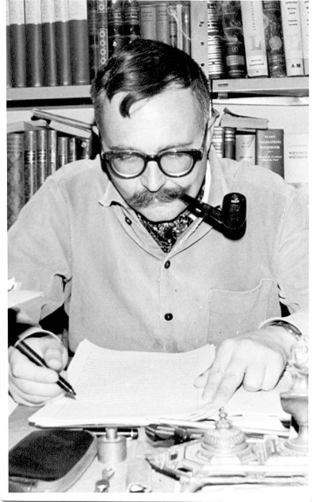
Figure 48 Danny Ben Yaakov "The Man Who Never Existed" Photo provided by Udi Cain.
In recent years, I have had the occasion to meet a number of Jerusalemites who personally knew Danny Ben-Yaakov.103 Apparently, he was a real character. But at the same time, all who recount their memories of him agree he was a formidable personality who not only hobnobbed with important Israelis, but was well-respected in the upper echelons of the Israeli military. And, yes, “the man who never existed” was invited as an advisor to many, if not most of the meetings of the general staff in the early 1970s.
103 History teacher Evyatar Reiter, Ruti and Michal Arbel (daughters of Yehuda Arbel, Shabbak Head), Dr. Nimrod Liram, Ilana Baum (widow of Shlomo Baum, colleague and co-founder of Unit 101 with Ariel Sharon), Yom Kippur War author Doron Hakimi, Udi Cain, others.
“The Bar Lev Line” was named for General Chaim Bar Lev, although his career and renown began long before he became well-known for this string of Israeli fortifications along the canal. These stationary defensive positions, Bar Lev’s brainchild, were not universally accepted by all Israeli generals. In fact, Arik Sharon was a vocal opponent and lobbied for mobile defense units in their stead. But Bar Lev’s voice predominated. Bar Lev bore serious criticism for “his” line in the late ’60s and early ’70s when the Egyptian War of Attrition took its toll on Israeli soldiers, who absorbing mortar and artillery shells raining down from the Egyptian side of the canal.
In the 1980s, I was interfacing with Chaim (yes, we were on a first-name basis). Chaim Bar Lev had a passion for Arabian horses, and each year, he would organize a horse event and ask my band and me to play country music. Never mind the fact that American horse events, rodeos, typically used the American-bred Quarter Horse and not Arabians; General Bar Lev wanted our music to give an American rodeo flavor to his event. In my private conversations with Chaim, he, like other generals involved in the Yom Kippur War, said that although there were ample signs of Egyptian and Syrian movement afoot before the outbreak of hostilities, it was AMAN’s “very low probability” assessment, conveyed by the prodigious personality of DMI Eli Zeira, that predominated, putting everyone’s minds at ease. On the Jonathan Pollard issue, he suggested I write to then prime minister, Yitzhak Rabin, and mention him.
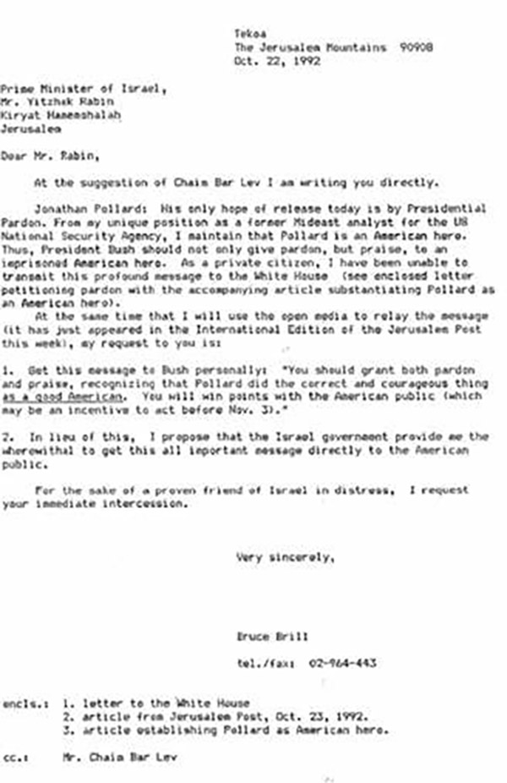
Figure 52: Chaim Bar-Lev inspired letter to Rabin.
As I mentioned, we would connect each year he had his horse event. However, one year at the end of the ’80s, I hadn’t heard from him about the time he usually held his horse event. I took the initiative to call him this time. At the time, Israel and the Soviet Union had just renewed diplomatic ties, and Chaim had been sent to Moscow as Israel’s ambassador to the Soviets.
Mrs. Bar Lev told me, “Mr. Bar Lev is presently in Moscow.” I was impressed with her cultured Hebrew and formal and dignified style of speech. “Would the gentleman care to leave a message for Ambassador Bar Lev?” I asked her to simply tell him I had called. “And what is the gentleman’s name, please?”
I answered, “Bruce Brill.”
“My apologies, kind sir, but would you care to please repeat your name?”
“Yes, ma’am. Bruce Brill.”
“I caught the gentleman’s last name, ‘Brill.’ But could you kindly repeat the gentleman’s first name?”
“Bruce”
“I’m sorry, sir. Could I ask you to kindly spell your first name for me?”
“B-R-U-C-E”
“Ahh, ‘Bruce’! We once killed a British soldier named ‘Bruce.’” So ladylike!
A final word related to Danny Ben-Yaakov. The way he described Eli Zeira’s dismissing him with a wave of the hand seemed real. This well-spoken English gentleman didn’t just use words to describe Zeira’s pooh-poohing his plea to execute his highly doable contingency plan. When he said that Zeira spun around in his swivel chair while waving dismissively, Ben-Yaakov described Zeira’s dismissiveness by his body language. Ben-Yaakov’s description was that realistic, too specific to have been invented. One can feel the same arrogant, know-it-all attitude in another instance where Eli Zeira behaved similarly rebuffing Lieutenant Colonel Yossi Zeira, a cousin of Eli’s. Yossi served in AMAN in October 1973. He tried to sound the alarm that the Arabs clearly intended to launch a surprise invasion. But Eli - with an action similar to what Danny Ben-Yaakov described - disdainfully dismissed him. After the war and the realization that Eli’s contemptuous spurning of his warnings resulted in such a terrible price in Israeli lives, Yossi said that Eli, as a gentleman and officer, “should have shot himself in the head with a bullet.”104

104 https://rotter.net/forum/gil/7990.shtml אל''מ יוסי זעירא:''אלי היה צריך לדפוק לעצמו כדור בראש

DOES IT MAKE A DIFFERENCE?

The “little detail” of close to 2,700 killed in the Yom Kippur War is an even bigger “little detail” since most of that number were unnecessary casualties. Recall historian Michael Oren implying that Eli Zeira is responsible for the loss. His clear assumption is that the losses were unnecessary.105
Some of the preventative, preemptive, preparatory measures that might have been taken would certainly have included implementing Danny Ben-Yaakov’s contingency plan on the Bar Lev Line.
On the front opposite the Syrians, Major General Yitzhak Hofi headed Israel’s Northern Command. Despite the assurances he was given by Eli Zeira in mid-September that war was unlikely, Hofi was still concerned. From his vantage point on the Golan Heights, he could see the Syrians had installed SAM missile batteries and were amassing forces not far from the border. This force included over 800 tanks, and by the beginning of October, the number was increasing daily. Hofi needed reinforcements to add to the mere 77 tanks at his disposal, certainly an insufficient number to match what would increase to some 1200 Syrian tanks by October 6. Yet Zeira continued to tell Hofi not to worry. The lack of reinforcements would prove costly to the Israeli soldiers facing the overwhelming enemy advance once the Syrian attack began.
The SAM-6 missile batteries installed on the West Bank of the Suez Canal and Syrian front were also not dealt with at the outset while it was still possible. These anti-aircraft batteries were known to be a most effective means of neutralizing Israel’s air force advantage. This was known to be most critical. In the spring of 1973, Israel Air Force Commander General Benny Peled briefed the General Staff and Moshe Dayan about the countermeasures the air force would have to perform to deal with the SAMs. Peled detailed what he jokingly called the “Star Wars” plan of battle. But he hastened to add that the plans, as effective as they were, were worthless “unless we get permission to strike first.” Dayan assured him, “Do you think that if we have even a hint of an Arab attack, we will not attack first?”106
105 Uri Bar Joseph, “Surprise as Disrupting Strategic Plans: The First Thirty Hours of the Yom Kippur War,” in National Trauma: The War of Yom Kippur after Thirty Years and Another War, eds.Moshe Shemesh and Zeev Drory (Beer Sheva: Ben-Gurion University Press, 2008), 137-149.

106 Abraham Rabinowitz, The Yom Kippur War, Schoken Books, New York, 2004, 33.
Even as late as the morning of October 6, General Peled was prepared to launch an air attack against the SAMs, particularly on the Syrian front. He was, however, notified at 07:00 hours of cloud cover over the Golan Heights; this negated his plan to eradicate the SAMs there that morning. As it turned out, even if the Israeli air force had been given the green light to eliminate the SAMs the previous day, it would not have been ready, because it hadn’t been given the required time to ready the necessary equipment. This, again, was due to Zeira’s dismissal of all the clear warning signs. Now, upon the outbreak of the Syrian attack, Peled realized the air force would have to fly into deadly SAM flack, with concomitant dreaded losses; alternatively, the Israeli ground forces would suffer serious casualties… or probably both. Again, all this dread would have been averted had the appropriate preemptive action been taken.
At that morning’s critical eight o’clock meeting of the Cabinet of October 6, CofS Elazar told Golda Meir that a preemptive strike would save many lives. But it still wasn’t clear a preemptive strike was needed, certainly not if the Arabs had no intention of launching a strike. And AMAN kept insisting throughout that fateful morning that the “probability was low” that the Arabs would begin hostilities. Dayan, persuaded by Zeira, said war wasn’t certain, and he maintained this stance throughout the early morning, even after 10 a.m.! But by 12:30, just about everyone saw the writing on the wall, except AMAN, meaning except General Eli Zeira. Golda Meir, herself, noticed by 12:30 that Dayan’s prior certainties of no pending Arab attack had suddenly melted away.
On the Southern Front, General Gonen, accepting AMAN’s “low probability” assessment, did nothing to strengthen the Bar Lev defenses, leaving the defenders there to become the Egyptian artillery’s punching bags and sacrificial lambs.
What numerical indication of losses would be hinted at as a result of the surprise? This was answered prophetically by a commander serving under General Sharon in the Sinai. Upon the outbreak of hostilities, Brigade Commander Colonel Chaim Erez immediately acknowledged that Israeli forces were in a predicament, one that would cost between “2,500 and 3,000 dead.” He was, unfortunately, correct.
The official body count of Israeli fatalities is 2,656. How many of these would have been prevented had the necessary preventive preparations been in place and the Israelis not, in the words of Golda Meir, been “caught with our pants down”? In personal communication with me, historian Michael Oren said that the surprise resulted in 2,600 unnecessary deaths. Is that an exaggeration? Can it be that, had Israel not been “caught with her pants down,” the losses would only have been in the dozens rather than the thousands?
The Six-Day War of 1967 woud be a natural means of comparison. In that war, Israel did take the initiative, and in that war, Israel was at an even greater strategic disadvantage than in ’73. In ’67, Israel fought on three fronts, not two. Israel then had zero strategic depth; in ’73, both the Golan Heights and the entire Sinai were in Israeli hands. The case can also be made that Israel was better armed in ’73 than in ’67, as many of her armaments were American in '73. In the ’67 war, on the Syrian and Egyptian fronts, 390 Israelis lost their lives. The difference between 2,656 and 390 is 2,266. This simple calculation belittles the loss of precious human life. It doesn’t consider the devastation felt by loved ones of the fallen. It doesn’t take into account the pain the fatally wounded suffered before dying. It doesn’t include the wounded who, in so many cases, would have preferred death instead of their handicaps. Their agony should not be trivialized by arithmetic.
How can one measure the anguish of the hundreds of war widows who were left without their dearest life partners, the parents who had to bury their children, or the children who would grow up fatherless?
Israeli writer Mordechai Rossel expressed the remorse that so very many Israeli families suffered:
Our generation is rich in tears. Hardly ever before were so many real tears shed as in our days. That is why we feel we are right to bang at the gates of Heaven and demand: Let there be an end to the shedding of innocent Jewish tears and blood!.
We have had more than our share of pain and suffering.
No, no arithmetic can calculate such losses.
Named for his famous grandfather, researcher and writer Winston Churchill wrote extensively about Israel’s blunder of not being first to strike, saying that because she gave up her most critical traditional weapon, the element of surprise, her losses were disproportionately higher than in the previous war.
By contrast, those responsible for Israel’s being taken by surprise sing a very different tune. In retrospect, Israel’s CofS said something similar, though - diplomatically - he did not point too accusative a finger at Israel’s decision makers: “Our losses most probably would have been less” (emphasis added). Golda Meir, adroit politician that she was, was even more speculative: “I do not know, and I cannot state for certain, that Israel would have suffered fewer losses if we had struck the first blow against the enemy.”
Less diplomatic and more genuine was the feeling expressed in 2011 by Dr. Itzhak Brook, who served as a medical doctor on the Sinai front:
Over thirty-eight years have passed since the Yom Kippur War took place in October of 1973, but its impact on me has not faded. I still think about the war and relive my experiences again and again. This war posed the most serious threat to the existence of Israel in modern history and shattered conventional wisdom about the country’s strengths and lack of vulnerability throughout the psyche of Israeli society. It came as a surprise to everyone involved and the army’s lack of preparation and consequent delay in calling up the military reservists inflicted a heavy toll on the entire population. 107
Meir, Dayan, and Elazar are no longer around. Golda passed in 1978, and Dayan in 1981. Elazar was faulted for not adequately preparing the IDF for the Arab surprise attack, resigned his commission in April 1974 and died in April 1976 at age 50 of a heart attack; many believe it was because of a broken heart.
107 Dr. Itzhak Brook, In the Sands of Sinai, 2011.

MAN WITHOUT A COUNTRY

Snowden worked for NSA, too. He was a whistleblower, as I could be perceived to be. Snowden left the United States; so did I. Snowden claims he loves America; I salute her mightily. That’s where the similarities end.
The differences dwarf the similarities. Snowden was an NSA employee at the time he chose to make his disclosures; I made mine decades after I left NSA’s employ. What he did was illegal; what I’m doing is not. He left for an enemy state, Russia; I relocated to a US ally. His disclosures deal with NSA’s data collection excesses and how they impinge on Americans’ privacy; mine have little to do with issues of privacy but concern actions that resulted in the deaths of thousands.
Who is Snowden, and what NSA wrongdoings upset him?
Edward Joseph Snowden was born in 1983. His family moved from North Carolina to Maryland, not far from Fort Meade. Although he didn’t graduate from high school, he took some community college courses and got a G.E.D (“General Equivalency Development/Diploma”) but not a college degree.
He enlisted in the Army as a Special Forces candidate in May 2004. His service record is blurry, if to judge from data available on the net. He was prematurely discharged four or five months after his enlistment. Although there are reports that he “broke both his legs in training,” resulting in his early discharge, an Army spokesman, George Wright, wrote, “He did not complete any training or receive any awards.” It is not clear what kind of discharge he got. In most cases, if a discharge is honorable, the person is quick to share the fact publicly. One might be prone to conclude, therefore, that Snowden’s discharge was other than honorable. In 2005, he worked as a security guard at the University of Maryland’s NSA-affiliated research facility’s Center for Advanced Language Study. Snowden demonstrated an aptitude with computers, and he was hired by the Central Intelligence Agency in 2006. He was given a top-secret clearance and, in 2007, was sent to Geneva to work as a network security technician.
Snowden began working as a private Dell and Booz Allen Hamilton NSA sub-contractor. In this capacity, he worked on NSA secret surveillance programs. He saw that they infringed on the privacy of Americans and began documenting these dubious activities. One such case was a secret court order compelling telecommunications company Verizon to turn over subscribers’ metadata. Another NSA secret leaked by Snowden was the existence of PRISM, a data-mining program that reportedly gave NSA and other American and British intelligence agencies access to Facebook, Microsoft, Google, and Apple.
Snowden requested a medical leave of absence in May 2013 and flew to Hong Kong, where he shared his disclosures with The Guardian. In early June 2013, the Washington Post also published his disclosures. Afterward, Snowden revealed his identity, claiming he had done nothing wrong and that there was no need to hide. In a subsequent interview with the South China Morning Post, he pointed to NSA’s hacking into Chinese computers since 2009.
The US charged Snowden with espionage on June 14, 2013, and Justice Department officials sought Snowden’s extradition from Hong Kong. The Hong Kong government, however, was uncooperative. Snowden then absconded to Moscow with the help of Wikileaks associates. At Moscow’s Sheremetyevo International Airport, an unusual situation developed for Snowden: by this time, his American passport had been revoked, and he couldn’t pass through the airport’s passport control and was stuck in the international section of the airport. He was forced to “camp out” in this section of the Moscow airport, specifically in Terminal F, for over a month. Russian President Vladimir Putin confirmed Snowden was somewhere in the international transit zone of Moscow’s airport but would not disclose where. Snowden’s exact whereabouts were kept unknown to the public and became the source of intrigue and speculation.
Another Edward comes to mind: Edward Everette Hale, the author of the 1863 short story “The Man without a Country.” Just as Hale’s man without a country, Lieutenant Nolan, was relegated to the confines of a ship on the ocean, so, too, was Snowden restricted to the confines of an international transit zone.
Herein lies another major difference between Snowden and Brill: Snowden became a man without a country, whereas Brill became a man with two countries.
One might assume I would feel a certain camaraderie with Snowden, or at the very least, a certain empathy. A visit of mine to Russia in early July 2013 answered this possibility. Snowden was holed up in Terminal F at precisely the same time I was there.
Just as in the case of Jonathan Pollard, my initial reaction to Snowden’s whistleblowing was that the dirty bum violated his secrecy oath and broke the law, and deserves to be caught and feel the full weight of American justice. My initial reaction to his whistleblowing and fleeing the United States was summed up at the time with my comment on the photo of me at Terminal F:

Bruce Brill: When I arrived in Moscow, it was at Sheremetyevo Airport, where Snowden was camping out. After I’d left Passport Control, I went to Terminal F where he was known to be, but I couldn’t find him. Upon my LEAVING Moscow, he was still in Terminal F and this time I was on the “right” side of Passport Control and thought to look for him ... again with no luck. My opinion: once he realizes the freedom Americans have compared to non-Americans - - particularly, I would say, Russians - - he’s going to understand what he forfeited.
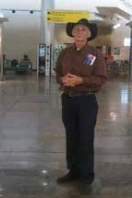
Figure 53: Sheremetyevo Airport Moscow.
Yet I had a certain curiosity: perhaps he, like Pollard, was correct in his actions. Illegal but correct. Perhaps. It would be interesting to hear more than just what the all-too-often-biased media was reporting to the public. Although it had expired years ago, I even took my Israel-issued press card just in case it might serve as a key to get to speak with him. He was there, yes, but I had no luck in finding him. My picking his brain would not happen then; it would have to wait until he could speak for himself, if not to me privately, then via some public forum.
My visit to Moscow included a friend’s friend, who gave me a gratis tour of the center of Moscow, including the Kremlin, on July Fourth. In Moscow, on Independence Day, I proudly wore an American-flag hat:
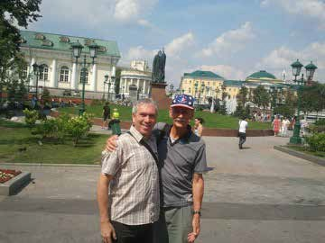
Figure 54: In Moscow on July 4, 2013
Bruce Brill: July 4, 2013
This is Mikhail, who took me on a walking tour ... and on what more appropriate day could an American tour the Kremlin and Red Square than on THE FOURTH OF JULY !! (notice my stars-and-stripes hat I wore to “make a point of it” ☺). - with Mikhail Kazbekov at Moscow Oblast.
It was an unforgettable Fourth of July. I even attended an official US embassy sponsored entertainment event. What was most memorable was not the official entertainment, but a group of Russian bikers from the Moscow Harley-Davidson Motorcycle Club. I thought, “Only in Russia.” What might the man without a country have been thinking on the Fourth of July in the Sheremetyevo transit zone, Snowden’s twilight zone?
American authorities pressured the Russians to extradite Snowden to the United States, but Putin defiantly refused. Snowden applied for asylum in several countries, Russia included. After spending over a month in the airport’s international transit zone, Snowden was granted temporary refugee status by Russia and finally left the airport.
Over the last half-dozen years since his twilight-zone limbo, Snowden has had ample opportunities to share his thoughts. In one of his many talks on the internet, “Democracy Under Surveillance,” Snowden poignantly tells his story and articulately makes well thought out points. Proof of this is how well received his talks are. Most tip their hats to his courage and even his patriotism. Ironic, then, that he is targeted by US Justice officials. Here is what he says:
People talk about privacy versus security and they say that’s what this is about: this is not what that’s about. This has never been a controversy of privacy and security, because they are not competing values.
When privacy increases of a person, their security increases. If no one knows what you’re up to, no one can take action against you. No one can basically make you vulnerable. When you’re being watched and recorded everywhere you go, not only are you becoming less private, you are becoming less secure. What this is really about… this is about liberty versus surveillance, not versus security or anything else like that. Surveillance preys on the lack of privacy.
There are two broad types of surveillance that are in broad use today. Mass surveillance, which is what I have criticized, what I have revealed in the United States. We have the Fourth Amendment in the United States which prohibits against unreasonable search of your private documents and things like that, seeing what you’re doing, what you’re up to, but also the seizure of them in the first place, which means grabbing them. Now, this issue has never been settled in the courts in modern day. The entire reason mass surveillance is happening right now is because of a court decision that happened in the 1970s in a case called Smith versus Maryland where one guy was making harassing phone calls to one woman. She saw him drive past her house or something like that, got his license plate… went to the police. The police went to the phone companies and said, look, in this case we don’t have a warrant. We do have this guy’s license plate, will you just give this information to us voluntarily? And the phone company said, yeah, sure… In that case the Supreme Court said this guy didn’t have a right to privacy because they didn’t actually wiretap him. They didn’t listen to his calls. They just got the records of who he had called and when, and it didn’t come from him. It came from the phone company, because the phone company said, they’re not his records they’re our records. This is called the Third Party Doctrine.
Since then, it has never been revisited at this level, in the context of mass surveillance. But the problem is this: In that court decision, they were talking about one lone individual in a specific instance, in a specific case. The government has interpreted that in the past 40 years to mean, well, if one person in one case, where they had eyes on this guy, we can do it to everyone, everywhere, all the time, forever…. and he was doing all this stuff, and the company did it in a very narrow, specific way, with just this range of calls here. If we can collect one guy’s phone calls without a warrant, we can collect everyone’s phone calls without a warrant, their emails, their internet traffic, whatever, as long as it means that some sort of idea where it’s metadata. It’s not what you say in the conversation, it’s who you say it to. It’s when. It’s the same kind of details a private eye would collect as they follow you around all day. They see when you left your house in the morning. They see where you went. They see the café you ate at. They see who you met with in the café. But they can’t sit right next to you and write down everything you say, because you might go, who is this weirdo sitting behind me everywhere I go and writing things down? But electronically, they can assign a private eye to follow everyone in the world all the time and it’s incredibly cheap. It’s incredibly easy.
This was my job at NSA.
On the other hand, we have targeted surveillance. And this I’m not a critic of in quite the same way. This is where they go, we have a specific individual, is a known associate of Al Qaida operative. We have evidence that he’s planning attacks … we have gone to a judge, the judge had said that the evidence is there, a standard, that authorizes a warrant to go collect information against him and then they hack into his phone, or something else. That’s fine. As long as it is always the least intrusive means of investigation necessary to achieve an investigative purpose. This means you don’t go for the atomic bomb to swat a fly. You climb the ladder and you go, look, nothing else worked, we have to go after this person and the judge says, look, that’s fine. And no judge in the world would get cold feet about authorizing warrants on terrorists…. Our secret rubber stamp FISA court (I talked about this sort of fake court before: two systems. We have the ordinary, open Federal Courts that everybody knows about, and as part of that grand bargain in the 1970s, the Foreign Intelligence Surveillance Court, called the FISC. All the judges on this court are appointed by the same person: the Chief Justice of the Supreme court…so you don’t have a normal mix of opinions on this court and in the 33 years that its decisions were being studied by Mother Jones, they saw that the government had requested warrants through this court about 33,900 times and in these 33,900 times over 33 years, you know how many times the court said no? …. 11!
Questions about who to surveil is “not a question to be answered by a few officials behind closed doors. This is something that maybe nationally, we want to say is okay. Maybe we want to say we want to have a panopticon government. Maybe we want to say the government has the absolute authority to unlock anybody’s Iphone at any moment, turn on my camera anywhere, turn on any microphone in any pocket, because it’s valuable, because it makes them more powerful and we want the government to be as powerful as possible because we trust the government. Maybe that’s the case. But if that is to be true, that’s a conversation that we have to have in the open, in the light of day, not behind closed doors. What happens in the last decades is the government removed the public’s seat at the table. In the last few years we’re getting it back, because now we know what’s going on. Now we can say something about it. But we don’t have that much influence, unfortunately. A vote only does so much. The current status of our national equilibrium should be all the evidence of that we need where we can have a majority that votes for one and another ends up in power.
What about the idea of proper channels? There’s a criticism against me and every other whistleblower that says, look, this guy revealed the CIA’s torture program or whatever for the ppr gentleman, John Kiriakon, who went to prison for that, the CIA’s operations [unclear] the Iranian nuclear program, that actually ended up accelerating it, because it was so incompetently managed, he also went to prison… if they had just told the government through the right way, things would be better. You would be able to make some Congressman know about these things and nobody int the public needs to be any wiser. But in many cases Congress already knows… You saw the Director of National Intelligence saying, “No. Not wittingly we don’t spy on American citizens,” when they were doing exactly that! Senator Ron Wyden knew that was the case, that’s why he asked the question. The Director of National Intelligence wasn’t surprised by it (he got the questions 24 hours in advance). These guys know. They weren’t trying to deceive each other. They were trying to deceive the public. Sometimes, the person that needs to be notified is not the government: the government is the cause of the problem. This is like reporting that the wolf is eating lambs to the wolf and we have actual evidence of that. There’s a case of an individual named Thomas Drake….He tried to blow the whistle the proper way: went through all the proper channels at the NSA, the Department of Defense’s Inspector General, went to Congress, told all these guys what was going on, said it was unconstitutional, that it was illegal and at every turn they told him, you don’t really understand this, this is above your pay grade, you’re getting this wrong, it’s not unconstitutional, the lawyers say it’s fine, don’t worry about this. In fact, we have the number two lawyer in the entire CIA who is asked about this, Thomas Drake, and what he did when Thomas Drake came to him, because Thomas Drake actually notified this guy that this was happening. This is the program that was written out of law after I came forward. Thomas Drake tried to stop it a decade earlier, but failed, because this is what proper channels look like.
“If he came to me, someone who is not running the program and told me that we were running amuck, essentially and violating the Constitution. There’s no doubt in my mind I would have told him, you know, go back to your management, don’t bother me with this. I mean, you now you did, the minute he said, if he did say, you’re using this to violate the Constitution, I mean, I probably would have stopped the conversation at that point quite frankly. So, I mean, if that’s what he said he said, then anything after that I probably wasn’t listening anyway.”
“Proper channels,” ladies and gentlemen! If I could close in on a specific note here, there’s a lot of leaking going on nowadays, perhaps more than we’ve ever seen. There’s going to be good. There’s going to be bad. And the question is, who’s the right person to decide this.
Ultimately, whistleblowers are elected by circumstance. Doesn’t matter who you are. Doesn’t matter why you did it. What matters is what you witnessed, what the truth is. If you have seen a crime, if you have seen an injustice, if you see something wrong that you think could be changed by speaking out, by doing something about it, you need to think very seriously about what your obligations are. Not just to the ideas of altruism, a better future, serving democracy or whatever, but to yourself, because when we tolerate injustice and we all have a level of this …. I would not encourage anybody to come forward if they didn’t think it could make a difference. But there are cases where it can. And when you see something, something wrong and you think the world would/could be better, you think the program could be better, you think the program is supposed to be better, you think it’s against the law for things to be occurring as they are, or even if it’s not illegal, it is clearly immoral, as so many institution throughout history have been, do you have an obligation to resist it? You have a voice, ladies and gentlemen, and that voice matters. It is not enough to believe in something. If you want to see a better world, you have to make it. Don’t believe in something: stand for something. Use your voice and good luck.108
In contrast to the initial image of a despicable, wretched, criminal lowlife, Snowden comes across as honorable, correct, well studied, and well spoken. His talks are received warmly and with almost universal kudos. The only objection I have would be his driving me to the dictionary (e.g., “panopticon”) and his slightly overly preachy style. Apart from that, I regret not having met him in Sheremetyevo.
108 https://www.facebook.com/events/facebook-live/democracy-under-surveillance-a-conversationwith-edwardsnowden/1604534192905041/

IS NSA AN ENEMY OF THE STATE
“Privacy’s been dead since the mid-1960s.” This was Scott Shane and Tom Bowman’s conclusion in describing the National Security Agency’s surveillance activities in their Baltimore Sun Sunday magazine exposé of December 1995. Because of NSA’s extensive efforts into collecting any and all communications, the writers maintained, “The only privacy left is the inside of your head.” Such disquieting “Big-Brotherism” certainly seems threatening to democracy. Big Brother’s creator, George Orwell, wrote in his book 1984, “You had to live…in the assumption that every sound you made was overheard and, except in darkness, every movement scrutinized.” Senator Frank Church noted, “That capability at any time could be turned around on the American people and no American would have any privacy left.”

Malevolent acts committed against proclaimed allies are not only sinister; they’re perverse, since they have no justification. However, the justification for mass surveillance activities is precisely the opposite: it is, in Shane and Bowman’s words, “democracy’s last hope.” They maintain NSA’s secretive activities are, in fact, the best way to combat threats to democracy and preserve our freedom. So, which is it: democracy’s protector or democracy’s scourge? Is NSA the guardian or the enemy of the state?
In today’s post-Edward-Snowden world, this question is widely debated. Today NSA is common knowledge. However, back in the 1990s - when Shane and Bowman wrote their piece - and before, NSA was hardly a household word. Few had ever heard of “the Agency,” much less its clandestine activities, yet NSA, then and now, is much larger and enjoys much more funding than even the well-known CIA. The question of whether the folks at NSA are good guys or bad was not an issue back before the turn of the century. Whistle-blower Snowden pointed to a convenient new lexicon where the National Security Agency’s mass surveillance actions are labeled “bulk collection” to disguise its pervasive spying. He also noted that the name of the huge NSA Utah Data Center complex at Bluffdale, Utah, was changed from the Massive Data Repository to the Mission Data Repository for the same reason. This is all current as of this writing, since it was - according to Wikipedia - completed in 2019.
Yet, a good half-dozen years before 9/11, the folks at Disney Studios decided to expose the feared danger. According to film producer Marty Kaiser, although the idea for the movie Enemy of the State came from Shane and Bowman’s Baltimore Sun series, it was his website that put meat on its bones. Walt Disney Productions/Touchstone Pictures saw in the Baltimore Sun article the potential for a movie and contacted British playwright David Marconi.
Although Bruckheimer and his late partner Don Simpson first began developing Enemy of the State in 1991, it took quite a long time for David Marconi to produce the screenplay. It encompassed the far-reaching scope of institutionalized information gathering.

Bruckheimer said:
I’ve always been interested in the inevitable questions surrounding the invasion of privacy. With today’s technology anything is possible and everything is probable. I don’t think the public is truly aware of what’s at stake in terms of an individual’s privacy. But the other side of the controversy remains - we need to be able to protect our borders and our citizens. The NSA has been incredibly active in preventing terrorist attacks and finding those responsible for the rash of senseless bombings that have erupted recently. 109
This was in the mid-1990s.
Marconi explained:
I eventually was able to come up with a boogie man - the National Security Agency, which at the time nobody had ever heard of. Their nickname was ‘No Such Agency.’ The more I dug, the less I could find of these guys, so I realized that we had the possible making for a great story. 110
Marconi decided to divide the movie’s lead character into two distinct characters. One, a black man (played by Will Smith), would be the victim of government abuse. The other (played by Gene Hackman) would be an ex-NSA intelligence analyst. The film’s director, Tony Scott, wrote:
I was always fascinated with the idea of surveillance, especially surveillance from hundreds of miles up in the atmosphere… NSA type surveillance activities are what the entire world is succumbing to today. 111
Scott wanted the film to be a character-driven piece set against the world of surveillance and espionage. “Gene and Will are perfect for their roles.”
Marconi was convinced anyone could manipulate modern technology (not to mention the press) to their advantage, enough to destroy a man’s reputation, and moreover, his life. He said, “Obviously we can’t stop the future, but what we can do is make sure that someone watches the watchdogs.” Gene Hackman added:
Almost all of us has had some difficulty with governmental red tape and intrusion. I think all of us has a bit of paranoia about other people getting into our lives. What’s fascinating is that certain situations depicted in this film can really happen. The government can go to great lengths to get information from someone if they want that information or feel it’s necessary. I think we all believe this could happen to some degree. That’s what’s exciting about a film like this. The main character in this showstopper film ‘is a bitter man.’ He’s certainly willing to do what he can to throw some sand into the gears of the government.112
And this movie character’s name? … Brill!
We leave this chapter with a few questions. First is the question we began the chapter with: is NSA friend or foe of democracy?
Secondly, can NSA’s secretive efforts to harm US allies somehow be justified in the same way its surveillance activities can?
And finally, am I “Brill”?
109 R. Emmet Sweeney No Such Agency: The NSA, Enemy of the State and Edward Snowden robertemmetsweeney blog, February 12, 2020, https://r-emmetsweeney.com/tag/jerry-bruckheimer/
110 http://www.martykaiser.com/enemy.html
111 Ibid.
112 Ibid.
IS BRUCE BRILL“BRILL”?
Gene Hackman was Tony Scott’s only choice to play the secretive, underground operative “Brill.” Scott wrote:
Gene’s character is another generation. Only a limited number of people had access to computers and the type of hardware we have today. Brill is of the old school so we took a lot of references from one of our surveillance experts, Martin Kaiser. I taped every meeting with Marty so we had all these transcripts to refer to, not only in terms of information about surveillance, but also for character reference. It’s a great way of pulling lines from the real guys. I rely on technical advisors most of all for character reference. And that was what Gene did - I could see him observing Marty and he would take just a little bit there and it would surface a week later.” Marty’s technical expertise, ingenuity, coupled with his unique ability to quickly produce many of the props seen throughout the film was a major part of the film’s success. Writer Marconi describes one of the scenes that sets up the relationship between Dean and Brill. “There’s a conversation Brill has with Robert Clayton Dean where he tells him, ‘You’re insane. You can’t go against these people. You’re nothing. You’re a speck of mud to these people, yet you want to go against the most powerful intelligence gathering agency in the world. It’s impossible, give it up.’113
All the above points to the high-powered resources put into this production, including the best writers, producers, actors, and distributors. No effort was spared to make Enemy of the State the box office success it was to become. And it was at the vanguard in exposing some of the misdeeds of NSA’s bad guys. Fiction, yes, but with a strong suggestion of the nefarious goings-on behind the scenes at NSA.
But why was “Brill” chosen as the name of the lead character, who is a former NSA intel analyst, just like the Brill writing this exposé? An acquaintance, who happens to be a lawyer, mentioned that he had seen Enemy of the State and asked rhetorically if the film producers had chosen the name Brill for the lead character because of disclosures about my own work at NSA, which had been published just before the screenplay was finalized. “How coincidental,” thought my lawyer friend. Or was it simply “coincidental”? He suggested it seemed likely the name might have been chosen after I had made my disclosures public and they chose my name since I had published my NSA-related story. And if so, he said, I should get a good lawyer -him- and sue the movie producers and “make a million.”
“Brill” is by no means a common name. According to an official U.S. Census study, over 160,000 last names appeared a hundred times or more in the 2010 census. A tabulation and ranking of such names were made for 2000, the closest census to the publication of Enemy of the State. A mere 9,069 Brills appeared in that Census. The ranking of the name Brill was 3,598, meaning 3,597 other last names were more common. This translates to the likelihood of the name being randomly chosen as close to zero. By comparison, the last name of the character played by Will Smith, Robert Clayton Dean, comes in at a ranking of 250, more than a full order of magnitude higher in likelihood to be selected; with a whopping 109,000-plus Deans in the telephone book, Dean is ten orders of magnitude more common than Brill.
However, one little detail was left out of this story: the claim the screenplay was itself the child of criminality. Yes, when researching how “Brill” was chosen as the name of the movie’s lead character, one is led to a scriptwriters’ website, the Internet Movie Script Database (IMSDb).

113 http://www.martykaiser.com/enemy.htm

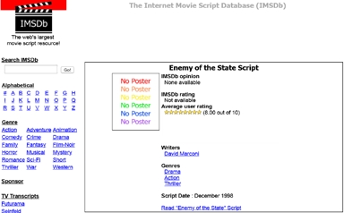
Figure 52: Internet Movie Script Database.114
On this site’s discussions about The Enemy of the State, the alleged theft is spoken about by someone who simply signed off as “Ray.”:
114 https://imsdb.com/Movie%20Scripts/Enemy_of_20_the_State_Script.html/p>
Ray (6 out of 10 ) Script was ripped off from me in 1996 by LA Premiere Agency through John Ouffland and given to David Marconi to re-write. Original script title was “The Closet Kill” based on an earlier draft of mine called “The "Solution”, both copyrighted. John called me and asked me to send him the script. I did. I never recieved a penny. Never let your script get in the "hands of anyone unless it is through someone you know in the Industry. If it is passed on that way it is much safer. I learned a hard “2 milion dollar” lesson the hard way on this one. Read my script and you will see how Enemy of The State came about. Have you ever wondered why "David Marconi never wrote anything before or after “Enemy of The State”? If you could write that then you can write anything. Another question you may be asking is why didn’t I ever sue? Because I did write the script I have the talent to write more. I was also wanting to get in the Industry at the time and did not want to be blacklisted. Also, I didn’t live in LA. I am 100% convinced that if I did, they never would have stolen it, they would have at least given me story rights. I have just finished writing, producing, and directing my first film called “Backstabbed”. All my scripts get better each time. Enemy doesn’t even come close. Also be very leery of script contests. It’s very simple, if you have a high concept idea, like I did, safeguard it. Do not enter it in contests or flash it around town.
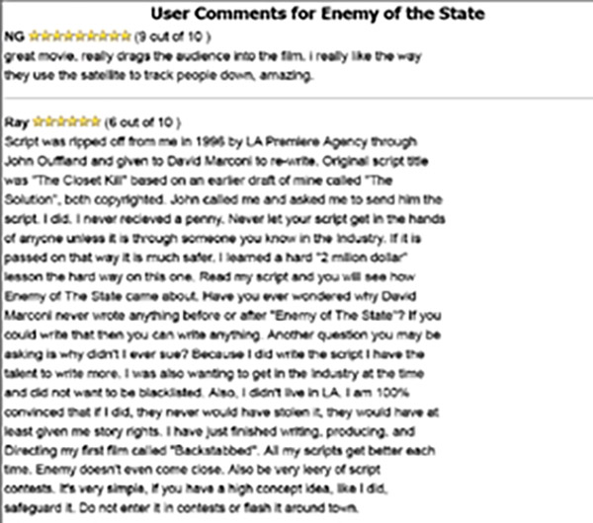
Figure 56: Enemy of the State User Comments115

115 Ibid.

Who is “Ray”? And can his claim be substantiated? With a bit of digging, Ray’s claim was somewhat substantiated. This is from the US Copyright Office’s official website:
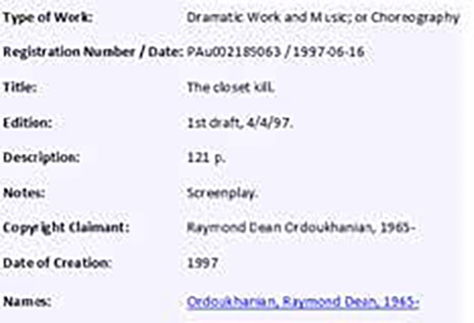
Figure 57: Proof Ordoukhanian’s claim is credible
The credibility of Raymond Ordoukhanian’s copyrighted scripts cannot be disputed. However, Mr. Ordoukhanian’s credibility itself is dubious: Raymond is behind bars, serving a life sentence in a Missouri penitentiary for statutory rape of a minor. As reported in the Lincoln County Journal:
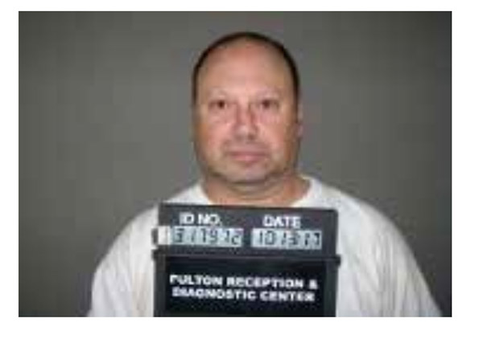
TROY MAN GETS LIFE IN PRISON FOR RAPE
Oct 17, 2017 Court documents show Raymond Dean Ordoukhanian, 52, was sentenced Oct. 10 by Judge James Beck
DOC ID:​1317972
Offender Name:​Raymond Ordoukharian
Race:​White
Sex:​Male
Date of Birth:​04/21/1965
Height/Weight:​5’7”/200
Hair/Eyes:​Brown/Brown
Figure 58: Raymond Ordoukhanian, jailed.
Assigned Location:​Potosi Correctional Center
Address:​11593 State Highway O, Mineral Point, MO 63660
Assigned Officer:​[Not Given]
Phone Number:​(573) 438-6000
Sentence Summary:​Life Registration Required Life Supv
Active Offenses:​STAT RAPE-1ST DEG-PERS UNDER 14
Completed Offenses:​Completed sentence not found
Aliases:​Raymond Ordoukhanian; Raymond D Ordoukhanian
Indeed, the screenplay was written in 1997, a few years after my disclosure being published in various newspapers, including multiple American journals. If all the above is not intriguing enough, I feel a certain obligation to add this footnote: I have a dear friend in Lemay, Missouri, a lady who has 29 children, four biological and 25 adopted. In addition, she has had dozens of foster children. One of her foster daughters was the victim of Ordoukhanian’s dirty deed. All this - the use of my last name as Enemy of the State’s lead character, the alleged theft of the script, the imprisonment of the theft’s victim, and the unlikely coincidence of the victim’s victim being the foster daughter of my dear friend - may pique the interest of the reader, but none of this can compare to the story of the Yom Kippur War Surprise. With not a small amount of effort, I contacted David Marconi’s lawyer. He assured me Marconi would contact me; he didn’t. It seemed he was avoiding me, and, indeed, he was. He was avoiding contact with “Brill” because, apparently, he had something to hide. A friend of mine succeeded in contacting him, though. He assured my friend he did not use “Brill” after discovering ex-NSA Analyst Bruce Brill had disclosed his work at the Agency. He would not, however, say how he came up with the name. Could the name, then, have been chosen by Ordoukhanian and used in his original screenplay? I contacted him in the Missouri lockup and asked him about the name. He said he couldn’t be sure; after all, he had written the screenplay two decades prior. He also said he envisioned Bruce Willis playing this character. Then he seemed to recall that he had taken the “Br” from “Bruce” and the “ill” from “Willis” and combined them into “Brill.” All this seems to suggest that Ordoukhanian came up with “Brill” and Marconi adopted it from Ordoukhanian’s manuscript.

DEEP AND EVEN DEEPER STATE

Back in the late 1970s, I worked with ARRM, Americans for Responsive and Responsible Media. We had encountered a lot of anti-Israel bias in what was then known as the “biased media” and the “permanent government” (e.g., the well-known anti-Israel stance in the US State Department). Today these terms have been replaced respectively with “fake news” and “the swamp” or “deep state.”
Also, today, since the Donald Trump presidency, there is much more focus on the news and the “deep state”. Those of us who recall John Daly, Walter Cronkite, Chet Huntley, and David Brinkley long for such straight, unbiased reporting.
These days, the discerning observer realizes today’s news is agenda-driven and biased. Subtle reporting can brainwash the undiscerning consumer without them realizing it. When someone allows themself to be exposed to only one slant of agenda-driven news, they consciously choose to reinforce their biases. This is made even sadder because they are complicit in their own duping. This happens to our political representatives and leaders as well as to the common man.
In late May of 2018, I invested several days in Washington, DC, to deliver my disclosure to the members of the intelligence committees of both the House and the Senate. I hand-delivered the disclosure to each and every member.
In the offices where they had a television tuned to the news channel, in each and every case, the televisions in the offices of Democratic members of Congress were tuned to MSNBC or CNN, and the Republicans’ were tuned to FOX. There were no exceptions.
It is no wonder these congressional leaders become so ugly with one another: their world views are so utterly disjointed. This disjointedness has percolated down to the rank and file citizen, too. I have friends for over 45 years who have unfriended me. And by “unfriending,” I’m not merely referring just to Facebook unfriending. Frankly, it’s a sick state of affairs.
I hoped the members of Congress, regardless of their political affiliation, would be lining up to contact me about what was a central item in 2018, the deep state, since my disclosure pointed to a very deep state…untouchable by any except those who happened to belong to it. Yet I heard not a word from any, left or right.
In addition to members of Congress, commentators should be interested in the deep state and the draining-the-swamp narratives. Since what I have to say points to a “very deep state”, shouldn’t this be of interest to them?
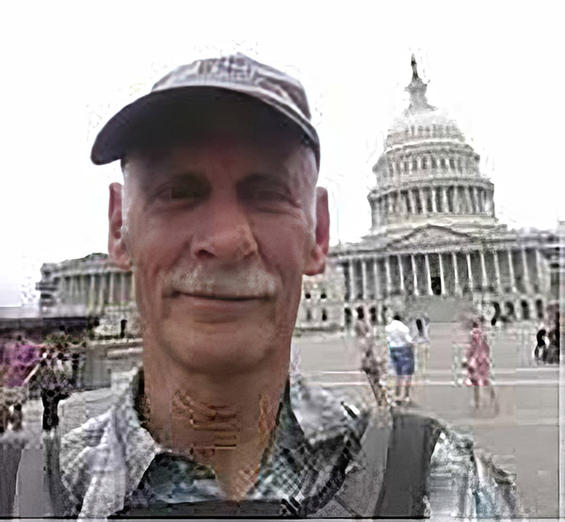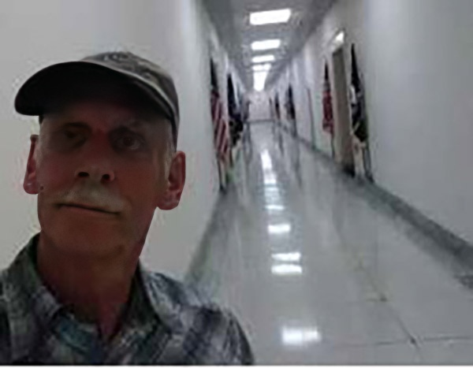
Figure 59: At the Capitol.​Figure 60: Congressional Halls.
On the other hand, the words of Rechavam Ze’evi ring in my mind: “You’re putting yourself in jeopardy.” Conversely, if my claim is “out there,” then it’s no longer a threat, and additionally, were I to be knocked off, my demise would serve as confirmation my claim is true. Getting the word out would be an insurance policy on my life.
>After returning to Israel later that year, I decided to continue to try to get the word out. But how?
I suspected my emails and snail mail were being interfered with. I decided on a novel approach: I would send snail mail out with friends traveling to the States and ask them to deposit it with US postage and no Israeli return address. Maybe this way, my letters would get to their destinations without interference.
I thought, “What would be a better conduit than US government officials and American Jewish activists (or at least American activists with Jewish-sounding names), like Dennis Prager, Alan Dershowitz, Ben Shapiro, and Mark Levin.” However, in a continuing effort to maintain a low profile, I didn’t wish to subscribe to any of their websites or blogs, which most required. So, I tried to discover mailing addresses for them and sent hardcopy letters to those whose addresses I was successful in finding. What I learned from this attempt is that few had clear mailing addresses listed. What a unique discovery: we live in the Digital Era. In the end, once again, no contact was made.
A friend took over half a dozen letters I had written to different addresses I had acquired in this way. The bad guys would have no way - I thought - to suspect I’d be using this brilliant technique… that is, until this same savvy friend sent me verification that he was mailing these letters by sending me a photo of him depositing them in a mailbox! So much for brilliant subtlety!
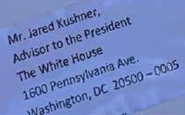
Figure 61: The “secret, subtle” mailout.​ Figure 62: Including Jared Kushner.
Again and again, doubts in my mind resurfaced. Maybe this “little detail” of 2,600 Israelis being needlessly killed by a cabal’s sabotage could be dismissed simply as an unprovable hypothesis.
As with the members of Congress, I heard back from not one of the addressees. I did, however, have the phone number of John Loftus, the author of The Secret War against the Jews. Since he was the head of the Florida Holocaust Museum, I sent my letter to him at that address, and I was not terribly surprised when he did, in fact, receive it. The point of my letter that most interested him was that I had gotten the confirmation of other NSA analysts that NSA had known in advance. He was especially interested in the one analyst who was stationed in , England. Apparently, John
knew the analysts had communicated directly to the White House
about Arab intentions to attack Israel. Perhaps the operative word “directly” needs further clarification: it could have been forwarded to the White House via the US secretary of state, Henry Kissinger.
In 2017, an Israeli by the name of Rami Rom contacted me and asked me to join a group of Israelis interested in the Yom Kippur War. Rami had been born after the Yom Kippur War and was named for his Uncle Rami, who was killed in that war. Rami had concluded that the man most guilty of the Surprise and the resultant agony was Henry Kissinger. Rami is not alone in this supposition. Many leads point to Kissinger’s possible culpability. My sharing the existence of the Jew Room and their likely major role in the deception did not reduce Rami’s finger-pointing at Kissinger.
Here, it would be appropriate to mention some of the shenanigans Kissinger was guilty of. The first was that Kissinger made light of the Soviet massive resupply of their Arab clients. “We have no proof concerning the Soviet arms shipments. And even if there are certain signs pointing in this direction, it is obvious the Soviet aid is definitely restrained,” he said. “I believe that until now the Soviet Union has not acted irresponsibly in the Middle East war.” This pronouncement riled Senator Henry Jackson to no end since it was precisely at a time when Israeli soldiers were fighting under tremendous duress caused by the imbalance of arms in the Arabs’ favor.
Kissinger’s foot-dragging of US resupply to Israel was well documented. He excused the slow resupply to Simcha Dinitz, Israel’s ambassador to the US, by saying the United States “does not have the proper transport equipment.” All this led Israeli correspondent Nachum Barnea in Washington to write, “Don’t put all your faith only in Kissinger.” He further noted, “Kissinger deliberately misled the American public and the Israeli government,” and made the point that not only was Kissinger’s reference to the Soviet resupply to the Arabs as “restrained” far from the truth, but Kissinger was well aware that it was not at all “restrained.” Golda Meir also realized that Israel shouldn’t put its faith in Kissinger, and she went directly to President Nixon concerning the resupply.
On the other hand, once President Nixon decided to get the resupply to Israel on course, Kissinger fell in line and actually did a serious job of executing the mission.
Before my disclosure about the culpability of the Jew Room crowd, those seeking a likely target for blame found Kissinger to be that convenient target: he orchestrated the means - namely the Surprise and the foot-dragging of resupply to Israel - to “make Israel bleed.” It could be Kissinger was simply ineffectual and not the shrewd and sinister master politician most make him out to be.
Rami said he’d like to meet me and have an Israeli author of an upcoming book about the Yom Kippur War chat with me as well. He arranged a meeting at Aviram Barkai’s home in Kochav Yair.
arkai mentioned he had already published two books on the Yom Kippur War. The first, Al Blimah, or On Containment: The Story of the 188th Division in The Yom Kippur War, had become an Israeli best-seller in 2009. His second was published in 2013, B’Shem HaShamayim, or For Heaven’s Sake: “The One” (Female) Pilot in the Yom Kippur War. But his biggest self-pat on the back was that he, and he alone, had been granted an extended series of interviews with General Zeira. These interviews were published in 2015 in the Hebrew daily Yediot Aharonot. Along with his exclusive access to Zeira, one could see Barkai held a certain loyalty to the man. This was manifested in his arguing that Zeira had never given “absolute assurances” the Arabs wouldn’t attack, but rather said there was a “very low probability” that they would. This clarification is intended in some small way to exculpate Zeira.
As part of Barkai’s next book, also on the Yom Kippur War, he was, of course, picking my brain. Additionally, he would once again meet with Zeira and question him in light of what I was disclosing to him. I asked him if he would ask Zeira four questions for me. First, did he get the letters I mailed him? Second, if he did, why didn’t he respond? Third, would he be open to being interviewed by the American TV magazine 60 Minutes? And fourth, did he check out The Secret War, and if he did, what did he think? Furthermore, I asked Barkai to give Zeira the correspondence I’d had with my three fellow Arabic linguists, who had confirmed that they’d known days before I did that the Arabs intended to attack Israel on October 6.
In 2017, Barkai published yet another book on the Yom Kippur War: HaSipor Sh’Lo Haya, or The Event That Wasn’t: The Conspiracy of the Yom Kippur War. After meeting with Zeira, he confirmed Zeira had gotten my letters and deliberately chosen not to respond. The friendly gentlemen who had so graciously invited me into his home is the same man who wouldn’t give me the courtesy of responding to my correspondence. In my last letter to him, I suggested two possible reasons for his not responding to my previous letters. The first was rudeness, which I summarily discounted. The second was that the subject pained him too greatly and he’d preferred to put the whole issue aside.
There’s actually a third, which I didn’t suggest to him but that one anyone who served in any military, including the US Army, would appreciate. It is the separation of the officer class from the enlisted men, the “separation of the pure from the defiled.” In the US Army, not only are residences and mess areas separate, even toilets are separate. As pointed out previously, this distinction was clear, and it could be that Zeira, so enamored with US Army protocol, saw corresponding with a lowly enlisted man as below the dignity of an officer, especially a general. Obviously, this third suggestion is a variation on the first, rudeness.
In June 2019, I spoke with Aviram by phone. He went into some detail about why Zeira wouldn’t respond. What he said was somewhat bewildering to me, bizarre, in fact. He repeated that Zeira had gotten all three of my letters and refused to relate to what I had written him. Barkai said Zeira felt uncomfortable talking about anything related to the Americans…saying that “the Americans are strong.”
I replied, “Huh?”
Barkai said we’d have to get together and talk face to face, not by telephone. We did speak subsequently. Barkai said Zeira told him, “The Americans have a long memory… and they can be brutal.”
Was I surprised by this? Yes and no. Even while I was composing my last letter to Zeira, I tried to figure out why he hadn’t answered either of my previous two. One of the outlandish thoughts that crossed my mind was that maybe he realized what I was telling him was true, and that he could “blow the whistle” on the Jew Room crowd more effectively than anyone. Maybe the bad guys were monitoring our conversation and they “got to him” with a little Mafia-type “friendly persuasion.” Shades of Rehavam Zevi’s words of warning.
When I tried to have my disclosures published in the Jerusalem Post (as they had almost routinely been back in the 90s), the op-ed editor refused without explanation. When I submitted a rewrite, he called me by telephone while I was driving with a carful of family members. I was on the car’s speakers so all could hear him screaming at me belligerently, “Don’t you ever contact anyone in my office again with your disclosure.” An Italian neighbor, who, in Italy, had contact with real Mafiosi, said the editor’s outlandish overreaction was an obvious sign he was being threatened.
Could it be?
UP AND UP
All agencies and departments in the US government pride themselves on being on the up and up; they conscientiously serve the policies of the federal government, follow the government’s policies, spend public monies wisely and efficiently, are transparent, monitorable, and answerable, and certainly do not engage in any illegal activities. One would assume NSA is no exception to this rule and that, if so, there would be no question a Jew Room could exist within its confines.
Back in 1947, the CIA was established by a public law, a charter, passed by Congress, defining both its legality and restrictions upon its operations.116 The CIA’s charter precisely defines its legal limitations. 117 By contrast, NSA was secretively established five years later,118 with no restrictions on its activities.119 In fact, the only public law impinging on NSA did the opposite, prohibiting the exposure of its activities.120 James Bamford wrote, “Despite its size and power, however, no law has ever been enacted prohibiting the NSA from engaging in any activity. There are only laws to prohibit the release of any information about the Agency.”121
Under these provisions, NSA was, for many years, engaged in three subsequently revealed secretive activities: Minaret, Shamrock, and “the watch list.” Anyone can Google these activities to understand what their purposes were. Our focus here is one of the aspects of Minaret’s provisions: “to restrict the knowledge that information is being collected and processed by the National Security Agency.”122 The importance of this is that a Jew Room could easily piggyback on such a provision. Even within the agency, it was classified higher than top-secret (namely, in addition to the usual top- secret designation, “background use only” was required). Minaret’s ultra-sensitivity was necessary since it bordered on the illegal.123
116 “USAF Established,” National Museum of the US Air Force, posted Mar. 5, 2009,http://www.nationalmuseum.af.mil/factsheets/factsheet.
117 “The Creation of the Intelligence Community: Founding Documents,” CIA, https://www.cia.gov/static/aa0f09a55dfcd5fa337e85f361347148/The-Creation-of-the-Intelligence-Community.pdf.
118 George F. Howe, “The Early History of NSA,” http://www.nsa.gov/Portals/70/documents/news-features/declassified-documents/cryptologic-spectrum/early_history_nsa.pdf.
119 James Bamford, The Puzzle Palace (New York: Penguin Books, 1983), pp. 18-19.
120 Ibid, p. 19.
121 Ibid, p. 18.
122 Ibid, p. 324.
123 Ibid.
At the outset of the ’70s, President Nixon launched his War on Drugs. Intelligence from domestic sources needed to be collected, but more transparent government agencies like the FBI and CIA weren’t permitted, by law, to spy on Americans. Here’s where the untouchable NSA stepped in. In what was known as “the Huston Plan,” President Nixon gave written approval in June 1970 for NSA to engage in domestic spy activities, entitled “Electronic Surveillances and Penetrations”124 (even using the FBI as their subcontractor), including legally dubious acts which, Huston noted, “amount[s] to burglary.”125 The next month, the president, realizing the illegality of the activities, withdrew his approval.126 However, NSA’s deputy director saw no reason to cease the operations.127 How would the president know?
Whether the president knew or didn’t know is unclear. But in 1973, the New York Times got hold of the Huston Plan and published it in its entirety on June 7. It exposed the US intelligence community in general, but it hardly focused on the low-profile “No Such Agency.” This was precisely the time US prosecutors were bringing indictments against the radical “Weathermen.” Just at the critical moment when the prosecutor could have nailed the Weathermen to the wall by having NSA provide the essential evidence it had, the case was withdrawn out of fear it might expose NSA’s illegal activities. Throughout 1973, there were fears in NSA about public exposure of Shamrock and Minaret as well.
In 1974, New York Times reporter Seymour Hersh exposed the CIA’s super-secret Chaos Operation.128 Congressmen, especially from the opposition Democratic Party, began to clamor for more transparency in the intelligence community In response, President Ford asked former New York Governor Nelson Rockefeller to head a commission of inquiry to neutralize any Democratic Party attack. Leading the Democratic Party’s charge was Otis Pike from New York, who laced into Assistant Secretary of Defense Albert Hall at a committee hearing of inquiry on August 7, 1975. Pike asked Hall for NSA’s charter, saying, “It seems incredible to me, very frankly, that we are asked to appropriate large amounts of money for that agency which employs large numbers of people without being provided a copy of the piece of paper by which the agency is authorized!”129

124 John Prados and Luke A. Nichter (eds.), “Spying on Americans: Infamous 1970s White House Plan for Protest Surveillance Released,” National Security Archive, June 25, 2020, https://nsarchive.gwu.edu/briefing-book/intelligence/2020-06-25/spying-americans-new-release-infamous-huston-plan.
125 Tom Charles Huston, “Operational Restraints on Intelligence Collection,” an attachment to memorandum Domestic Intelligence Gathering Plan: Analysis and Strategy, Section D: Surreptitious Entry, Subsection: Rationale, July 7, 1970.
126 James Bamford, The Puzzle Palace (New York: Penguin Books, 1983), p. 350.
127 Ibid, p. 351.
128 Seymour M. Hersh, Huge C.I.A. Operation Reported in U.S. against Antiwar Forces, Other Dissidents in Nixon Years, New York Times, Dec. 22, 1974, https://Www.nytimes.com/1974/12/22/archives/huge-cia-operation-reported-in-u-s-against-antiwar-forces-other.html.
129 The First Congressman to Battle the NSA Is Dead. No-One Noticed, No-One Cares, Pando, https://pando.com/2014/02/04/the-first-congressman-to-battle-the-nsa-is-dead-no-one-noticed-no-one-cares/.
If the charter -- a mere “piece of paper” -- was not forthcoming, how much less so might be the details of NSA’s hidden, and even illegal, operations. The details of such operations as the watch lists, Minaret, and Shamrock were successfully hidden from view. How much more so could the likes of the even more sensitive and embarrassing Jew Room be safely hidden from outside monitoring?
I think the reader gets the point: NSA has been trying to remain aloof from public scrutiny. Up until the Church and Pike Committee hearings in August of 1975, it was doing a superb job. Before 1975, there was not a peep. Why, way back in the late ’50s, NSA kept Congress in the dark about an Air Force EC-130 that crashed in Armenia while on a spying flight of the Soviet Union.130 Subsequently, NSA has been very good about keeping its activities under wraps. The period we are focused on, October 1973, came before serious efforts to expose NSA’s activities. Even the Church and Pike Committees in 1975 hardly scratched the surface. Only after “Mr. Whistle Blower,” Edward Snowden, in 2013, has NSA become a household word.
What about internal monitoring?
130 1958 C-130 Shootdown Incident, Wikipedia, last modified March 3, 2021, https://en.wikipedia. org/wiki/1958_C-130_shootdown_incident.
MONITORING
While NSA should follow the same basic federal guidelines requiring agency directors to know what’s going on in agency departments, we have seen that at NSA this routinely does not happen
That would be one aspect of internal monitoring. Another aspect is comprised of several additional factors: compartmentalization, special clearances, and the need-to- know principle. As mentioned earlier, there are sections within the agency where only cleared members can enter and know what is happening inside them. How do I know this? Because I worked in one such section. I mentioned and vaguely described the section I worked in that had limited access. I never questioned why what we were doing needed to be removed from the general area or why we needed to have special access: I did not need to know why. But now, in retrospect, I really don’t know why it was removed and isolated from the general area. No idea. But there were other such areas. I described one, the room through which I needed to pass to access the teletype, which might - again, with suspicious 20-20 hindsight - have been a part of the Jew Room. I don’t know. I didn’t know then. I never asked: I did not need to know.
Compartmentalization and shields of classification effectively serve to keep certain departments well insulated and off the radar for those without the need to know. In the mid-’70s a top-secret congressional task force was set up to investigate the legality of NSA SIGINT operations. In its report, Dougald McMillan affirmed:
It is likely … that we had insufficient information on occasion to frame the ‘magic’ question. One also had to ascertain the specific person or division to whom the right question should be addressed, since compartmentalization of intelligence-gathering often results in one hand not knowing what the other is doing.131

131 Dougald D. McMillan “Report on Inquiry Into CIA-Related Electronic Surveillance Activities”, June 30, 1976 https://nsarchive2. gwu.edu/NSAEBB/NSAEBB178/surv09a.pdf).
In describing NSA’s Shamrock operation in the early 1970s, researcher James Bamford wrote, “So compartmented was the program that besides the middle-level manager, the only other persons exercising responsibility over the operation were the director and deputy director.”
Could the compartmentalization be so strong that even the director might be in the dark about certain offices’ activities? Richard Helms, the director of the CIA a half-dozen years before the Yom Kippur War, admitted, “It was unrealistic for any Director of Central Intelligence to think that he could have a significant influence on U.S. intelligence-resource decisions or the shaping of the intelligence community,” and he observed that while he, “as DCI, was theoretically responsible for 100% of the nation’s intelligence activities, he in fact controlled less than 15%.”
Section 6 of Public Law #86-36 ensures that NSA’s organizational structure, namely both positions under the director as well as departments controlled by mid-managers, are anything but public:
Nothing in this Act or any other law … shall be construed to require the disclosure of the organization or any function of the National Security Agency, of any information with respect to the activities thereof, of the names, titles, salaries, or number of the persons employed by such Agency.
What this translates to in simple, non-legalistic terms is that within NSA, there can exist taxpayer-funded departments engaging in unmonitorable activities whose existence, not to mention activities, remain out of public view. This could easily shield the likes of the Jew Room and its activities.
The Pike Committee’s investigation requested that the General Accounting Office (GAO) review the budgets and management of the various US intelligence agencies. An eight-page letter dated July 31, 1975, from Elmer B. Staats, the comptroller general, was sent to Chairman Otis Pike detailing their findings. 132
132 Elmer B. Staats, “Statement of Elmer B. Statts Comptroller General of the U.S.,” United States General Accounting Office, 1975, https://www.gao.gov/ assets/094629.pdf.
133 Ibid, p.4.

The letter begins by referencing their previous findings about the US intelligence community in a May 10, 1974, report sent to Senator William Proxmire. 133 Staats states that the GAO’s authority encompasses both financial auditing and “also management reviews and evaluations of programs and activities.” But then he adds that although “broad access to records and information is necessary to accomplish these tasks,” there are certain restrictions on the GAO’s audits of the intelligence community. “The intelligence community generally requires special security clearances, which are expensive to process and require at least 6 months or more to complete.” An explanatory note is added: top-secret clearances are not sufficient for accessing certain classified intelligence. A list is then made of instances where Staats was “unable to gain access to the necessary information.”
The Instances included:
• The CIA disallowed the GAO access to certain information requiring special clearances (above top secret).
• Only summaries from some FBI programs were given to the GAO due to the possibility of compromising informants.
• The GAO could not obtain verification of data from the CIA to fulfill an October 1974 mandate from the House Committee on Foreign Affairs/ International Relations.

• The CIA did not respond to a January 17, 1975, GAO letter regarding a specific inquiry surfacing from a query by Senator James Abourezk.
• The Office of Management and Budget was refused data requested from the CIA and NSA regarding certain “sensitive Defense Intelligence activities.”
• Reviews of NSA were limited to administrative compliance audits.134 No management-type reviews were conducted.
• The GAO was precluded from reviewing NSA expenditures due to operation and maintenance appropriation acts of May 1974.
• A well-written summary of the GAO is given in a section labeled “Observations:”
134 From https://www.lucidchart.com/blog/understanding-types-of-compliance-audits: "A compliance audit is a formal external review of an organization’s operations and procedures to ensure they are following all applicable laws, rules, standards, and regulations.”
The letter continued:
In general the GAO has not taken the initiative in pressing for oversight of intelligence operations but has made serious efforts to assist the committees on a request basis. Even so, we continue to have serious difficulty in obtaining information from and about the intelligence community in those limited instances where intelligence information is germane to the issues we are addressing. On occasion the community cooperates to the extent of giving us certain requested information but even then we are afforded insufficiently broad access to agency records to independently verify the accuracy and/or completeness of the material supplied to us precluding us from reporting to the Congress in a way that would materially contribute to the exercise of its oversight function. Also lacking, in our opinion, is any clear-cut mechanism for acquiring access to information when our views and the agency’s views differ as to our right to access, such as power to enforce access in court. We believe a strong congressional endorsement will be necessary to open the doors to intelligence data wide enough so that we can make the meaningful reviews of intelligence activities that would assist the Congress in performing its oversight function. We have been asked for our views of how congressional oversight and control over the intelligence community might be improved in the context of the sensitivity necessarily attached to intelligence matters and the desire to reduce the risk of leakage by minimizing the number of people having access to intelligence data. Our experience in the intelligence community, as indicated above and in our letter to Senator Proxmire, has been relatively limited. However, we have had sufficient experience to identify the hard policy questions, outlined below, that we conclude deserve congressional attention and your Committee undoubtably will focus upon:
1. Significant amounts of public funds are spent on intelligence, but only a small congressional minority has access to the use planned to be made of these funds. We believe, therefore, that Congress should once again, as it has in the past, consider the manner in which oversight of the intelligence community is managed in the light of the constitutional provision that no moneys be spent from the public treasury unless appropriated by the Congress. In this regard, the Congress should consider the role GAO is to play in what the Congress ultimately decides should be the requisite congressional approval of intelligence community funding and activities. GAO’s role should be sufficiently clarified so that it can determine its reporting responsibilities.
2. The Central Intelligence Agency, in effect, serves as more than an intelligence agency. In addition, a number of authorities have expressed concern that it has been permitted to enlarge its purpose and to exceed the authority contained in its enabling legislation. We believe the Congress should address the questions of whether some broad policy guidelines and criteria for certain types of covert national security activities should be established by legislation; whether any agency responsible for intelligence collection should also be responsible for carrying out actions; and whether the existing congressional system for identifying, approving or disapproving significant individual covert projects is adequate.
The letter continues to a third point, which touches on two items. First is the unclear budget, which Staats estimates being between two and five percent of the federal budget. How this undefined budget is allotted needs to be made clear, he states. The main point that relates to our concern is the compartmentalization within the intelligence community. Staats explains: “The U.S. intelligence community is such a highly compartmentalized structure of organization and management that only a few people at the top have visibility and cognizance of all activities.” This problem brings the comptroller general to end his report with these questions:
Are the agencies within the intelligence community so organized and structured as to permit such a management review function as an “internal” matter? If not, can they be made so to enhance the possibility of congressional oversight management review, wither by the oversight of congressional oversight management review, wither by the oversight committees themselves or with the assistance of GAO or others?

CHAIN OF COMMAND

The US military’s webpage “Grievances and Filing Complaints”135 discusses what constitutes legitimate reasons for filing complaints as well as the proper procedure for filing them.
135 https://girightshotline.org/en/military-knowledge-base/topic/grievances-and-filing-complaints
Two such legitimate grievances are “mistreatment by a superior” and “unlawful discrimination.” Both these types of abuse were certainly at play during my work at NSA in 1973. Since Mike G wasn’t a military superior, the proper military chain of command wasn’t apparent. The correct procedure was not clear. In any case, good- hearted military superiors came to the rescue and resolved the abuse.
When racial or religious prejudice is subtle, such abuse is typically unprovable. In my case, my being dumped on by an immediate supervisor was something the good folks in management saw, understood, and dealt with. If they hadn’t “come to my rescue,” it would have been difficult for me to have proven the abuse. This was something difficult, if not impossible, to prove. Thank God for good people with the eyes to see and the ability and courage to act.
Even more difficult to prove is the national-level abuse perpetrated by the Jew Room crowd. How can a drunk’s finger-pointing be taken seriously by the authorities? Furthermore, once a Big Brother-fearing supervisor was sober, why would he be open to divulging this abuse when his career might be at stake? Once again, the necessary requisites are not only the eyes to see, but the ability and courage to act.
In any case, this abuse only became apparent to me after years of agonizing over and dwelling on the problem, along with reading the corroboration about NSA’s “Jew Room” detailed in John Loftus’s The Secret War against the Jews. This was some two decades after I had left my work at NSA and shed my uniform for civvies.

On the “Grievances and Filing Complaints” page, the proper procedure is laid out. The first two steps outlined under the rubric “There are several formal methods for requesting redress of grievances” are:
1. Complaints through the chain of command
2. Correspondence with a member of Congress.
I believe I have behaved correctly in this regard at every stage.
First and foremost, I did not violate my secrecy oath by making any of my disclosures public. Some of the information I shared was sensitive, yes, but not classified. Disclosing sensitive information, if it is unclassified, is not a disclosure of classified material. Why is it “unclassified”? Simply because, as stated before, my NSA supervisor shared it with me over a black phone. In any case, before I went public, I tried to alert US government officialdom by first going to the US consulate in Jerusalem. There I spoke with Deputy Consul Eugene D. Through him, I tried to get my revelations to someone within the government. Only when this failed did I publish. Later on, after meeting John Loftus and learning of the Jew Room and that crowd’s mischief, I sought further redress - by turning to members of Congress. As previously detailed, in May of 2017, I handed hard copies of my disclosure to the DC office staff of each and every member of the intelligence committees of both the House and the Senate. In accordance with the chain of command principle, I also tried to indicate the need for an investigation of NSA’s Jew Room through my local congressman.
For the past half-dozen years, my official residence in the States has been my son’s address in Nevada County, California. There, my representative in Congress is Douglas LaMalfa in California’s First Congressional District.
Several times since 2015, I tried to alert him about the issue of the Jew Room. I had discovered it back in 1973, and it had also existed in 1996, the year of The Secret War’s publication, so why wouldn’t it still exist now? How can the existence of clandestine rooms within a top-secret-plus agency be ascertained? Even I, having above top-secret clearance, was prevented from learning of their existence. How is it possible to know if such rooms are still operating today?
It would require a serious congressional investigation. It wouldn’t have to be a public investigation, but it would have to be monitored by trusted members of Congress. But think about it: how can it be truly monitored? Who would have the permission to enter behind the closed doors within a secret universe? In 1973, there was no reason to believe that even the president of the United States of America knew of the existence of the Jew Room, much less the goings-on within these secret cells.
Conspicuous by their being exceptional were the visits to NSA of Vice President Hubert Humphrey in 1967 and Vice President Bush in 1981. Neither could have possibly been shown each and every department and room. Humphrey’s superficial tour brought him to the very accessible and well-known Friedman Auditorium, not at all connected to the Jew Room (despite its Jewish-sounding name). There, he acknowledged that NSA’s work was appreciated by the country, even though few outside the Agency knew about it, most likely including himself. The specific work of this taxpayer-funded Jew Room crowd within NSA and other intelligence agencies has been immune to scrutiny.
Already in 1959, the obscure Public Law 86-36, Section 6, stated,
Nothing in this Act or any other law… shall be construed to require the disclosure of the organization of any function of the National Security Agency, of any information with respect to the activities thereof, or of the names, titles, salaries, or number of persons employed by such Agency.
James Bamford notes: “Under this little-known law, NSA has the unusual authority virtually to deny its own existence.”136 Given that, this congressionally passed legislation gives total immunity to any Jew-Room-like departments and their activities.
136 James Bamford, The Puzzle Palace (New York: Penguin Books, 1983), 122.
So, immune from disclosure, it is possible - even probable - that the Jew Room’s existence might not have been known even to the director of NSA. DIRNSA manages budgetary issues, internal politics, and relations with outside officialdom. Most directors have little background in SIGINT or COMINT. The day-to-day management is left to D/ DIRNSA, the deputy chief. The director could very likely not be aware of hidden departments within the Agency. As a general rule in many sensitive government agencies, those with easy access to classified information are the workaday employees and not the department heads. Ironically, the need-to-know principle often allows underlings access to information, including programs and departments, of which the director could be unaware. For 16 years, from 1958 to 1974, the position of deputy director was held by one man, Dr. Louis William Tordella. During his reign, directors came and went. One, General Pat Carter (who arranged for VP Humphrey’s visit) once remarked “the director was a transient.”
Carter admitted he couldn’t be certain he knew all NSA’s secrets, understanding that underlings felt justified in not burdening him with such details.137 One immediate “underling,” D/DIRNSA Louis Tordella, for example, waited an entire year before telling "Carter’s replacement,", Noel Gayler, about NSA’s secret watch-list program (targeting US citizens).138 Others within NSA were also kept in the dark, including the program’s own intercept operators.
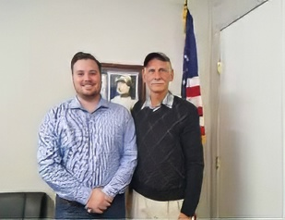
Figure 60: David Morgan and the author at Auburn office.
137 Ibid. 333.
138 Ibid.
"Still, even though it would be next to impossible to provide hard evidence of the Jew Room, I tried to alert government officials. My main hope in the chain-of-command procedure was via my congressman. After getting no response from Congressman LaMalfa to numerous emails and written letters, I had my son hand-deliver my petition and disclosure to an aide, Ms. Lisa B. Mark, to pass on the congressman. Again, no response. When I came to California on a visit in the fall of 2019, I called his Auburn office and spoke with another aide, David G. Morgan. I arranged an appointment and went to the congressman’s office. Although it wasn’t possible to meet with the congressman, David assured me the congressman was a true and proven friend of Israel and that the matter would be brought to his attention. David guaranteed me that he, David, would get back to me and would remain available.
In fact, he did. But the exchange was not terribly reassuring. We discussed two issues: the non-response to my multiple inquiries and the Jew Room itself. (You can find the exchanges in the Appendix.)
David said the congressman’s staff in Washington checked into the matter and learned from their DC office that there is no policy of maintaining Jew-free “Jew rooms” at NSA; I would add “today” since he did not deny the policy existed in the past. But as I noted to him in my correspondence, “I’m from Missouri.” Show me! Assure me! Prove it!
How can we know the Jew Room does not exist today, as David Morgan learned from his Washington contact? Who could verify this claim, and who among such individuals would be reachable? The first person would, of course, be the president of the United States, but would he be “reachable”? The answer is, probably no.
Solving the unreachability problem would require what I call the “this is the hand” principle. “This is the hand that shook the hand that shook the hand that shook the hand… of the president of the United States.” In other words, whoever had the ear of the president might be reachable. White House staff, of course, and family. Jared Kushner was both. Others on the staff, such as Kelly Ann Conway, were possibilities. Newscasters with occasional contact with the White House were also possible avenues. Finally, Donald Trump’s close friend, David Friedman, the US ambassador to Israel, was possibly the best avenue.
In any case, the proper chain of command would dictate using the route of the ambassador to Israel since I resided in Israel. But what was the proper way to reach the ambassador? There were three possible routes: the “this is the hand” method, the postal service, and going in person to the US embassy.
Having failed to reach Friedman through mutual acquaintances, I sent a letter containing my disclosure by registered mail to the US embassy in Tel Aviv. After the embassy was moved to Jerusalem, I sent a second letter by registered mail to the Jerusalem address.
At the same time, I personally went to the US embassy in Jerusalem to knock on Friedman’s workplace door. I met with a consular official and told him I had written two letters to the ambassador at the embassy in Tel Aviv and later to the embassy in Jerusalem and received no response, not even an acknowledgment of receipt, and that I suspected they never reached him. The official asked me if I had the disclosure with me. I did. I asked him if he would get it to the Ambassador, and he assured me that he would “try”. I asked him for his name, and he said, “David.” I asked for his card. He wouldn’t give it to me. I asked for his last name. He refused to give me his last name, saying, “I’m the only official at the embassy whose name is David.”
I wonder what David Friedman would have to say about how his underling treated a visitor to the embassy.
No matter what method I used, I got no reply or any indication my message reached the attention of the US ambassador to Israel.
So much for going through the chain of command. Even registered letters to NSA’s security chief received no response. In addition to the two registered letters I had sent to NSA’s security chief in 1993 and 1994, a 2019 registered letter I sent to him was also summarily ignored.
How might one deal with the frustration of unresponsiveness? Maybe the solution to the problem of getting the word out is to write a book. In fact, almost everyone with whom I shared my disclosures, especially after Zeira’s hard-to-believe admission to me, would suggest, “Bruce, you should write a book.”

CORROBORATION
Would the story be of interest to a publisher? An acquaintance arranged a meeting with the president of Koren Publishers, Matthew Miller. He listened attentively to my story and said that although Koren doesn’t publish stories like mine, it is a story of interest, but only on the condition that I have corroboration that I knew in advance about the attack.
I told him I had taken a polygraph test in 1993 confirming not only that I knew in advance, but also that I had learned there are rooms within NSA where Jews are not allowed entry.
Mr. Miller replied that lie detector tests can be fooled. Something more reliable would be needed to substantiate my claim. I answered by saying I had been caught in a lie while being interrogated by an NSA security officer in 1974, demonstrating I am incapable of lying to a polygraph.
No, this corroboration was not adequate. He asked if I knew of someone who could provide corroboration. I explained that I had told two people and was confident they would corroborate what I knew: my girlfriend at the time and my sister.
No, this, too, was not adequate corroboration. He said another NSA analyst who knew what I knew would be the corroboration essential to making this story salable.
Other NSA analysts who would be willing to confirm this story would make it unquestionable and, therefore, not only compelling and explosive, but also salable.
Certainly, those fellow analysts who were still working for NSA would not - or could not - come forward and “rat on” NSA misdeeds that cost an allied country 2,600 dead. That would be too much to ask. Anyway, I wasn’t in contact with any of them. They -- for reasons of security -- preferred not to maintain contact.
Uncleo, on the other hand, was a good friend, a really good friend, and we, of course, had maintained contact. When Vivian and I got married in Brooklyn in 1976, Uncleo was our best man and held one corner of the wedding canopy. After our honeymoon, we moved in with him, and when Vivian and I moved back to Israel, I would always visit Uncleo whenever I took a trip to the States. There was no question about it; he was practically family.
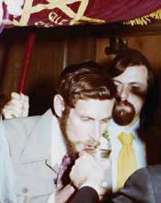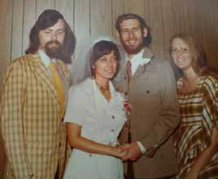
Figure 65: Uncleo holding our marriage canopy. Figure 66: Uncleo, bride Vivian, me, sister Rachel.

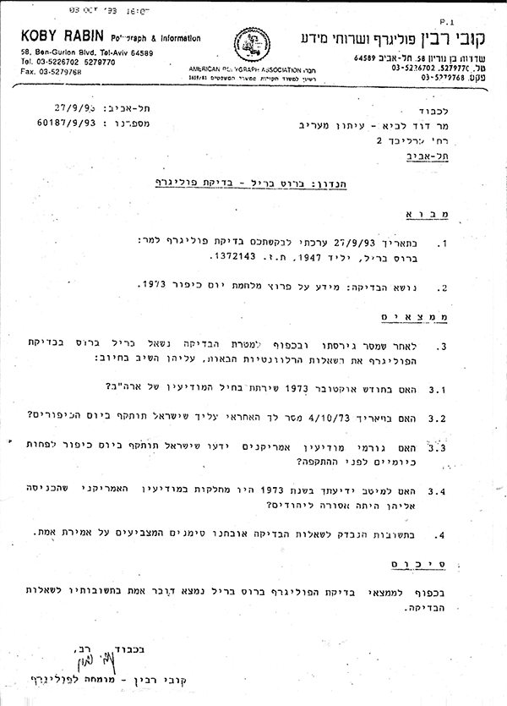
Figure 64: 1993 polygraph test results.
Sometime in the 1990s, Uncleo had mastered Arabic so well that he had become the head of the Arabic Division at NSA. As I said before, he is nothing less than a linguistic genius.
After 9/11, though, Uncleo, ever wary of Big Brother, suddenly refused to see me. I was told by mutual friends that this had something to do with NSA’s Arabic Section not anticipating the 9/11 attack in advance and the severe censure that fell upon them. That and Uncleo’s being extremely wary and apprehensive of Big Brother somehow seemed to make some sense. On the other hand, I asked myself, what on earth would be troubling to him about him staying in contact with me? I had moved to Israel, not Saudi Arabia or Afghanistan.
Losing connection with Uncleo has been a painful loss to me. I will always remember him fondly. Fondly shmondly, Uncleo was no longer a possibility for corroboration. In any case, in 1973, he was the head of the Hebrew Department, not the Arabic Department. The Hebrew Department was spying on Israel, not the Arabs. It’s not clear, therefore, that he would have known.
FACEBOOK TEXT CHATS WITH DAVID G, KAREEM, AND DAOUD

But wait a minute; I did maintain contact with some of the other NSA analysts who did not take on NSA positions after their discharge from the military.
Additionally, we are now in the 21st century, and connections can be made digitally, so I contacted three colleagues who worked Arabic targets and with whom I’d kept contact. I broached the subject with the three of them.
All three not only confirmed that they knew with certainty, but they knew before I did. One knew four days in advance, one a week before, and the third nearly two weeks prior.

MY CHAT WITH DAVID G (8/2018)

Me: David. Hi. Yom Kippur just began here a couple hours ago. I have a strange question to ask you…
David: Ok. Have a blessed Yom Kippur. Ask away.
Me: How many days in advance did you know that Egypt and Syria were going to attack Israel?”
David: Ah. Good question. A long answer is in my book, Storm Over Malham Cove. It is fiction, but some of the core facts re the invasion and what I knew are in there, although hard to sift. But the quick answer is that there was a gradual lead-up of facts that I directly translated.
Me: YOU WROTE A BOOK ABOUT IT?!
David: I can’t be sure now but I believe that it was getting more and more likely a week or so ahead. [David pasted an Amazon link for his book] It is highly highly fictionalized but I did a lot of research on the Yom Kippur War itself and that is in my book … a whole espionage scenario with bad and good guys on every side.
Me: So, you know who Eli Zeira is?
David: Anyway, I think the translations I sent showed clear signs that the invasion was imminent a couple of weeks ahead although the signs had been there (Egyptian Army full-scale exercises with tank snorkeling, etc.) a month before.
Eli Zeira doesn’t come out well in my book!!! I mean, not in a good light.
Me: I met with him at his home on July 4th.
I asked him straight out, why he was SO CONVINCED that the Arabs were NOT going to launch an attack.
David: Wow!
[David pasted a page from his book]
I sent pic of page of my book with first mention of Eli Zeira. I had theories not believe the clear evidence the invasion was imminent…
Again, fictionalized out the wazoo but with a framework of fact. I can’t know of course.
Me : That’s the point…. THEY DID…. But Zeira pooh poohed his own people’s take. And I asked him WHY…
David: I know some of the transcripts I did (in Arabic with translations) went right to the White House in the end.
I also believe, from what I have studied, that Kissinger and Nixon buried the attack info.
Me: Wow
David: As you know… the Nixon tapes were very revealing.
…
I believe that Kissinger was the chief architect because of his efforts with the Soviet Union. Nixon was horribly anti-Semitic of course.
Kissinger was essentially anti-Zionist I believe. He was a European. I think the record bears that out. Although I am reluctant to make those kinds of assessments. I do, however, in my book as fiction.
Me: Ahha…. that’s “safe?”
You don’t feel in any kind of danger for writing your book?
David: I thought about that for years. But after all the exposés, I decided that NSA and, I hope, others have bigger fish to fry.
Me: You’re a brave man, my friend. (brave or crazy! ��)
David: Plus not many people will read it because it is self-published, although on all the platforms.
I am more likely to die riding horses than any other way! My book is also about horses and the Romany people and music and the Yorkshire Dales, etc. Starting a sequel right now.
Me: I would guess that once the book was out you’d feel safer… because
1. If they knocked you off that’d be proof that what you wrote is based on truth, and 2. You’re not longer “a threat” since it’s already out there.
David: Yes. I think that attracting any publicity to the book would only tend to confirm things.
Me: Right. You heard of “The Jew Room” at NSA?
David: So I don’t market (at least yet). I might when I go to Yorkshire again next year to ride my bike. I think that the folks in Yorkshire should read it.
I think I heard something about the Jew Room but I can’t recall. I do show NSA as distrustful of Jewish analysts etc.
And I mention that Hebrew was referred to as Special Arabic - we were not supposed to be spying on our friends! I translated a lot of battles during Yom Kippur War with both Hebrew and Arabic. Most Hebrew was scrambled, however.
Arabs had very lax comms discipline.
Including Syrians, Egyptians, and later the Iraqis.
…
Me: Can I share with you what I wrote about my Zeira visits?
David: I would LOVE that! The military and intelligence aspects of the Yom Kippur War are fascinating to me.
Me: Here goes...

The Truth Behind the Yom Kippur Surprise

[Author"Me" in writing] We in the Arabic Section of the US National Security Agency (NSA), where I worked at the time, knew days in advance and with certainty that Syria and Egypt were about to launch a coordinated attack against Israel on October 6th 1973.
Yet, on the eve of the 1973 Yom Kippur Surprise, Israel’s Prime Minister, Chief of Staff, and Defense Minister were all given absolute assurances [“very low probability”] the Arabs had no intention of attacking Israel on or before Yom Kippur, October 6th. The assurances were given by Israel’s Head of Military Intelligence, General Eli Zeira. In spite of his very own Army Intelligence indications, General Zeira was thoroughly convinced the Arabs had no intention of attacking because of unnamed friends’ assurances.
Who were these “friends” that Zeira relied on with absolute trust and confidence? This troubling question could be answered by one man and only one man, General Eli Zeira. I met with the General at his home on July 4th. A man of almost 90 years of age, he listened intently to my story. He then drew a sketch on a sheet of paper and labeled a box at the top. This box represented the US generals with whom Zeira was in direct contact. They were fed intelligence synopses from NSA.
Finally I asked the question that had been troubling me for 44 years. Were “the friends” he so completely relied upon those American generals?
Zeira kept his lips sealed tight. He closed his eyes. He slowly and deliberately nodded his head in the affirmative. But Zeira assured me these US generals were completely trustworthy.
How was it that we at NSA’s Arabic Section knew, but even those trustworthy US generals didn’t know? It was clear to General Zeira that the correct intelligence that we had in the Arabic Section was already manipulated before it ever reached these US generals. One would assume that President Nixon himself was also given the adulterated intelligence. How was it that NSA had even reported to the 1974 US Congressional Commission of Inquiry that NSA did not know? Yet we in the Arabic Section knew, and knew it for a certainty.
I could see that Zeira was troubled by this inexplicable point. I shared with the General that while I was at the Agency I discovered that there were rooms there that I couldn’t enter in spite of my well-above top- secret clearances. I learned that they were off limits to me because I am a Jew. Since these Jew-free areas’ existence was secret, especially to Jews, it was pure happenstance that I discovered them. In The Secret War Against the Jews authors Loftus and Aarons talk about the “Jew Room” at NSA. They say it’s a total misnomer since it is not just one singular room, and that anti-Israel and anti-Jewish activities occur within them. I suggested to Zeira that the manipulation happened in this Jew Room.
Zeira seemed troubled by this revelation and was curious to learn more. He understood that his American counterparts, themselves thinking the misinformation they passed him was correct and certain, naively passed him their assurances. They, themselves, were duped and not to be faulted. By the same measure, Ziera cannot be totally faulted.
In spite of the Israeli government Agranot Commission of Inquiry’s conclusions and public perception putting the blame on Zeira’s shoulders, the blame belongs to NSA’s Jew Room.
David: Just read what you wrote. Seems very accurate to me overall and quite consistent with both the fact and fiction (i.e. not known by me but suspected) in my book….. I also believe there were elements in the military who couldn’t believe that Egypt would attack. You are aware of the Egyptian double agent who was feeding misinformation to Aman? I believe that was also a big factor.
[some alehouse chat for some minutes here…]
Me: You didn’t know the head of the Hebrew Division…I assume (?) … I was his roommate.
David: The guy who sang “Take Me Out to The Ballgame” in Chinese? And various other tricks.
Me: We became very close friends, but after 9/11 he refused to see me.

David: Yes. I slept on your couch for a bit while I was finding my room in Laurel.
Me: Right. He was a genius. And F U N N Y … hysterical.

David: I still do his singing one or two words off. And he is in the book - recognized as a true genius. A funny character and unforgettable. With his Fu Manchu.
Me: I don’t know why he refused to see me after 9/11.
David: I think I made him my roommate. If he was still working at NSA, it’s obvious. He was scared.
Me: But why? I didn’t relocate to Saudi Arabia or Afghanistan.
David: My father-in-law worked for NSA and retired after many years. NSA is paranoid. They made him give up his friendships with very good German friends (friends of ours also) going back 30 years because they were “foreign.”
Me: Not only was he still working for NSA, but he became the head of the ARABIC Division!
David: A real genius! What was his name again?
Me: We called him “Uncle Leo.”
David: As in Trotsky?"
Me: I loved him.

Kareem's Corroboration (8/2018)

Me: Hi ---[Kareem]----. You there now?
Kareem: Yes.
Me: Howdy partner
Kareem: Howdy. How you?
Me: I was just speaking with an Arabist who was stationed in Europe … I wonder if you know David Gallaspy? He was a zoomie.
Kareem: Sort of sounds familiar, but I was only Arabic speaker in All zoomies were Russkies.
Me: He was stationed in Great Britain. … maybe Scotland.
Kareem: That is why I was deployed for Yom Kippur War. I was only Arab/Russian speaker they had."
Me: Ahha.
Kareem: No. never contacted them. He was probably in air support group.
Me: He said that they knew the Arabs were going to attack a good week prior to Yom Kippur.
Kareem: They had airborne listening posts at . Yeh, I got an Arcom for first reports of Israeli success.
Me: What’s “Arcom”?
Kareem: Army Commendation Medal
Me: How far in advance did YOU know the Arabs were going to attack? Do you remember?
Kareem: Not really. We started getting lots of traffic and knew something was in works a couple weeks ahead. Arabs were really noisy in moving people.
Me: Yeah, but they were also noisy when they had maneuvers weeks and months before…. so it COULD HAVE BEEN just another exercise. (??)… right?
Kareem: As I recall the Arab brigades came up on radio and announced their units and what callsign they would use. Not when you had Egyptian and Syrian both doing stuff and lots of them.
Me: Gotcha. … so there was no doubt (?)
Kareem: I don’t think the Israelis had any doubt that a move was coming. I assume Sadat’s people were as bad about security as their troops.
Me: By “The Israelis” you mean Israeli intelligence?
Kareem: Yes. I was getting atmospheric skip of the field level comms. Usually wouldn’t get to Europe. They deployed me south to have me in the strongest radio skip zone.
Me: Right…. but there was ONE Israeli in Israeli intelligence that not only DID have doubts, but he was convinced that the Arabs WOULD NOT attack… and that was the Head of Israeli Intelligence. General Eli Zeira.
Kareem: Don’t know that, but he had to be ignoring a lot. Arab radio “lit up” in late September 1973.
Kareem: Interesting. My medal was written up in a commendation which at the time was classified. It commended me for reporting that the Arab tanks were preparing to cross the water. I wrote in the report that I felt the water was the canal."
Don’t use my name in any discussion of this.

Daoud's Corroboration (8/2018)
I mention that I was just texting with David G and Kareem and told Daoud they said they knew a week and more in advance about the Arab plan to attack Israel by surprise]
Me: How much in advance did YOU know?
Daoud: Are you talking about how far in advance we knew it was happening?
Me: Yeah. I only knew a couple days in advance.
Daoud: I don’t recall very well, but what I remember is that the AOB’s (Air Order of Battle) were showing a lot of troop movement, and everyone knew something was going on, but not necessarily what.
Me: But… do you recall if it was like a week or two earlier, like David and [Kareem] were saying? … or just a couple-few days?
Daoud: I don’t recall - seemed like a few days. That is 40 years ago. [A few years earlier, when I visited Daoud at his home in Oroville, CA, he had told me “four days in advance”.]
Me: 44 to be exact. I’ll tell you why I’m asking… I visited the Israeli General who was Head of Military Intelligence. He was absolutely convinced that the Arabs were NOT going to attack in spite of his own people telling him that an attack was imminent. And he succeeded in convincing Golda and Dayan and the Chief of Staff (Elazar) there was nothing to worry about. But his own people were trying to alert him that something was afoot.
But he was certain that there’d be no attack. Why? … because he was assured by “friends.”
Daoud: Well that is how history works.
One can see the different approaches the three other Arabic analysts take. Daoud, in contrast to David G and Kareem, seems very dismissive, or at best, uninterested. After he got divorced, he had to leave the pulpit of his fundamentalist Protestant church (Church of God, I think). He became an Episcopalian priest. We were Facebook friends and, I have to say, he’s not the same friend I liked so well 30 or 40 years ago. He hates Israel and believes Israel is oppressive. He posts all kinds of nasty things about Israel, which fits nicely with the Episcopal Church’s antipathy toward the Jewish state. When I asked Daoud about NSA’s Jew Room, he told me he’d never heard of such a place. I would like to believe him, but in light of his vocal disdain for Israel, I’m not convinced.
I did not learn of Arab intentions to attack Israel by surprise from any raw, first-hand intelligence I was working, since I wasn’t working any, but from my supervisor. By contrast, at least two (David G and Kareem) of these three colleagues gleaned the intelligence firsthand. They were privy to raw intelligence that required a non-trivial use of Arabic.
Since none had better Arabic language skills than I upon leaving Dillywick, my being assigned an inconsequential NSA job requiring but a paltry use of Arabic strongly suggests that I had been sidelined. Additionally, what minimal Arabic I used was not the Egyptian I was trained in, but Syrian.

YITZ’S CORROBORATION
“Yitz” is an Israeli name. How could a “Yitz” offer corroboration as an NSA insider at the time of the 1973 Yom Kippur War? 139
Keith Kothe stands 6 foot four inches and adopted Texas as his home state at age 29. “I wasn’t born in Texas, but I got here as soon as I could.” After a couple of years of college Keith enlisted in the US Army. Did he have to enlist, like I did?
Actually I used to lie about my draft number and say it was 69 same year I graduated from high school. Fact was I was 350! [the highest number called that year was 125140 ] I didn’t want anybody to know how crazy I was, so I lied about my lotto number being low.
Because he scored well on the pre-enlistment tests and because he had a couple of years of college, he was recruited into the selective ASA upon induction.
Before I even left the induction center, I was approached by two men who asked to speak to me privately and I was recruited to work for the Army Security Agency which is a military operation of the National Security Agency.
After basic training at Fort Leonard Wood Missouri, he was sent to Fort Devens, MA for security training with a class consisting of a mixture of Army ASA and Green Berets.
That training was loosely referred to as intelligence analyst, but specifically it was more intently focused on traffic analysis… meaning deciphering the structure, frequency and importance of various communication networks by radio in the combat area. It also included elements of cryptography and a number of other things (Soviet military Doctrine Etc.) That was followed by an additional three weeks of school called TAOT, Target Area Orientation Training and was aimed primarily at Indochina and particularly at South Vietnam as an environment for our work.
I was a member of the 10th Special Forces 402nd S.O.D. Parachute Club and used to go skydiving with those guys. We would go drinking and go skydiving although not necessarily in that order
139 Personal Communication July 2021.
140 Ibid.
Keith then volunteered for a tour of duty in Vietnam.
In Vietnam we ASA personnel were variously assigned to field stations, headquarters, small detachments, and tactical field operations. Often ASA soldiers were deployed in conjunction with Special Forces units such as the Green Berets. There were sometimes hard feelings about this because a few ASA guys basically got the ‘big head’ syndrome and started acting as if they had some authority over the Green Berets in the field. Of course, that was totally off track, we were there to work as partners and get the job done. I was ashamed of ASA troops who behaved badly. My view was that we should behave as professionals in a partnership.
In Vietnam I worked several different assignments undercover for ASA. We were placed undercover because there were reward posters put up offering a large reward for the capture of “spies of the ASA”141. These posters specifically stated that we were to be captured alive in order to be interrogated. As a result, we were assigned to different units under the military assistance command of Vietnam (MACV) and we no longer wore Military Intelligence Brass or ASA unit patches and insignia.
I had a few assignments within the country. In the last months of my time in Vietnam I was sent to the Joint Chiefs of Staff in Saigon where I was cross-trained as a 96b Intelligence Analyst. My job was to gather overnight intelligence from several sources, write a briefing, and present the daily intelligence summary briefing to the Joint Chiefs of Staff each morning. I continued in this role until my tour was over in Vietnam.
From sometime in February 1973 Keith was reassigned to Europe.
My supervisors in Vietnam asked me where I wanted to go since I had time left to serve in the military and I requested to be sent to Germany. When I arrived in Germany, I was assigned to a but rather to a brand new ASA Forward Operations Tactical Company, the 326th ASA Ops Fwd Co. The operational mission of this type of ASA Fwd Ops Unit was to get as close to the enemy as possible, or even beyond enemy lines, to collect intelligence information. This is boots-on-the- ground intelligence collection as opposed to field station/headquarters type intelligence operations.
In 1973, I was working various missions and training new ASA soldiers in Europe. My efforts were targeted toward Warsaw Pact nations and the Soviet Union’s activities in Eastern Europe.
The focus of Yitz’s corroboration about the Yom Kippur War begins a few days before the coordinated Egyptian-Syrian attack against Israel on October 6, 1973.
I was aware that tensions had been rising in the Middle East. And that Egypt had conducted a couple of military exercises in preparations of an attack in January and May of 1973. These exercises could and should have been interpreted as preparations for war with Israel. But we knew that these were just exercises, so observation of the Egyptians continued. However, several days before October 6th, I was contacted in the field and told to leave the mission I was assigned to and to return to my home base. I and seven or eight other men were briefed on a Middle East War contingency plan that was being activated and we were assigned to that plan. The essence of that plan was that at the outbreak of hostilities between Israel and Egypt we would be tasked with gathering intelligence from within the combat arena. We were moved forward from our base in Augsburg, German to Vincenza, Italy and we were instructed to stay very close to our transportation and be ready to leave at a moment’s notice for a FOTASAC redeployment into the Sinai.
Within a couple days hostilities broke out, yet we were not redeployed into the Sinai. We were not told why.
While ASA/NSA continued to collect intelligence about the Egypt- Israel battles we were not briefed, as per standard operating procedures, on any other activities outside of those we needed to be aware of for the completion of our own mission. However, I later - to my great disappointment - understood that the intelligence that we were collecting was not shared with the Israelis. During this operation, there were no more than eight or so men involved in the task. Almost no one outside of our small team would have known what we were doing. Such compartmentalization was routine for our work to maintain secrecy. Shortly after the Middle East October War I was reassigned back to Germany to assist in the establishment of the European All Source Intelligence Center.
Keith understood that the intelligence his unit was gathering was not being shared with the Israelis. He was troubled even more by ASA knowing in advance that Egypt was going to attack Israel but that the Israelis were caught by surprise. How could that be? Wasn’t Israel our ally?
Keith admits that his soul has been encumbered by this burden since he realized that ASA didn’t share the vital intelligence with the Israelis. “Who could I share this with? Who would understand? Am I even allowed to share this grave disclosure?”
Keith’s may not have been the same kind of epiphanic experience that I had on the first day of the Yom Kippur War, pained by how ASA had definite knowledge of Arab offensive intentions but did not, apparently, share it with the Jews, did have a certain impact on his decision to convert to Judaism; Keith Kothe changed his name to Yitschak Levkowitz. Yitz and his family immigrated to Israel 15 years ago. The unlikelihood of Yitz and I meeting, is a “finger of God” event. Sharing with one another our troubling NSA - Yom Kippur War experiences that made the two of us change our lives’ directions so radically, gives both of us a profound measure of closure.
THOUGHTS AND AFTERTHOUGHTS
UNANSWERED QUESTIONS
The main question - how on earth did Israel allow herself to be duped at the cost of over 2,600 lives - has been answered. But other questions remain unanswered:
• Why was Mike G’s sudden hunting trip in the midst of the Yom Kippur War so essential?
• Is it not beyond coincidental that Weinberger and Richardson had to answer the siren call of steelhead trout at precisely the same moment?
• Why is General Eli Zeira reluctant to clear his name and not jumping at the opportunity to expose the truth?
• What do the still-classified portions of the Agranat Commission of Inquiry Report say?
• Why did NSA lie to the congressional inquiry commission and state that they knew nothing of Arab intentions to attack Israel when we (at NSA) clearly did know?
• Where is the absolute proof that the Jew Room was really disbanded, and, if it was, when did this take place?
• Why were Jonathan Pollard’s supervisors never brought to task for not passing critical intel on to Israel, in violation of the 1983 US-Israel Bi-national Intelligence Exchange Agreement?
• The main unanswered question of current concern is: Can Israel depend on American security assurances today? Back during the mid-’90s, the US pressured Israel to abandon the Golan Heights to Syria in exchange for American security assurances. Israel was to leave her “eyes and ears” into Syria, Mount Hermon, and the US would supply Israel with the vital intelligence Israel could not now gather on her own from the top of Mt. Hermon. Recently we have seen how, under the Obama administration, Iran was given millions of dollars, which Israel feared would be used to strengthen Iranian staging bases in Syria for eventual use against Israel.

In addition to these questions, two more are worth pondering:
• Kazimierz Glowacki, the Polish deputy chief intelligence officer with the military attachment of the Polish Republic in Washington, DC, from 1971-1973, knew of Arab intentions beforehand. When speaking with me, however, he was reticent to share details. Why? He said:
I am very sorry. It was so many years ago. I worked at the Polish Embassy in Washington and maybe I knew such details then, but memory is very subjective and maybe I don’t remember details exactly correctly from that time.
• Who assassinated Israeli Lieutenant Colonel Joe Alon? Paraphrasing from Wikipedia:
The documentary film Who Shot My Father? by Liora Amir-Barmatz aired in Israel in 2011. Historian Uri Milstein and Colonel Yakov Agassi presented a theory that Alon had been assassinated because he learned about the Kissinger Plan for the Yom Kippur War which involved collusion between the US, Israel and Egypt and was designed to allow entry for the US into the region as a “savior” (and future power broker) by stopping the fighting after previously agreed objectives had been achieved. Ezer Weizman said “Joe was killed because he knew something he should not know about.”142
Agassi further said, “Weizman told me, ‘The Israeli people would be in trauma’ if they knew why Joe Alon was killed.” The head of Israel’s celebrated Mossad, Tzvi Zamir, was asked if the Arabs murdered Joe Alon, and he answered in one word, “No.” Israeli Brigadier-General Ran Pecker said Alon’s wife, Devora, believed in her heart that “Joe knew too much.” When she went to Israel’s President Ezer Weizman, he advised her to drop her inquiries, saying that the motive behind Joe’s murder “won’t bring him back.” When beseeched by Agassi to say what he knew about Joe Alon’s murder, Weizman conceded, “If I open my mouth, the Israeli public will be in shock.”143
142 Liora Amir-Barmatz, Who Shot My Father, documentary film, Israel broadcast Authority, April 2011.
143 Ibid.
Joe and Devora Alon’s daughters, Dalya, Yael and Rachel, have been trying to get answers from the security establishments in Israel and the United States. They have been told the information is too sensitive and can only be considered for release after 50 years from the time of the murder. Agassi says categorically, “The Americans killed him,” adding, “with the tacit agreement of the Israeli Mossad.” Could this be? Israeli filmmaker Moshe Devora had been making a movie that asked precisely that question.144 He inexplicably dropped the project in 2022.
144 Ibid.

BARKING UP THE WRONG TREES
Moshe Dvora didn’t stop with the suggestion that US agents were responsible for the assassination of Lieutenant Colonel Joe Alon in July 1973. He offers other explosive conspiracy theories for which he claims to have ample evidence. Besides the common conspiracy theory that Kissinger, with the possible knowledge of Nixon, was in cahoots with Sadat to bring about the Surprise, he claims there was a third party, an Israeli: none other than Moshe Dayan. Suspicions began to surface soon after the murder of Joe Alon when Dayan was quick to point an accusing finger at Arab terror groups, thereby deflecting focus away from possible American culprits.
Dvora claims he has proof Dayan quietly ordered the removal of a vast network of land mines on the East Bank of the Suez Canal just two weeks before the Egyptian onslaught. He also claims he has other convincing pieces of evidence to be disclosed in his upcoming movie.
Some know-it-all Israelis pat themselves on the back, claiming Israeli intelligence knew all the time but chose not to preempt. As I mentioned earlier, this holds no water since the Ben-Yaakov contingency could easily have been implemented…but wasn’t.
Other know-it-all Israelis will point to “the Concept,” but as we’ve shown earlier, this idea was dead a week and a half before the outbreak of hostilities.
This puzzle still baffles researchers, and the answer has eluded everyone for almost half a century. This is no wonder, for it was hidden in the most unexpected and inaccessible place imaginable - unexpected, in that it involved enemies of Israel disguised as Israel’s best friend, and inaccessible in that it was buried deep within the bowels of the most secretive place on earth, NSA. So, researchers have been looking hither and thither for a somewhat logical explanation. At the forefront of the search is Professor Uri Bar Yosef. The abstract of his paper “Strategic Surprise or Fundamental Flaws? The Sources of Israel’s Military Defeat at the Beginning of the 1973 War,” published in The Journal of Military History (April 2008), states:
During the decade after the 1973 War of Yom Kippur, the consensus was that Israel’s military defeat in the war’s first stage was caused by the failure of intelligence to provide a warning prior to the Arab attack, but many experts maintained later that it reflected improper preparations for war. Using recently released evidence, this article analyzes Israel’s inadequate war deployment when firing commenced and its impact on the failure to repel the attack. It concludes that since this deficient deployment resulted from the absence of a sufficient intelligence warning, the intelligence failure was at the root of the Israeli failure at the war’s start.
And, to leave no stone unturned, Bar Yosef collaborated with Professor Arie Kruglanski of my alma mater, the University of Maryland, College Park, in a joint paper entitled “Intelligence Failure and Need for Cognitive Closure: On the Psychology of the Yom Kippur Surprise.” The abstract reads:
This paper uses newly available evidence to shed light on the circumstances and causes of the 6 October 1973 Yom Kippur surprise attack of Egyptian and Syrian forces on Israeli positions at the Suez Canal and the Golan Heights. The evidence suggest that an important circumstance that accounts for the surprise effect these actions managed to produce, despite ample warning signs, is traceable to a high need for cognitive closure among major figures in the Israeli intelligence establishment. Such a need may have prompted leading intelligence analysts to “freeze” on the conventional wisdom that an attack was unlikely and to become impervious to information suggesting that it was imminent. The discussion considers the psychological forces affecting intelligence operations in predicting the initiation of hostile enemy activities, and it describes possible avenues of dealing with the psychological impediments to open-mindedness that may pervasively characterize such circumstances.
Some 1,300 books have been written on the Yom Kippur War, a majority by serious historians, researchers, and academics. Most are very thorough, going into great depth about almost every aspect of the three-week war. None, however, have offered satisfactory explanations for the Israelis falling prey to the deception, even those serious academic ones mentioned above. None offer an acceptable explanation. None. Not one.
The search for the answer to the inexplicable intelligence failure has gone on for decades, but every attempt has barked up the wrong tree. But here you have it. The real- albeit obscure - answer is that the true and worrisome assessments we had at NSA were hijacked and distorted by the Jew Room crowd. The impassive and disarming counterfeit assessments were passed on to Israel’s DMI, who relied on their veracity and then proceeded to convince Israel’s leaders to put their guard down, despite all the worrisome intelligence that Israel possessed. IDF General Dr. Benny Michalson, former head of the IDF History Division, said that my disclosure brings “a new light” to the question.
No serious Israeli position can be contented with the feeble attempts to explain how Israel allowed herself to be duped and fall victim to the deception. For Israel, this has been an open wound. Finally, for the first time since 1973, I trust my disclosure brings closure.

EPILOGUE:

TODAY’S NSA JEW ROOM
Toward the beginning of this exposé, I mentioned having been warned that I would be putting my life in jeopardy by publicizing my disclosures, yet I am still around today. Was the warning false? Serendipity may have saved my life. In the mid-’90s, I made an incorrect supposition. I did not, at that time, suspect any calculated dirty deed on the part of NSA to intentionally dupe Israel. However, I still sought an explanation for how the Israelis hadn’t known Arab intentions while we at NSA had. I assumed some bureaucratic inefficiencies in NSA’s administration must have slowed down getting the vital intelligence to our Israeli friends. I falsely assumed we had passed the vital intelligence to the Israelis but that it must have gotten hung up in the transfer and got to them too late. I put my “giving the benefit of the doubt” assumption in writing. It was even publicized in the Jerusalem Post that our certain knowledge had somehow been delayed in reaching the Israelis until after the fact.
… While working at the Agency as an Arabic and “Special Arabic” traffic analyst in the early 1970s, I learned of the planned October 6, 1972 invasion of Israel by Syria and Egypt 30 hours before the US notified Israel. Upper-echelon Agency personnel knew of the planned attack hours, if not days, prior to that. Not passing this vital information along in time resulted in the unnecessary deaths and maiming of thousands of young Israelis.
In the international edition of the Post, the subtitle read:
Bruce Brill, a former US intelligence analyst, charges that Washington waited over 30 hours before telling Israel of the impending attack in 1973.
My naive and mistaken assumption was subsequently picked up by Loftus and Aaron’s, where they repeated my mistaken assumption that the intelligence was forwarded, just not in time. There is nothing intrinsically sinister in being inefficient. Incompetence is not necessarily evil. When General Ze’evi had warned me about putting my life in jeopardy some twenty years after the misdeed, I had naively thought that we had passed on the information too late. I wasn’t a threat to expose the real misdeed, which was not incompetence but something much more sinister: passing misinformation to our ally, Israel.
So, my whistle-blowing was not about the truly dirty deed of the Jew Room. I only found out about that much later, when I discovered that the head of INR, Ray Cline, blatantly lied to Congress about US Intelligence NOT knowing Arab invasion intentions. Cline’s false testimony under oath was in 1975, but I hadn’t see the recorded transactions until the 1990s. The Secret War against the Jews was published in 1996. When I saw my “benefit of the doubt” assumption there, I understood it was probably incorrect.
Why would Cline testify that the US intel community did not know? Why couldn’t he simply have said, “There was a tie-up in the transmission of the intelligence we had”? He didn’t. He said, “We failed to see Arab intentions.”
He lied.
My discovery of this sinister misdeed had to wait until my 2017 visit with Eli Zeira, when I heard from his mouth - his closed mouth - that his American friends had passed him the assessment that the Arabs would not attack. My disclosures about this dirty deed were made afterward, in 2018, 45 years after it happened. The perpetrators today are almost a half-century older, if alive. One would assume most of the bad guys, like Weinberger and Richardson, are dead and gone. In other words, even the revelation of the true crime is no longer a threat to the culprits because they are simply not around. Therefore, they are no threat to me. This may explain why I am still alive today and can share the truth of this heinous and costly betrayal. Thank you, serendipity.
The love my first-generation parents had for America was instilled in them by their parents, who left their lands of birth for de goldene medina. This love was passed on to my sister and me. The appreciation I received from Mentor Johnson for the non-New York America of his youth was just a springboard for my actively seeking further familiarity with that “other world” of rural America. I could write a book about the dear friends I made in that other America.
I had never had a thought to leave the land of my birth, “the grandest on earth,” until October 6, 1973. My four decades of life here in Israel have had their ups and downs, like anyone’s anywhere. I appreciate the positive and unique things about this country and its people, but I am more at home in America and would not have relocated if it hadn’t been for that epiphany on the first day of the Yom Kippur War.
However, “my America” was not guilty; a small group of un-American Americans orchestrated the deception. John Loftus’s sources, former NSA Jew Room members, report today the Jew Room has been disbanded. Congressman LaMalfa’s Washington office declared the Jew Room no longer exists in NSA. Maybe there is hope for a more Jew-friendly US intelligence community today. Still, with the increase in anti-Semitism (read: Jew-hatred) in the world today, and to some degree the States as well, we should maintain vigilance. We don’t know with 100% certainty that some manifestation of the secretive Jew Room of the ’70s doesn’t exist today and is still clandestine within the Agency.
The Jewish calendar is loaded with holidays commemorating evil perpetrated against the oppressed Jews. One exception celebrates a heroine rescuing the Jews from certain demise. The heroine on Purim is the valorous and beautiful Queen Esther of ancient Persia. The evil government minister, Haman, planned the extermination of the country’s Jews. Through fasting, prayer, and supplication to the Persian king, Esther succeeded in getting the decree revoked and reversed.
A friend familiar with my Yom Kippur Surprise story was excited to tell me there is a modern Queen Esther. But she’s not from Persia; she’s from the virtual capital of American Jewish Orthodoxy: Borough Park, Brooklyn. Anne Neuberger is a child of Holocaust survivors who escaped to America from behind the Iron Curtain. She is an Orthodox Jewess. She is highly educated, classy, well spoken, efficient, and good- hearted. She is a most patriotic American. What else is she?
She, until recently, had been the director of cybersecurity of NSA and had been working toward engendering public trust in NSA. At public lectures, she advocated for increased NSA transparency:
NSA employees truly are loyal, dedicated public servants who joined the Agency out of a desire to serve. The sense that over the last years that they - that we - have lost the trust of the public we serve has been tremendously devastating. So, here are some of the steps that we have taken:…
First, the Director of National Intelligence and NSA are working to share - have shared more and declassified - more information than ever in its history. And it hasn’t just been random declassification of the key programs to allow folks to understand those programs [and to] read about them in detail. So that overseers and the public itself [can] make more informed decisions about whether programs are warranted or achieving their intent. [Another] thing: engaging with the media, for example the present presentation.
Second, to provide USA trust abroad, the administration is extending new privacy protection to foreigners typically only available to U.S. citizens.
We’ve begun to develop new safeguards to limit the duration and use of personal information. It’s real. I’ve been in myriad meetings to measure in the government of whether something is being taken seriously.
More undoubtedly needs to be done.
We do not know if Mrs. Neuberger, even as an NSA high official, could have accessed every nook and cranny within the Agency to assure there is no Jew Room in NSA. John Loftus tells me:
NSA no longer has a “Jew room”. There is still an anti-Jewish unit within the NSA in the form of the GCHQ liaison office. They target American Jews using NSA equipment, and in return the NSA office in the UK spies on British Jews using GCHQ equipment.
Each side can truthfully swear to their own legislators that they are not spying on their own citizens without search warrants. No one realizes they are trading information obtained from warrantless surveillance and that the trading of “liaison intelligence” is traditionally exempt from congressional oversight or parliamentary approval.
Can we know that intelligence vital to Israel today or tomorrow will not be kept from the Israelis by Jew-haters in the system, as happened in 1973? Mrs. Neuberger had tried her best to bring public trust to the workings of NSA. I had written her at her NSA office:
Israel
July 28, 2020
Mrs. Anne Neuberger,
Director of Cybersecurity,
NSA Fort Meade, USA

Dear Mrs. Neuberger:
I’ve been listening intently to your talks (on YouTube) about increasing NSA transparency in order to increase public trust in NSA activities. So, I trust you will be more responsive than non-responses to letters (1993, 1994, 2019) I’ve written to NSA’s Security Chief. I’m counting on your being responsive for a more important reason: your family background of Holocaust victims, Holocaust survivors, and refugee parents.
I worked at NSA while serving in the U.S. Army in the early 1970s as an Arabic and Hebrew linguist. Being a Jew myself, I had no proverbial “need to know” about the Jew Room at NSA. I discovered the Jew Room’s existence by pure happenstance. I am told by John Loftus (author of The Secret War Against the Jews) from his NSA informants that the Jew Room has been disbanded. Independently, I learned from my Congressman, LaMalfa, that the Jew Room no longer exists...
1. Neither Loftus nor LaMalfa could tell me when it was disbanded.
2. Nor could either provide hard proof that it no longer exists.
Could you please get the answers to these two questions? Thank you.
I’m writing a book about the Jew Room’s culpability in duping the Israelis about Arab intentions to launch their surprise invasion on Yom Kippur, 1973:
Former National Security Agency (NSA) Mideast analyst Bruce Brill is in a unique position to understand -more than almost anyone else- how Israel fell prey to a deception that resulted in the unnecessary deaths of over 2,600 Israelis. He learned days in advance of the Egyptian and Syrian plan to attack Israel on Yom Kippur, October 6th, 1973. He also discovered NSA’s secret Jew Room, where this vital intelligence was suppressed. From visits withIsrael’s then-head of Military Intelligence at his home, Brill learned a false assessment was passed to America’s ally, Israel.
I end the book mentioning you:
Maybe there is hope for a more Jew-friendly U.S. Intelligence Community today? Still with the increase in anti-Semitism (read: Jew-hatred) in the world today, and to some degree the States as well, we should maintain vigilance. We don’t know with 100% certainty that some manifestation of the secretive Jew Room of the 70s doesn’t exist today and is still clandestine within the Agency. We don’t know if Mrs. Neuberger, even being an NSA high official, can access every nook and cranny within the Agency. We can’t know for sure. We can’t know that intelligence vital to Israel today or tomorrow might be suppressed from the Israelis by Jew-haters in the system, as happened in 1973.
Would you like to review my book?
Sincerely,
Bruce Brill
Service #
P.S. I’m enclosing a letter that I’ve written (this, the second time by the way) to the NSA Medical Clinic with one very simple question. Could I ask you help me get an answer from them?

Sent by Registered Mail #RR036631295IL
July 29, 2020
I never received a reply to the above letter or even acknowledgment of receipt. Ms. Neuberger no longer is at NSA.
With regard to the present and future, while we hear from Loftus’s NSA sources that the Jew Room has been disbanded, and my congressman confirmed this, we must still be aware that the Jew-haters might still be well-entrenched in the US intelligence community under a different cover.
With regard to the past, we have seen that because of deceit emanating from within the bowels of NSA that Israel needlessly lost 2,600 lives. As Yitz’s and my mutual corroboration brings personal closure to us, my hope is that exposing the secret behind the Yom Kippur Surprise brings closure from this half-century old, open wound to Israeli society. Amen.
APPENDICES
APPENDIX 1:
BARKAI INTERVIEWS WITH DMI ZEIRA RE: BRUCE BRILL
ראיון בנובמבר 2017 (טרום פגישתנו)
אני: אחד, ברוס בריל, טוען שבאגף הערבי של הסוכנות לביטחון לאומי בארה"ב הם ידעו ימים מראש ובוודאות שסוריה ומצרים עומדות לפתוח במתקפה מתואמת נגד ישראל בשישי באוקטובר. לטענת הכותב הוא פגש אותך בביתך בחודש יולי וכששאל אותך למה לא ידעת שעומדת לפרוץ מלחמה ענית - בגלל הבטחות של
ידידים אנונימיים. מי הם "הידידים האנונימיים?"
זעירא: אני לא יודע על מה אתה מדבר. זעירא: כן. היה אחד כזה אצלי בבית שאמר לי שעבד ב-אן-אס-איי
ועשיתי כך וכך. לא ידעתי אם להאמין לו או לא. סיפר סיפורים. שלום-שלום. אמרתי
לו אני מהסיפורים שלך לא ידעתי. שלום שלום. וזהו.
אני: לפי אותו אחד, ברוס בריל, אמרת לו שלמרות הסימנים המעידים שהביא אגף המודיעין שלך היית משוכנע לחלוטין שאין לערבים כוונה לתקוף בגלל הבטחות של
ידידים אנונימים. גנרלים אמריקנים?
זעירא והוא גם אמר ששם עשו כל מיני מניפולציות נגד ישראל. ולכן לא
העבירו לישראל את החומר שהאגף הערבי ידע עליו. אני לא יודע אם זה נכון או לא
נכון. זה מה שהוא אמר. הקשבתי. אני: ואתה מתעקש שלא אמרת לו - שמע ידידי עכשיו זה "עושה לי שכל" למה לא ידעתי את האמת כי אני לעומתך - שהיית שם וידעת שהם יוצאים למלחמה - הוזנתי על ידי ידידים אנונימיים בארה"ב שאמרו לי שלערבים אין שום כונה לתקוף ולכן לא
ידעתי את מה שאתם ידעתם. אמרת לו או לא אמרת לו דבר כזה?
זעירא אני עושה לו כוס תה. אני אומר לו אני לא יודע על מה אתה מדבר. הלך. זהו.
ראיון באוקטובר 2018
(והפעם אחרי המפגש שלי אתכם בביתי בינואר )2018
אלי זעירא אני: בוא נדבר שוב על המסמך של ברוס בריל.

אלי: לא אדבר אתך אף מילה על המסמך של ברוס בריל.
אני: למה?
אלי: יש לי סיבות. אף מילה. בנושא הזה אף מילה. -
25 אוגוסט
2019
מה היה המשקל של שירותי הביון האמריקאים בהערכת המצב המודיעיניות טרום
מלחמת יום הכיפורים?
אני לא רוצה לענות. הלאה. שאלה הבאה.
אתה במצב רוח...
לא יש לי את הסיבות שלי.
האם בתור ראש אמ"ן היית בקשר שוטף עם הגנרלים האמריקנים אלכסנדר הייג ו/או
ברנט סקוקרופט?
לא היה לי שום קשר איתם. עם שניהם. שום קשר.
בשבת בבוקר ה6- באוקטובר יוצא ממשרדה של ראש הממשלה גולדה מאיר מסמך המתאר את המפגש עם השגריר האמריקני קנט קיטינג ולפיו קיטינג מסר לגולדה שהאמריקאים כבר נשאלו על המצב, הם מודעים לכוננות במצרים, ולדעתם הכוונה המצרית היא
הגנתית בלבד.
מי שאל את האמריקנים מה דעתם על המצב?
בטח לא אני.
אם הדיסציפלינה באמ"ן, כחלק מעבודת המטה הקבועה, לא קובעת שכאשר יש דברים לא
ברורים שמעוררים סימני שאלה מטרידים פונים לאמריקנים כדי להבין מה קורה?
יכול להיות שכן. אבל את זה לא עושה ראש אמ"ן. יכול להיות שמישהו במחקר. אבל

אני לא זוכר אם העבירו לי משהו.
תראה אלי, ביום שבת בשעה 0637 בבוקר אתה מצטרף לפגישה בין דיין ודדו ואתה נשאל על ידי דיין - "האמריקנים יודעים"? ואתה עונה - "הם יודעים ולא מגיבים. אומרים הכול
שקט. לא תהיה מלחמה". אז מאין קבלת את המידע הזה?
אני לא זוכר מי העביר לי.
אני רוצה להבין ושואל שוב - האם לך אישית בתור ראש אמ"ן לא היה צינור תקשורת ישיר, נתיב עוקף מנגנונים, לאנשים מסוימים בארה"ב שאולי הכרת אותם בתקופתך כנספח
הצבאי בוושינגטון שהיית מרים אליהם טלפון ומקבל מידע ישיר?
בזמן שהייתי ראש אמ"ן?
כן.
לא היה לי שום קשר מהסוג שהזכרת. כלום.
זה מה שברוס בריל, שהיה אצלך אמר לי בריאיון: "אני רוצה שתדע שמאוד אהבתי אותו. דברנו על מוזיקה. שאלתי אותו אם יש לו פטפון. ענה בוודאי ושמנו תקליט שהבאתי שהקלטתי לפני עשרות שנים. כשניגנתי בבנג'ו עם להקה. עמדנו שנינו והקשבנו. הייתי אצלו בערך שעה. אהבתי אותו מאוד במהלך הפגישה. הרגשתי רע בשבילו. הבטחתי לו שנצא יחד ונעשה רעש כדי לנקות את השם הרע שלו כי זה לא הוא שאשם וגם לא
הגנרלים אלא ה"חדר היהודי", שהטעה את כולם - הטעה את הגנרלים שהטעו את אלי.
אחר כך כתבתי לו שני מכתבים. תיארתי לו את פרשת השבוע ולמה יש יוד בתוך השם
פינחס ויש פרשנות שהיוד בתוך הפינחס מוציאה אליו את הרצון לעשות טוב למרות הכול. אפילו אם יש מחיר. ואיך קוראים ליוד הזה? זעירא. וכתבתי לו ואמרתי לו שאולי זה סימן. בוא אתי לעשות רעש כדי לנקות את שמך. הוא לא ענה לי על שני המכתבים. זה לא
נימוסי. תגיד לו...
אז הנה אני אומר לך וגם שואל - האם קיבלת את שני המכתבים של בריל?
כן. הם הגיעו.
APPENDIX 2:
EXCHANGES WITH CONGRESSMAN LA MALFA’S ASSISTANT, DAVID MORGAN
Oct 11, 2019, 9:37 PM
Hi David,
It was SO NICE to meet you yesterday and feel your understanding and support.
I’m attaching the 2017 letter to Congressman LaMalfa. What is our next step?
______

Dear Congressman LaMalfa,
13 October 2017
My official residence is Grass Valley. However, I’m presently living in Israel.
The following reveals the reason that Israel was surprised in the 1973 Yom Kippur War: the Head of Israel’s Military Intelligence relied on American intelligence that was designed to deceive Israel. The deception was the work of certain cells at the National Security Agency. I was a Mideast Intelligence Analyst at NSA then.
My disclosure, confirmed by a polygraph test I can provide as well as corroboration of three fellow Arabic linguists who worked for NSA at the time (all three, California residents; one, in Oroville), needs to get to the attention of the Congressional Intelligence Committee and the White House.
Don’t you agree?
Very Sincerely,
Bruce Brill

______
Hello Bruce,
A couple of quick questions for you. Was this the letter that was dropped off at our DC office? Did you talk to any of our staff members at that time or did you just drop it off? Was this all you dropped of or was there other material?
Again, I’ve relayed your presented information to our DC office. According to them and our sources this room does not exist. I would also like to state that the United States, this President and our Office have been and will continue to be strong partners and close ally to the State of Israel. If you come across anything else please feel free to send it over to us. I am more than happy to take a look at it. As for this letter, I’m going to try and see what happened and why you weren’t issued a response.
Thank you again for reaching out.
Morgan, David
Thank you, David, for your email and your questions.
To recall: I sent and emailed the 2017 letter to the Congressman’s California offices. It included the attachments noted in the CC:
The letter I left at the DC office in late May 2018 included the disclosure (which you have: you showed it to me on your computer). This letter was a general --”Dear Congressman”-- letter, which I also hand-delivered to each and every member of both the House and Senate Intelligence Committees. My son left the same 2017 letter at your Auburn Office (about 2 1/2 months ago?) with Lisa.
Now I met with you, yesterday, 10/10/2019 and just emailed you a copy of the 2017 letter [noting this for my own records].
You have my mobile phone number; let’s keep in touch... and I will make myself available to meet with the Congressman if he’s interested in discussing this matter further with me personally.
______
Understood, thank you for the clarification. Morgan, David
______
Hi again David,

I just noticed that I neglected to answer one of your questions: Did I hand the letter to a staff member when I distributed the (general) letter to multiple congressmen and senators when in DC in late May 2018. At Congressman LaMalfa’s office, I just left it since his staff hadn’t arrived in the morning (when most all the Congressional offices were open) ... this might have been by 9:30 A.M. as I recall. I have a photo (pasted below).
Bruce Brill
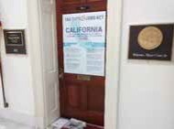
______
Oct 15, 2019, 4:54 PM
Hi David,
I’m attaching the letter that I had written to Congressman LaMalfa. In addition, I’m attaching the general letter that I distributed to members of the House Intel Committee (and left at Cong. LaMalfa’s Washington office).
Dear Congressman/Senator
The following disclosure (pasted below) reveals the real reason that Israel was surprised in the 1973 Yom Kippur War: the Head of Israel’s Military Intelligence relied on American intelligence that was designed to deceive Israel. The deception was the work of the National Security Agency’s secretive “Jew Room.” I was a Mideast Intelligence Analyst at NSA at the time. I may be contacted at while presently visiting the States.
Bruce Brill

APPENDIX 3:

THE TRUTH BEHIND THE YOM KIPPUR SURPRISE

The following is a continuation of communication with Congressman LaMalfa's office from Appendix 2.
Excerpt from Bruce Brill's earlier published article discussed in communication:
We in the Arabic Section of the US National Security Agency (NSA), where I worked at the time, knew days in advance and with certainty that Syria and Egypt were about to launch a coordinated attack against Israel on October 6th 1973.
Yet, on the eve of the 1973 Yom Kippur Surprise, Israel’s Prime Minister, Cheif of Staff, and Defense Minister were all given assurances that the Arabs’ intention of attacking Israel on or before Yom Kippur, October 6th was “very low probability.” The assurances were given by Israel’s Head of Military Intelligence, General Eli Zeira. In spite of his very own Army Intelligence indications, General Zeira was thoroughly convinced the Arabs had no intention of attacking because of unnamed foreign friends’ assurances.
Who were these “friends” that Zeira relied on with unflinching trust and confidence? This troubling question could be answered by one man and only one man, General Eli Zeira.
I met with the General at his home a year ago on July 4th. A man of 90 years of age, he listened intently to my story. He then drew a sketch outlining US intelligence structure on a sheet of paper and labeled a box at the top. This box represented the US generals with whom Zeira was in direct contact. They were fed intelligence synopses from NSA.

Finally I asked the question that had been troubling me for 44 years. Were “the friends” he so completely relied upon those American generals?
Zeira kept his lips sealed tight. He closed his eyes. He slowly and deliberately nodded his head in the affirmative. But Zeira assured me these US generals were completely trustworthy.
How was it that we at NSA’s Arabic Section knew, but even those trustworthy US generals didn’t know? It was clear to General Zeira that the correct intelligence that we had in the Arabic Section was already manipulated before it ever reached these US generals. One would assume that President Nixon himself was also given the adulterated intelligence. How was it that NSA had even reported to the 1974 US Congressional Commission of Inquiry that NSA did not know? Yet we in the Arabic Section knew, and knew it for a certainty.
I shared with the General that while I was at the Agency I discovered that there were rooms there that I couldn’t enter in spite of my well-above Top Secret clearances. I learned that they were off limits to me because I am a Jew. Since these Jew-free areas’ existence was secret, especially to Jews, it was pure happenstance that I discovered them.
In The Secret War Against the Jews authors Loftus and Aarons talk about the “Jew Room” at NSA. They say it’s a total misnomer since it is not just one singular room, and anti-Israel and anti-Jewish activities occur within them. I suggested to Zeira that the manipulation happened in this Jew Room.
Zeira understood that his American counterparts, themselves thinking the misinformation they passed him was correct and certain, naively passed him their assurances. They, themselves, were duped and not to be faulted.
By the same measure, Ziera cannot be totally faulted.
In spite of the Israeli government Agranot Commission of Inquiry’s conclusions and public perception putting the blame on Zeira’s shoulders, the blame belongs to NSA’s Jew Room.
Bruce Brill was an NSA Mideast Intelligence Analyst. His writingshave been published in The Jerusalem Post, The Christian Science Monitor, Midstream Magazine, The Washington Times, The Jerusalem Report, and others.
Bruce Brill, Kfar Eldad, Israel
Bruce: To review our discussion, you assumed that “The Jew Room” no longer exists in NSA. How can we get proof/assurance that your assumption is correct?
All the best,
Bruce (Bruce Brill)
Bruce:
Hello (again) David,
I apologize for the multiple emails instead of just one. I’m writing again because of a question that you had asked me that is answered in my 2017 letter to Congressman LaMalfa. You had asked me if I required a response. If you read the letter, you will see that I did ask for a response (by asking the Congressman, “Don’t you agree?”).
I just wanted to point this detail out to you. As Ever,
bruce (Bruce Brill)
David:
Hello Bruce,
Our office receives many correspondences from a plethora of individuals and constituents. Asking “Don’t you agree?” is not asking for a response. And to respond to your other email I don’t know how you would go about collecting evidence of the room and if it is still in existence. I have checked with our DC office and they have assured me that the room does not exist. You are more than welcome to pursue other avenues for research. But from our office, we have looked into it and have found nothing.
And finally, the Congressmen and our staff are major supporters of the state of Israel. We are proud to stand with one of the only democracies in the Middle East and our close ally. If you have any other questions or concerns please feel free to reach out.
Thank you.
Morgan, David Oct. 217, 2019, 1;13 AM

APPENDIX 4:

DANNY BEN-YAAKOV

Danny was a frequent guest there, visiting her husband.
Danny was not a commissioned officer in the IDF. He did however, take part in General Staff (ל”מטכ) meetings and had a status there. He may have obtained some benefits or merit as a language specialist with modi’in. His participation in high command meetings is therefore corroborated. Strange … but … knowledgeable.
Ilana Baum recalls that he had belonged to their group of friends. … some distinctive quality had earned him a unique status, as I found. He had unmasked a dangerous spy that nobody else suspected (article attached [below]).145
אני אומר לכם, ישראל בר הוא מרגל” דני בן-יעקב, איש מסתורין, 2003-1928)?( מאת: אורי דרומי דני בן-יעקב היה איש שחבריו הרבים כמעט שלא ידעו דבר על אודותיו, ואת המעט שידעו שמעו מפיו. הוא נולד כנראה בגרמניה, ובגיל תשע שלחו אותו הוריו לאנגליה, שם גדל אצל משפחה אומנת, לדבריו בעלת תואר אצולה. אחרי המלחמה, כשנודע לו שהוריו נספו בשואה, הוא קרא לעצמו בן-יעקב, על שם אביו. הוא עלה לארץ, לדבריו, באונייה "אלטלנה," לחם במלחמת הקוממיות בירושלים ואף נפצע, יש אומרים שבשורות האצ"ל, אך סביר יותר שבגדוד בית חורון בפיקודו של מאיר זורע "(זרו.)"
דן פון ויזל, שהכירו בתש"ח, הפגיש בינו לבין דינה מאייר, אשתו של הצייר לודוויג בלום, ובני הזוג הפכו למעין הורים מאמצים שלו. בן-יעקב החל להופיע בבתי הקפה הירושלמיים ובחבורה שסבבה את לוחם ה101- שלמה באום. דידי מנוסי זוכר את הופעתו המוזרה - שפם עשוי בקפידה, חליפת טוויד, כובע ציידים, מטפחת ירוקה לצווארו, מקל הליכה מגולף ולפעמים אף מונוקל. הוא הדהים את שומעיו בידיעותיו בהיסטוריה צבאית ובשליטתו המושלמת בשמונה שפות. אנשים נטו לפקפק באמינות

145 Dr. Nimrod Liram, Private communication, Jerusalem 2021.

סיפוריו, אם כי תמיד ביצבץ מהם גרעין של אמת. העיתונאי ורדי בן-יעקב (אין
קרבה) מתאר אותו כדמות מספריו של יז'י קושינסקי, שאי אפשר למסגרה.
בראשית שנות החמישים היה בפיו של בן-יעקב סיפור מדהים: סא"ל ישראל בר, שהיה עוזר ראש אג"ם בתש"ח וההיסטוריון של צה"ל, היה מרגל סובייטי. הוא חקר ומצא כי בר לא לחם במלחמת האזרחים בספרד, כפי שטען, וכי תאריו האקדמיים
היו מזויפים. אז החל, לדבריו, איסר הראל, הממונה על שירותי הביטחון, להתנכל לו: בריונים ארבו לו בסימטאות חשוכות והכוהו, זונה שנשכרה לכאורה על ידי השב"כ התלוננה כי אנס אותה, מקומות עבודה נסגרו בפניו. יהודה ארבל, בכיר בשב"כ ומפקדו לשעבר, ניסה לגונן עליו. הוא הסתובב עם אגרופן בכיס, ולעתים אף השתמש בו. אבל ב1961- אכן נעצר ישראל בר באשמת ריגול לטובת ברית המועצות. בן-יעקב כתב במאמרים עיתונים כי הראל חיפה על בר במשך 11 שנים. הראל תבע את "דבר" על הפרסום, והשופטת שרה סירוטה פסקה ב1994- כי מה שהניע את בן-יעקב היה
שנאת חינם לאיסר הראל. העיתון חויב לשלם להראל 300 אלף שקל.
חברים נחלצו לעזרתו של האיש הבודד, הגאה, שלעתים הגיע לפת לחם. הפרופסורים
גבי שפר ויואב גלבר שילבו אותו במשחקי סימולציה שנערכו בעבור צה"ל (ובהם, כך טען לימים, הוא חזה בדיוק את פרוץ מלחמת יום הכיפורים;) חיים גורי פנה לשר הביטחון יצחק רבין כדי להסדיר לו קצבה בשל פציעתו בתש"ח. הוא הפציר בחבריו
לארגן לו רשיון של סוחר נשק והבטיח למכור פצצת הדף אוויר - דבר שנשמע כהזיה, עד שבשבוע שעבר האמריקאים השליכו פצצה כזאת לניסיון. הוא התחתן עם אשה אוסטרית וסעד אותה במחלותיה. לפני כמה שבועות, כשחזר מביקור אצלה, מיהר לטלפן לכל חבריו: "ה(ביטוי גנאי חריף) מת"! צהל, בהתכוונו לשנוא נפשו איסר הראל. יומיים אחר כך הלך לעולמו, בודד, בדירתו הירושלמית המוזנחת145.

145 2003-1928https://www.haaretz.co.il/misc/1.869633 .18.3.2003 הארץ«
APPENDIX 5:
UNITED STATES PENTAGON APPROVALS FOR PUBLICATION OF THIS BOOK
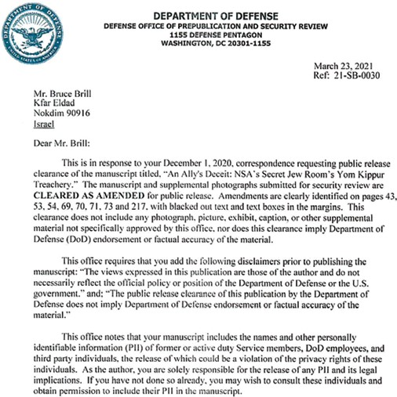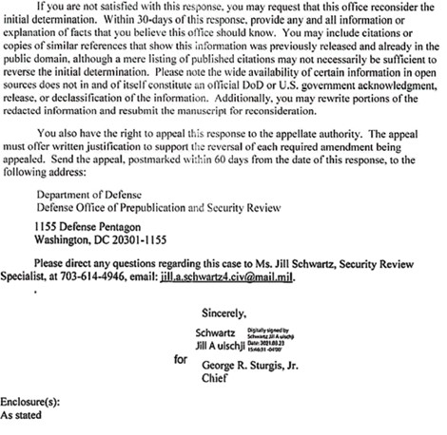
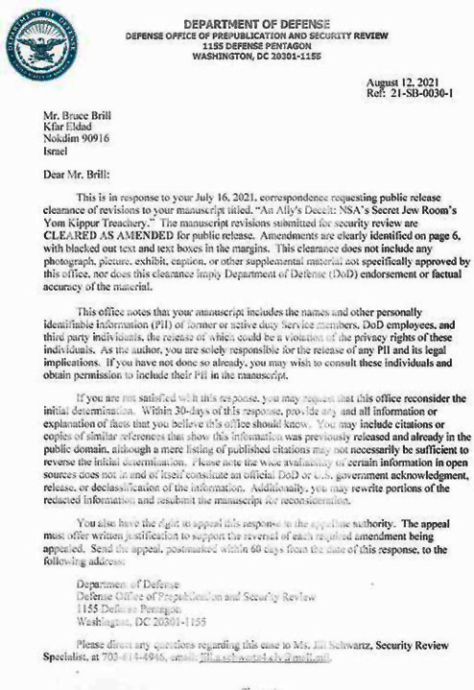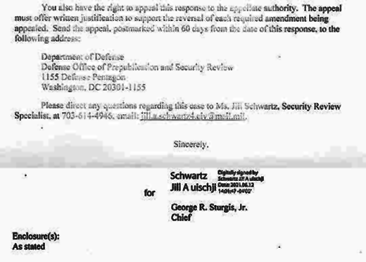
FIGURES LIST
Figure 1: Assaf Berg Sketch. Printed with permission of the Jerusalem Post.
Figure 2: NSA Complex, Fort Meade as it looked in the early ’70s.
Figure 3: “Uncle Sam” Wants You!
Figure 4: “2A” Occupational Deferment.
Figure 5: Robert Johnson and Mom.
Figure 6: Pvt Henry Brill, “Protestant.”
Figure 7: Selective Service notice to appear.
Figure 8: Selective Service appeal notice.
Figure 9: Board of Education deferment request.
Figure 10: USASA: U.S. Army Security Agency recruitment flyer.
Figure 11: Induction notice.
Figure 12: My attempt to guarantee assignment to ASA for the Arabic language and orders to Fort Dix.
Figure 13: It worked! My assignment to USASA
Figure 14: Basic Training.“Eight more weeks of cleaning brass, then Fort Dix can kiss my…”
Figure 15: Presidio of Monterey.
Figure 16: “Temporary” WWII wooden barracks at the Presidio of Monterey.
Figure 17: Presidio of Monterey: a mixed services base.
Figure 18: Separate “rats.”
Figure 19: Merwan… “The Goat Roper.”
Figure 20: DLI diploma.
Figure 21: Orders to security training, San Angelo, TX.
Figure 22: Merwan in uniform.
Figure 23: Kareem.
Figure 24: Early out.
Figure 25: Arabic Egyptian “MOS.”
Figure 26: Goodfellow Security: No cameras! No photographing!
Figure 27: Security training diploma, Goodfellow Air Force Base, Texas.
Figure 28: National Cryptologic School certificate.
Figure 29: Peter: hippy Hebrew head
Figure 30: Specialist Bruce Brill, “Protestant.”
Figure 31: Israeli Defense Minister Moshe Dayan’s letter to me.
Figure 32: Moshe Dayan’s secretary’s letter thanking me for the “eye patch.”
Figure 33: The Rebbe.
Figure 34: The Lubavitcher rebbe at a tish.
Figure 35: Evaluation report.
Figure 36: Assignment to reserves, honorable discharge, and the president’s letter of appreciation.
Figure 37: 1993 Letter to NSA Security Chief.
Figure 38: 1994 Letter to NSA Security Chief.
Figure 39: General Rehavam Ze’evi.
Figure 40: “Pollard and Dreyfus,” the Jerusalem Post.
Figure 41: 1993 letter to NSA security chief.
Figure 42: “Signs of 1973 Mideast War Eluded U.S. Spy Agencies”.
Figure 43: CIA’s “Complete Deployment of Syrian Units for Assault upon Israel”
Figure 44: September 30, 1973, Israeli intelligence summary.
Figure 45: October 1973 AMAN report.
Figure 46: The U.S. Intelligence Board of 1973.(Permission given to use the photo from the CIA)
Figure 47: Moshe Dayan Protocol: October 7, 1973.
Figure 48: Danny Ben-Yaakov, "The Man Who Never Existed", photo provided by Udi Cain
Figure 49: Chaim Bar-Lev inspired letter to Rabin.
Figure 50: Author at Sheremetyevo Airport Moscow.
Figure 51: In Moscow on July 4, 2013.
Figure 52: Internet Movie Script Database.
Figure 53: Enemy of the State User Comments.
Figure 54: Proof Ordoukhanian’s claim is credible.
Figure 55: Raymond Ordoukhanian, jailed.
Figure 56: At the Capitol.
Figure 57: Congressional Halls.
Figure 58: The “secret, subtle” mailout.
Figure 59: Including Jared Kushner.
Figure 60: David Morgan and me at Auburn office.
Figure 61: 1993 Polygraph Test Results.
Figure 62: Uncleo holding our marriage canopy.
Figure 63: Uncleo, bride Vivian, me, sister Rachel.
